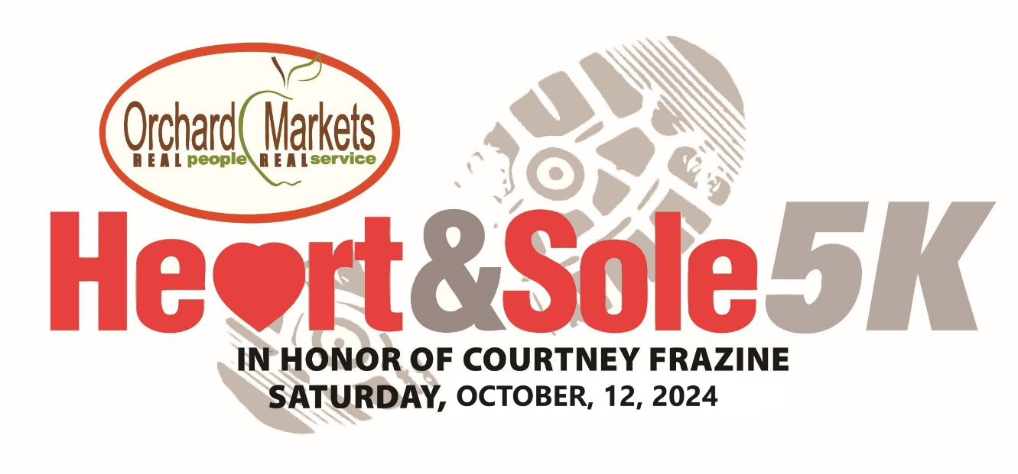
ORCHARD MARKETS HEART & SOLE 5K
SATURDAY, OCTOBER 12, 2024

ENTRY FEES:
PRIOR TO 08/01/24 08/01/24 TO 10/10/24 10/11/24 & 10/12/24
INDIVIDUAL: $30.00 $35.00 40.00
FAMILY (EACH MEMBER) $25.00 $30.00 35.00

FIRST NAME:______________________LAST NAME:____________________________________MI:________
STREET:_____________________________________________________________________
CITY:_______________________________________STATE:_______________________ZIP:_______________
DAY PHONE:________________________________CELL PHONE:_____________________________________
E-MAIL:___________________________________________________________________________________
BIRTHDATE:_______________________AGE: (AS OF RACE DAY)______________GENDER:_____________________
EVENT:___________________________________________
SHIRT SIZE (UNISEX):________________________________
ESTIMATED RUN PACE PER MILE:_________________________________
EMERGENCY CONTACT NAME:_________________________________________________________________
EMERGENCY CONTACT PHONE:___________________________________RELATIONSHIP_________________
MEDICAL CONDITIONS:_______________________________________________________________________
_______________________________________________________________________
ANY AND ALL MEDICATIONS:__________________________________________________________________
ALLERGIES:__________________________________________INSECT OR OTHER STING SENSITIVITY?_______
OTHER MEDICAL ISSUES:_____________________________________________________________________
WILL YOU BE WEARING CONTACT LENSES?_______________________________________________________
SIGNATURE OF PARTICIPANT (PARENT OR GUARDIAN IF UNDER 18)
X_____________________________________________________AMOUNT ENCLOSED:__________________
WAIVERS WILL BE AT PACKET PICK UP AND EVENT SITE FOR YOUR SIGNATURE

MAKE CHECKS PAYABLE AND MAIL TO:

CMF HEART & SOLE 5K
15764 – 148TH AVE.
SPRING LAKE, MI. 49456

HEART & SOLE 5K “VIRTUAL” EVENT
RELEASE AND WAIVER OF LIABILITY AND PERSONAL ASSUMPTION OF RISK AND INDEMNITY AGREEMENT
READ THIS DOCUMENT CAREFULLY BEFORE SIGNING. THIS DOCUMENT HAS LEGAL CONSEQUENCES AND WILL AFFECT YOUR LEGAL RIGHTS AND WILL LIMIT OR ELIMINATE YOUR ABILITY TO BRING FURTHER ACTIONS.

In consideration of being permitted by Superior Multisport, LLC (The LLC) to participate in Heart & Sole 5K event and any related pre or post-event activities (collectively the “Event”), I understand and acknowledge by signing below, that I am agreeing to the statements in the following Release and Waiver of Liability and Assumption of Risk and Indemnity Agreement (The “Agreement”) and that these statements are being accepted and relied upon by the LLC and “RELEASED PARTIES” (as defined below). I hereby freely and voluntarily acknowledge and/or take action for myself and on behalf of my spouse, significant other, children, parent, guardian, heirs, next of kin, and any legal or personal representative, executors, administrators, successors and assigns, or anyone else who might claim or sue on my behalf or other subsequent parties as follows:

1: I hereby acknowledge and assume ALL the risks of participating in this Event. Running, walking and ALL other portions of this event are inherently dangerous and are an extreme test of my physical, mental and emotional limits that carries with them the potential for serious bodily injury, partial and/or permanent disability, paralysis, death, and property damage or loss. I acknowledge and agree that it is MY responsibility to determine whether I am sufficiently fit, prepared and healthy enough to safely participate in the Event, which I elect to enter. I certify that I have not been advised against participating in the Event by any healthcare provider. If I or a healthcare provider determine I’m not physically, mentally or emotionally fit to participate, I will voluntarily NOT participate. Furthermore, I fully understand that running or walking and all facets of an Event that is organized as a VIRTUAL activity where I run or walk on MY own, at a date and time of MY choosing, in a location and run/walk route of MY choosing, which will NOT have ANY support or security measures in place by the LLC and “RELEASED PARTIES” is a potentially hazardous activity which could result in bodily injury, partial and/or permanent disability, paralysis, death and property damage and loss. I further agree to abide by the Center of Disease Control (CDC)’s recommendations for the prevention of the spread of COVID-19 and attest to having read the CDC’s guidance at: https://www.cdc.gov/coronavirus/2019-ncov/prepare/prevention.html. I attest that if my community, or the community where I elect to do my virtual Event has a shelter in place or stay at home order, I will not participate outside and only run indoors on a treadmill or indoor track. I hereby understand the serious risks of COVID-19 and hold harmless, discharge and will indemnify the LLC and “RELEASED PARTIES” if I directly or indirectly contract the COVID-19 virus. I understand and acknowledge there may be (motorized and non-motorized), vehicular (or any other motorized units) or pedestrians on the course routes and I assume the risk of participation on the courses and all other portions of MY Event under these circumstances. I also assume ANY and ALL other risks associated with participating for MY Event, including but not limited to the following: cramping, hypothermia, falls, dangers of equipment, trail, sidewalk or bike path hazards, road/traffic hazards, and ANY OTHER hazards that may be posed by ANY parties or entities and weather conditions. I fully understand and acknowledge the course I select to do MY virtual Event are of MY choosing, only MY choosing and no one else. I also take responsibility as to the conditions of these courses. I certify that I’ve read the event’s details and cautions as provided on their event website and/or emails to me. I agree to read and FULLY abide and adhere to ALL road traffic and pedestrian laws. I agree that prior to participating in MY virtual Event, I will inspect MY race course, facilities, equipment and areas that I will utilize. If I believe or become aware that if anything is unsafe, I will NOT use MY selected course and I’ll personally create/select a different course.

2: I understand and acknowledge the dangers associated with the consumption of alcohol and/or drugs (including prescription drugs) before, during and after the Event and I recognize that consumption of alcohol and/or drugs (including prescription drugs) might impair my judgement and motor skills. I assume any injury, loss or damage associated with my consumption of alcohol and/or drugs (including prescription drugs).

3: I WAIVE, RELEASE AND FOREVER DISCHARGE THE LLC, I AM Athlete, LLC (aka: imAthlete), Sportsware, Inc, EnMotive, LLC, Event sponsors, organizers, promoters, producers, race directors, officials, staff, advertisers, property owners, volunteers, administrators, contractors, vendors, any and all other persons or entities involved with the Event, all governmental bodies and any of their staff and/or agents acting on their behalf and private/public/municipal/governmental agencies whose property is used in any way assist in locations in which the Event or segments of MY Event take place and each of their respective parent, subsidiaries, and affiliated companies, licensees, officers, directors, partners, board members, shareholders, members, supervisors, agents, insurers, attorneys, employees, volunteers, and other participants and representatives (individually and collectively, the LLC and “RELEASED PARTIES”), from ANY and ALL claims, liabilities of every kind, demands, damages (including direct, indirect, incidental, special and/or consequential), losses, (economic and non-economic) and causes of action, of any kind or any nature which I have or may have in the future, including court costs, attorney’s fees and litigation expenses (individually and collectively, the “claims”) that may arise out of result from or relate to my participation in MY virtual Event or my traveling to or from MY Event, including my death, personal injury, partial or permanent disability, negligence, property damage and damages of any kind, property theft and claims relating to the provision of first aid, medical treatment or medical decisions (at MY Event site or elsewhere) and any claims for medical or hospital expenses even if such claims were caused by the negligent acts, omissions, or the carelessness of the LLC and “RELEASED PARTIES”.

4: I FURTHER COVENANT AND AGREE NOT TO SUE any of the LLC and “RELEASED PARTIES” for any of the claims that I have waived, released or discharged properties, I AGREE TO INDEMNIFY, DEFEND AND HOLD HARMLESS the LLC and “RELEASED PARTIES” from ANY and ALL expenses incurred, claims made by me or ANY other individuals, parties, or entities for liabilities assessed against or expenses incurred by the LLC and “RELEASED PARTIES”, including but not limited to court costs, attorney’s fees and litigation expenses arising out of or resulting from, directly or indirectly, in whole or in part, my breach or failure to abide by any part of this agreement, rules or direction, my breach or failure to abide by any rules of competition or instruction (including in this waiver) and information provided by any of the LLC and “RELEASED PARTIES” relative to the event and my actions or omissions which cause bodily injury or property damage to any other person, property owner, business or governmental agency.

5: I HEREBY GRANT TO THE LLC AND “RELEASED PARTIES” the right, permission and authority to use my name, image, voice and likeness, without compensation, captured by and/or provided to the LLC and “RELEASED PARTIES”, all affiliated entities, or contractors and the media in any photographs, videotapes, CD’s, DVD’s, broadcast, telecast, podcast, webcast, recordings, motion pictures, commercial advertisement, promotional materials and any other medium as a result from MY virtual Event for the sole purpose of promoting this Event in a legal and moral manner. I ALSO HEREBY GRANT TO THE LLC AND “RELEASED PARTIES” permission to contact me prior to and after the Event by mail or email. This includes providing post-race details, results, photos/videos and sponsor/vendor services and products.

6: I understand the LLC reserves the right in its sole discretion, to deny entry, revoke the entry application of any applicant at any time and/or to disqualify any individual from their participation in the Event. I hereby understand, as stated on the event website registration page, “THERE ARE NO REFUNDS OR TRANSFERS FOR ANY REASON”. Applicant expressly waives any claim for any damages arising from the denial, revocation of an entry application or cancellation of the Event and will forego his or her entry fees and expenses.

7: A legal guardian that signs this agreement on behalf of a minor, incapacitated and/or mentally or emotionally challenged person (hereinafter, “Said Person”, hereby acknowledges that he or she has the legal capacity and authority to act on behalf of “Said Person” and to legally bind “Said Person” and to legally bind “Said Person” to this agreement. “Said Person” and the legal guardian that signs this agreement agrees to indemnify and hold harmless the LLC and “RELEASED PARTIES” for any expenses incurred, claims made or liabilities assessed against them as a result of any insufficiency of legal capacity or authority to act on behalf of “Said Person” in the execution of this agreement.

8: This agreement supersedes any other agreements between the parties, whether written or oral and which is intended to provide a comprehensive release of liability, but it is not intended to assert any claims or defenses which may result in any waiver of right s of the LLC and “RELEASED PARTIES”. The internal laws of the State of Michigan govern this agreement, exclusive of any conflicts of law provisions. If any part of this agreement is unenforceable, all other parts shall still be given full force and effect.

Participant Name (Print):__________________________________________________________Date__________________________________________________

Signature:____________________________________________________________Parent/Legal Guardian______________________________________________

