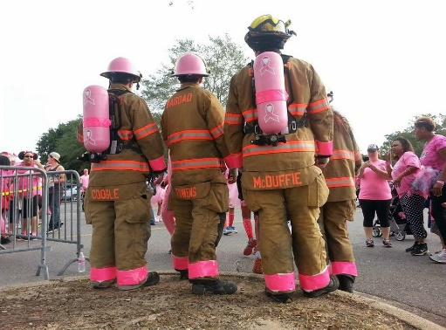 | October 2016

Sun. | Mon. | Tue. | Wed. | Thu. | Fri. | Sat.
 |  |  |  |  |  | 1
2 | 3 | 4 | 5 | 6 | 7 | 8
 | Dave’s Bday  Business Meeting |  |  | Jerry’s Bday | Gidget’s Bday  Eddie’s Bday | Cookout
9 | 10 | 11 | 12 | 13 | 14 | 15
 |  |  |  | Truck Checks
16 | 17 | 18 | 19 | 20 | 21 | 22
 | Medical Training
23 | 24 | 25 | 26 | 27 | 28 | 29
 |  |  |  | Fire Training |  | Breast Cancer Walk
30 | 31
 | Halloween

notes | Cook out – 1700 station 1 – bring a side and drinks  All trainings – 1830 station 1 – please attend  Breast cancer walk – Cordova Mall - 0700 registration – 0800 beginning of walk  Fire prevention week – 10th through the 14th

