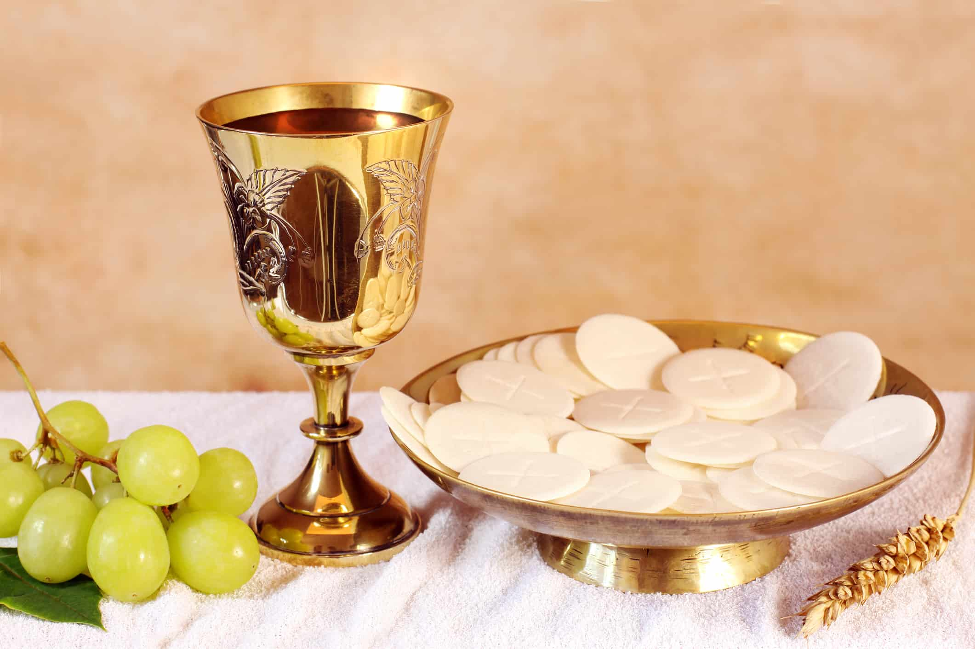

Ninth Sunday after Pentecost

Carson City United Methodist Church

10:30 am
Greeting/Announcements

Call to Worship

L: We believe in God, the Father Almighty, creator of heaven and earth.

P: We believe in Jesus Christ, his only Son, our Lord,
who was conceived by the Holy Spirit,
born of the Virgin Mary.

L: Suffered under Pontius Pilate, was crucified, died, and was buried.

P: He descended into hell. On the third day he rose again;
he ascended into heaven, is seated at the right hand of the Father, and will come again to judge the living and the dead.

L: We believe in the Holy Spirit, the holy universal church.

P: The communion of saints, the forgiveness of sins,
the resurrection of the body, and the life everlasting. Amen.

*Hymn: Lord of the Dance UMH 261

Opening Prayer:
Heavenly Father make us instruments of your peace. Where there is doubt help us to sow faith in you. Where there is despair help us to sow the hope found only in you. Where there is pain and hurt help us to bring healing and comfort in your name. Where there is hate, let us sow your love. In Jesus name we ask this AMEN.

Contemporary Song: Holy Water (We The Kingdom)

Offering

Doxology UMH 95

Offertory Prayer

Sharing of our Joys and Concerns

Call to Prayer: He is Lord UMH 177

Pastoral Prayer

Gospel Reading: JOHN 1:1-5, 10-13

Old Testament: PSALM 100:1-5
Epistle Lesson: EPHESIANS 2:4-10
Contemporary Song: Don’t Tread on Me
(We The Kingdom)

COMMUNION

MESSAGE

*Hymn: Lead On, O King Eternal UMH 580

Benediction

CCUMC – Announcements & Upcoming Events:

As a courtesy to others please silence or shut off cellphones

==================================================
Upcoming Hall Rentals: 8/20 @ 8:30am. Also, for Drivers Training Class, see calendar in Welcome Center.
==================================================
Michigan Conference Mission U: Is held at Gaylord UMC October 17-18. Walthagaye is attending both so if you need a ride, please get in touch with her. The flyer is on the What’s Happening bulletin board with registrations on the shelf under it.
==================================================
Craft & Vendor Show: CCUMC will be hosting a Craft Show on Sat, Nov 5th, 9:00 am thru 2:00 pm. If you are a Vendor interested in reserving a spot, please contact Dawn Wager @ 989-285-2518.
==================================================

SPRC/Single Board Governance Meetings & Charge Conference Information

SPRC
Saturday, September 10th 3:00 pm, to be held at the Alma UMC.

CHURCH CONFERENCE 2022
Sunday, October 30th 2:00 pm, to be held at the Alma UMC.
Everyone is welcome to attend.

Serving & Supporting Sunday Worship
Audio/Video: Pat Monroe

Joys, Concerns & Prayer Request
For those battling cancers:
Jim Dunlap, Carolyn Nykerk, Dillan Abell,
Amorena Newman-Wojciakowski

For those who need support, guidance or have health concerns: Mindy Dennis, Jim Dunlap, Heather Kile

Weekly Giving
7/31 $1183.84

Nursery Schedule
Open for the summer but no supervision

Lighting of Candles

Passing of Collections Plate

Our Church in Ministry This Week
Mon: PT Class 6:30-8 pm
Tue & Thu: COA Meal 10 am – 2 pm

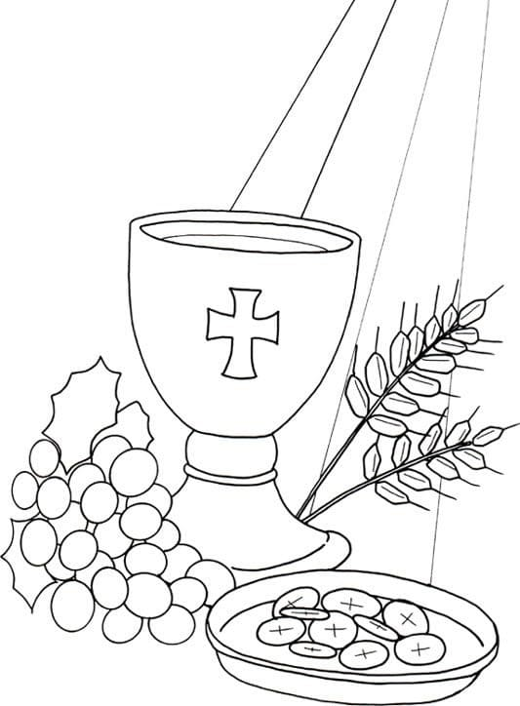
Coloring Page

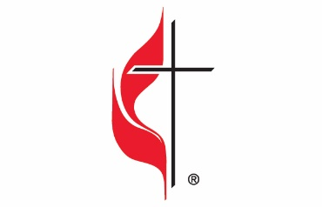

Carson City United Methodist Church
Location: 119 East Elm St., Carson City, MI
Mail: PO Box 298, Carson City, MI 48811
Phone: 989-584-3797 Email: carsoncityumc@gmail.com
Website: carsoncityumc.com
Sunday Worship Service: 10:30 am
Office Hours: Monday-Thursday, 9:00 am-12:00 pm
After hours by appointment
Pastor: Ian McDonald 906-322-5318
Secretary: Bonnie Seaman 989-763-1674

Weekly Sunday Bulletin now available on our website
@ www.carsoncityumc.com

“Loving God, thank You for the gift of life with You. Thank You that I don’t need to be more than I am. Thank You that in You I find all that I need and more”

