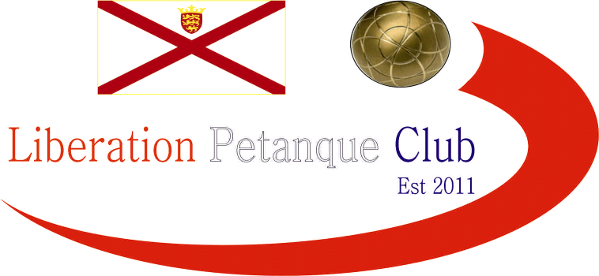

SUMMER 2023 SEASON
2023
CLUB SINGLES CUP

22 Players took part this year on a beautiful evening.

Round 1 saw Andrew BB lose a clos match to Paul Bell 13 – 11 and current champion Geoffroy beat Daniel V 13 – 9.

Two 13 – 12 wins win the way of James G over Brian and Jean over Joey. Biggest win of the round saw Keith beat James V 13 – 2 and only one match didn’t make 13 and this was an 11 – 5 win for Callum over Ross C.

Round 2 saw Laurent beat Toby 13 – 10, Callum made it back to back wins 13 – 2 over Paul and this was the same score as Alan beat Jean.

James G made it two wins with a big win over Keith 13 – 4.. Five matches didn’t make it to 13 in this round as Joey won 10 – 8 over Lorna, James V beat Branden, Mo beat Jim and Geoffroy Beat Alex 12 – 9, the same score for Andrew L over Tim.

Callum won 11 -10 over Andrew L to make it three wins and Geoffroy also moved onto three wins with a win over Alan.

James V beat Paul for his second win as did Toby over Keith and Tim over Joey.

Mo beat Jean 12 – 9 and Lorna 9 – 8 over Jim. Laurent also made it three beat James G 13 – 5

In the final round Toby Northern beat James Villalard 13 – 1 to finish fifth and Andrew Bellamy-Burt beat Alan Oliveira 13 – 7 to finish fourth.

James Gennoe lost again to Tim Jackson to go out with Tim finishing sixth. Laurent lost to Callum to finish third which meant Callum finished top of the Swiss Rankings with four wins from four, a feat also achieved by Geoffroy over Andrew Limbrick so Geoffroy finished second. Andrew L finishing seventh.

Eighth spot went to Paul Bell by one BHN over Alan Oliveira.

Swiss Rankings

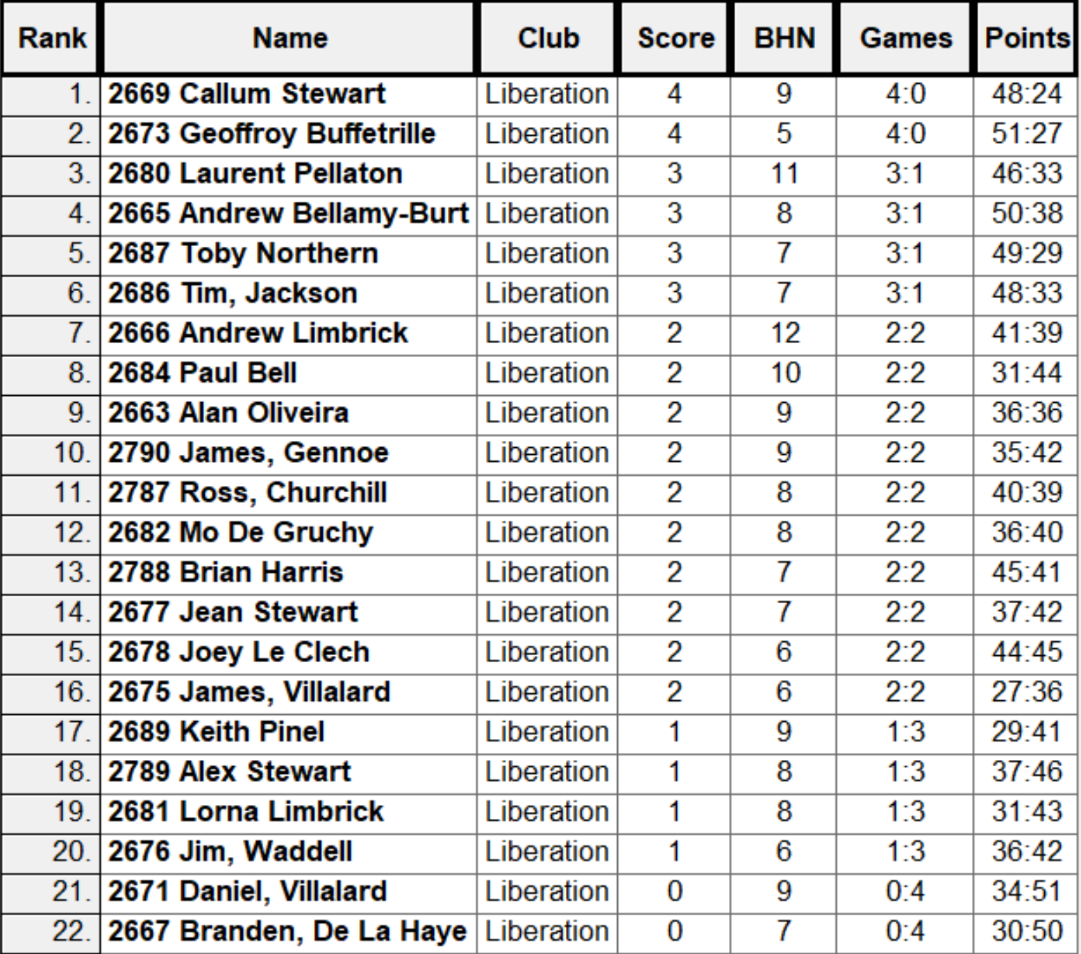

Quarter Finals

Ranked 1st Callum Stewart v Paul Bell Ranked 8th

Ranked 2nd Geoffroy Buffetrille v Andrew Limbrick Ranked 7th

Ranked 3rd Laurent Pellaton v Tim Jackson Ranked 6th

Ranked 4th Andrew Bellamy-Burt v Toby Northern Ranked 5th

Callum got the best of Paul for the second time in the competition winning 13 – 3, the biggest win in the Quarter Finals. A surprise as Andrew Limbrick who had just lost to Geoffroy Buffetrille in the last qualifying round, turn it around to get to the semi finals with a 13 – 9 win.

Tim Jackson pushed Laurent Pellaton all the was but lost out 13 – 11 and Andrew Bellamy-Burt beat Toby Northern 13 – 12 on the last end.

Semi Finals

Ranked 1st Callum Stewart v Andrew Bellamy-Burt Ranked 4th

Ranked 7th Andrew Limbrick v Laurent Pellaton Ranked 3rd

Semi Final one never went Callum way as he struggles against Andrew, who won comfortably 13 – 3.

Laurent seemed in control of his match against Andrew but it was close with Laurent just winning 13 – 10.

Third Place went to Andrew with a 13 -10 win over Callum.

The final, which you can see in full on our facebook page. Was pretty one sided as Laurent played exceptionally well before a comeback by Andrew but not enough as Laurent sealed his first win in the competition 13 – 9.

Thanks to Laurent, Geoffroy and anyone else who helped Toby run the competition.

Winner

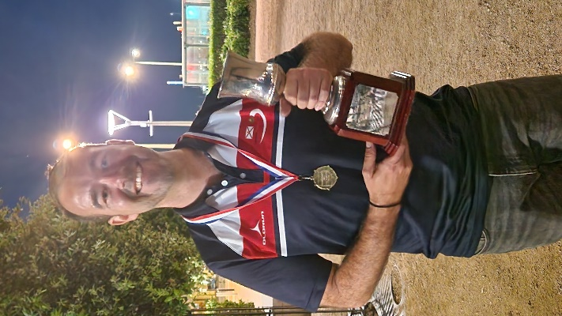

NEXT WEEK - SINGLES LEAGUE

Club email address - liberationpc@gmail.com

Club Website - www.liberationpetanque.co.uk

Kind Regards

Toby Northern

Chairman

Liberation Petanque Club

