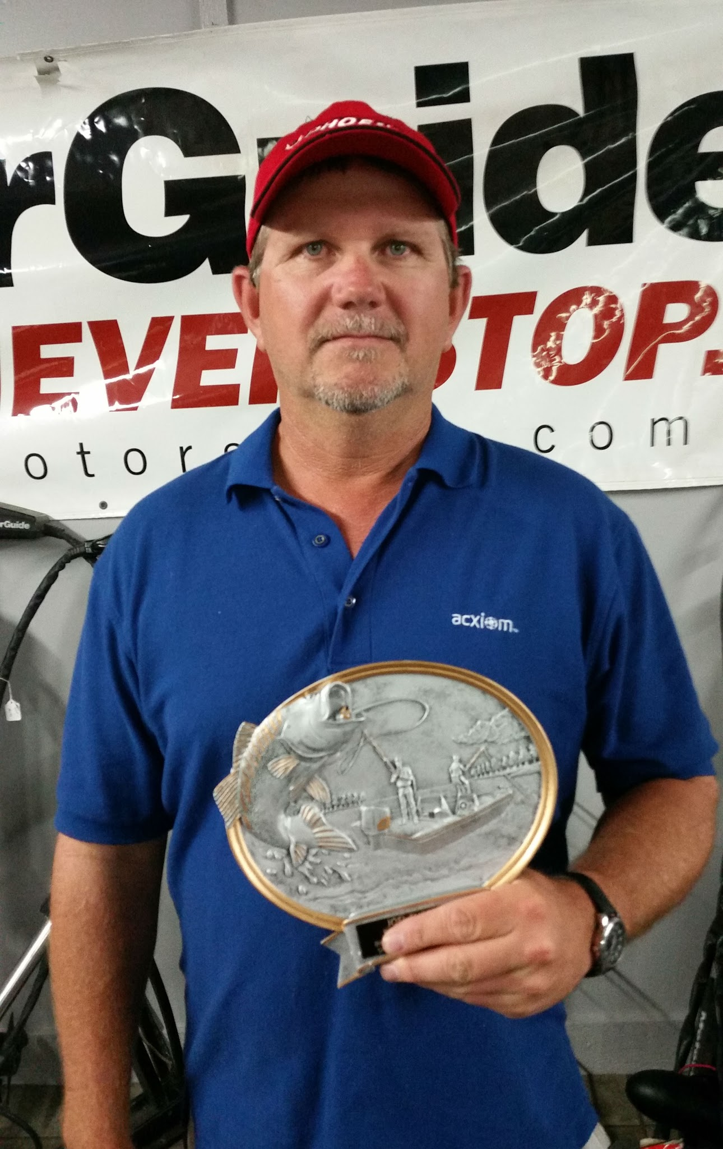 | Doug Thompson and Hoyt Akins cap off their year by winning the Team of the Year award at the annual Sherwood Bass Club winter meeting. Doug and Hoyt were able to close the door at the September derby, in Little Rock, by taking home first place. They would follow it up with the largest bag of the Sherwood Classic in October. Doug stated that he enjoyed fishing in the Sherwood tournaments, that the club was made up of great guys he enjoyed being around, and that's what it is all about.
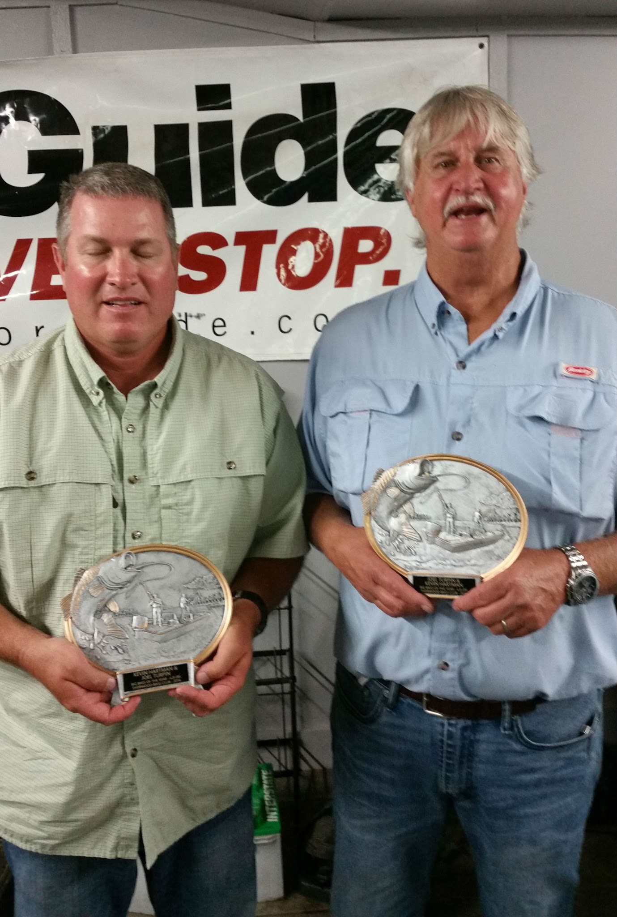 | Kevin Hartman and Joel Turpin take home the Sherwood Bass Club, Big Bass of the Year Award. The 7.67lb swamp donkey was caught on the "Big O", Lake Ouachita, in the April derby. Kevin and Joel would go on to win the April Sherwood Bass Club derby with a winning weight of 16.49lbs, anchored by the future 2016 Sherwood Bass Club Big Bass of the Year.

