Rock City Church Unoffendables
Curriculum

Contents

Introduction………………………………………………………………………..........Page 4

Table of Contents

Lesson 1: “A Clean Heart”……………………………………..………………….....Page
Lesson 2: “It’s Not Fair”...........…………………………………………………….. Page
Lesson 3: “Mad at Dad: When Fathers upset us.…………………………..Page
Lesson 4: “Don’t Quit, Stay and Obey”………...…………………………….....Page
Lesson 5: “Stronger than the Giants”…………………………………………..Page
Lesson 6: “A Precious Stone”…………..…………….………………………........Page
Lesson 7: “Building others up”..………………………………..…………..........Page
Lesson 8: “Forgiving others” ………………………...........................................Page
Lesson 9: “He is My Defender”………….………………………………………...Page
Lesson 10: “Don’t Judge Others”……………………………………………........Page
Lesson 11: “Getting It Right”.........………………………………………………..Page
Lesson 12: “Will you Forgive Me?”……………………….................................Page
Lesson 13: “Walking in Forgiveness”…………………………………………...Page

Lesson 6: The Rock of Offense.
New Title: A Precious Stone
Key: Love is the bottom line in our relationship with the Lord-not love of principles or teachings, but love for the person of Jesus Christ.
Biblical Component: The main element of believing is obedience. Therefore, to you who obey, He is precious; but to those who are disobedient, “The stone which the builders rejected has become the chief cornerstone,” and “a stone of stumbling and a rock of offense.” It is not difficult to obey when you know the character and love of the one to whom you are submitting.
Lead Verse: “Behold, I lay in Zion a chief cornerstone, elect, precious, and he who believes on Him will by no means be put to shame.” Therefore, to you who believe, He is precious; but to those who are disobedient, “The stone which the builders rejected has become the chief cornerstone,” and “a stone of stumbling and a rock of offense.” They stumble, being disobedient to the word, to which they also were appointed. - 1 PETER 2:6-8
Closing Prayer Time: Telling Christ that you will trust, love, and obey Him.
Interactive Ideas By Age Group:
- Nursery: Infants: build a house with blocks. Toddler: Painting river stones.
- Preschool:
A Precious Stone
GODS GENERALS FALL LESSON 6
AGE: ELEMENTARY 6-8 YEAR OLDS
Adopted From Bait of Satan by John Bevere

Lesson Topic: Jesus is the Precious Stone and Many were offended by Him

LESSON | WHAT CHILDREN DO | SUPPLIES | PREPARATION
1  Getting Started | Introduction/Ice Breaker: Play Jenga | Jenga game or 2 games  Cardboard bricks can be used also. | Make sure there are enough games per group of 6.  These games may need to be borrowed.
2  Bible Exploration.  Key Verse Activity | Key Verse: 1 Peter 2:6 ESV  “Behold, I am laying in Zion a stone, a cornerstone chosen and precious, and whoever believes in him will not be put to shame.”  Bible Story: Matthew 13 Jesus tells many parables about the Kingdom and then goes to teach in the synagogue.  Matthew 13:55-57 will be the focus | Bibles,  Idea: Print the verse and surround it with precious stones.  Pictures or props of the things mentioned in the parables: Seed, sower bag, weeds, mustard seed, treasure, net and fish, robe and scroll to represent Jesus teaching in synagogue | Study definition of parable, synagogue. Find pictures or props to help describe what Jesus was doing and saying.
 | Bible Activity: Act out the scene in Matthew 13:55-57. | Printed copies on separate cards or paper of what each person said.  Costumes, props | Print each person’s dialogue on separate cards or paper.
 | Brainstorm and act out offense situations:  Brainstorm a modern day example of what it was like for Jesus to preach in the synagogue. | Chart paper and markers | Help children think of examples of what Jesus’s story may look like in modern times.
LESSON | WHAT CHILDREN DO | SUPPLIES  NEEDED | PREPARATION OVERVIEW
3  Weaving Faith  Into Life | Craft/Make and Take:  Chief Cornerstone Pop-up Card | Index card, construction paper,  Markers, pens, crayons etc.  Small stick-on jewels  Glue  Copy of the building page per child | Gather enough materials for each child to have 1 unlined index card or card stock cut to 3”x5”, a piece of copy paper for the inside of the card and a piece of construction paper for the background.
 | Object Lesson/Activity:  Digging for Treasure Stones | Precious stones or old jewelry stones.  Bins or tubs filled with sand or packing peanuts or shredded paper to bury treasures.  Chart about stones. Magnifying glasses. | Make enough bins for groups of 4 to treasure hunt.
 | Additional Activity: Jesus is the cornerstone Craft. | Copy of the verse  Small stick-on jewels  Construction paper  2 popsicle sticks per child | Print verse on paper for each child.  Make a sample
 | Daily Challenges:  Write in journal what makes Jesus special to you.  Ask the Holy Spirit to help you share Jesus with someone. | Journal. pencils
4  Lasting Impressions | Prayer Points: Jesus is the center of our faith.  Jesus loves us.  We believe and experience His love.
 | Faith at Home:  Talk about how to share what they learned with their families. |  | What parents can do at home:  Talk about the love of God and personal experiences. Talk about how special it is to be loved and how love is a foundation in the Kingdom.
Lesson Topic: Jesus is a precious stone.

Lesson Background/Foundation for Teachers: Jesus is the precious stone. For those who love, believe in Him, and obey Him, life is great. To those who disobey or doubt Him, He is a stumbling block.

Introduction Activity
Supplies Needed: Jenga Games or Precious Stones for buried treasure
Directions: Divide the children into groups. Set up the Jenga games for each group.
Or children dig for stones in sand, observe and talk about precious stones. A chart of stones is included in this lesson. Discuss how easy or hard it is to get the pieces out of the tower without the tower falling. Or discuss the precious stones. What makes something precious or a chief corner stone?

Praise & Worship:
- Song 1: How He Loves Me by Kim Walker or Jesus Culture
- Song 2: Where You Go I Will go by Kim Walker
- Song 3: The Creed by Bethel
- Song 4: The B-I-B-L-E https://www.youtube.com/watch?v=ahHWtvOmt2E
- Song 5: Jesus Loves Me This I Know

Key Verse: 1 Peter 2:6 ESV
“Behold, I am laying in Zion a stone, a cornerstone chosen and precious, and whoever believes in him will not be put to shame.”

Bible Story:
- Scripture Reference: Matthew 13 with a focus on Matthew 13:55-57
- Narrative of Story: Jesus loves us and was an awesome teacher. He wanted the people to understand God’s Kingdom so he spoke to them in parables or stories, giving them a vivid picture of the Kingdom of God. This is a good place to review the parables Jesus told in the first parts of Matthew 13. Use pictures or props to review the parables.
- In those Bible days the Israelites were used to hearing wise words and scriptures from the trained priests and other religious leaders of the day. When Jesus spoke in the synagogue with such wise sayings the people were offended.
- Help the children understand that out of Jesus’ love for us, we can believe and trust and obey God’s ways. When we know God and have accepted Jesus’ love it is easier to not be offended by the things God commands us to do.

Bible Activity: Have props and cue cards with the different words the people said in Matthew 13:55-57. Children act out the scene.
Game/Object Lesson: Jesus is a precious cornerstone. Have the children dig for buried treasures of precious stones. While they are digging and observing stones with magnifying glasses and looking at the chart of precious stones talk about things that are precious to them.
Optional: Invite someone in who makes jewelry or who has tools to look test gold, diamonds etc. Talk about the special stones found in Madagascar. Stones are special because people add value to it.

Craft/Make & Take:

Title: Pop Up Card

Supplies Needed: See Overview

Directions: See directions included in the lesson

Additional Activity:
- Title: Jesus is the Cornerstone Craft
- Supplies Needed: See overview
- Directions: Glue the two popsicle sticks on construction paper in a backwards “L” shape near the lower right corner of the paper. This represents the cornerstone.
- Glue the Key verse somewhere near the “L” corner.
- Children add stick-on jewels or draw a building.

Closing Activity & Prayer:
Call to Action:
- Write in journal what makes Jesus special to you.
- Ask the Holy Spirit to help you share Jesus with someone
- Prayer: Lord help me to love you, trust you, believe you and obey you.

Faith At Home:
- Talk about the love of God and personal experiences. Talk about how special it is to be loved and how love is a foundation in the Kingdom.
- Share Jesus with someone as a family.

Gem Stone Chart ( to be used as reference for “Introduction Activity”).

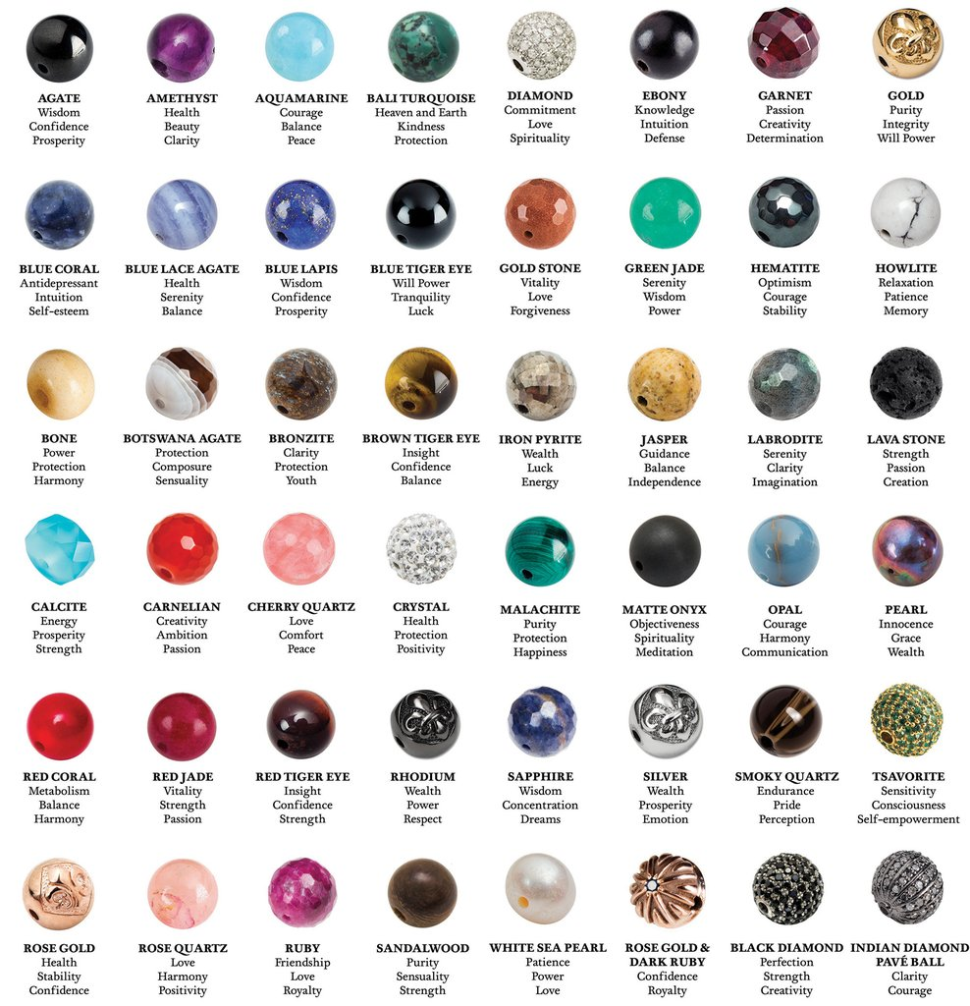

Cornerstone Activity Pop-Up Card
1. Lightly color the bricks. Do not color the corner stone, so that it is more visible.
Fold the construction paper in half like a card. The card should open from the bottom up. Glue the cornerstone picture on the front. See card example below.

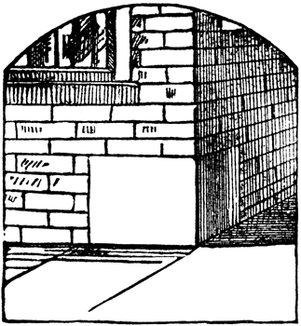

Who is the
Chief
Cornerstone
in the Kingdom?

2. Children write the word Jesus on an index card. They can use markers, crayons, pencils, small stick-on jewels etc. to make the name as special as they want.

3. Follow the instructions to make a pop-up card frame. The word Jesus will be glued to the pop-up part on the inside of the card.
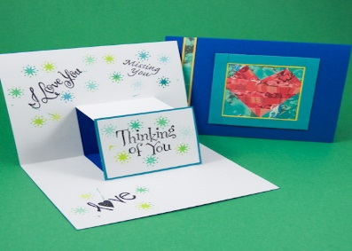

Pop Up Card
Retrieved from: https://www.origami-resource-center.com/pop-up-card.html

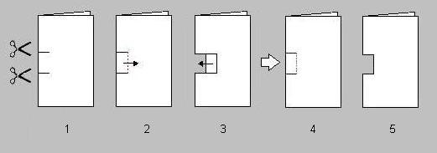
Why buy a card when you can make an easy pop up card yourself? This craft is kid-friendly, very doable and safe. You will need a pair of scissors, a piece of white paper, and a piece of colored paper for backing. You may also use stickers, crayons, markers, and color pencils for decorating.

Pop Up Card Instructions
- Fold a piece of white paper in half; this will be your 'card'. Cut two notches (about one inch in lenght) along the folded edge of the paper.

- Fold over this small flap of paper. Press firmly and make a nice clean fold that is straight (parallel to the folded edge of the paper).

- Unfold the flap so that it lies flat again. You may need to wiggle it back and forth a little.

- Open the card half way. Use your fingers to push the flap of paper into the card so that the flap lies between the two layers of the paper.

- This is how the outside of the card will look like. When you open the card, a box-like shape will pop up at you.

- To complete the card, glue it onto a colored piece of paper for backing. You can decorate this pop-up so that it looks like a house. Draw a heart on it and make it a Valentine's card. Use stickers and other craft tools to make it special.

