INSPIRATION C:\Users\Stephanie\Pictures\Microsoft Clip Organizer\j0416014.wmf

Be Fearless in the Pursuit of what sets your Soul on ***Fire.***

#motivation

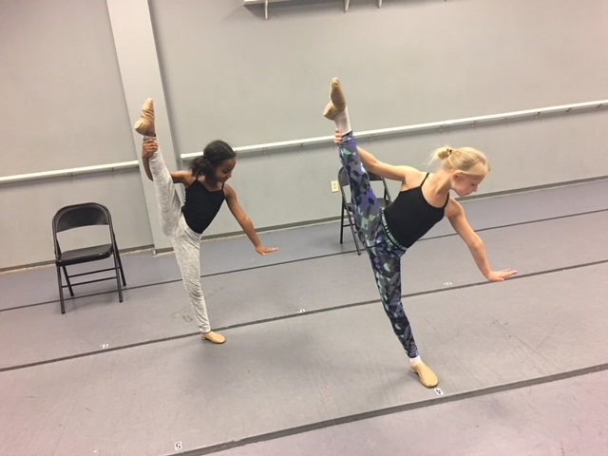

***THANK YOU***

***TO OUR 2018-19 COMMUNITY SPONSORS!***



**Hendrick Toyota of Concord**

**7670 Bruton Smith Blvd.**

**Concord, NC 28027**

**Platinum Community Sponsor**



**Freddy’s**

**8475 Pit Stop Court**

**Concord, NC 28027**

**Platinum Community Sponsor**



**CoreyAnthony Inc. Foundation**

**www.coreyanthony.org**

**Platinum Community Sponsor**

C:\Users\Stephanie\Pictures\Microsoft Clip Organizer\j0416014.wmfC:\Users\Stephanie\Pictures\Microsoft Clip Organizer\j0416014.wmfC:\Users\Stephanie\Pictures\Microsoft Clip Organizer\j0416014.wmf

#class of the month

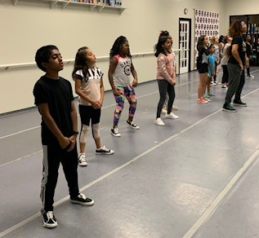

***HIP HOP CLASSES***

Our biggest classes at the studio! Whether you are 2 or 18 come join a class made for you age group. And bring a friend because… #dancefriendsarethebestfriends

**2019 BALLET**

**CHILLIN’ WITH THE VILLIANS**

** **

Each year we select a ballet for our annual recital. This year we chose to do a scene from some of our favorites that include our favorite villains! All of our ballet students, ages 5-18 participate in this fun adaption of the stories. If your younger student has not had the opportunity to view the particular story they will be a part of please make that an assignment for the Thanksgiving break! Telling a story is always exciting both for the students and the audience. Remember our recital is Saturday, June 20, 2020 with dress rehearsal on Friday, June 19, 2020. Both are at Kannapolis Middle School at 1000 Virginia Dare Street, Kannapolis 28081.

C:\Users\Stephanie\Pictures\Microsoft Clip Organizer\j0416014.wmf C:\Users\Stephanie\Pictures\Microsoft Clip Organizer\j0416014.wmf

Steppin’ into ***NOVEMBER******2019***  with Next Step Dance

[**www.thenextstepnc.com**](http://www.thenextstepnc.com)

**7712 Sossamon Lane, NW Concord, NC 28027 (704) 786-7837 nsdcalendar@gmail.com**

**LOOKING FOR A WINTER SPORT?**

**Share with your friends you have the perfect indoor winter sport for them!**

**\*dance reduces stress**

**\*dance boosts memory**

**\*dance builds confidence**

**\*dance encourages socialization**

**\*dance helps with depression**

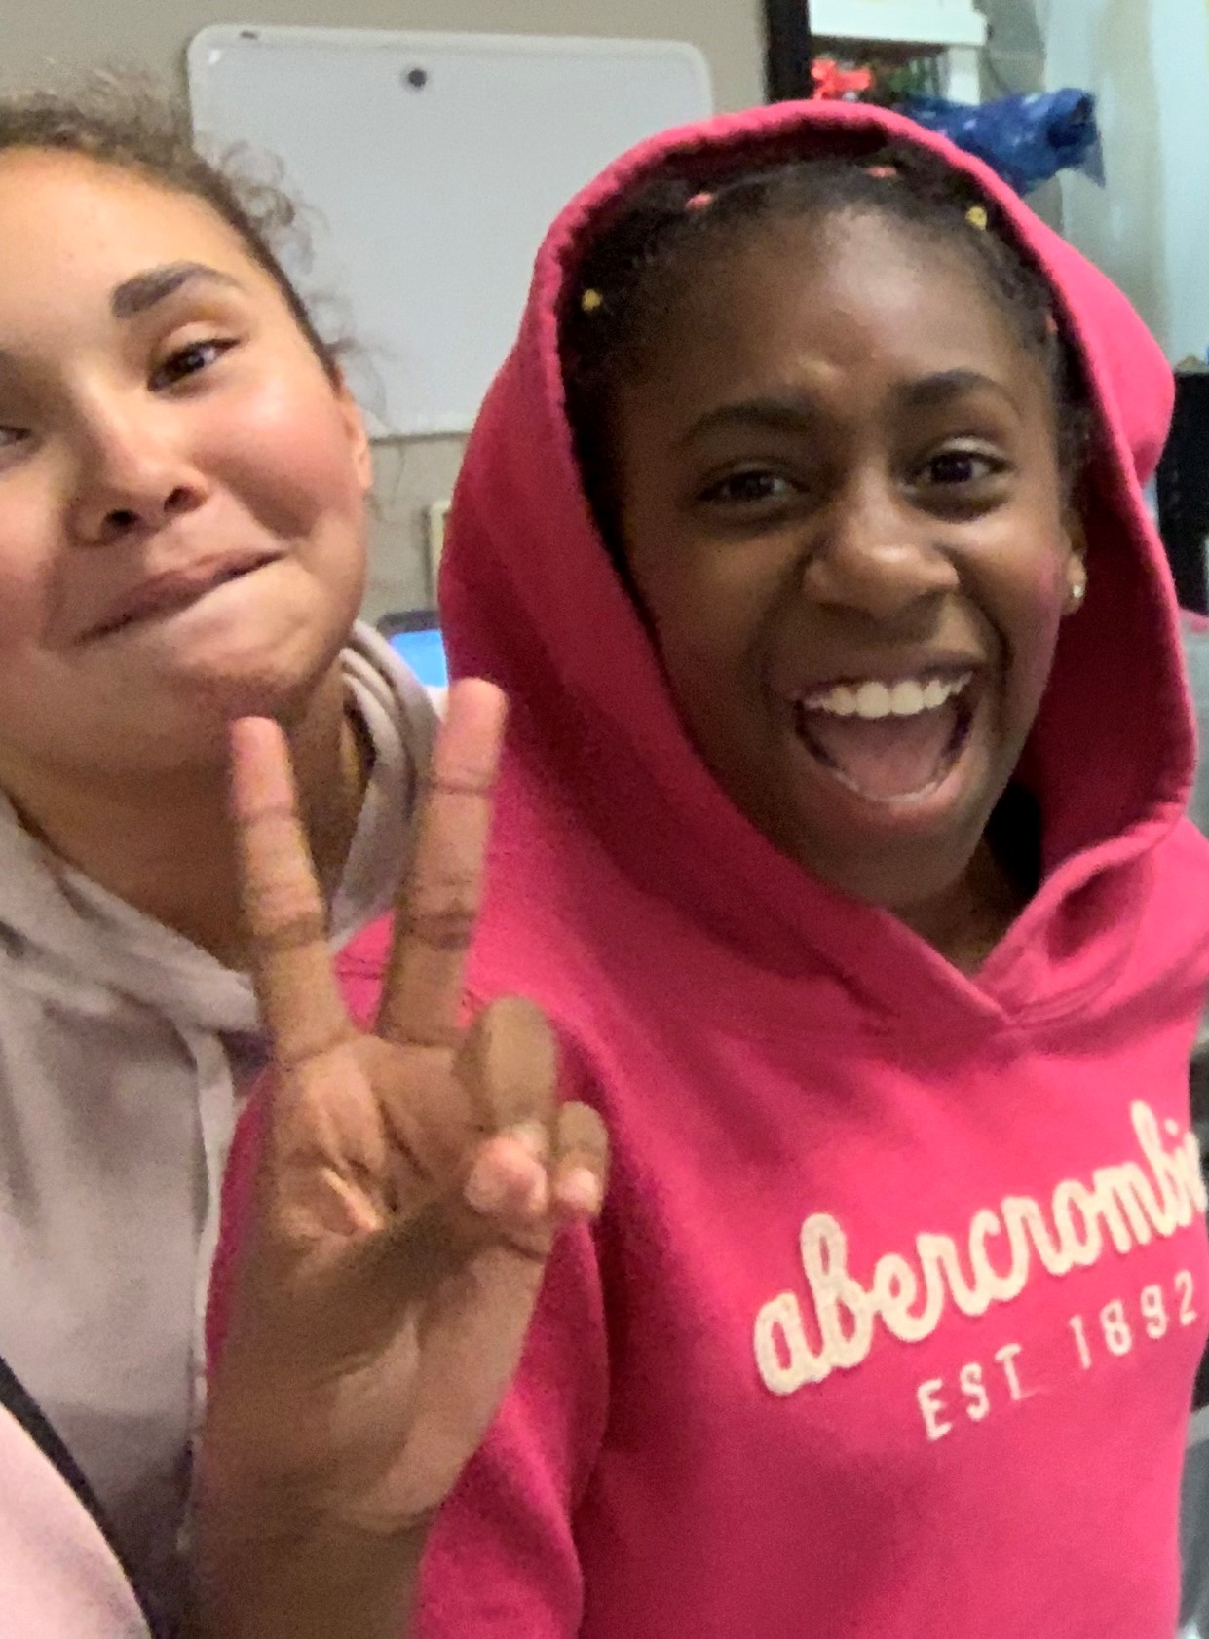

**Who knew dance was SO GOOD for you?**

**SAVE THE DATE** C:\Users\Stephanie\Pictures\Microsoft Clip Organizer\j0416014.wmf

Recital Costume payment due 11/15

Closed for Thanksgiving-

11/25-11/29

GIFTS FOR THE SEASON

It is always the season for gifts. Check out our jackets, shirts, and other dancewear for a great gift that will be worn all year!

