Stellar investment

BEDFORD — When Bedford was announced as a Stellar Community in 2013, the promise of millions of dollars in funds for downtown revitalization was celebrated for putting the city in a position to take on large-scale projects that most small cities can only dream about.
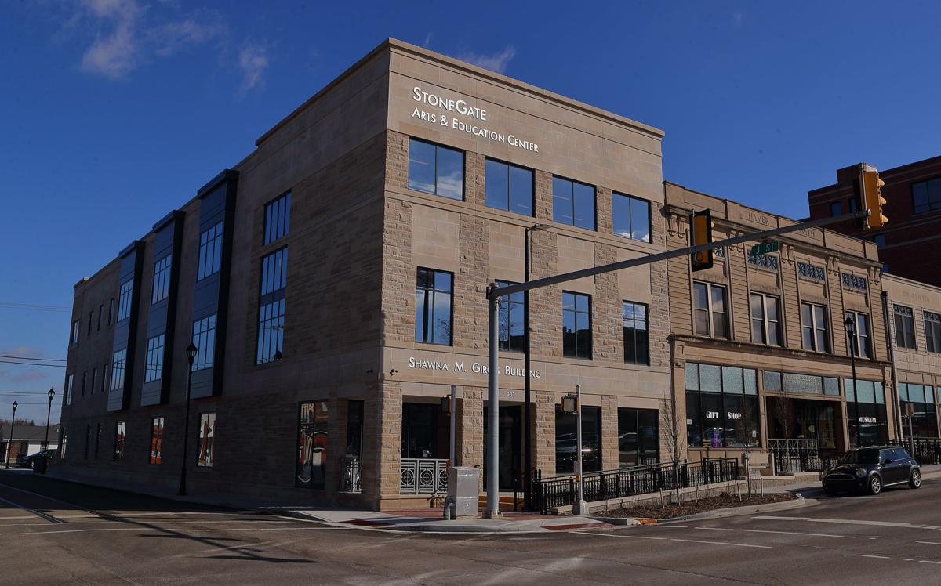
Nearly six years later as the city buttons up the final projects, the downtown looks vastly different.
The courthouse grounds received new landscaping, lighting and walkways, a dozen downtown facades were refurbished, new senior housing was built downtown, the historic Milwaukee depot was moved downtown, a trail connector and downtown streetscape was undertaken and the StoneGate Arts & Education Center opened to offer college classes and job training where a vacant building once stood.
RICH JANZARUK/Times-Mail
BEDFORD – StoneGate Arts& Education Center began offering classes in January. Located at the corner of 15th and J streets, the building was one of the City of Bedford’s Stellar Community projects.
To date, the 2013 Stellar Community projects have brought more than $27 million of investment to downtown Bedford, according to information released by the city. Of these funds, about $945,000 came from the city budget.
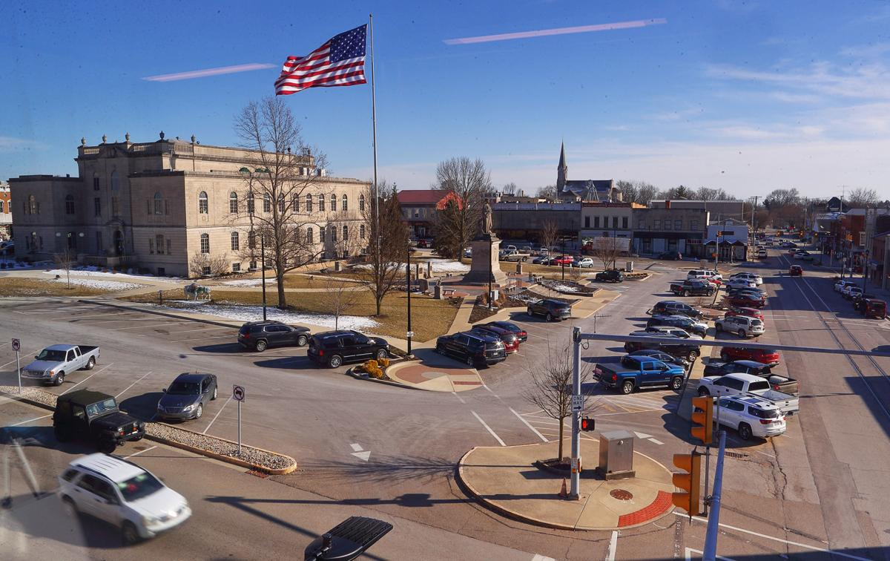
Funding for Bedford’s Stellar projects came from the Ind iana Housing and Community Development Authority, [Grab your reader’s attention with a great quote from the document or use this space to emphasize a key point. To place this text box anywhere on the page, just drag it.]
OCRA, Indiana Department of Transportation, as well as local private and public funds. Stellar is a program of the lieutenant governor’s office and its goal is to improve opportunities in small, rural cities in the state.
RICH JANZARUK/Times-Mail
BEDFORD – Improvements to the grounds of the Lawrence County Courthouse were among the first projects completed by the City of Bedford’s Stellar Community Investment.
The 2013 application was not the city’s first Stellar proposal. In 2011, the city submitted a strategic investment plan. Although a Stellar finalist, Bedford was not selected. However, several projects in the 2011 application — including the Lincoln Avenue roundabout, Milwaukee Rail-Trail, Stalker School Apartments, Lincoln Avenue and U Street channel stormwater infrastructure improvements — have been completed through grant funds the city secured. The total of those projects was outside of the Indiana Stellar Program and have brought over $10.7 million to the community as a result of state or federal grants.
Bedford Mayor Shawna Girgis gave an overview of the Stellar investment in the city during a recent meeting of the Lawrence County Economic Growth Council.
“The city of Bedford led proposal development, but the Stellar Community designation was the result of a team effort that would not have been possible without local financial investment in this endeavor,” Girgis said in a statement. “The city of Bedford worked with Hope Flores, director of the Lawrence County Community Foundation to establish a Bedford Community Development Fund that started a local fundraising campaign. When the Lawrence County Commissioners and Lawrence County Council pledged $500,000 toward a dollar for dollar matching fund for all non-city investment, fundraising efforts flourished.”
The Bedford Redevelopment Commission invested $3.2 million and secured a $3.5 million USDA Rural Development low-interest loan using TIF funds to complete the StoneGate Arts & Education Center. The remainder of the funding was provided through state and federal grants, private local investment and donations.
The city used a comprehensive plan to craft its investment plan that would become its Stellar proposal.
The plan had four goals:
- Promote economic development
- Insure a trained and ready workforce
- Cultivate a vibrant downtown district
- Enhance quality of life
A breakdown of funds invested show how the city was able to leverage support for projects. From 2011 to 2019, the city invested just $1 of general budgeted funds to leverage nearly $20 in investment or 4.7 percent of the $38 million in projects that were initiated as a result of the Indiana Stellar Community Program, according to the release.
The entire 2013 Stellar project area and downtown Bedford is in a TIF district, which enabled the Bedford Redevelopment Commission to invest in the project. The RDC invested 17.8 percent of project funds with each $1 through TIF funds leveraging $4.59 of additional investment.
“Bedford’s 2011 and 2013 Stellar Community planning efforts and implementation demonstrates the commitment of city leaders to the growth and improvement of our community that would not have been possible without state and federal grant funds,” Girgis said. “I am extremely grateful to the state of Indiana for investing in Bedford, as well as the commitment of the City Council, Redevelopment Commission, Lawrence County government, and numerous private partners that believed and invested in this work.
“It is because of each of these organizations and individuals that these plans have become reality. I encourage future leaders to vigorously pursue state and federal dollars that would otherwise go to other communities. These dollars enable us to improve the quality of place in Bedford, which is essential to attracting and retaining individuals, families, and businesses to the greater Lawrence County community.”
The city will begin meetings with stakeholders this month to develop a new comprehensive plan.
Contact Times-Mail Staff Writer Carol Johnson at (812) 277-7252 or cjohnson@tmnews.com

