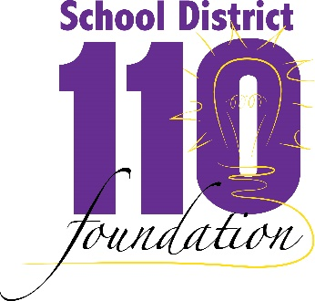

MINIGRANT APPLICATION FORM
(Proposed grants up to $250; Grant over $250 will be considered)

Applicant(s) Name(s) Date of Submission

School(s)

Position/Title Phone

Address

Phone Email

Project Start Date Project End Date

PROJECT TITLE FUNDING REQUEST

SUMMARY OF MINI-GRANT PROJECT (100 words or less)

NEED
- Describe the proposed need for the project, activity or resource request? Please specify in terms of academic achievement, social-emotional learning, life skill, or post-secondary readiness.

PROJECT DESCRIPTION
- Specify goals and/or objectives for the project.

- Specify anticipated learning outcomes (knowledge, skill, behavior) as a result of the project.

- Describe project activities. What you will do, who will do it, what resources will be required, and where project activities will take place. If possible, include a time schedule.

- Approximately how many students will be affected by this project? (Short term & Long term)

EVALUATION
- How will you know if the project has been successful? How will you measure and determine project outcomes?

- What will happen to the project at the conclusion of the grant? If it is to continue, how will it be funded?

FUNDING REQUEST
NOTE: Typically, Mini-Grant awards are for amounts up to $250. Exceptions will be considered on a case by case basis.

Description of Item | Quantity | Amount
Total Request

SIGNATURES

I grant School District 110 Foundation the right to use this proposal and the results of this project, if funded, for public informational purposes.

Signature of Applicant(s) Date

I support this applicant and this grant.

Signature of Principal(s) Date

Signature of Director of Curriculum (If applicable) Date

Please direct questions to Roger Sauerbrey: phone – 952-657-2431
Email – rlsauerbrey@frontiernet.net

Send the completed application to the District Office.

