FRIDAY FISH AND SHRIMP SPECIALS
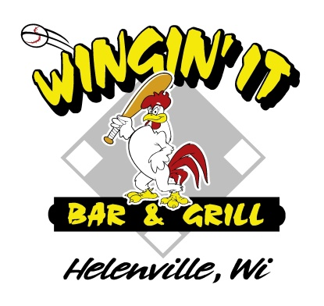
- 2 piece Cod, Baked or Deep Fried - $11.95
- 3 piece Cod, Baked or Deep Fried - $13.95
- Perch Dinner - $16.95
- 8 Jumbo Shrimp, Hand Breaded & Deep Fried or Sautéed in a secret butter sauce - $ 16.95
- 3 Jumbo Stuffed Shrimp filled with Crab and Cream Cheese - $16.95
- Combo Dinner – 2 piece Cod and 4 Jumbo Shrimp - $16.95
- Captains Platter – 2 cod, 1 jumbo Perch, 2 Jumbo Shrimp, 2 Stuffed Shrimp (all Deep fried) - $19.95
- Shrimp Lover’s Platter – 4 Deep Fried Jumbo Shrimp, 4 Sautéed Shrimp, and 2 Crab Stuffed Shrimp - $19.95
- 1 trip Soup and Salad Bar - $6.95
- Soup and Salad Bar as a meal - $9.95
All Dinners include a one trip soup and salad bar, choice of potato (cheesy hashbrowns, fries, potato pancakes), rye bread, and coleslaw.

OTHER FRIDAY NIGHT SPECIALS
Appetizers – choice of Cheese Nuggets, Breaded Mushrooms, Mozz Sticks, Jalapeno Poppers, or Onion Rings - $6 each
½ # Cheeseburger * or 6 oz Grilled Chicken Breast topped with lettuce, tomato, and mayo, served with fries - $9.75
A Basket of 16 jumbo chicken wings with two sauces - $16
16” Homemade Pizza - $15 cheese only - add $1 per topping (sausage, pepperoni, mushroom, onion, black olives, green pepper, banana pepper, jalapeno, bacon $2)
KID’S MENU
5 Chicken Chunks & fries - $5
4 Mini Taco’s & fries - $5
*Consuming raw or uncooked meats, poultry, seafood, or eggs may increase your risk of foodborne illness.

