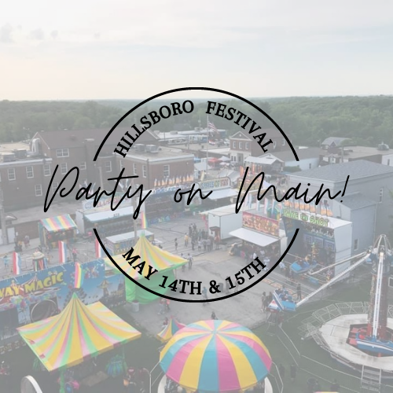
The Greater Hillsboro
Chamber of Commerce

Hillsboro Homecoming & Festival
“Party on Main Street!”
Because lets face it, we all need a night out!
May 14th & 15th Hillsboro Homecoming & Festival Events

Dear Chamber Member & Supporter:
The Hillsboro Homecoming and Festival Committee, has decided to move forward with the planning of the Hillsboro Festival for 2021. There is still time to join the committee and bring ideas and suggestions. The format for this year’s event will be very similar to that of Homecoming/Festivals of the recent past but it will look a bit different due to Covid. We have had to eliminate a few of the events this year that we hope to bring back next year, we are just happy we are able to have anything to offer the community this year. The Golf Tournament will be moved to the Fall until further notice. This year our theme will be “Party on Main St” A Celebration that we all so desperately need after being at home for year! We expect to see many people coming out to celebrate. We will proceed with caution and ask you to come celebrate with us at your discretion and to please keep socially distanced while at the event. A partial list of the tried-and-true activities are listed below which will take place on Main Street and the surrounding area.

- Main stage Bands on Friday and Saturday evenings
- Carnival (Friday evening and all-day Saturday)
- Car Show, Parade, Cornhole and much more (Saturday)
- Numerous vendors, including food, craft’s and businesses.
- Beer sales provided by the Hillsboro Community Civic Club

Since there is no admission charge, the Chamber is again asking for your help in underwriting the involved expenses. We will have Sponsor Sheets (listing the names of the Festival Benefactors) and event programs posted on attractive A-frame signs at several prominent locations on the grounds. We have partnered with the Leader to offer great advertising opportunities for our members and to help promote the festival. This year we will again focus on Online Social Media Advertising through paid ads on Facebook and using our community following on our Chamber Facebook page. We will also utilize our website www.hillsborochamberofcommerce.com for advertising of the festival and highlight our sponsors for the event!
It truly takes the community to put on a great festival. Please consider volunteering time to help with festival. Volunteers are needed to help with clean up and running of events on the main stage and other areas and just overall supervision and presence of chamber members. The more volunteers we have the less work for all chamber members. Contributing four hours of time during the festival will be greatly appreciated. If you are interested in volunteering, please complete the attached form.
We hope we can count on you to be as generous this year as you have been in the past. Now more than ever we need your support! This is the largest fundraiser of the year for the chamber and helps ensure that we can continue our efforts to support the community and promote businesses in the greater Hillsboro area. If you can lend a hand with a monetary donation and/or physical labor during setup and cleanup, everyone on the Chamber's Executive Board, the Festival Committee, and all of the attendees will appreciate it. We look forward to seeing you during the festival!
Thank you,
Mandy Alley- Chamber Administrator & Festival Chair
Debbie Colletti- Chamber President Sara Sucharski-Festival Committee Marissa Newman-Festival Committee
Kami Kimes-Chamber Vice President Brian Gaudet- Secretary Matt Woods-Festival/Golf Committee

SPONSORSHIPS

Help support the Hillsboro Homecoming & Festival by joining us as an event sponsor!

Gold Level - $550
- Largest of the festival sponsor ads, full color advertisement in the featured festival section of the Leader Newspaper to run the week before the festival. (Limited ads available)
- Recognized as a Gold Level Sponsor on the back of all festival t-shirts and on festival supporter banner listed on the main stage. Larger Print
- Banner (Provided by Sponsor) displayed on main stage during the festival weekend events.**
- Listed on website as a Gold Level Sponsor for the Festival.
- Online Social Media advertising

Silver Level - $350
- Smaller size of the festival sponsor ads, full color advertisement in the featured festival section of the Leader Newspaper to run the week before the festival. (Limited ads available)
- Recognized as a Silver Level Festival Sponsor on the back of all festival t-shirts and on festival supporter banner listed on the main stage. Medium Print
- Banner (Provided by Sponsor) displayed on festival grounds during the festival weekend events**
- Listed on website as a Silver Level Sponsor for the Festival
- Online Social Media advertising

Bronze Level - $100
- Company name listed as a sponsor in the featured festival section of the Leader Newspaper to run the week before the festival.
- Listed under Bronze Level Sponsorship on the back of all festival t-shirts and on festival supporter banner listed on the main stage. Smaller Print
- Listed on website as a Bronze Sponsor for the Festival
- Online Social Media advertising

Friends of the Festival- $50
- Listed as a Friend of the Festival in the featured festival section of the Leader Newspaper to run the week before the festival.
- Listed as a Friends of the Festival on the back of all festival t-shirts and on festival supporter banner listed on the main stage.
- Listed on website as a Friend of the Festival Sponsor for the Festival
- Online Social Media advertising

I would like to contribute__________________ in kind donation or $________________
- Listed as a festival donor on the back of all festival t-shirts and on festival supporter banner listed on the main stage.

NOTE: **Banners are to be supplied by the advertiser and should be in the Festival Committee’s possession at least one week before the event. Banners should not be larger than 5ft x 3ft. in order to fit all sponsors banners on the main stage.

I would like to help the chamber as a: Sponsor Volunteer Both

Organization/Business Name:
Contact Name: Contact Phone Number: ( ) ______
Name of donor (as you would like it to appear in advertising):
Address:
City: State: Zip:
Email:_______________________________________________________________________________

Authorized Signature:

Amount enclosed: $

If you are able to volunteer please report to the main stage on Main Street for the time you have selected. A committee member will be in touch to give you more details before the festival.

Friday Events; 8pm-Midnight- clean-up.

Saturday Events; 12pm-4pm

Saturday Events; 4pm-8pm

Saturday Events; 8pm-Midnight – clean up

Sunday morning clean up; 8am on Main Street

- Please provide finished, camera-ready artwork for your ad – attach artwork or email to, Leader Advertising department or send to chamberoffice@sbcglobal.net no later than April 23rd.
- Payment is due with this form
Contact Mandy Alley, Festival Chair- Greater Hillsboro Chamber of Commerce 636-586-0041

Please return completed form (front & back) by April 23, 2021
All Forms received after April 23, 2021 will not be guaranteed advertising on the
T-shirts or placement in the Leader Advertising. Thank you for your support!
Attn: Hillsboro Festival
Greater Hillsboro Chamber of Commerce
PO Box 225
Hillsboro, MO 63050

