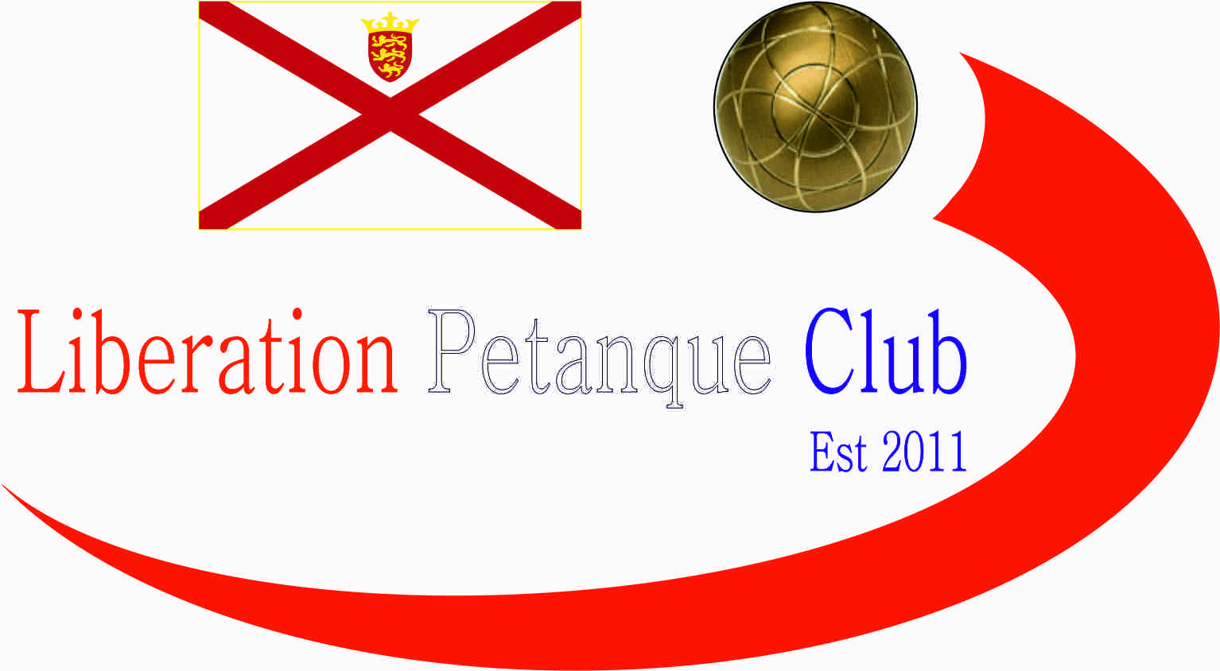  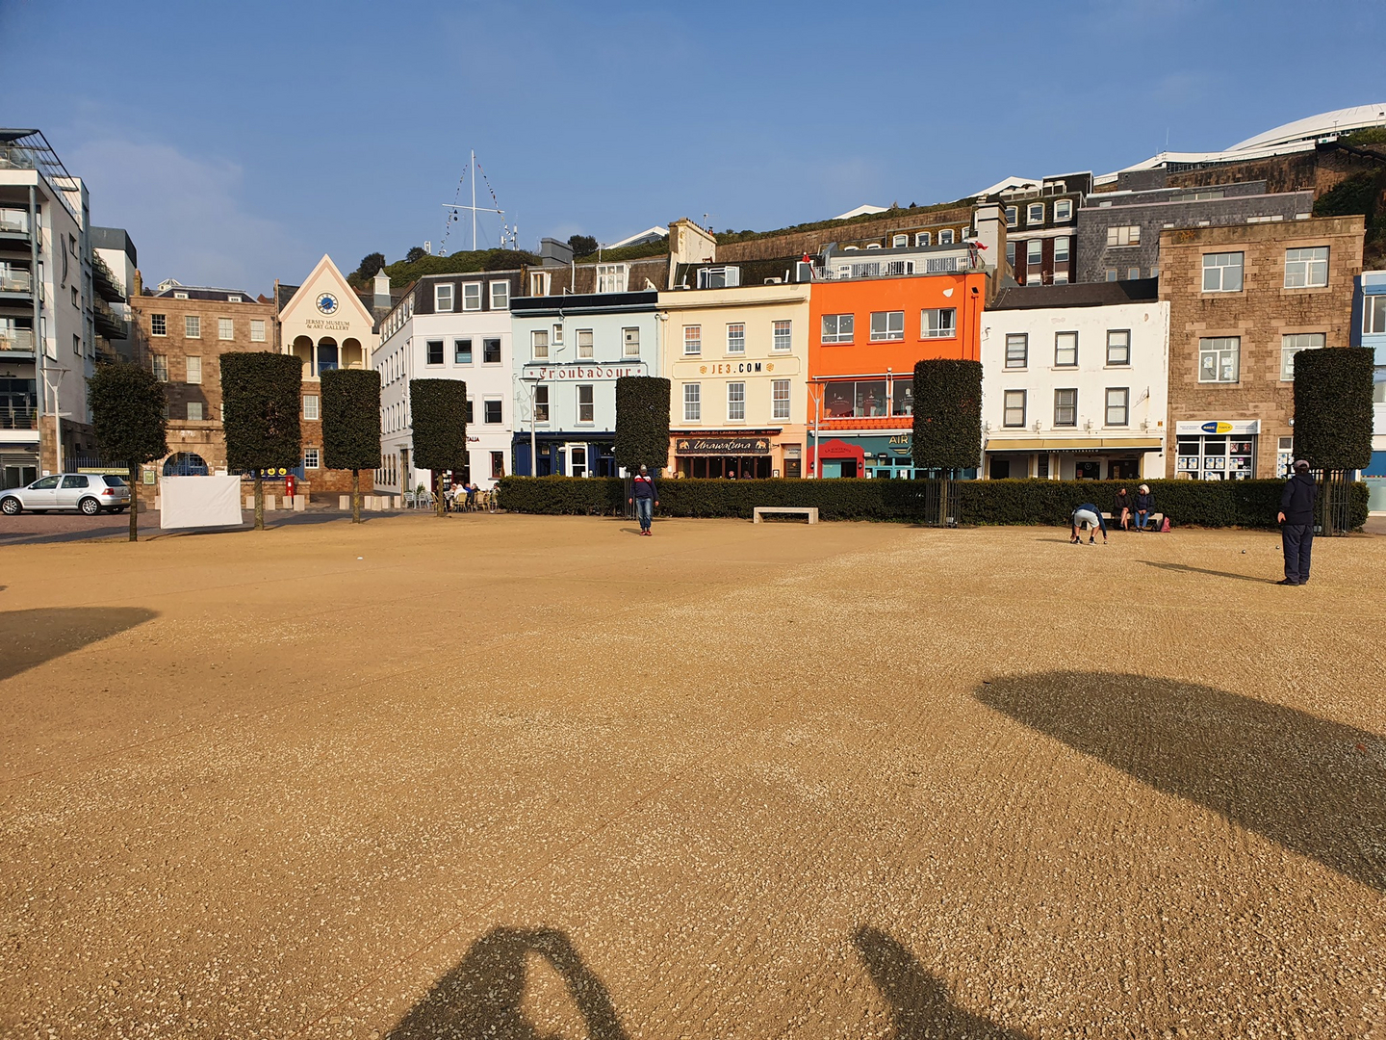  - 2024  open competitions  We are pleased to announce we will again be holding our International Open over Friday 26th to Sunday 28th July. See separate Entry form for International Open.  Entry Fee’s are £10.00pp for None Members for our Island Open Competitions.  Singles Open _______________________________  Doubles Open Player 1 _______________________  Doubles Open Player 2 _______________________  Charity Triples Open Player 1 _______________________  Charity Triples Open Player 2 _______________________  Charity Triples Open Player 2 _______________________  Contact No. _____________ Email ____________________ | Competition Dates  ____  International Open July Singles – Fri 26th Doubles-Sat 27th Triples-Sun 28th  ____  Singles – 13th April  ____  Doubles – 29th June  ____  Charity Triples Open 19th October  Liberation peranque club  www.liberationpetanque.co.uk  Club Email - liberationpc@gmail.com  Bacs Payments to: Sort Code – 40-25-34 Account No. 92557738
Liberation Petanque Club

