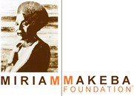

9th November 2020
For immediate release

SUBJECT: Mama Africa – Miriam Makeba documentary
CONTACT: Millstream Films and Media email: millstreamfilms@gmail.com

On the solemn 12th anniversary of the death of South African singer songwriter Miriam Makeba during a concert at Castel Volturno (Italy), Millstream Films and Media is pleased to announce that the Miriam Makeba Foundation and Miriam Makeba Estate & Family respectively, have agreed to participate in a feature length documentary celebrating the life and legacy of Miriam Makeba, to be directed by Academy Award winner Pietro Scalia. This documentary will be Pietro Scalia’s directoral debut after a career as the editor of over 30 Hollywood films, including four Oscar nominations, two of which he won (JFK and Black Hawk Down).
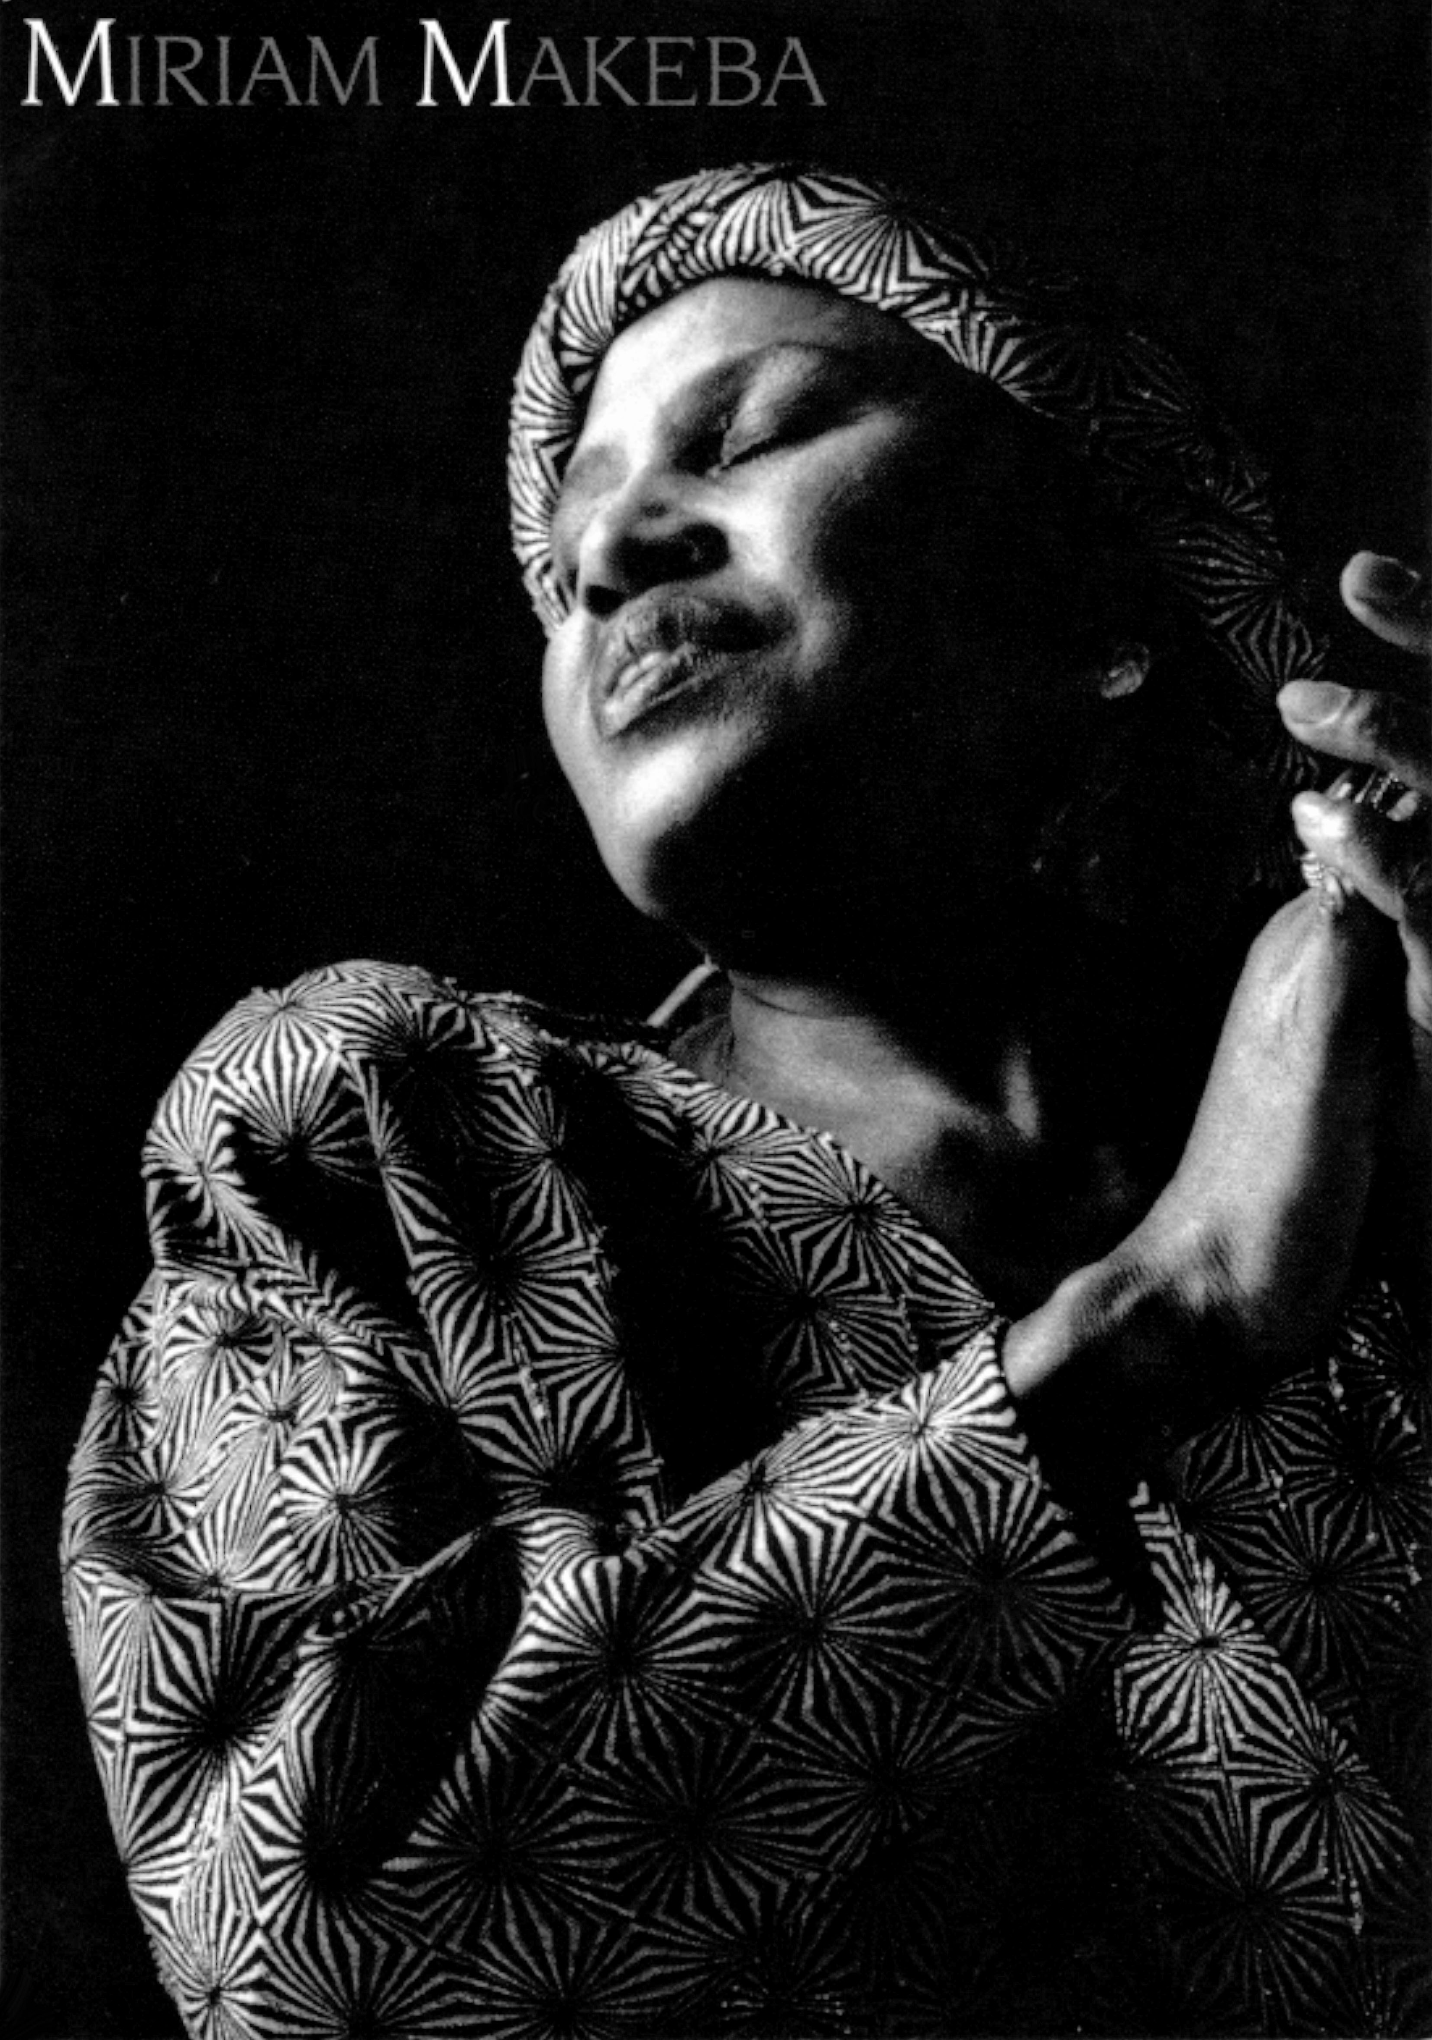
From the Family Mr. Nelson Lumumba Lee said that he is “happy that Mama Africa will be given a voice again, telling her own story through archival film of her performances, interviews and other documents, thanks to the masterly directorship of Pietro Scalia.”
“My primary objective in this film is to create the conditions for the voice of Miriam Makeba – Mama Africa to emerge through her own accounts, both video and audio, via the richness and variety of archival material that exists across the globe.” says Pietro Scalia, “Her voice is the beating heart of the documentary.”
The film’s producers have also secured unique access to never-seen public records and interviews held in government archives that shed new light on the powerful legacy of Makeba, an icon who symbolises the flame of unity in cultural diversity of the Republic of South Africa, the continent of Africa and the world over.
Millstream Films and Media is a British documentary production company with offices in Italy. Its founders and producers, Paul Russell and Andrea Vogt, have teamed up with Roberto Meglioli, Miriam Makeba’s manager since 1985 and veteran music industry professional Charlie Rapino of Artist First to bring together the elements needed to make this feature length documentary.

