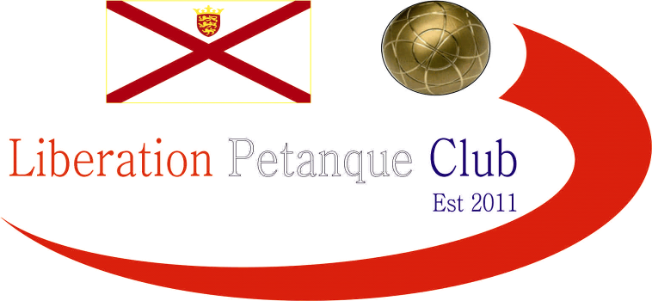

Summer 2019
End of Season
Report
What a great season it has been, with a number players achieving their first title successes.
Premier League Double Champions
Dawn Buckley and Mark Nicol
Mark made it three on the spin of Summer Premier League titles despite changing partner this year to play with Dawn Buckley. They beat Toby Northern & Matt Pinel who finished second in the Premier League for the third season in a row. Third place went to Andrew Bellamy-Burt & Callum Stewart who were the only team undefeated.
Commiserations to those relegated from the Premier League, Andrew & Lorna Limbrick, David Le Gresley & Paul Bell and Alex & Cassie Stewart.

Division 1 Double Champions
Colin Myers & Steve Simpkin
Division 1 Doubles was won by Colin & Steve who started out as one of the favourites beating a tough field to the title, also joining them in promotion was Runners Up, Laurent Pellaton & Matt Hutchings and third, Joey Le Clech & Brendan Jones. All three teams playing in the Premier League next Summer.
Commiserations to those relegated Brandon De La Haye & Tim Jackson, Colin & Karen Hidrio and Daniel & James Villalard.

Premier League Singles Champion
Andrew Bellamy-Burt
Well Done to Andrew who ended the season unbeaten to win his 4th Premier League title. He pipped last Summer’s Champion Matt Pinel to the title with Matt scoring 13 points less than last summer with Matt finishing third and Geoffroy Buffetrille taking second place.
Commiserations to those relegated Richard Williams and Keith Pinel who will be playing in Division 1 next Summer.

Singles Division 1 Champion
Callum Stewart
Callum won in impressive style remaining unbeaten meaning Matt Ryan had to settle for second place with Joey Le Clech finally getting to third place and promotion having missed out several times in recent seasons.
Commiserations to those relegated James Rondel, Cassie Stewart and Paul Bell who all had disappointing seasons and will therefore drop to Division 2.

Singles Division 2 Champion
Andrew Limbrick
Andrew started off as Pre Season favourite and quickly built up a lead before just winning the title after Natasha Romeril almost caught him. Jean Stewart took third place as all three will be in Division 1 next Summer.
Commiserations to those relegated Daniel Villalard, Branden De La Haye and Luke.

Club Singles Cup Winner
Andrew Bellamy-Burt
Andrew Bellamy-Burt beat Neil Selby in the final for his third success.

Club Doubles Cup Winners
Andrew Bellamy-Burt & Callum Stewart
Andrew Bellamy-Burt & Callum Stewart beat Brian Harris & Paul Le Moine in the final for their second success in the competition.
Club Super 7’s Cup Winner
Toby Northern
Toby beat Brian Harris in the final for his first success at this event.

Player of the Season
TBC at the End of Season Meal

Last but certainly not least –
Liberation Petanque Club are the InterClub Champions 2019!
The team captained by Toby Northern retained their title in impressive style becoming the first club to win with +100 games points difference and will again represent Jersey in the EuroCup in 2020.
Team Photo below. (a few missing players though), not forgetting Matt Pinel, Andrew Bellamy-Burt, James Rondel, Natasha Romeril, Callum Stewart, Jean Stewart and Cassie Stewart.
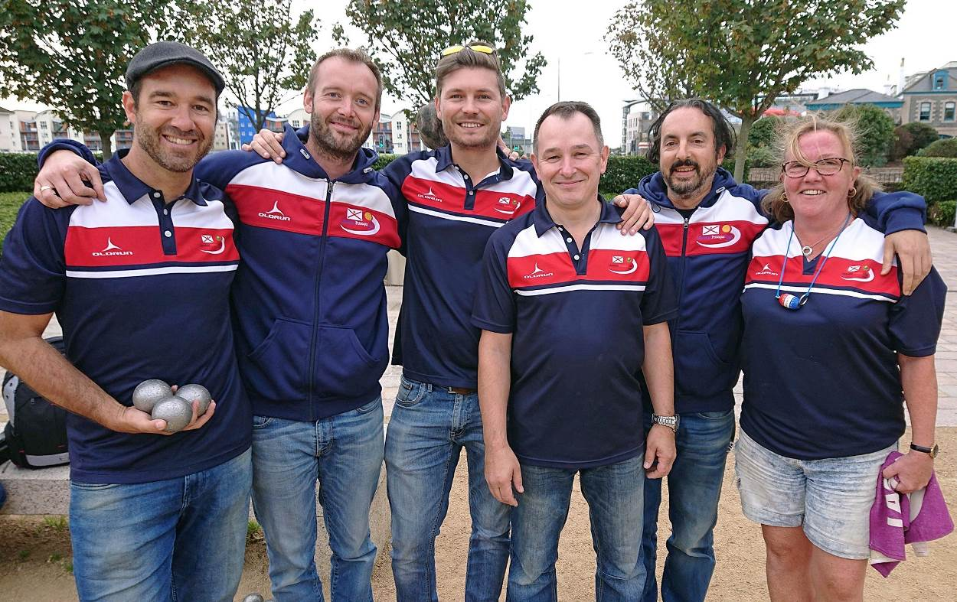
I hope you all enjoyed the season and are looking forward to another great winter of petanque.

All end of summer season tables, are on the website.

Club email address - liberationpc@gmail.com

Club Website - www.liberationpetanque.co.uk

Kind Regards

Toby Northern

Chairman

Liberation Petanque Club

SPONSORED BY

