Summer Newsletter 2017
Ilarion Residence

Table of Contents

Page 2 Photos from Canada 150 BBQ and Celebration

Page 3 Photos Cont’d…

Page 4 Ilarion News and Birthdays

Page 5 Events not to miss at Ilarion and in Saskatoon

Page 6 Canadian Trivia and news

Take some time to think about reasons why you are thankful to live in such a great country! Enjoy thinking about great memories, while also continuing to make more!

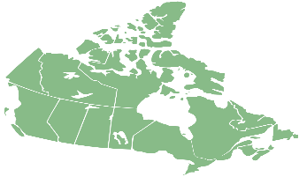

2509 Louise Street Saskatoon SK. S7J 3L7
www.ilarion.ca T: (306) 373-7011 ilarion@sasktel.net
Happy 150th Birthday Canada!!!
Did you attend Ilarion Residence’s Canada 150 BBQ and Celebration on June 29th? If you did, then you already know how big of a success it was! If you were unable to make it, then you will get to read about it here, and even see some pictures! First of all, from everyone at Ilarion we want to thank our special guests Kevin Waugh, MP- Saskatoon – Grasswood, Bev Dubois- Councillor Ward 9, and Lisa Lambert, MLA- Saskatoon Churchill – Wildwood. Their appearances made our day at Ilarion even more special.
Secondly, thank you to our Program Coordinators, Sophie, Ilaria and Dianne for organizing and facilitating all of the programs that took place in the afternoon. Some of these included Horse and Buggy rides, Sale of Cotton Candy, Fudge, and Popcorn for a nickel, games, tenants sharing their stories, classic movie, and a Photo booth with instant polaroid photos. Thank you also to the volunteers who assisted with these programs. We had both tenant volunteers, and family and friends come in to help and enjoy our celebration!
Lastly, a huge thank you to the Board of Directors, the Kitchen staff, and the Social Committee volunteers for the tasty meal that fed us all, and Ken and Kim for helping organize the day and assisting where help was needed. The BBQ was sponsored by the Board Of Directors, while the kitchen staff and the social committee helped prepare and serve the food. Thank you all!

Programs went on all around Ilarion both indoors and out during our Canada 150 Celebration. Here are some photos from the various locations!

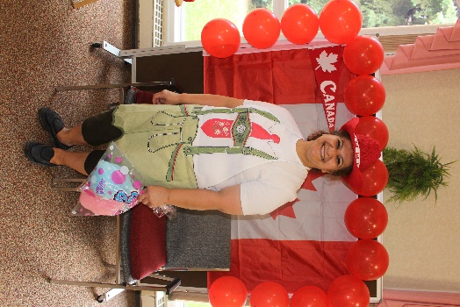
Lower Lounge
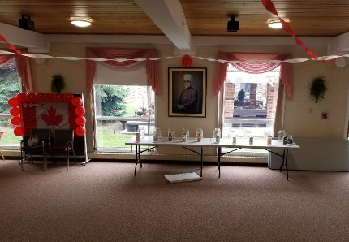
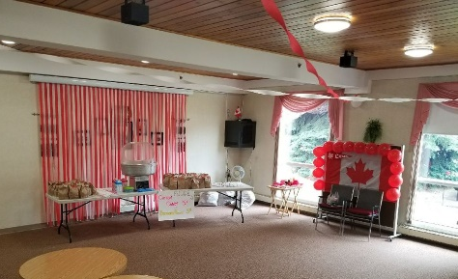
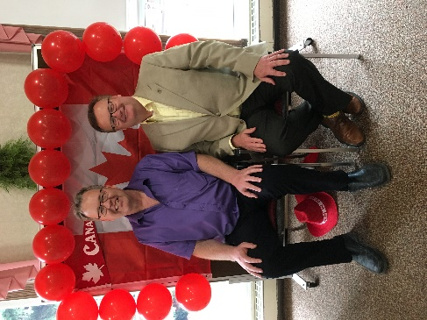
Lower lounge activities included Cotton Candy, Popcorn, and Fudge on sale for a nickel, a photo booth with instant Polaroid pictures, “Guess how many” game with jars filled with treats, ping pong cup toss, tenant show and tell, and a Frisbee pole toss!

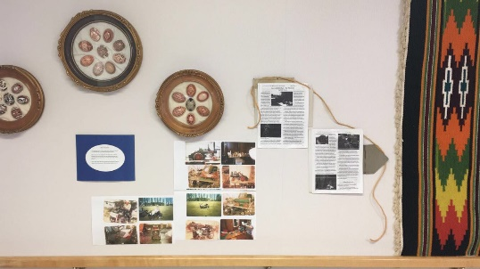
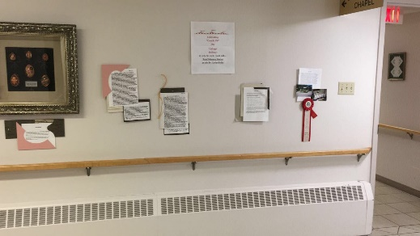
Linkage Hallway
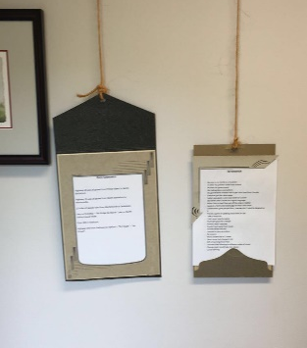
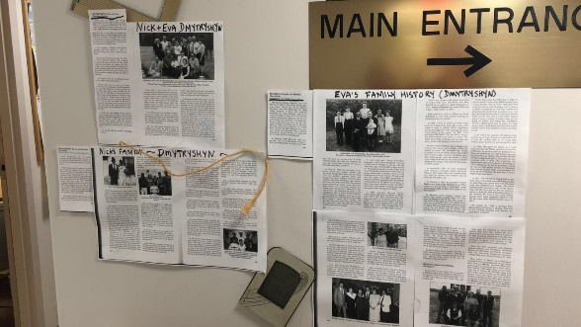
The linkage hallway was decorated with stories that tenants wrote about their memories and lives since they have been in Canada.

Dining Room
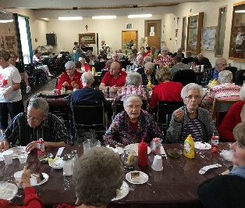
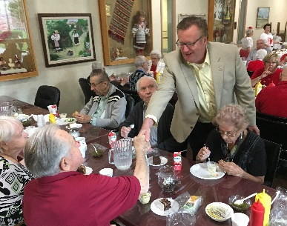
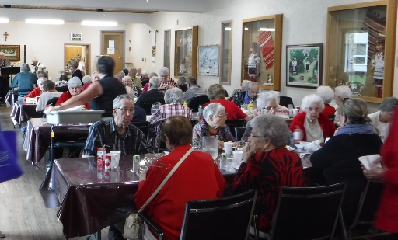
The Dining Room was used to seat people for the BBQ, and is where the social committee and the Kitchen staff helped serve food. It is also where the entertainment played.
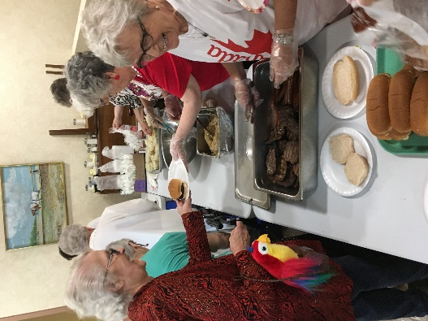

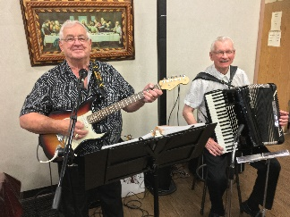
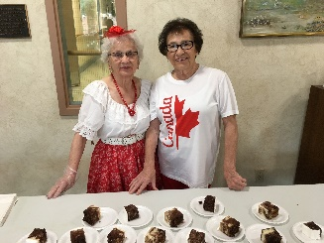
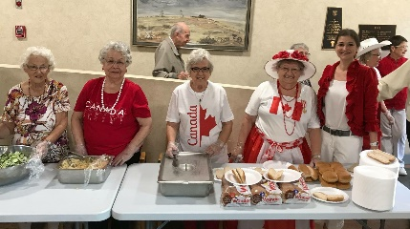

Courtyard
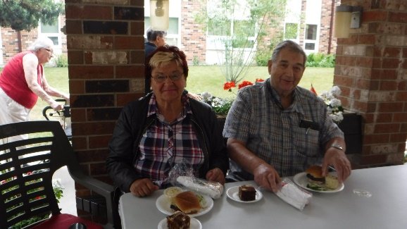
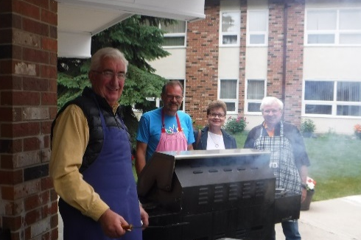
The Board of Directors BBQ’ed the burgers in the court yard, and with all the beautiful décor and recent updates thanks to the maintenance staff, it made a great place to sit and eat!
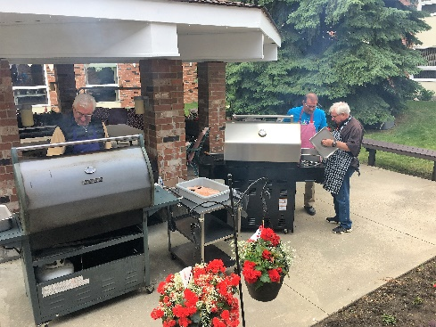
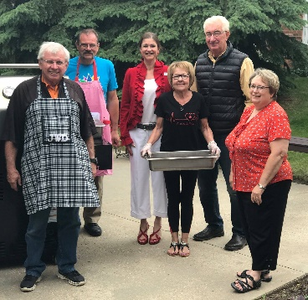

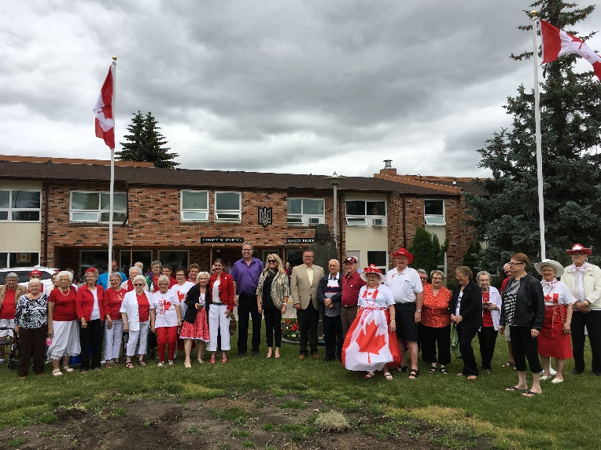
Outside in front of Ilarion
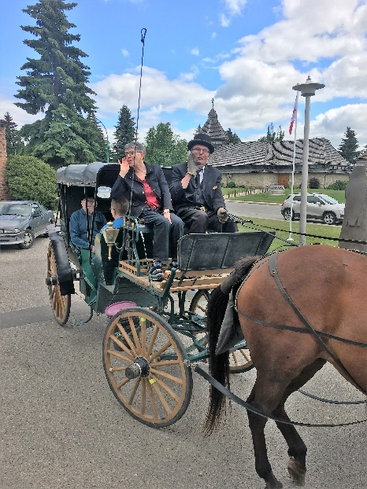
Outside in front of the building there was a flag raising ceremony for the new poles, and also horse and buggy rides!
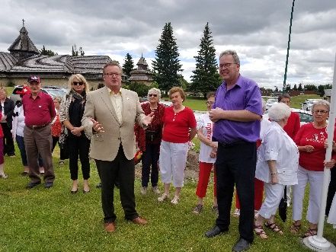

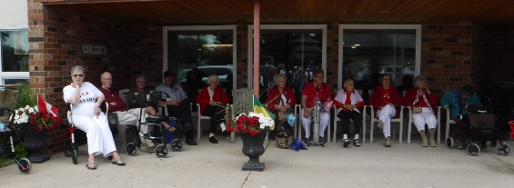
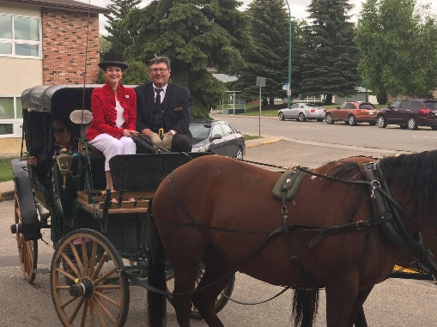
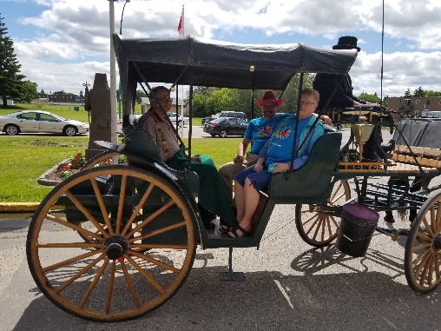
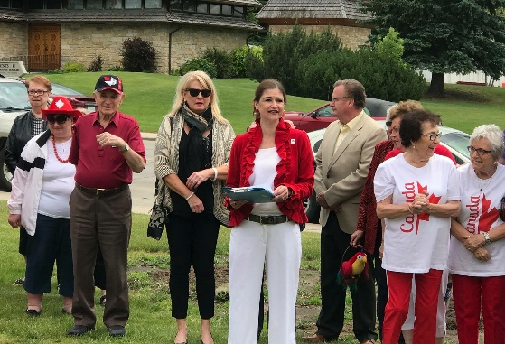
Photos of the three politicians and their visit to Ilarion Residence.

Photos

Ilarion News and Announcements

Summer Birthdays!

June Margaret E. Helen E. Eugene F. Eleanor F. Gloria H. Forrest K. Alice K. Sylvia K. Audrey L. Laverne L. John L. Joy M. Mary M. Mark P. Joyce S. Lois S. Helmut T. Loyd U.  July Sharon F. Sylvia G. Ken L. Annie M. Catherine P. Fern P. MaryBelle P. Sally S. John S. Jerry S. Irene T. Don T. Elsie Z. | Aug. Art B. George F. Andree G. Clara H. Tillie K. Ed K. Margaret M. Eileen M. Pearl S. John S. June V. Mike W. Julia Y. Peter Y. Gloria Z.  Ilarion wants to wish a happy birthday to all of our tenants who celebrate a birthday in the summer.

Amateur Hour News
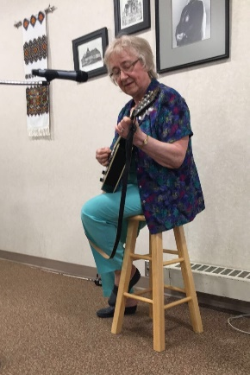
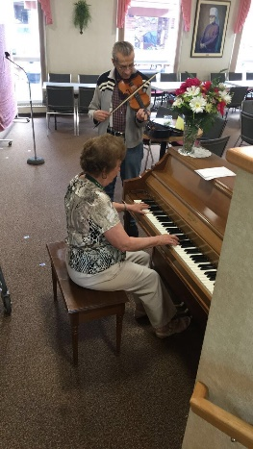
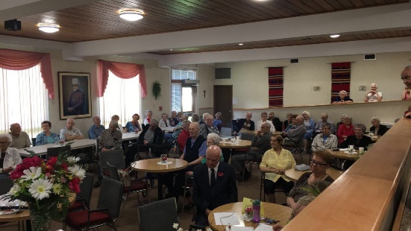
Our very first Ilarion Amateur Hour was an absolute success! We would not have had the spectacular outcome that we did without the participation of all the wonderful people who were brave enough to share their talent. A huge thank you to the person behind the wonderful idea and who helped bring everything together, Rachel Kowaluk. It was Rachel who had the vision to put on a show where the people of Ilarion were the entertainment! We had many good laughs and were greatly entertained with the songs, instruments played and skits that people showed off! What a show it was!

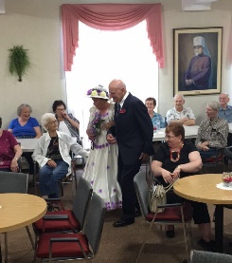
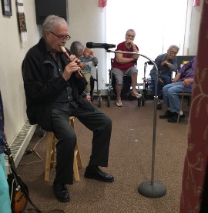

Library Revival
The Library is getting revamped thanks to a bunch of wonderful volunteers who have already put in hard working hours to make finding the right book for you easier. All of the books have been rearranged into categories according to the book’s genre, making finding your ideal book more easily accessible. So go check out the hard work that's been put into the library and find a great read! Also to keep the selection new and exciting Saskatoon Public Library brings in new books every 3 months, these books come in large print so they are easier to read!

Events not to miss
July and August are busy months not only for Ilarion, but also for the City of Saskatoon. Keep this page of the Newsletter on your fridge or bulletin board to insure that you do not miss out on some fantastic events that are happening both in your home, and in your city!

Events not to miss at Ilarion!
Jack’s Slide Show – Wednesday July 19th 2:30 p.m.
Entertainment Nite – Wednesday July 19th 7:00 p.m.
Men’s Party – Saturday July 22nd 1:00 p.m.
Free Noon BBQ – Tuesday July 25th
Outdoor Games (meet at front entrance) – Wednesday July 26th 2:30 p.m.
Ukrainian Movie – Wednesday July 26th 6:30 p.m.
Free Noon BBQ (Hosted by the Board of Directors) – Tuesday August 29th
Events not to miss around Saskatoon!
If you are physically able to leave Ilarion and have your own transportation or can use the transit system, here are some events coming up that you won’t want to miss!
Nascar Pinty’s Series – Wednesday July 26th All day @ Wyant Group Raceway
Shakespeare on the Saskatchewan – July 5th through August 20th @ Big white tents off Spadina Crescent
PotashCorp Fringe Theatre and Street Festival – August 3rd – 12th @ Broadway District
Saskatoon Ribfest – August 4th – 7th @ Diefenbaker Park
Saskatoon Exhibition – August 8th – 13th @ Saskatoon Prairieland Park
Folkfest – August 17th – 19th @ various venues throughout the city
Rock 102 Show & Shine Weekend – August 18th – 20th @ Downtown Saskatoon
Rock the River – August 18th – 20th @ Delta Bessborough
Ukrainian Day in the Park – Saturday August 26th @ Kiwanis Memorial Park
For more details on events around Saskatoon, visit: www.tourismsaskatoon.com

Canadian Trivia Contest
Let’s see how well you know this amazing country. You can submit your answers to the front office (do not forget to put your name on the paper!!!). The person/people with the most correct answers will receive a prize at the end of the month! Good luck Questions and fun facts were found at: http://globalnews.ca/news/3526717/canada-day-trivia-how-many-of-these-150-facts-do-you-know/.
Did you know?
- Curling became Saskatchewan’s official sport in 2001
- O Canada was first performed on July 24th, 1880 in Quebec City
- Canada’s first railway line opened in July 1836
- The Mounted Police were formed in 1873, with nine officers
- The first Tim Hortons opened in 1964 in Hamilton, Ont.
- Canada didn’t get its official flag until 1965, almost 100 years after it became a country
- The first YMCA started in 1851 in Montreal
- 77% of the world’s maple syrup is made in Quebec
- Each Canadian eats an average of 190 eggs per year

YOUR TURN!

- Which cheese is the most popular in Canada?
- What is the official symbol of Canada?
- What percentage of the world’s fresh water is in Canada?
- How many people speak French in Canada? (Canada total population is 34.9 million)
- What is a hoodie called in Saskatchewan?
- What is the most common surname in Canada, according to the nation’s phone books?
- What is the average age of a Canadian?
- What year did Canada become its own completely independent country with the Canada Act?
- What year was the toonie introduced in?
- How many time zones does Canada stretch across?
Please write your answers to these trivia questions, along with your name on a piece of paper and hand it in to the office by July 31st!

Thanks for reading our Spring Newsletter! If you want to contribute anything to the next newsletter, you can talk to Kim or Ken in the office!

