Briar Cove Tree and Shrub Replacement:
Our arborist has identified what bushes could be used where moisture is a problem .They are as follows. gray Dogwood (Cornus Racemosa)…..American Cranberry (Viburnum Trilobum)…..Buttonbush (Cephalanthus Occidentallis)……Winterberry (Ilex Verticillata)……Blackhaw (Viburnum prunifolium) ……Arrowwood Viburnum (Viburnum Denatum) Most bushes will grow no higher than 10 feet and no more than 8 to 10 foot wide. If it is the homeowners desire to plant something other then what the arborist suggested you can fill out an exterior modification request, and if approved, all costs associated with the planting and maintenance will be at the homeowner’s expense.

(updated 6.17.19 with photos)

Gray Dogwood
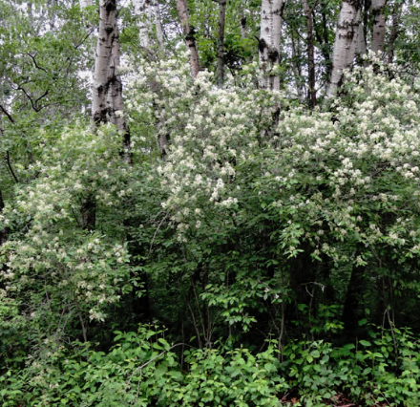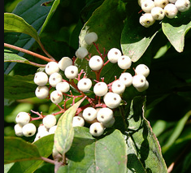

American Cranberry (for pine tree replacement)
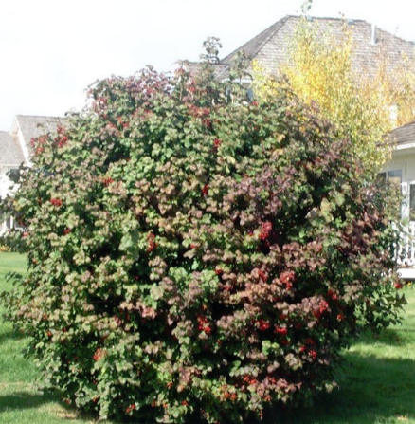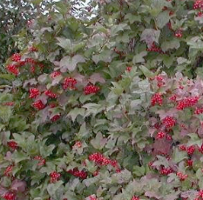

Buttonbush (for pine tree replacement)
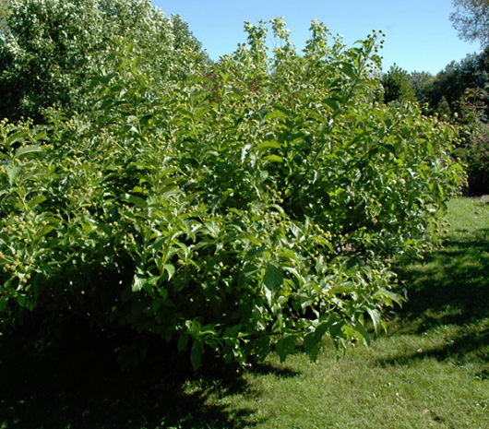
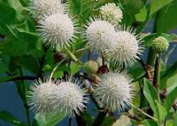

Winterberry (for pine tree replacement)

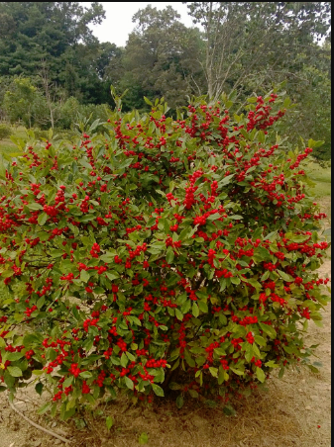
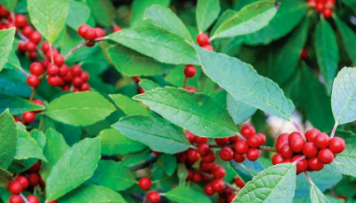

Blackhaw (for pine tree replacement)
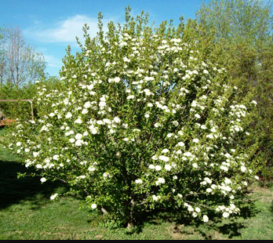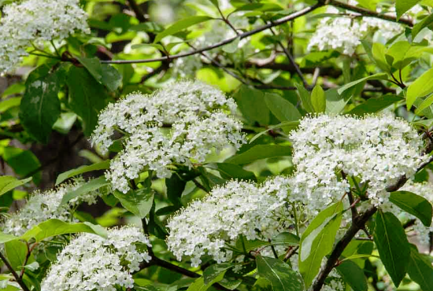

Arrowwood Viburnum (for pine tree replacement)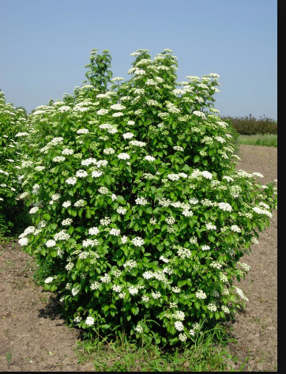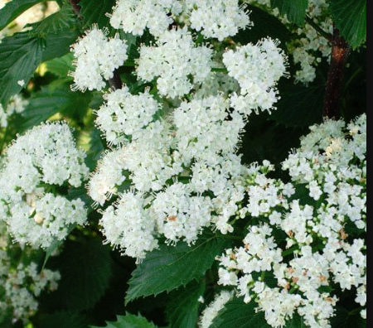
Boxwood (for shrub replacement near front door or in front of front window)
