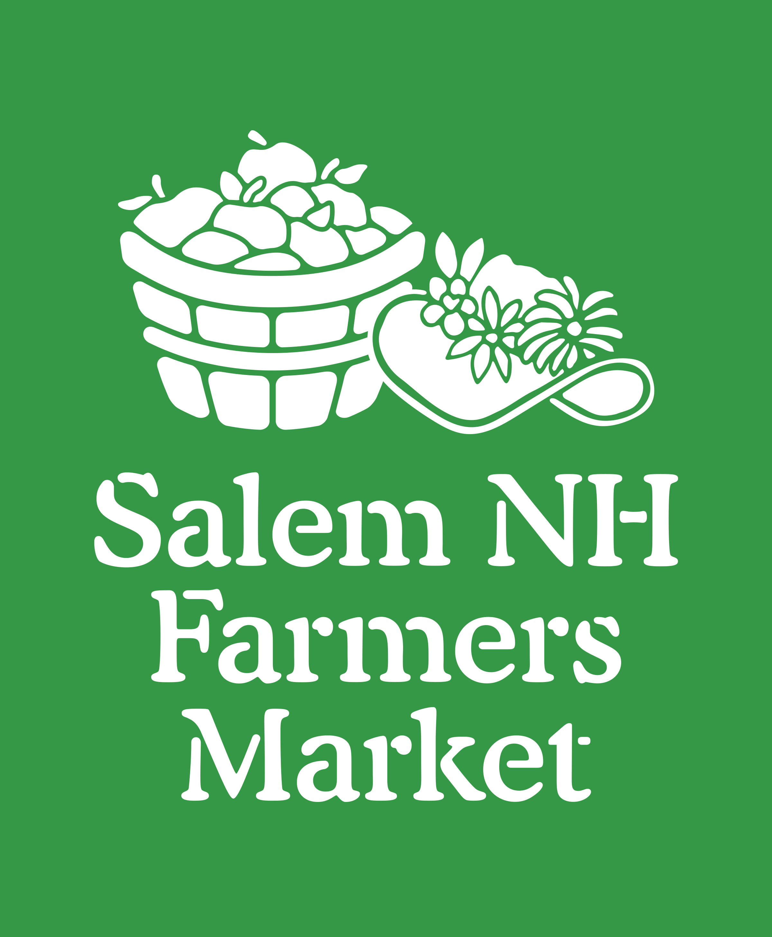
We are in full swing at our summer location along Route 28. With that come all of our summer vendors. Although the Salem NH Farmer’s Market is a year round market, vendors can sign up to be at the summer and winter market separately. The variety in vendors and offerings makes both the summer and winter market unique. A few features of the summer market include face paint for children, live music, and fresh lemonade. It creates an outing and experience for the entire family or group to enjoy.

Every week we are open for CSA pickups and other local goods. We are located at Salem Market Place, 224 North Broadway in Salem. Visit our website, SalemNHFarmersMarket.org, where you can sign up for weekly e-newsletters letting you know what vendors will be at the market. You can also find us on Facebook and Instagram for weekly updates, more vendor info and beautiul pictures @salemnhfarmersmarket. We accept credit, debit and EBT (food stamps). Please contact info@SalemNHFarmersMarket.org with any questions.
Salem NH Farmers Market Vendor of the Month
Farmhouse Roasters

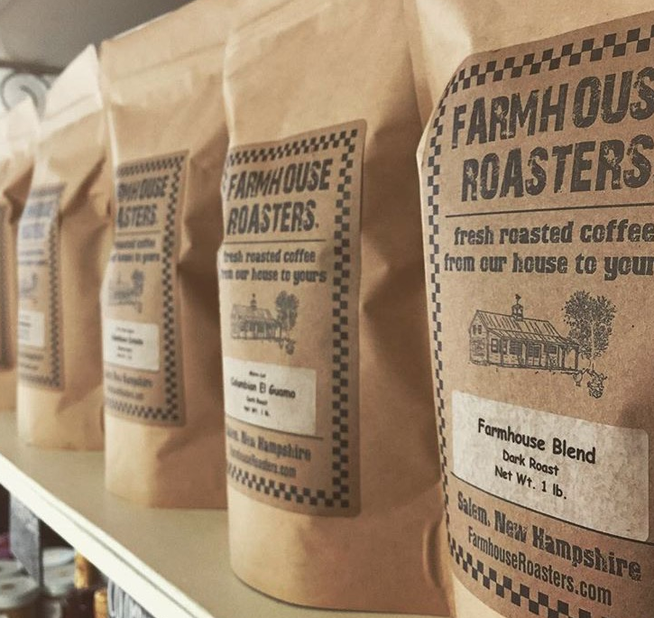
Farmhouse Roaster’s coffee is a micro-roasted, fair trade and organic coffee. As folks walk through the Salem Farmer’s Market, it is not uncommon that they will have a Farmhouse Roasters coffee to go cup in their hand. Hot or iced, many people opt for house-brewed coffee on Sunday mornings since it is available fresh from the Market. Luckily you don’t have to wait for Sunday for this coffee. Fortunately for those of Salem and the surrounding area, Farmhouse Roasters has a storefront and coffee shop located in Salem at 163 Main Street. Whether you are there for breakfast or lunch, when you walk in, the friendly staff greets you and is always happy to chat about the current offerings. The soup and sandwich offerings are all very flavorful. If you like, cookies and pastries can be the perfect way to end a meal. Along with dessert, you may opt to play one of the many games that can be found around the café. Dominos and other such games can be found on a nearby shelf or table waiting for you to challenge your friends. Since Farmhouse Roaster’s coffee is a micro-roasted, fair trade and organic coffee, the allure of the café is not the only thing Farmhouse Roasters have to offer and customers can be sure that they are receiving a quality and sustainable product. Coffee offerings include Guatemalan Sierra Nevada Estate, Ethiopian Konga, Indonesian Sumatra, and Farmhouse Blend just to name a few. Come to the Market on any given Sunday for a taste.

