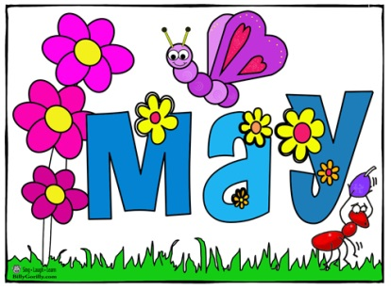 May Lunch 2017
Sunday | Monday | Tuesday | Wednesday | Thursday | Friday | Saturday
 | 1 | 2 | 3 | 4 | 5 | 6
 | Hamburgers, bun, cheese, lettuce, grapes, Milk | Chicken Teriyaki, rice, mix veg, pineapple, milk | Spaghetti, tomato sauce, parmesan cheese, gr. Beans, pears, milk | Pasta, Meat sauce, Veg. blend, Pineapple, milk | Cheese & Pep. Pizza, corn, Peaches, milk
7 | 8 | 9 | 10 | 11 | 12 | 13
 | Chicken soup w/ veg., and pasta, apples, milk | Ham sandwich, cheese, lettuce, apples, milk | Grilled cheese sandwich, lettuce salad, oranges, milk | Polish Sausage French Fries, Gr. Beans, melon, Milk | Cheese Pizza,  peas, pears, milk
14 | 15 | 16 | 17 | 18 | 19 | 20
 | Hotdog, bun, lettuce salad, grapes, Milk | Turkey sandwich, cheese, lettuce, grapes, milk | Mac & Cheese, baked beans, mix veg. , apples, milk | Chicken nuggets, Ranch, corn, melon, milk | Cheese & Pep. Pizza, Veg. blend, applesauce, milk
21 | 22 | 23 | 24 | 25 | 26 | 27
 | Chicken soup w/ veg., and pasta, pears, milk | Soft tacos, meat, tortilla, cheese, lettuce, tom., pears, milk | Pasta and tomato sauce, parmesan cheese Lettuce salad, oranges, milk | Meatballs, French fries, gr. Beans, apples, milk | Cheese and Pep. Pizza, mixed veg. apples, milk
28 | 29  Memorial Day | 30  Chicken Teriyaki, rice, mix veg, pineapple, milk | 31  Spaghetti, tomato sauce, parmesan cheese, gr. Beans, pears, milk | Fruit/Vegetables subject to change based on availability

