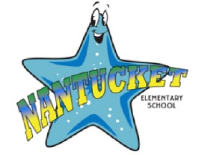
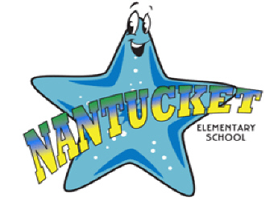
Nantucket Elementary PTA
General Membership Meeting Agenda
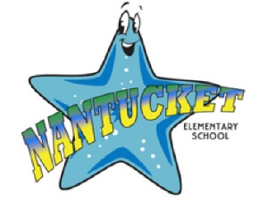
11/6/2019 6:30pm, Media Center

Important Upcoming PTA Dates:
- November 6th - PTA General Meeting
- November 8th – PTA Sponsored Fall Fest!
- November 25th – Hospitality Event
- December 2ns – Chick Fil A Spirit Night
- December 5th - Hospitality Event
- January 8th - PTA Board Meeting
- January 10th – PTA Sponsored Family Dance!
- February 12th – PTA Sponsored Summer Camp Fair
- February 12th - Hospitality Event
- February 18th - Spirit Night at Ledo Pizza!
- February 19th - PTA General Meeting
- March 11th - PTA Board Meeting
- March 17th - Spirit Night at Ledo Pizza!
- April 8th - Hospitality Event
- April 21st - Spirit Night at Ledo Pizza!
- April 29th - PTA General Meeting and Election
- May 8th – Spirit Night at Skate Zone
- May 20th - PTA Board Meeting

- Call to Order and Establish Quorum
- Review prior General Meeting Minutes
- Treasurer Report (Jennifer Cavin)
- Review by Committee
  - Membership – Robyn Nesmith
    - Membership Count:
  - Hospitality Luncheons – Swapna Sripada
    - November Event
    - December Event
  - Hospitality Appreciation Days – Jessica Wilson
  - Hospitality Coffee Cart – Robyn Cohen
  - Fundraising - Jodie Carpenter
    - Boosterthon Recap
    - Ledo Recap
  - Community Events – Katie McKeon
    - Fall Fest 11/8
    - Family Dance 1/10
    - Summer Camp Fair 2/12
  - Spirit Wear - Erin Waite
    - Sale and distribution update
  - Communication – Darlene Clark
  - Yearbook – Samantha Weaver
    - New Company and Sale
    - 5th Grade Ads
  - School Kits – Erin Waite
    - No Report
- New Business
  - Chromebook and Cart Purchase
  - Chick Fil A Spirit Night – December 2nd.
- Principal’s update
- Adjournment

.

