3/31/2018 Tiangong-1 Launched on the Day of Trumpets 2011

Here's an update to the previous article concerning the sign of the city from the sky descending to earth authored today, 3/31/2018.

The Tiangong-1 (Chinese meaning - Heavenly Palace) space station is right now slowly descending toward earth. It will probably disintegrate and burn up in earth's atmosphere in the next few days.

The Day of Trumpets is a special day set apart and appointed by YaHuWaH Elohim Himself each year for His use and purposes.

It happens that the Tiangong-1 space station was launched on the Hebrew Hillel calendar Day of Trumpets, 9/29/2011, at 16:16 PM Jerusalem time.

It also happens that exactly 3 years to the day earlier, the New York stock market suffered a 777 points Dow Jones loss when it closed at 4 PM EDT on 9/29/2008, the eve of the Day of Trumpets. However, it was 11:00 PM in Jerusalem at the time the stock market in New York City closed, and the Hebrew Day of Trumpets had already begun at sunset in Israel.

The Tiangong-1 space station is right now returning to earth in the middle of its 7th year of flight.

Below is a graphic that shows a relationship between these events and their relationship with other major appointed times on the Hebrew Hillel calendar.

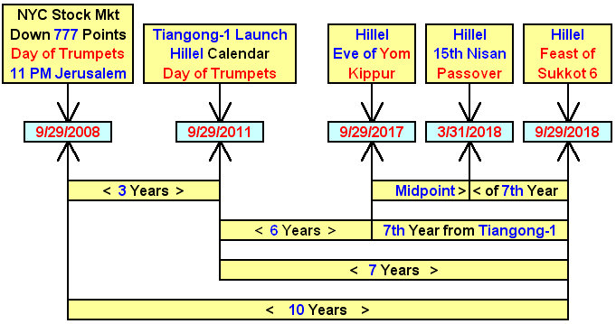

Above: The exact midpoint of the 7th year from the launch of the Tiangong-1 space station, which is symbolic of the coming arrival of YaHuShua Messiah's "City from the Sky", is precisely the date of the authoring of this article, 3/31/2018, and the Hillel calendar date Pesach 1.

The events above have been intimately intertwined with the Jewish calendar by YaHuWaH Elohim in order to get the immediate attention of the Hebrew nation.

Moshiach is coming!

