SECOND SUNDAY IN ORDINARY TIME
JANUARY 19 & 20, 2019
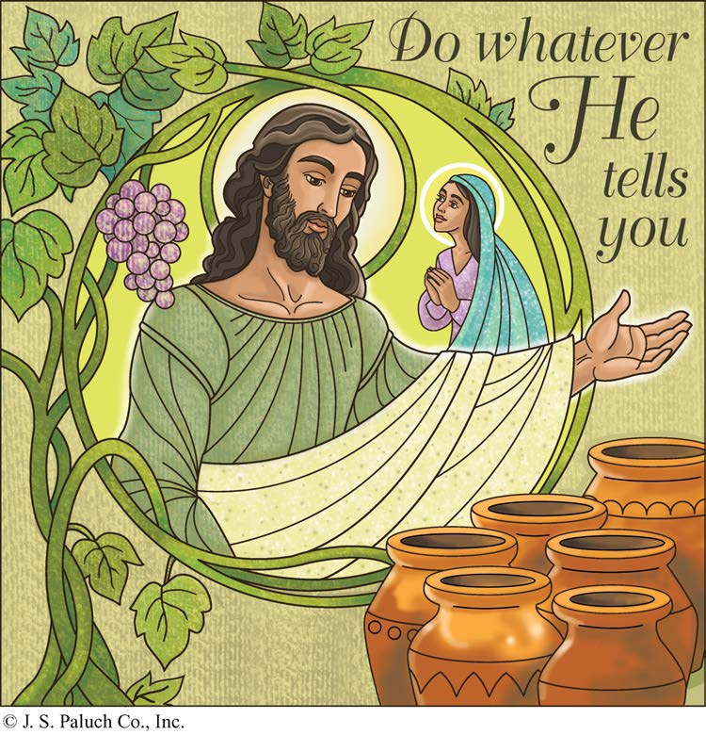
A VISIBLE GOD

We find it difficult to convey ideas to people unless we can actually show them something, demonstrate what we mean. God, who is invisible and truly beyond human understanding, apparently faces the same difficulty. People want to see, not just listen to an idea. So God gave us Jesus Christ, God made visible in the world.
During these past weeks, we have seen how Jesus was revealed as an infant to the shepherds and the Magi, and then began his adult “public life” at his Baptism by John. Today’s Gospel reading, tells us of this “first sign,” providing wine for the wedding guest of Cana.
Of course, even Jesus, God made visible, was not always easily understood in his own day, nor is he even now. So, we have to ponder what we see: the poverty and simplicity of his birth, his humility and openness before John the Baptist, his kindness and compassion toward people in their ordinary problems, such as running short of wine at a wedding. Yet, it is in coming to know Jesus that we come to know God.

THE INDESPENSIBLE LINK
By Dennis Tavares
Humans connect the Spiritual and Material worlds because by their very nature, they are beings with a body and a soul. They are thus a crucial logical element in the whole of creation, because they serve to bring together the whole of reality; they act as a link or communication line between the Spiritual and Material Worlds. Consequently, our central importance in the great scheme of things is that we can help to bring God’s will and design into the material world. This means that the All Powerful God allows us to act as partners in the maintenance of planet Earth and guides in the development of its history during our time on this planet. This is a great gift of God to us, and helps to explain the necessity of Jesus’ life, as a guide to spiritual fulfillment of His plan for the world.

THE LIFE OF SAINTS
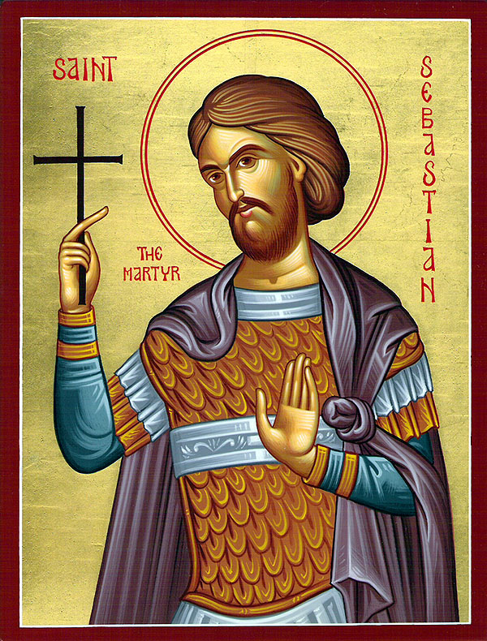
SAINT SEBASTIAN
JANUARY 20TH
Patron of Athletes & Soldiers

O Lord, grant us a spirit of strength. Taught by the glorious example of Your Martyr St. Sebastian, may we learn how to obey You rather than men.

Sebastian was the son of wealthy parents. He became the Captain of the Soldiers, who guarded the Roman Emperor. The Emperor made the Christians suffer very much. Sebastian helped them by visiting them in prison, bringing them money, clothing and food.
Once Sebastian healed a soldier’s wife by making the Sign of the Cross over her. Both, she and her husband asked to be baptized. He also converted a Governor at Rome and many others.
Sebastian was accused of being a Christian and was to be put to death. He was tied, and soldiers shot arrows at him. That night a Christian woman, thinking he was dead, had some men bring the Martyr to her home and prepare his body for burial. However, the martyr was still alive. She cared for him until he was well again.
Sebastian went back to see the Emperor and begged him to be kind to the Christians, but the Emperor ordered soldiers to kill Sebastian. After his death, the Martyr appeared to a holy woman and told her where his body might be found. His body was then brought to the Catacombs and buried there.

PLEASE PRAY FOR OUR SICK PARISHIONERS
Richard Braga, Lisa Wright, Ricardo Contreras, Florencia Chávez, Refugio Yáñez, Tarcicio García, Sofía García, María de Jesús Mendoza, Ana García, Antonio Cazares, Ryan Moore, Eileen Seeman, Marianne Brannan, Lilia Parrish, Nancy Smith, Julián Palomar, Luisa Martínez, Jennifer Vera, John Braet, Kim Koskinen, Margaret Valencia, Matthew Marcoulier, Dennis Tavares, Jose Freitas, Alfredo Sousa, Juana Arreguín, Aron Yasskin, Victoria Walzer, Fidela Yáñez Jara, Erika Ramos, Bill Gibson, Carla Tomas, Erasmo Yáñez, Memo Soria, Patricia Vargas, Fidela Yáñez, Elvia Flores, Camila Blanco-Cherrez, Yonel Ruíz, Angie Freitas, Russel Bryant, Derrick Heater, Luis Angel, Juan Barrera-Terán, Gabriel Hurtado, Gerald Butler, Helen Reynolds, Toni Clark, Ann Gallagher, Brianna Lopez, Margaret Milliken, Gina Pivirotto, Nick Quin, Mary Servis, Denis Sousa, Victor Venegas, Matty Walker, Charles Lorenz, Rebecca Lorenz, Ofelia Ibarra, Leonardo Naal, Gina Leal.

Walk for Life West Coast Great News!
This year’s Walk for Life West Coast will be in San Francisco’s Civic Center Plaza on
Saturday, January 26, beginning at 12:30 PM.
AND, at the request of Archbishop Cordileone and his brother Bishops, the Vatican has declared an opportunity to obtain a plenary indulgence for those participating in the sacred celebrations related to the Walk for Life West Coast!
Pope Francis has also given a Papal Blessing, which will be imparted by Archbishop Cordileone at the Mass in St. Mary's Cathedral before the Rally and Walk.
For full information and the Vatican letter about the indulgence, go to www.walkforlifewc.com

PRAY FOR OUR FAMILY AND FRIENDS THAT ARE IN THE MILITARY SERVICE
José Araiza Jr., Edgar Toscano, Marina González, Alondra Jara,
Sonia Jara, Jason Lorenz, Matt Mill y Jared Schroeder

MASS INTENTIONS
JANUARY 23 - 27, 2019
Wedneday (23)  Thursday (24)  Friday (25)  Saturday (26)  Sunday (27) | 12:05pm  12:05pm  12:05pm  5:00pm  6:30pm  8:00am  10:00am | Katie Richards †  Bruno & Camilla Benedetti †  Antonio Hernández †  Fred & Clara White †  Katie Richards †  Eliazar Ramírez †  María de la Luz Fierro †  Angelo & Cesarina Murada †  Manuel & Mary Mello †

FIRST COMMUNION MASS
WILL BE
MAY 11TH AT 12:00PM.

CONFIRMATION MASS
WILL BE
MAY 12TH AT 10AM.
ATTENTION OLGC‘S YOUTH

NET Ministries is coming to
Our Lady of Good Counsel again!
So mark your calendars for Saturday, March 2nd.
How will you make a personal response to God's invitation?
Come learn from the NET Ministry team the truth of who you are as God's children and how true joy and meaning in life are found by accepting Christ's gift of salvation and living as His disciple.
The retreat is for all OLGC Youth in grades 6-12. MANDATORY FOR ALL CONFIRMATION STUDENTS.
Come enjoy talks & discussions, games, skits, moving dramas, live music, guided prayer time, recreation, confession and adoration led by 10-12 teen and young adult NET missionaries.
Help set up and clean up for additional service work hours that count toward your requirement for Confirmation.
Can't wait to see you all there!
For questions, please call Kathleen Kasperson at
964-5854 or the Parish Office at 964-0229.

READINGS FOR THE WEEK:
Monday: Heb 5: 1-10; Ps 110: 1-4; Mk 2: 18-22
Tuesday: Heb 6: 10-20; Ps 111: 1-2, 4-5, 9, 10c; Mk 2: 23-28, or any of a number of readings for the Day of Prayer
Wednesday: Heb 7: 1-3, 15-17; Ps 110: 1-4; Mk 3: 1-6
Thursday: Heb 7: 25 – 8: 6; Ps 40: 7-10, 17; Mk 3:
7-12
Friday: Acts 22: 3-16 or 9: 1-22; Ps 117: 1bc, 2;
Mk 16: 15-18
Saturday: 2 Tm 1: 1-8 or Ti 1: 1-5; Ps 47: 2-3, 6-9
Or Ps 96: 1-3, 7-8a, 10; Mk 3: 20-21
Sunday: Neh 8: 2-4a, 5-6, 8-10; Ps 19: 8-10, 15;
1 Cor 12: 12-30 (12-14, 27); Lk 1: 1-4; 4: 14-21

WEEKLY COLLECTION

JANUARY 12 & 13, 2019……$1,708.00
MAINTENANCE FUND…$810.00
THIS WEEKEND’S SECOND COLLECTION:
CHURCH IN LATIN AMERICA
NEXT WEEKEND’S SECOND COLLECTION:
YOUTH MINISTRY AND RETREATS

THANK YOU
FOR YOUR SUPPORT & CHRISTIAN GENEROSITY

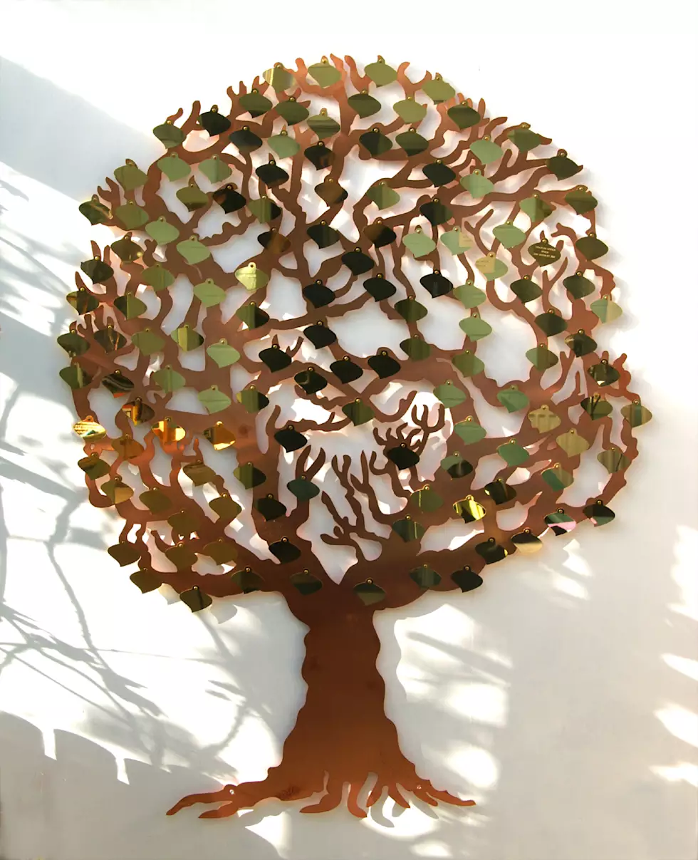
OLGC’S MEMORIAL TREE
In the vestibule of the Church, on the southern wall, is a beautiful Memorial Tree.
Its bright leaves represent permanent memorials to the departed of our Parish.
For the sum of $200.00, you can give to the Parish Secretary, the correct spelling and dates of the departed and in due time the leaf is printed and attached to the tree: a permanent reminder of a loved one who is gone.
For more information, call the Parish Office at
964-0229.

LATIN MUSIC-DINNER & FUN

DATE:
SATURDAY, FEBRUARY 16th, 2019

PLACE:
FATHER MICHAELRAJ’S HALL

TIME:
HAPPY HOUR: 6:00PM
DINNER: 7:00PM
DANCE: 8PM – 11:30PM

3 COURSE DINNER – APPETIZERS – DRINKS – DESSERT & DANCE

TICKETS:
$30/PERSON OR $50/COUPLE

TICKETS MUST BE PRE-PURCHARSED BY
FEBRUARY 6TH!

FOR TICKET PURCHASE OR MORE INFORMATION, PLEASE CONTACT:
RAQUEL HUERTA: 813-1293 &
MARIA CRUZ: 813-9392

ORGANIZED BY OLGC COUPLES FOR CHRIST
PROCEEDS GO TO THE PARISH’S GENERAL FUND

