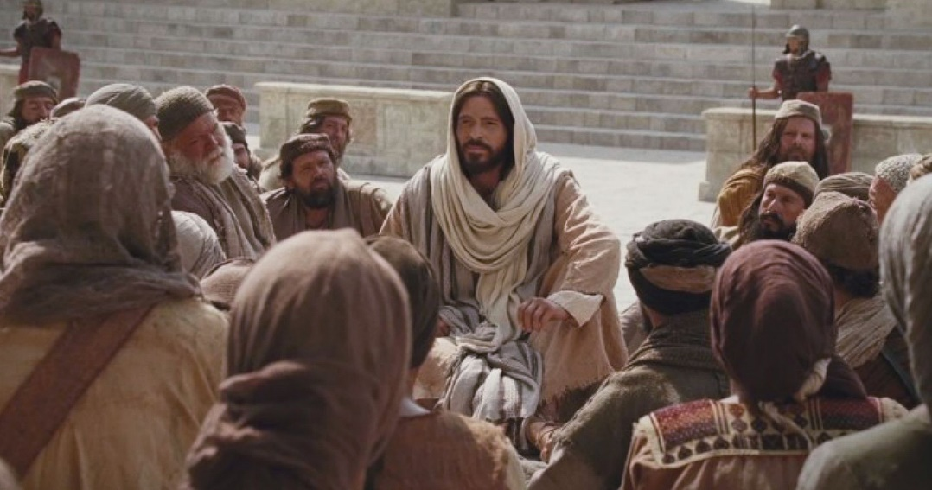

May 22, 2022

6th Sunday of Easter

Carson City United Methodist Church

10:30 am

Greeting/Announcements

Call to Worship
L: Lord, our Lord, how majestic is your name in all the earth!
P: You have set your glory in the heavens.
L: Through the praise of children and infants you have established a stronghold against your enemies, to silence your foes.
P: When we consider your heavens, the work of your fingers, the moon, and the stars, which you have set in place,
L: What is mankind that you are mindful of them, human beings that you care for them?
P: You have made us a little lower than the angels and
crowned us with glory and honor. Lord, our Lord, how
majestic is your name in all the earth!

*Hymn: Oh, How I Love Jesus UMH 170

Opening Prayer: (unison)
Heavenly Father, we ask for your, blessing on all who are gathered here in this place to worship you. May any doubt be replaced with unshakeable faith. May our anxieties be replaced with your peace. Here may the sorrowful comfort. Here may the weary find rest, and our strength be renewed. May we all be reminded of your very real presence in our lives. We ask this in Jesus’s name who lives and reigns with you in Heaven One God forever and ever. AMEN.

Contemporary Song: Listen to Our Hearts (Casting Crowns)

Offering

Doxology UMH 95

Offertory Prayer

Sharing of our Joys and Concerns

Call to Prayer: El Shaddai UMH 123

Pastoral Prayer

Gospel Reading: LUKE 17:10

Old Testament: JOB 22:2-3
Epistle Lesson: 1 CORINTHIANS 9:16-17
Contemporary Song: Goodness of God

MESSAGE

*Hymn: We are Climbing Jacobs Ladder UMH 418

Benediction

CCUMC – Announcements & Upcoming Events:
==================================================
As a courtesy to others please silence
or shut off cellphones
==================================================
Scrap Drive: We are looking for some supplemental money to fund the budget. It has been decided that we will conduct a Scrap Metal Drive for the whole month of May. Here's how you can help:
If you have any scrap metal, appliances, etc. you can take them to the Fair Salvage Company in Sheridan. They will issue you a check. You can call the church office (989)594-3797 to have your items picked up. You can give a special donation for the general fund. Currently, the mortgage is down to $18,500. This means only 3 more payments. We have several items that need repair in the church. As with anything, eventually they wear out. Any little bit will help. If you have any questions, please feel free to call me or any Finance Committee person.
Thank-you for all you do.
==================================================
Graduation Sunday is June 12th. The church needs to know who is graduating from college or high school this year. We would like a picture in addition to obtaining each graduate plans of where they are going and field of study so we can share at our Sunday services. Please turn in to the church office as soon as possible.
==================================================
VBS Supplies needed: white flat sheets, cylindrical oatmeal boxes, tissue paper, pool noodles, boxes, brown packing paper. Please place in tub under the Monumental table.
==================================================
AD Board/Finance mtg: Wed, May 25th @ 6:00 pm.
Everyone is welcome.
==================================================
LAST DAY REMINDERS BEFORE FOR SUMMER
Euchre: Last meeting is Sat, May 21st
Women’s Group: Last meeting is Sun, May 29th
==================================================
Christmas 2022 Service: With Christmas Day falling on Sunday for 2022 we would like to go with the following schedule so people can spend Christmas Day with family and friends. Please let us know your thoughts.
- Christmas Candlelight Service: 12/24/22 @ 7 pm
- Christmas Day Service: No Sunday Worship Svc

Frontier Days 2022 Activities:

Sat, June 4, 11:00 am to 1:00 pm @ CCUMC
Picnic Lunch, Whole Pie Sale, Rada Cutlery Sale, Arctic Blast Saved Ice
Proceeds to go towards Mortgage

Sat, June 4, around town
City Wide Yard Sales/Sidewalk Sales – All Day
Marketplace Craft Show, located along Sherman St. 9:00 am to 5:00 pm

Main Street:
Buckaroo Parade 1:15 pm
Grand Parade 1:30 pm

At Dusk:
"Light Up The Night" Balloon Glow
@ Fort Frontier Park
Emergency Vehicle Light Parade (Main Street)

Serving & Supporting Sunday Worship
Audio/Video: Pat Monroe
Children’s Ministry Audio/Video: Colin Fitzpatrick

Joys, Concerns & Prayer Request
For those battling cancers:
Jim Dunlap, Carolyn Nykerk, Ray Seaman, Dillan Abell, Andrew Hogan, Amorena Newman-Wojciakowski

For those who need support, guidance or have health concerns: Mike Decker, Jeff Beechler

Monthly Giving
5/1 $4306.02 5/8 $3382.68 5/15 $2593.14

Nursery Schedule
5/22 Jenna Benjamin 5/29 Alex Krantz

Lighting of Candles

Passing of Collections Plate

Children’s Church

Our Church in Ministry This Week
Sun: Women’s Group 6:30-8 pm
Mon: PT Class 6:30-8 pm
Tue & Thu: COA Meal @ Noon

Coloring Page

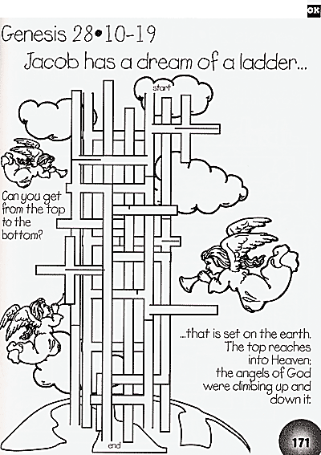

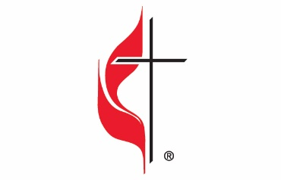

Carson City United Methodist Church
Location: 119 East Elm St., Carson City, MI
Mail: PO Box 298, Carson City, MI 48811
Phone: 989-584-3797 Email: carsoncityumc@gmail.com
Website: carsoncityumc.com
Sunday Worship Service: 10:30 am
Office Hours: Monday-Thursday, 9:00 am-12:00 pm
After hours by appointment
Pastor: Ian McDonald 906-322-5318
Secretary: Bonnie Seaman 989-763-1674

Weekly Sunday Bulletin now available on our website
@ www.carsoncityumc.com

“Beautiful Savior, I’m so thankful Your love for me never grows old! Help me love for You to grow ever deeper.”

