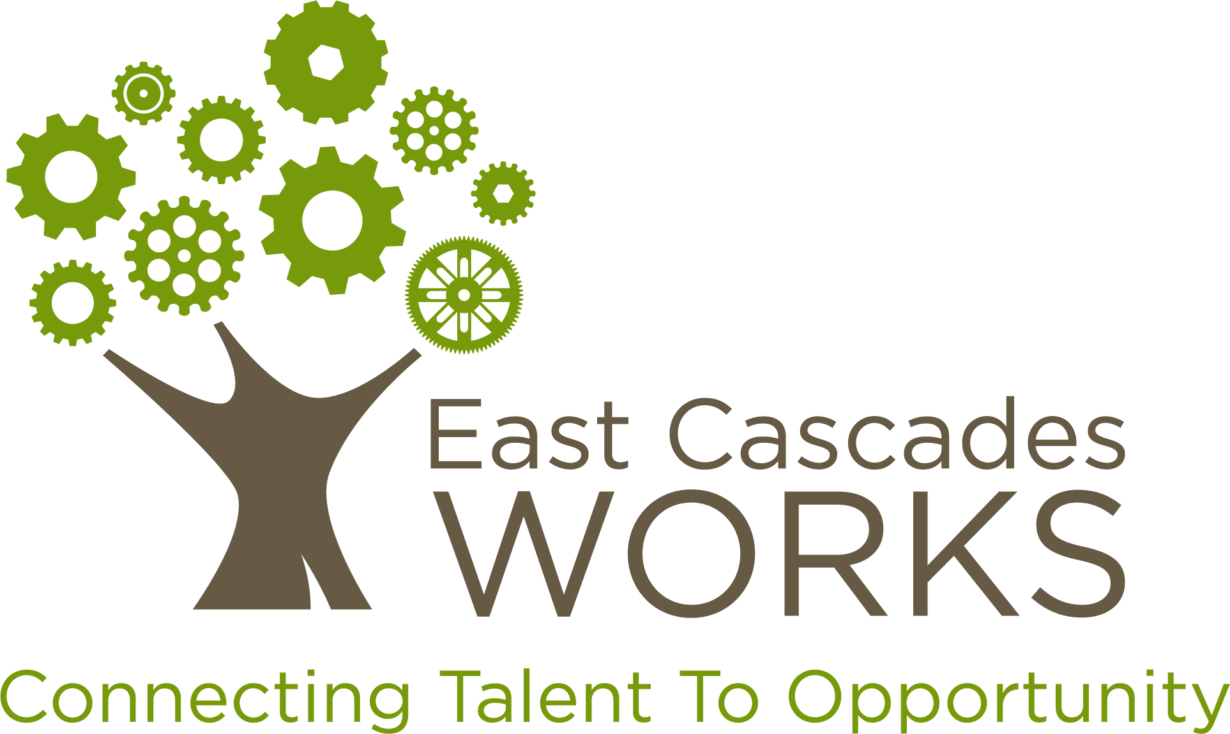

Proposal Narrative

Cross Gorge

Incumbent Worker Training Grant

***All fields are required. Any applications that are incomplete will not be reviewed. There are 101 points possible (100 points +1 bonus point).***

|  |  |  |
| --- | --- | --- |
| *Applicant Information* | | |
| *Lead Applicant & Primary Contact (Name, Company, Address, Phone, Email)* |  | |
| *Fiscal Contact (Name, Company, Address Phone, Email)* |  | |
| *Partner Applicant(s), if applicable (Name, Company, Address, Phone, Email)* |  | |
| *Has your company been awarded an Incumbent Worker Training Grant from EC Works before?* |  | |
| *Request Information* | | |
| *Training Program Title* |  | |
| *Training Period* |  | |
| *Total Amount Requested* | *$* | |
| *Total Employer Match* | *$* | |
| *Minimum Criteria Certification & Submission Review Verification* | | |
| *In submitting this application, we certify that we have read, understand and meet all “Application Criteria”, as described in Section VI. Of the Request for Proposal.* | | YES/NO (Circle) |
| ***As the authorized representative of the lead applicant, I hereby certify that the information contained in this application is true and accurate and reflects the intentions of the program.*** | | |
| *Signature/Date:* | | |

|  |
| --- |
| *General Training Information (30 total points)* |
| *1. Briefly describe the training opportunity identified, the number of employees that will be trained and how training will improve labor market competitiveness. (example: training will avert layoffs, etc)* |
|  |
| *2. What is the method for delivery of training? (example: in-class room, on-line, on-site)*  *Where is the training held? (example: Training Institution X, Hood River, OR)* |
|  |
| *3. What are the beginning and end dates of the training(s)?* |
|  |
| *Consortia Training (10 total points)* |
| *4. Will multiple companies be participating together, in the same training opportunity? If so, please list the names of each company as well as the number of employees from each company.* |
|  |
| *Expression of Need (10 total points)* |
| *5. Please describe how this award will help your employees become more competitive as a result of receiving training. (example: Training will avert layoffs. Training will result in credential/certificate, etc.)* |
|  |
| *Sector/Industry Information (10 points)* |
| *6. Is your company private, for profit, or other? Which industy or sector is your company a part of?* |
|  |
| *Employee Information (40 total points)* |
| *7. Please list the positions employees accessing training currently hold and indicate the current average wage range of these employees. (Employee wages must meet Median Wage of $15/hour).* |
|  |
| *8. How does training directly benefit the individuals to be trained?(Example: Does the training result in an industry recognized credential or certificate?)* |
|  |
| *9. Please indicate the total number of individuals to be trained, as well as the number who reside in each of the following counties:* |
| *TOTAL:*  *Hood River:*  *Wasco:*  *Sherman:*  *Gilliam:*  *Skamania:*  *Klickitat:* |
| *10. What employee wage growth and/or promotions for participating employees are expected as a result of training?* |
|  |
| ***BONUS: WorkSource Connection (1 total point)*** |
| *Please describe the way your company utilizes WorkSource Oregon or Worksource Washington to identify new hires?* |
|  |