Directions to Intergrove Shelter in the North Chagrin Reservation of the Cleveland Metroparks:

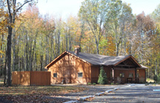

From I-271…
Exit at the Wilson Mills exit. Turn east onto Wilson Mills. Turn left onto Rt. 91 (S.O.M. Center Rd.) The North Chagrin main entrance (Sunset Lane) is 3.5 miles on the right. Turn right onto Sunset Lane. At the first stop sign, turn left onto Buttermilk Falls Parkway. The Intergrove Shelter will be approximately 0.5 miles on the left.
Note: If you enter the North Chagrin reservation from the Chardon Rd. (Rt. 6) entrance, the shelter will be on the right on Buttermilk Falls Parkway.

