Center Ice Skating Club
CISC Seller - _____________________ Orders due February 4th Pick Up February 15th 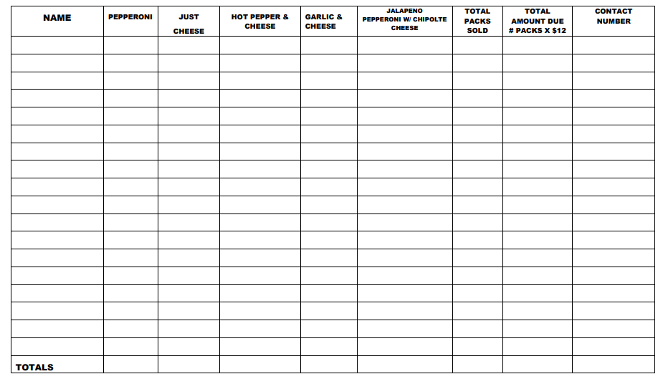 **One payment must be submitted with the order. Individual checks are made directly to the skater. Roll Totals & Payment due 2/4.

