January 2020
Subject to Review: January 2021

Please visit our website for recent news and policy changes:
- http://www.theguesthouseshelter.ca
- www.facebook.com/TheGuestHouseShelter

SHELTER OPERATIONS MANUAL
STAFF
TABLE OF CONTENTS
preface 4
history of the guesthouse shelter 4
organizational structure 4
information & safety 6
fire safety information 6
basic rules of the guesthouse shelter 8
basic information and contacts 9
your role as staff 10
accountability 10
avoiding burnout and compassion fatigue 11
boundaries 11
communication 12
documentation 12
screening 13
training 13
shelter operations 13
homeless individuals and families information system (HIFIS) 13
day-to-day operations 14
day shift 14
evening shift 16
overnight shift 18
shelter procedures 19
automated external defibulator (aed) 19
confidentiality 19
daytime use of beds 20
daytime use of televisions 20
deviation reports 20
donations 21
entrance and security 21
emergency buttons 21
first aid kits 21
guest clothing and personal items (storage) 22
guest responsibilities 22
guest storage and disposal 22
guestroom configuration 22
harm reduction 23
incident reports 25
- police attending an incident
- relationship to the police
laundry 26
prescription medication 26
routine cleaning practices 27
sharps 27
showers 27
suspension of service and trespassing 28
use of telephone 28
special considerations 29
communal living requirements 29
deviation and exception of policy and procedure 29
families 29
storage of personal food items for guests 30
infection prevention and control 30
risk factors 30
workplace hazardous materials information system (whmis) 31
the guesthouse shelter documents 32
call log 32
communication log 33
deviations report 35
drop-in program log 36
emergency test button log 37
guest attendance log 38
incident report 39
medication log 40
overnight guest sign-in 41
personnel log 42

Preface
This manual will help you understand what is expected of you as a TGHS staff member as you assist the homeless and vulnerably housed who seek food and emergency shelter in our community.
The Guesthouse Shelter’s ongoing mission and vision:
To provide food and shelter in a safe and familial environment within North Simcoe that cares for those in physical, intellectual, emotional, social, and spiritual need.
The Guesthouse Shelter Organizational Structure
The Guesthouse Shelter is a non-profit, registered charity, governed by a volunteer Board of Directors.

History of the Guesthouse Shelter
The Guesthouse Shelter (TGHS) evolved from the Out of the Cold initiative, a grassroots social-justice movement initiated by several Toronto high school students in 1988. Their goal was to provide food and shelter to community members in need in a non-judgmental setting. The design and name quickly caught on, with various Toronto faith groups opening places of worship one day a week, providing food and shelter from the cold winter.
Out of the Cold programs now exist from coast to coast. However, most are found in Southern Ontario communities. Cambridge in particular, provided our local Out of the Cold program with an exemplary model of what is possible. Started by seven churches in 1998, the Cambridge Out of the Cold program matured into Cambridge Shelter, a permanent best-practice solution occupying an attractive new facility within a vibrant part of the downtown. While changing significantly through taking on paid staff and provision of formally funded social support programs, Cambridge Shelter is still largely a volunteer-driven entity.
Midland Out of the Cold began in 2003 as a temporary solution to the loss of Experience House, a year-round emergency shelter that had first opened in 1985. Similar to other communities, our local Out of the Cold program moved each day from church to church from December 1st to March 31st. In December 2007, Midland Out of the Cold moved into a permanent space in the basement of Knox Church.
With numbers of guests continuing to grow, Midland Out of the Cold was incorporated in 2010, and charitable status was achieved the following year. Inspired by the example of Cambridge and informed by much study to determine the extent of local homelessness, in May 2012 the board of Midland Out of the Cold voted unanimously to stay open year-round. With this expanded vision, we built upon our roots as Out of the Cold and in April of 2013 we formally adopted the name The Guesthouse Shelter.
In 2014 a new plan was developed to move forward with an innovative shelter facility which would be fully-accessible, equipped with a commercial-grade kitchen, 18 beds and a community ‘hub’ space for partnering service providers to deliver needed services to those in our community struggling from inadequate or no housing. As of June 2017, The Guesthouse Shelter officially launched a “Grand Opening” of its new facility at 522 Elizabeth Street.
The Guesthouse also operates as a vital Community Hub, partnering with a wide array of social service agencies and organizations.
As the organization moves forward, administration and operations continue to expand to offer programming options such as emergency shelter, meal programming and housing supports. The Guesthouse Shelter & Community Hub is quickly growing as a community leader which largely relies on a team of dedicated staff, volunteers, and community partners.

Fire Safety Information
Fire Procedure
The Fire Department can be reached by dialing:
911 or 705-526-4279
Before trying to help others in an emergency situation, please make sure you are safe.
Upon discovery of fire:
- Pull the fire alarm there are several located throughout the shelter
- Leave the fire area immediately and assist anyone in immediate danger to evacuate
- Close all doors behind you to contain the fire
- Alert other staff, volunteers, guests of the situation
- Use fire exit stairwells and doors to leave the building
- Proceed to the parking lot on the South side (Elizabeth St) or the North side (Easy Street) and take attendance of staff, volunteers and guests
- Press emergency button for three seconds
- When safe, call fire services at 911
- The SSL will meet the arriving fire crew and advise on the number of volunteers and guests and whether all are evacuated
Upon hearing the fire alarm:
- Leave the building immediately and alert/assist anyone in danger to evacuate
- Use fire exit stairwells and doors to leave the building
- Close all doors behind you to contain the fire
- Proceed to designated outside assembly area and take attendance
- When safe, call fire services at 911
It is paramount that all TGHS staff, volunteers, and guests understand the fire safety and evacuation plan. TGHS staff should be familiar with all exits and locations inside of the building. Details are illustrated on a TGHS map found in this manual and include:
  - Two fire exits: (1) leading from the dining room to the main entrance and exit of the shelter, north side of the building, (2) leading from the common room, south side of the building – these are to be used by staff, volunteers, and guests
  - The designated assembly points, in the municipal parking lot across on First St. and Easy St. All guests and volunteers must remain at the assembly point until allowed to leave by the attending fire or police officers

The six TGHS fire extinguishers are located (i) left of the main shelter entrance door, directly right of the shelter office door, (ii) directly under the sink to the left of the shelter kitchen entrance (iii) located to the left of the shelter kitchen fridge, (iv) automatic fire suppression system for rangehood, (v) located on the left side of the hallway wall in between bathroom entrances, (vi) located in common area slightly left of the fire exit door. All staff members should be aware of the extinguisher locations and how and when to use them.
The carbon monoxide detectors are located in the kitchen pantry-storage area, in the shelter hallway, in the medical exam room, in the custodial storage room and one located in every sleeping area (guestroom).
Smoke/heat detectors are located in the shelter office space, the main dining area, the shelter hallway, the kitchen, and the pantry storage area, custodial storage area, in all bedrooms, in the common area, the laundry room, and both north and south entrance/exit ways.
The use of candles or open flames is not permitted at any time. Deviation may be acceptable in meeting a guests’ religious/spiritual needs.
As part of TGHS regular security rounds, it is staffs’ responsibility to ensure:
- All garbage is in proper waste receptacles
- No open flames are present
- Fire exits are not locked or blocked
- All other fire safety rules are observed and followed
Please be mindful that fire safety knowledge for our guests is increased when staff are confident themselves in demonstrating and sharing important safety information.
Fire Drill
TGHS conducts quarterly fire drills for the shelter and building occupants. In the event of a scheduled fire drill, the SSL will inform all TGHS guests of the proper procedure and protocols. All TGHS guests and staff members will meet in a designated location of the parking lot located on Easy Street. SSLs should take attendance of all present guests.
Details of the drill should be logged in the SSL Communication Log. Any specific issues, problems, or needs associated with the drill should be shared for the SOM/CEO to review.

BASIC RULES OF THE GUESTHOUSE SHELTER
RESPECT OTHERS
RESPECT THE BUILDING

RESPECT THE NEIGHBOURHOOD
NO WEAPONS
NO DRUGS or ALCOHOL

PROTECT ALL GUESTS

ENJOY YOUR TIME WITH US!
BE MINDFUL OF BOUNDARIES

BASIC INFORMATION SHEET

Welcome to The Guesthouse Shelter & Community Hub, our contact information and hours of operation are as listed below:

The Guesthouse Shelter maintains 24/7 operating hours for all registered guests.
Dinner and Drop-In Hours as follows:

Daily:

Breakfast
6:30AM to 7:30AM, non-registered guests must depart TGHS by 7:45AM
Dinner
5:30PM to 6:30PM, non-registered guests must depart TGHS by 8:00PM

SHELTER CURFEW IS 11:00PM!

The Guesthouse Shelter Staff Directory
Steven Pelletier  Chief Executive Officer | 705-528-1096  ext. 200 | ceo@theguesthouseshelter.ca
Rosemary Sykes  Shelter Operations Manager | 705-528-1096  ext. 207 | som@theguesthouseshelter.ca
Katie Staneland  Shelter Outreach Worker | 705-528-1096  ext. 205 | sow@theguesthouseshelter.ca

Your Role as Staff:
To safely provide for our guests, staff members must be respectful, firm and mindful of boundaries at all times. It is expected that staff members familiarize themselves with TGHS Staff Manual, policies, and procedures in order to confidently maintain a productive and safe environment inside the shelter.
As you will quickly discover, our guests are diverse human beings with complex and fascinating stories to share. The low-barrier environment at TGHS often presents individuals experiencing multifaceted social vulnerabilities, such as mental health issues, substance abuse, homelessness and poverty. You will encounter challenging and diverse scenarios. This manual aims to equip staff members with the skills, practices, and information to keep yourself and our guests safe.
Specifically you will read about:
- The history of The Guesthouse Shelter
- Day-to-day program operations and shift schedules
- Safety measures and procedures
- Boundaries amongst guests and staff
- General communication forms
- Mandatory staff trainings
Please read this manual carefully. Ask questions and learn your role. Complete all required paperwork and attend staff trainings. It is recommended that you stay current by reading all emails, newsletters, shelter documentation and policy derivatives associated with TGHS. Past experience has shown us that staff members who maintain clear, consistent boundaries and recognize guests as autonomous individuals thrive in their roles as TGHS staff members.
This manual has been developed through the knowledge and experience of over fifteen years. We have learned what works well. We continue to expand our social knowledge by visiting other thriving shelters and community organizations.
This manual represents our current vision for a successful low-barrier and “best practice” driven emergency shelter.
Guests of TGHS face many social challenges and barriers making them marginalized and vulnerable members of our community. Often, guests are without strong support networks, may struggle with substance abuse or mental health issues, be without any possessions, or have experienced violence. Knowing the vulnerable reality many of our guests’ experience, TGHS strives to create an empathic and strong staff team through up-to-date screening measures and training practices.
Please note the use of the following acronyms throughout the manual: The Guesthouse Shelter (TGHS), Shelter Shift Leads (SSLs), Shelter Operations Manager (SOM), and Shelter Outreach Worker (SOW).
Staff Accountability
Staff accountability ensures a strong team where members are responsible to one another and the wellbeing of the shelter space. Schedules are produced eight weeks in advance. Staff are accountable to the shifts in which they are scheduled, pending any extenuating circumstances.
In the event of a staff member not being able to attend their shift, the SOM must be made aware no later than three hours prior to the start of their shift.
Any deviation from this guideline, will result in a documented “three-strike” system, followed by a written warning and consultation with the SOM and/or CEO.
Avoiding Burnout and Compassion Fatigue
Burnout is a natural emotional response often associated with individuals working in social service fields. It is the result of not meeting our own needs while acting in high-stress, emotional, and caregiver roles. Our guests often experience intense hardships, and it can be difficult to remain neutral and protect ourselves while navigating social safety nets and support for our guests.
As communicated previously, it is likely that as a TGHS staff member you may come to closely understand the realities and adversities that our guests have faced. It is possible to help a guest navigate their trauma and avoid compassion fatigue by setting limits and practicing self-kindness and care.
SSLs are encouraged to communicate with the SOM or CEO if experiencing burnout or compassion fatigue.
Ways to avoid burnout:
- Eat, drink, and sleep well
- Practise self-care strategies when you get home
- Keep work at work
- Talk to someone you trust – family, friends, coworkers are helpful individuals to utilize when experiencing burnout
- Implement boundaries when you are working and set limits
- Do not be a sponge – you will hear experiences and stories of intense hardship or trauma. It is important as TGHS staff member that you do not absorb the emotional experiences of others
- Talk it out – if you have experienced a crisis on shift – debrief, talk, and seek support from co-workers or the SOM/CEO
Staff Boundaries
TGHS staff members are strongly encouraged to implement boundaries when working inside the shelter environment. Upholding the standards of this profession means that we must protect our safety and the safety of others by creating strong boundaries between staff and guests. Think of boundaries as invisible walls. We encourage staff members to understand and implement boundaries while working with our guests.
Many of our guests have experienced trauma, abuse, may struggle with addiction, or have experienced violence. It is important to be mindful of this as a TGHS staff member, as we hold positions of power in relation to our guests, and we can cause harm to our guests if we are not maintaining boundaries.
Crossing boundaries can look like:
- Engaging in any outside work, activity, or business that conflicts with the duties of a SSL
- Sharing personal and identifying information with guests (such as a cell phone number or home address)
- Sharing social media information, such as your Facebook profile or Instagram page
- Texting guests on a personal phone number
- Offering personal rides to guests
- Accepting or offering significant gifts to/from guests
- Picking and/or choosing favourite guests
The above list are some examples of crossing boundaries that are unprofessional and unacceptable. Boundaries help avoid burnout. It is your responsibility to create boundaries for yourself. In doing so, you create a system of accountability where you can give of yourself to a guest without “crossing a line.” You keep yourself and the guest safe.
Staff Communication
TGHS’ staff team consistently communicates via a centralized password protected email server. It is expected that all staff will maintain email access on their personal devices in order to stay connected to the team. When communicating with the team, staff members are expected to use neutral language and to address fellow team members and guests by their initials. Protecting guests’ privacy and being mindful of confidentiality is key. Appropriately documenting the day-to-day shelter operations ensures consistent awareness of guests and shelter atmosphere.
Staff meetings are conducted monthly, and it is anticipated that all staff members will attend meetings. Meetings will be conducted with the full administrative team, and will address concerns or matters related to guests and daily shelter operations. Staff members are encouraged to be present and share their ideas at scheduled meetings.
Staff Documentation
Consistent communication is a mandatory element of a TGHS staff members’ duties. SSLs are expected to have excellent communication skills as relaying matters of importance with clarity is an essential component to a thriving shelter and cohesive staff team.
SSLs complete two forms of communication logs upon completion of a shift. In such, staff are reminded to address any staff or guest by their initials only. When documenting the events of the day, SSLs should be using professional neutral language and wording. It is important that SSLs do not insert their personal judgments about guests into TGHS communication documents, but rather be mindful of their choice of words.
An example:
“John is acting crazy, must be off his meds”
VS.
“John is exhibiting signs and/or symptoms that could indicate he is no longer taking his medication.”
When documenting interactions with guests, TGHS asks SSLs be professional in their choice of words, phrases, and punctuation.
Additionally, it is helpful for SSLs to document the date and time as relevant to events of the day.
Staff Screening
All staff are required to obtain a police record check and vulnerable sector component, at the request of the CEO. Staff must present the original record to the CEO, where a record of completion will be kept in the employee’s file.
All staff are subjected to a three month probationary period.
Staff Training
New staff should read this manual and stay attentive to communications from The Guesthouse Shelter, social media and email threads. Existing staff should refer to this manual periodically as reference. All staff will be informed of any policy or service changes.
Staff are required to participate in mandatory training and workshops offered by TGHS in order to ensure the safe space of the shelter and community hub.
Mandatory training includes:
- First AID and CPR
- WHMIS
- HIFIS
- Naloxone
- Crisis Prevention Intervention
- Food Handlers Certificate
Please note that some training may not be offered by TGHS. In such situations, staff will complete the workshops on their own time with reimbursement from TGHS.
Inside TGHS, new staff members will be partnered up with an experienced SSL for a designated number of shelter training shifts. The number of training shifts will vary depending on the new staff’s experience, and ongoing progress reflected by the SOM and CEO. New staff members will complete training shadowing an experienced SSL to ensure a full understanding of the TGHS shelter duties.
Shelter Operations
The Guesthouse Shelter is open twenty-four hours a day, seven days a week for registered guests. TGHS is a vital community space serving breakfast and dinner to the public through its two daily drop-in hours of operation. SSLs facilitate the operational hours of the shelter, interact with guests and volunteers in positive and productive ways, and oversee the health and safety of guests and staff.
At the onset of each shift, SSLs are expected to arrive ten minutes before their scheduled shift time. Upon arrival, it is mandatory for SSLs to sign into TGHS Communication Binder. It is expected that SSLs will share with one another TGHS daily occupancy rate, ongoing communication/follow-ups with guests, and any pertinent information SSL needs to know prior to their shift start. This sharing of information acts as a communicational tool, ensuring SSLs are aware and mindful of the current atmosphere in the shelter.
Homeless Individuals and Family Information System (HIFIS)
TGHS works in partnership with Simcoe County and as such collects information into a database called Homeless Individuals and Family Information System – HIFIS. HIFIS is a county-wide information system aimed at consolidating social service information to better understand homelessness in Simcoe County. As a case-management system, HIFIS intends to facilitate the collaboration of social service organizations in the county, and acts as a crucial tool in calculating information used to reduce homelessness.
Our Day-to-Day Programs
The shelter operates optimally with consistency and structure. Day-to-day operations follow similar patterns and procedures ensuring that staff, volunteers and guests alike are comfortable in a regulated environment. Many of our guests experience instability in several realms of life, and adhering to a consistent routine helps to reduce stress and discomfort.
The shelter schedule reflects TGHS’ 24/7 operational hours for registered guests. The shelter opens to the public daily for breakfast and dinner meals. SSLs are scheduled for a period of eight or nine hours and are single-shifted for the duration of their shift. TGHS holds a staff to guest ratio of 1:18.
The shifts are as follows:
- Day shift: 9:00 am to 6:00 pm
- Evening shift: 4:00 pm to 12:00 am
- Overnight shift: 12:00 am to 9:00 am
Each shift has been designated a set number of volunteers to help facilitate the mealtime operations of the shelter. Volunteers are crucial members of the programs at TGHS, and we are thankful for their support.
TGHS welcomes anyone to the shelter, regardless of gender identity or self-expression. Past experience has shown us that a diverse team of staff and volunteers help guests feel safe and comfortable. We strive to have at least one male and female volunteer present during volunteer operations.
It is not unusual for TGHS to provide emergency shelter and aid for families and youth. This demographic often requires special consideration. Staff are encouraged to “think outside the box” when families are in our care. Families need time and privacy to exist as a family unit, and children need to turn to their parents first in times of instability. Homelessness and poverty place severe stress on a family and children. Staff should be approachable, vigilant, and kind in providing support and love to families at TGHS.
Children and youth are vulnerable members in our community, and as such require protection from predators, criminal activities, inappropriate media, and inadequate supervision. TGHS is committed to focus first on the safety of children and youth in the shelter.
Alternative food and shelter arrangements may be made so that children and youth remain in the shelter safely housed with a sense of normalcy. In these instances, SSLs would be required to generate a Deviation Report, effectively communicating the rationale behind the deviation to the TGHS staff team.
Day Shift – 9:00AM to 6:00PM
Start of Shift
Prior to arriving at TGHS, SSLs are expected to have read the Communication Log located in the SSL email server.
SSLs should begin each shift by securing an Emergency Button and wearing it for duration of the shift. Please refer to the Emergency Button test sheet to see when the button was last tested and if a new test is necessary.
Ensuring the security and safety of the shelter space at the onset is a main duty for an SSL to remember, and as such should be initiated at the start of the shift. SSLs should walk the shelter floor, walking into each room and examining thoroughly, including shower stalls, linen and cleaning closets, and underneath beds. When completing the security check, SSLs should be attentive to how many guests are in house, guests’ belongings, and any issues pertaining to health and safety, such as items on the floor and around bed areas.
SSLs should consult with the SSL leaving their shift and/or the SOM as to any ongoing issues of significance, or changes to shelter operations.
Review the Communication Log binder and the registered guest manifest.
Shift Operation
Guests are encouraged to be productive and actively work on the nature of their situation during day-time shelter operations. SSLs should engage with guests regarding the progress of their housing, and communicate any relevant information or changes to the SOW (relationship status, health, finances, etc).
A component of a SSL’s duties include maintaining the functions and operations of the shelter environment. It is common for a day shift to include sweeping and mopping high-traffic areas of the shelter, completing loads of house laundry, preparing and serving food, and engaging with our guests on all aspects of life.
Depending on bed availability, individuals may present to TGHS in need of a bed. A regular duty of a daytime SSL is completing shelter intakes and introducing a guest to the shelter. Shelter intakes involve a guest understanding and signing TGHS intake paperwork, receiving a TGHS Guest Package, a belongings search, and a house tour including all emergencies exits of TGHS.
When arriving to TGHS, guests are provided with a package detailing local resources, including those serving food in our community. Guests are encouraged to access our community partners during lunchtime hours. Lunch will be at the discretion of SSLs on shift, and dependent on a number of factors (number of guests in house, food availability, weather etc). Lunch is served between the hours of 11:30AM -12:30PM. TGHS is not open to the public during lunch.
The SSL should refer to the daily posted volunteer schedule depicting the day’s plan for dinner. Dinner is served and prepared by community volunteers, but in the event that TGHS provides dinner, meal planning and preparation should occur at this time (noon).
The kitchen should be kept clean at all times. By 4:00PM each day, the SSL on shift should have the kitchen swept, mopped, counters disinfected, and dishes completed for the oncoming shift. For two hours, SSLs are double-shifted to facilitate a smooth environment through dinner operations.
The day shift encompasses dinner which is served and provided through a rotation of generous community volunteers and partners. Volunteers arrive on site as early as 3:30PM and are equipped with the knowledge to complete their duties on shift. If TGHS is responsible for dinner, the freezer meal should be placed in the oven on LOW by 3:30PM.
SSLs will consult with their shift partner and divide the duties of the dinner hour accordingly. One SSL should be responsible for door maintenance and securing safe entries. The other SSL should oversee the functions of the dining room as the amount of guests increase. Volunteers are responsible for serving food to guests and cleanup.
General day shift duties include:
- Liaison with the SOW if scheduled on shifts Monday—Friday
- Communication via partner agencies and community organizations for guest referrals, information, and support
- Guest intakes
- Positive and productive engagement with guests
- Cleaning high-traffic shelter areas
- Ensuring the health and safety of TGHS through the enforcement of the Code of Conduct
- Documentation of shift operations
End of Shift
All high traffic areas of the shelter should be cleaned thoroughly for the oncoming SSL. This includes the shelter office, kitchen, dining area and tables, shelter washrooms and hallways.
All information collected throughout the shift should be documented appropriately in the communication log and forwarded to the SSL email server.
SSLs should remember to hand in their emergency button before leaving TGHS property.
Evening Shift – 4:00PM to 12:00AM
Start of Shift
Ensuring the security and safety of the shelter space at the onset is a main duty for an SSL to remember, and as such should be initiated at the start of the shift. SSLs should walk the shelter floor, walking into each room and guestroom thoroughly. When completing the security check, SSLs should be attentive to how many guests are in house, guests’ belongings, and any issues pertaining to health and safety.
SSLs should consult with SSL leaving their shift and/or the SOM as to any ongoing issues of significance, or changes to shelter operations.
Shift Operation
A main component to the evening shift is facilitating a smooth environment for our guests and volunteers during the busy dinner hour. TGHS opens to the public daily promptly at 5:00 pm. Guests are encouraged to come in and socialize. Care should be taken not to admit any guest who has an active TGHS service restriction. The SSL supervising the front door should refer to the service restriction binder for more information. All entries into TGHS must be safe.
Dinner is served at 5:30PM.
TGHS dining room holds a capacity of 40 individuals. Occasionally, the dining room will reach capacity during the dinner hours. In such circumstances, entry for all incoming guests will be stopped until there is space to safely enter the room.
SSLs must assess a guest’s behaviour and demeanor at the point of entry. Remember that you are under no obligation to admit everyone. Some potential warning signs of instable behavior include:
- Excessive inebriation
- Aggression and violence
- Verbal abuse
- Attempts to conceal drugs/weapons
Each guest arriving to TGHS for dinner must sign their name at the shelter entrance on the sign in sheet. If it is a guest’s first time at TGHS, they are expected to sign TGHS Code of Conduct, and adhere to the basic guidelines of the shelter. TGHS requires all staff, volunteers, and guests to wear nametags during the dinner hours. Guests are provided by a SSL with a name tag at arrival, if their entry is deemed safe. Guests are expected to contribute a dollar towards the cost of their meal through TGHS Pay-It-Forward program. Contributions from the program are invested into the shelter, allowing us to expand our community reach. Guests should never be forced to donate a dollar, and should always be provided with dinner.
Prior to serving dinner, the SSL overseeing the dining room should engage the room in TGHS suppertime engagement speech. This speech shares with guests important shelter information such as fire safety/drill, community engagement, and TGHS announcements. The details of the engagement speech should be documented thoroughly in the communication log. SSLs are expected to deliver the engagement speech. If a guest wishes to say grace, they may do so at this time.
Dinner is served from 5:30 pm to 6:30 pm. Guests line up and are served dinner buffet style. Depending on the amount of food, seconds are offered once everyone has received a plate.
TGHS closes its doors to the public nightly at 8:00 pm. All non-registered guests must depart the building at this time.
Frequently, registered guests may shower in the evening, and many of our guests are in bed by 8:00 pm. SSLs are expected to oversee the operations of the shelter, and ensure the atmosphere remains quiet heading into the night.
Many guests depart for the evening and return for TGHS’ curfew at 11:00 pm. All guests returning to the shelter must demonstrate respectability and safe behavior.
General shift duties include:
- Suppertime engagement speech and facilitation of smooth dinner hours
- Guest intakes (depending on bed availability)
- Cleaning of all high-traffic areas
- Appropriate documentation of the shift’s events
- Engagement with guests
- Shelter security and safety – awareness of all registered guests
- Completing house laundry
End of Shift
All high traffic areas of the shelter should be cleaned thoroughly for the oncoming SSL. This includes the shelter office, kitchen, dining area and tables, shelter washrooms and hallways.
All imperative information collected throughout the shift should be documented appropriately in the communication log and forwarded to SSL email server.
SSLs should remember to hand in their emergency button before leaving TGHS property. If an emergency button has left the building; it is imperative that the SSL contact the CEO, as site removal renders the emergency buttons ineffective.
Overnight Shift – 12:00AM to 9:00AM
Ensuring the security and safety of the shelter space at the onset is a main duty for an SSL to remember, and as such should be initiated at the start of the shift. SSLs should walk each level of the building – confirming locked doors, especially building entrances. TGHS’ doors (Elizabeth St. and Easy St.) are locked consistently every night at 11PM. A building check should be completed prior to the SSL on shift departing.
Start of Shift
Prior to arriving at TGHS, SSLs are expected to have read the Communication Log located in the SSL email server.
SSLs should begin each shift by securing an Emergency Button and wearing it for duration of the shift.
Ensuring the security and safety of the shelter space at the onset is a main duty for an SSL to remember, and as such should be initiated at the start of the shift. SSLs should walk the shelter floor, walking into each room and examining thoroughly, including shower stalls, linen closets, and underneath beds. When completing the security check, SSLs should be attentive to how many guests are in house, guests’ belongings, and any issues pertaining to health and safety. At this point, it is necessary for the SSL to have a clear understanding of guest attendance in the shelter.
SSLs should consult with the SSL leaving their shift and/or the SOM as to any ongoing issues of significance, or changes to shelter operations.
Review the Communication Log binder and the registered guest manifest.
Shift Operation
TGHS’ overnight shift is an awake shift – SSLs are expected to stay awake for the duration of the shift.
For safety, TGHS’ building is locked at 11:00 pm on a daily basis. Smoking is prohibited between the hours of 11:00 pm and 6:00 pm. If a guest chooses to leave after 11:00 pm, they are not permitted to reenter until 6:00 am the next day. If a guest seeks access to the shelter after 11:00 pm, they MUST be escorted to the building by OPP.
Guests usually stay sleeping for the majority of the overnight shift. It is not uncommon however, to chat with a guest experiencing difficulty sleeping, or provide a pair of ear plugs to guest in need. Occasionally, a guest will arrive back to TGHS under the influence of drugs or alcohol in the night hours. In such situations, an SSL would assess the guest’s state and determine if entry is safe.
SSLs are asked to use their discretion in allowing TV watching through the overnight hours. It is reasonable to allow a guest experiencing difficulty sleeping to watch TV quietly in the dining room throughout the night. Due to the location of the TV in the back lounge and the potential for noise disruptions, the back lounge TV must be turned off nightly at 11PM.
Guest engagement tends to be on the minimal side through the overnight hours. SSLs are expected to adhere to the overnight cleaning schedule. It is anticipated that between the hours of 2:00 am – 5:00 am, a significant amount of cleaning will be completed to ensure the health and safety of the shelter space.
General cleaning duties between these hours include:
- Shelter office – garbage and recycle changed, floors swept and mopped, desks dusted and disinfected, door windexed
- Shelter kitchen – floors swept and mopped, dishes completed, snack items put away, counters disinfected
- Shelter washrooms – floors swept and mopped, garbages changed, counters/mirrors wiped and disinfected, and supplies restocked
- Shelter dining area – tables and chairs wiped, floor swept and mopped, garbage and recycle changed, coffee/tea area tidy and replenished
- Disinfecting all handles and light-switches in the shelter
Additionally, SSLs should refer to all shelter paperwork and restock office supplies as needed.
TGHS serves breakfast to registered guests and the public between the hours of 6:00 am and 7:45 am. All breakfast goods should be placed in the kitchen pass window prior to the start of breakfast. It is common for TGHS to serve breakfast cereal, oatmeal, toast, bagels, and fruits. The SSL is responsible for waking up all guests, as guests are required to be awake and attend breakfast. Engaging guests and waking them for the day should be done with care and consideration.
Depending on the day, one or two volunteers may be scheduled to facilitated the breakfast meal for guests (refer to the TGHS posted volunteer schedule for the day).
General shift duties include:
- Shelter security checks
- Facilitation of medication to guests
- Cleaning of high-traffic areas during quiet, overnight hours
- Facilitation of breakfast and supply of breakfast goods
- Restock shelter supplies
- Engagement with guests
End of Shift
At the end of a shift, an SSL should have completed all relevant paperwork – SSL Communication Log, Incident/Deviation Reports (as necessary), and hand in their emergency button.
Pertinent information should be shared with the oncoming staff member, such as registered guest count and bed availability. If any issues or incidents occurred overnight, details should be shared in full with the oncoming SSL.
All cleaning duties should be completed to the best of the SSL’s ability.
Shelter Procedures
Automated External Defibrillator (AED)
An Automated External Defibrillator is located in front of the shelter office door. All staff should be familiar with the AED and its function.
Any use of the AED should be accompanied by a call to 911 emergency services.
Upon finalization of the incident, the use of the AED should be detailed in an incident report and TGHS communication logs.
Confidentiality
Confidentiality inside and outside of TGHS is of the utmost importance. As a TGHS staff member, you will likely come to know closely the stories and personal information of some, if not many of our guests. Guest information should never be shared outside of TGHS, except in situations where an immediate risk to safety or personal harm is present (eg – a guest reveals their intent to physically harm another guest). Personal information of a guest should only be provided to those who have a lawful necessity to know (in the above example, the OPP). SSLs should never share a guest’s personal information with another guest.
Staff are advised not to share their personal information with guests.
Daytime Use of Beds
TGHS remains committed to fostering a productive and motivating atmosphere for our guests and as such, TGHS policy requires all registered guests to be awake and out of their beds daily from 8AM to 8PM, otherwise to the discretion of the SSL on shift.
Daytime Use of Televisions
TGHS has two TVs for shelter use located in the dining room and the back lounge area. Guests are permitted to use the TV in the dining room daily from 5PM onwards. The back lounge can be accessed after 8PM. The TVs are not to be turned on during daytime hours as TGHS encourages guests to be actively engaged in their housing strategies and searches.
Deviation Reports
Special considerations will be made in the event of medical needs, sickness, etc. All considerations should be directed to the SOM.
The daily diversity of TGHS means that occasionally SSLs or the SOM may need to deviate from TGHS Code of Conduct, policies, and procedures. Deviation decisions are made at the discretion of the SSL on shift.
Some common examples of deviations include:
- Allowing a guest bed access between the hours of 8AM and 8PM
- Allowing a guest to smoke after hours
- Allowing a guest in past curfew
All deviations must be accompanied by an appropriately documented deviation report, and should be directed to the attention of the SOM.

Donations
TGHS is incredibly fortunate to receive many essential items from generous community members and partners. Donations are given to TGHS in the form of food and drinks, personal hygiene products, clothing, shoes, cleaning products, etc. SSLs will often facilitate the influx of donated goods to the shelter. Large donations should be recorded in the SSL Communication Log.
It is common to receive monetary donations. Any monetary donations should be placed in the black box located on the shelter office wall.
Please generously thank our community members when receiving donations.
Entrance and Security
Shelter Shift Leads are responsible for controlling entry into The Guesthouse Shelter. The front door remains locked and individuals seeking access into TGHS must ring the shelter door bell and wait for an SSL to safely answer the door. SSLs retain the right to deny access to any individual if they feel the entry is unsafe and poses undue risks to shelter staff, guests, or volunteers.
Familiarize yourself and be completely comfortable enforcing TGHS Code of Conduct to all guests.
The SSL on shift must feel satisfied that each entry into TGHS is safe.
Emergency Buttons
Emergency buttons are portable panic buttons that connect TGHS to emergency services in times of need. There are two emergency buttons located in the shelter itself. Our partners throughout the Community Hub also maintain emergency button access. Each button is designated to specific area of the building.
If for any reason an emergency button has left TGHS (even just outside the door), please contact the CEO and share the date and time of the removal.
SSLs are required to wear an emergency button for the duration of their shift. In the event of an emergency or incident, SSLs should press the emergency button for a duration of three seconds. Representatives from Huronia Alarms will then contact TGHS and ask what is needed.
Please be prepared to say the type of emergency service you are requesting.
Emergency buttons must be tested weekly to ensure working order and efficiency.
First Aid Kits
A fully supplied first aid kit is located between the shelter office and the shelter entrance door, additional first aid kits can be found inside the shelter office and kitchen. First aid kits should be monitored regularly for supplies. Please familiarize yourself with what is included in them.
If a guest requires minor first aid assistance, when possible, let the guest administer the supplies themselves. When exposed to bodily fluids, always ensure you are wearing medical-grade gloves. There are several glove locations throughout the shelter.
Any use of first aid kits should be documented in the SSL communication log. Details of documentation should include the guest and nature of injury, supplies used, actions taken, and what items may need to be restocked.
First aid kits should be examined regularly for full content.
Guest Clothing and Personal Items
Any items or personal belongings left on TGHS site after a guest has been discharged or asked to leave will be held for a period of 48 hours, unless otherwise specified by the SOM. When collecting a guest’s belongings, SSLs must appropriately bag the items, write the guest’s first and last name, and the date of discharge on the bag.
Likewise, if a guest abandons their belongings for a period of 48 hours – items will be collected (in the same process highlighted above) and stored for an additional 48 hours, unless specified otherwise.
Guest Responsibilities
TGHS seeks to create an environment where registered guests are engaged and productive within the shelter. Upon arrival to TGHS, guests will meet with an SSL and read, review, and sign TGHS Code of Conduct. Guests are expected to adhere to the guidelines established in the Code of Conduct during their stay at TGHS. Any deviation from the Code of Conduct, may result in the guest receiving a written warning, service restriction or suspension from TGHS.
In order to ensure a successful stay at TGHS, guests are responsible for working on their housing strategy. Guests must arrange an appointment with TGHS SOW no later than 48 hours after arriving at TGHS. If a guest has arrived to TGHS on the weekend, that time frame is extended to 72 hours. It is anticipated that guests will actively engage with our community partners and resources inside the building as part of their housing strategy.
It is expected that guests will help when necessary in the various duties of the shelter. SSLs are expected to engage guests in cleaning and maintaining the shelter atmosphere where/when appropriate. This may look like a guest sweeping and mopping the shelter floor, taking out the garbage, or cleaning the bathrooms. We encourage the collaboration of staff and guests in activities that ensure the safe space of the shelter.
Guest Storage and Disposal
Due to limited storage space and the communal nature of the shelter, registered guests are required to keep their belongings limited while at TGHS. Belonging checks should be conducted regularly in alignment with TGHS policies and procedures.
Registered guests are encouraged to use the lockers located in the guestrooms to store non-valuables, clothing, and common items. Guests are not permitted to store food and drinks in the guestroom lockers. These lockers are not secured, and the TGHS is not responsible for any lost or stolen items.
In certain situations, it may be required (at the approval of the SOM) to store registered guests’ belongings in TGHS’ onsite storage room. Registered guests’ belongings should be placed in black garbage bags, and labelled clearly with the guests’ name and date of departure.
It is imperative that TGHS staff understand the realities of homelessness, and the sensitive disposition guests retain over their belongings. All guests’ (drop-in and registered) personal items must be stored in a locker located at the front entrance to shelter.
Bags are not permitted inside the shelter, unless the contents have been subjected a content search and approved by the SSL on shift. Before engaging in a content search with a registered guest, guests should be reminded that any attempt to bring banned items into the shelter will result in denied entry. Content searches should be orchestrated in an area away from other guests to maintain privacy and security. When conducting content searches, SSLs should wear prick-resistant gloves and guests should control the search by opening zippers, pockets, pouches, etc.
Frequently, registered guests will ask to retrieve an item or belongings from their locker; it is the SSL on shift responsibility to aid registered guests in this fashion. SSLs will provide registered guests’ access to their locker when the SSL is safely able to do so. Registered guests should be encouraged to retrieve what they need at the time when the lockers are being opened. Ensure the locker is locked when finished.
Guests should be reminded that TGHS is not responsible for items located in lockers. At no time will anyone be given access to anyone else’s possessions.
Frequently, SSLs will conduct belongings checks to enforce TGHS policies and the health and safety of the shelter. Belongings checks will be conducted at random, and banned items will be confiscated. Guests are expected to adhere to TGHS belonging limit, and able to appropriately fit all belongings into the lockers provided.
Any belongings left behind by a guest (drop-in or registered) will be removed from TGHS within a period of 48 hours.
Guestrooms Configuration
TGHS is committed to providing a low-barrier and accommodating safe space to anyone in need. Guestrooms are regularly reconfigured to the suit the needs of any given demographic. Families may be placed in the same room. Individuals may be assigned to different rooms to accommodate the increased usage of another gender. Individuals may be assigned to bedrooms by themselves for safety concerns.
Guest beds are not reserved. Beds are occupied on a first come, first serve basis to individuals within our catchment area. Special considerations for bed reservations often come from the OPP, GBGH, and other shelters/community supports.
Harm Reduction
TGHS is a harm reduction friendly environment. Harm reduction principles aim to reduce the negative consequences associated with substance abuse and addiction. It is a vital component in health promotion, illness prevention, treatment, and the care continuum. TGHS believes that by providing low-barrier and client-centered approaches, effective harm reduction policies and programs can help communities achieve positive health outcomes, and reduce the stigmatization associated with substance use.
TGHS does not take an abstinence only or zero tolerance approach to substance use. The SSL on shift must be aware and vigilant in assessing guests’ behaviour. If a guest is suspected of using substances at the time of shelter entry, the SSL on shift may ask themselves the following:
- Is the guest respectful to others?
- Is the guest demonstrating any aggression or violent tendencies to themselves or others?
- Is the volume of their voice acceptable?
- Is the guest being respectful to the building?
- How steady is the guest on their feet? Can they walk?
- Does the guest pose a health risk to themselves or others?
If you feel the guest is not safe to enter into the shelter, other arrangements may be made. It is reasonable to ask the guest to leave for a specific period of time, and return when they have collected themselves, up to a few hours. It is reasonable to offer the guest a food provision as they leave the shelter. During TGHS’ busier hours of operation (public breakfast and dinner), it is especially important to be mindful of guests’ behaviours as to avoid any disturbance of issue that may impact the shelter.
Opiates: Naturally derived from the poppy plant, such as heroin and opium.
Opioids: synthetic opiate drugs such as fentanyl, morphine, buprenorphine, codeine, hydromorphone, hydrocodone, oxymorphone, methadone, and oxycodone.
Opioid Overdose: an acute condition including but not limited to extreme physical illness, decreased level of consciousness, respiratory depression, coma or death resulting from the consumption or use of an opioid, or another substance with which an opioid was combined, or that a layperson would reasonably believe to be an opioid-related drug overdose that requires medical assistance.
Naloxone: an opioid receptor antagonist and antidote for opioid overdose produced in intramuscular, intranasal and intravenous forms.
In cases of suspected overdoses, call 911 immediately. TGHS staff members are encouraged to administer Naloxone at the earliest possible time. Naloxone training is mandatory for all TGHS staff members.
Call 911 immediately.
There is a Naloxone kit located to the left of the wall in front of the shelter entrance. Additional kits can also be found in the shelter office medication cabinet shelf.
Information that a subject is suffering from opioid overdose includes but is not limited to:
- Pinpoint pupils, even in a darkened environment
- Depressed or slow respirations
- Difficulty breathing (labored breathing, shallow breathes)
- Blue skin, lips, fingernails
- Decreased pulse rate
- Low blood pressure
- Loss of alertness (drowsiness)
- Unresponsiveness
- Evidence of ingestions/inhalations/injections (needles, spoons, tourniquets, needle tracks, bloody nose etc)
- Blood-shot eyes
- Past and known history of opioid use/abuse
CALL 911 IMMEDIATELY IN CASES OF SUSPECTED OVERDOSES!
Incident Reports
Incident reports are necessary tools of communication, and are formal documentations of shelter situations requiring additional support (eg – the OPP, fire, ambulance services, or incidents affecting health and safety for the shelter).
Incidents should be documented appropriately and should contain the following details:
- Date/time of the incident
- Individuals involved
- Author of the report
- Badge numbers of emergency personnel (if applicable)
- Resolution of the situation
Intervening in an Incident
Conflict resolution and de-escalation skills are imperative for SSLs to possess. Shelter environments can often be unpredictable and unique incidences will occur from time to time. SSLs should remain aware and vigilant while on shift to the dynamics and attitudes of guests on that day. Heading problems off before they began is the best approach. Every effort should be made to keep things running smoothly and comfortably.
An incident is characterized by any staff or volunteer feeling their safety (or perceiving another’s safety) is threatened.
Incidents can be diverse, unique, and very much different from one to the next.
While no complete list exists, some examples of incidents are:
- Violence – fist fights, throwing objects, aggressive body language
- Displays of weapons, drugs or alcohol in clear violation of TGHS Code of Conduct
- Overly aggressive behavior
- A guest persistently asking staff to violate shelter rules
If outstanding guests are present during a serious or violent incident, all bodies not directly involved in the situation will be asked to clear the area. The SSL should call Southern Georgian Bay OPP non-emergency line (911 in emergency situations). The OPP will respond quickly to any call for assistance from TGHS. Once the incident is resolved, the details of the situation should be documented appropriately in an Incident Report. Details should be shared immediately with the SOM on call.
Police Attending an Incident
Once called, police will arrive to TGHS shortly. OPP will speak with the SSL on shift, assess the situation and take appropriate action. If a criminal offense occurred or is occurring, OPP will know what to do.
In many cases, situations will have calmed down and no apparent problem will be presenting by the time OPP arrive. It is paramount that the SSL communicate clearly the actions they would like OPP to take.
- What has occurred?
- What do you want OPP to do about it?
Be prepared for these questions. The SSL on shift will propose a solution to the OPP such as removing the guest from the premises for a period of time. SSLs should remember to take down details of the incident – date, time, individuals involved, OPP badge #s, and a description of the event. All pertinent information should be assembled in an Incident Report, and shared in the TGHS Communication Log.
Relationship to the Police
TGHS holds a strong relationship to our local OPP detachment Southern Georgian Bay. As a TGHS staff member, you are encouraged to err on the side of caution when addresses possible incidents. You will not be judged poorly for requesting police assistance. Southern Georgian Bay OPP are an integral component to the operations and programs at TGHS.
Laundry
Guests are provided with the means to launder their clothing and bedding materials. There is one set of washing and drying machines available to guests, staff and volunteers.
When a new guest is admitted, the guest is required to launder their belongings at the point of arrival.
Guests will be encouraged to launder their clothes with SSL supervision regularly. Sometimes there are complaints that a guest’s clothing and fabric materials are presenting issues to others in the shelter space (bugs, odors, etc). In such circumstances, guests will complete their laundry with SSL supervision at the earliest convenience.
Only laundry soap provided by TGHS will be permitted to use with the washing machines. No exceptions will be made for the use of other soaps and products. Requests for alternatives are made at the discretion of the SOM only.
Registered guests may complete their laundry between the hours of 8AM to 3PM or from 8PM to 11PM at the discretion of the SSL on shift.
In-house laundry is conducted by SSL staff during TGHS operational hours.
TGHS will provide access to emergency clothing in accommodation with guests’ needs.
Prescription Medication
Many of our guests take prescription and over-the-counter medication. A number of these substances are highly addictive, widely abused, and are often stolen or traded for additional illegal substances. It is in everyone’s best interest to consistently follow and routinely enforce TGHS medication policy.
For the safety of all, the following policies are to be closely enforced:
All guests entering TGHS with prescription AND/OR over-the-counter medication must secure their medication in a locked cabinet located in the shelter office. If a guest refuses to lock their medication, the SSL may deny admission into the shelter.
Guests may refer themselves to the SSL on shift for any medication locked inside the medication cabinet. Medications handed in to the medication cabinet MUST be in their original dispensing container. Guests are only to take their medication as prescribed on the bottle, and medication should be ingested in the shelter office in the presence of the SSL on shift. Guests presenting with medication NOT in its original dispensing container are encouraged to seek direction from their local pharmacy.
The medication cabinet is locked at all times and can only be unlocked by TGHS staff members. It is expected that SSLs will appropriately document the date, time, and dose of medication a guest has taken.
TGHS will not be held responsible for the loss or theft of medication.
TGHS will not be responsible for the administration of a guest’s medication.
Any deviations from TGHS medication policy MUST be approved by the SOM and/or the CEO.
Routine Cleaning Practices
TGHS adheres to strict cleaning guidelines and principles. Routine practices are common methods used to protect ourselves and others when there is a potential to come in contact with the body fluids or blood from others. TGHS employs routine cleaning practices by regularly disinfecting the various components of the shelter.
It is expected that TGHS staff members will regularly and appropriately adhere to the established cleaning practices, ensuring the health and safety of the building for themselves and others. Alcohol-based hand rubs can be found in several areas of the shelter.
TGHS staff members are encouraged to regularly practice effective hand washing, and should actively encourage TGHS guests the same.
Sharps (Syringes)
Drug paraphernalia, on rare occasions, have been found inside TGHS or on the outside premises. Syringes (or any sharp) pose health and safety risks, and must be disposed of correctly in a SHARPS disposal bin. There are five Sharps disposal locations in TGHS – in every guest bathroom (3), the level 1 bathroom, and on the west exterior wall off the Easy Street entrance.
In order to safely dispose of syringes, staff must wear medical grade disposable gloves and be equipped with a disposing container. Keep onlookers to a minimum, and do not advertise what you are doing. If possible, bring a portable additional sharps container with you (located in the shelter office) as you carry out the procedure. Put the sharp into the disposal unit, and remove your gloves by turning them inside out and disposing of them.
Finding sharps on site is grounds for an Incident Report – once the disposal is complete, the SSL on shift is required to share all details of the situation in an Incident Report (location of the sharps, date/time, individuals involved etc).
Showers
Guests may shower at the discretion of the SSL on shift between the hours of 8AM to 3PM and 8PM to 11PM. TGHS limits durations of showers to twenty minutes. SSLs are encouraged to knock on the door of any guest who has exceeded the shower duration. Special consideration for requests from families and children will be respected regarding shower usage.
The accessibility washroom should be only be used for guests who may encounter difficulty in the standard washrooms.
The Telephone
There are two working telephones located inside the shelter premises and stationed in the shelter office. Guests are permitted to use the telephone to conduct productive conversations at the discretion of the SSL. Each call must be documented on TGHS Telephone Log.
Staff and volunteers are not permitted to use TGHS telephones for personal calls.
Guests may use the wired telephone at the discretion of the SSL. Prior to allowing a guest wired telephone access, SSLs should ensure the following:
- A cell phone is located nearby and accessible for emergency use
- Remind the guest that calls should be brief and impersonal
- Ensure the call is appropriately logged in TGHS call log
Telephones should be disinfected daily with a disinfecting solution suggested by the Simcoe Muskoka District Health Unit.
In the event of an individual calling for a guest residing at the shelter, the SSL should not confirm or deny a guests’ presence; rather state: “If X is here and I see them, I would be happy to pass along the message.”
Suspension of Service and Trespassing
Guests can present certain behaviours or incidents that may represent a serious and immediate threats to the shelter safety. In such situations, the SSL may decide to suspend the guest for a period of 24 hours. This decision will be communicated to the attending officers on scene, and the guest in question will be escorted by OPP off the property. At the time of the incident, timelines for service suspension will be determined at the discretion of the SSL.
The SSL will contact the SOM to advise them of the situation. All important details of the incident and suspension must be included in the Incident Report documentation.
The SOM will, in turn, communicate the details of the incident to the CEO as soon as possible. Depending on the circumstance, incidents may require a higher level of intervention, and brought to the attention of the Board of Directors.
Copies of a “Notices of Trespass” will be delivered by TGHS staff to the OPP, and where possible – personally handed to the trespassed guest. Final decisions regarding the trespassing of anyone from the shelter rests on the CEO.
Definition of trespass: Denial of access to all services and physical property of 522 Elizabeth Street, Midland ON – enforced by the Trespass to Property Act, R.S.O. 1990, c. T. 21.
Definition of suspension of services: The suspension of one, or multiple services administered from the location and physical property of 522 Elizabeth Street – based on individual and behavioral circumstances
The daily diversity of TGHS means that occasionally SSLs or the SOM may need to deviate from TGHS Code of Conduct, policies, and procedures. Deviation decisions are made at the discretion of the SSL on shift.
Some common examples of deviations include:
- Allowing a guest bed access between the hours of 8AM and 8PM
- Allowing a guest to smoke after hours
- Allowing a guest in past curfew
All deviations must be accompanied by an appropriately documented deviation report, and should be directed to the attention of the SOM.
Special Considerations
Communal Living Requirements
TGHS is a communal living environment. We value respect and cooperation within the spaces guests share with one another. Guests are encouraged to be mindful of themselves in common areas by cleaning up after themselves, using facilities appropriately, and being respectful to their roommates.
It is required that all guests are able to safely and effectively share common spaces with one another.
Any guest presenting with behaviours or issues contrary to the communal living requirements (such as willful neglect of bodily fluids, for example) will be supported in seeking shelter elsewhere from TGHS.
Deviation and Exception of Policy and Procedure
This operation manual acts as a guideline for TGHS’ daily programs and shelter operations. Individuals utilizing our services are often highly vulnerable and experience many social barriers. TGHS staff members must be cognizant that barriers are unique, and often we encounter scenarios that may challenge the policies and procedures outlined in this manual. We are all humans. Danger and emergency situations will usually always supersede the operations manual and will allow for deviation of written guidelines.
There will be situations during daily shelter operations that may force you to deviate from these guidelines. This is okay. It will be the discretion of SSL or the SOM to deviate from the operation’s manual directives. TGHS staff members are held accountable for deviations, and all deviations must be correctly documented in the “Deviation Report” binder.
Families (including babies, children, and youth)
There are times when family units may need to utilize shelter services. TGHS understands that families often move in phases, and will likely require special consideration while staying in the shelter.
It is not uncommon to see babies, children, and youth utilizing shelter services. It is paramount that TGHS staff members are mindful that these little humans may need extra care, protection, and special services.
All considerations are subjected to the approval of the SOM.
Some examples include:
- Allowing families to occupy one room, including both male, female parents and children
- Allowing a family to access the back lounge before 8PM – this could include allowing the family to use this space during dinner (food is not allowed in this area)
- Access to shower and bathing opportunities proper to 8PM and in the morning as needed
- Flexibility towards more belongings in the room (eg – toys, special care items, and homework supplies etc.)
- Allowance of special food provisions and dietary considerations
Storage of Personal Food Items for Guests
TGHS maintains minimal storage options for personal food items for guests. Any storage of food (whether in the pantry, fridge, freezer, etc) is at the discretion of the SOM, or the SSL on shift in communication with the SOM.
Storage of personal food items will be limited to those with dietary or medical needs, families with children, and other special considerations. The general storage of food on a regular basis is not permitted.
Infection Prevention and Control
Prevention and control of infections are necessary to allow TGHS staff, volunteers and guests to stay healthy and to reduce the risk of spreading disease and infection.
It is every Ontarian’s legal responsibility to reduce the risk of exposure and infection. Timely reporting of communicable diseases is a mandatory and essential factor in limiting the spread of infection. In our area, reporting is made to the Simcoe Muskoka District Health Unit in Barrie. A list of reportable diseases is provided in Appendix A of this manual.
Risk Factors
Our guests experience numerous risk factors that make them vulnerable to infections and diseases. Risk factors include drug or alcohol dependencies, lack of education, homelessness, mental illness and poverty.
TGHS successfully manages common emergency shelter challenges such as bed bugs and head lice. It is important for TGHS staff members to remember that bed bugs and head lice do not transmit disease.
Risk factors impact our guests’ mental and physical health greatly, leaving them especially vulnerable to infection and disease. It can often be difficult for our guests to stay healthy and fight infection and disease because of the challenges of maintaining healthy hygiene when experiencing homelessness. The cyclical nature of these risk factors increases the likelihood that our guests often have poor immune response and thus are more susceptible to diseases and illnesses. Our guests frequently encounter difficulties in securing nutritional food, exercise and rest. Many struggle to attend necessary appointments and follow-ups for health care services. When individuals live together and share spaces closely, the potential for the spread of infection and diseases increase.
What we all can do to prevent the spread of infection and disease:
- Frequent hand washing by EVERYONE and encourage others to practice the same as well
- Flu shots – to better equip the immune system
- Food handlers certificate
- Frequent sanitization of food preparation surfaces and table tops
- Clean washrooms
- Clean linens and bagging used linens for laundry
- Appropriate and immediate first aid treatment
- Sharps disposal containers
- Strive to maintain 2 ½ feet (3/4 metres) between beds
- Appropriate barriers for volunteers and staff such as a medical grade gloves
- Encouraging dental hygiene and professional dental care
- Staying home when sick
- Discourage sharing of clothing or other personal items
- Sweep and clean the floors
- If an infection or disease is suspected, medical attention is provided promptly
Workplace Hazardous Materials Information System
The Workplace Hazardous Materials Information System (WHMIS) is a Canada-wide system designed to give employers and workers information about hazardous materials used in the workplace. Under WHMIS, there are three ways in which information on hazardous materials is to be provided:
- Appropriate and identifying labels on the hazardous materials
- Material safety data sheets – complied in the WHMIS binder and kept in an accessible (where?) place. The data sheets supplement the label, contain the detailed hazard and additional precautionary information
- Worker education programs
The shelter WHMIS binder is located in the shelter office. Staff are required to review the WHMIS binder as necessary.
It is mandatory that all TGHS staff members complete WHMIS training.

The Guesthouse Call Log
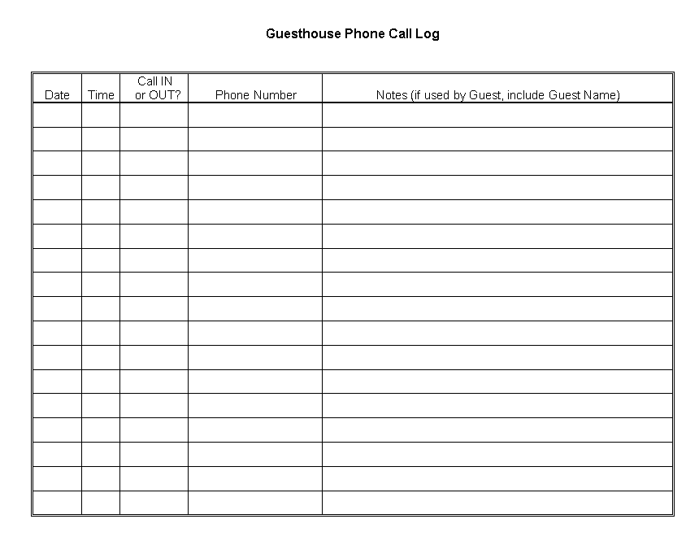

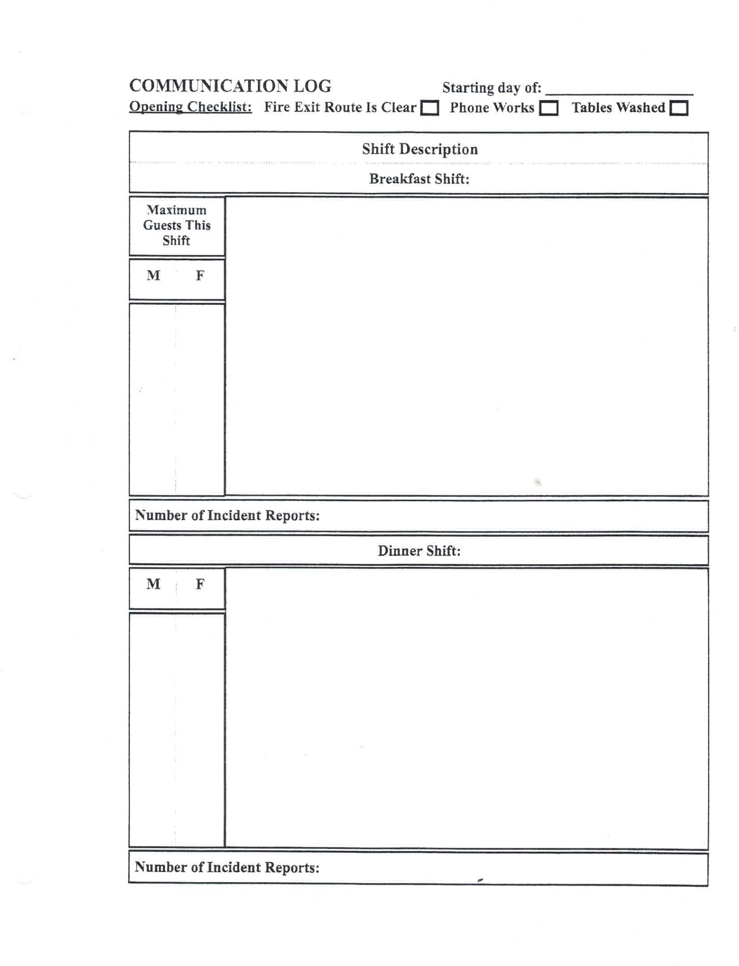
The Guesthouse Communication Log

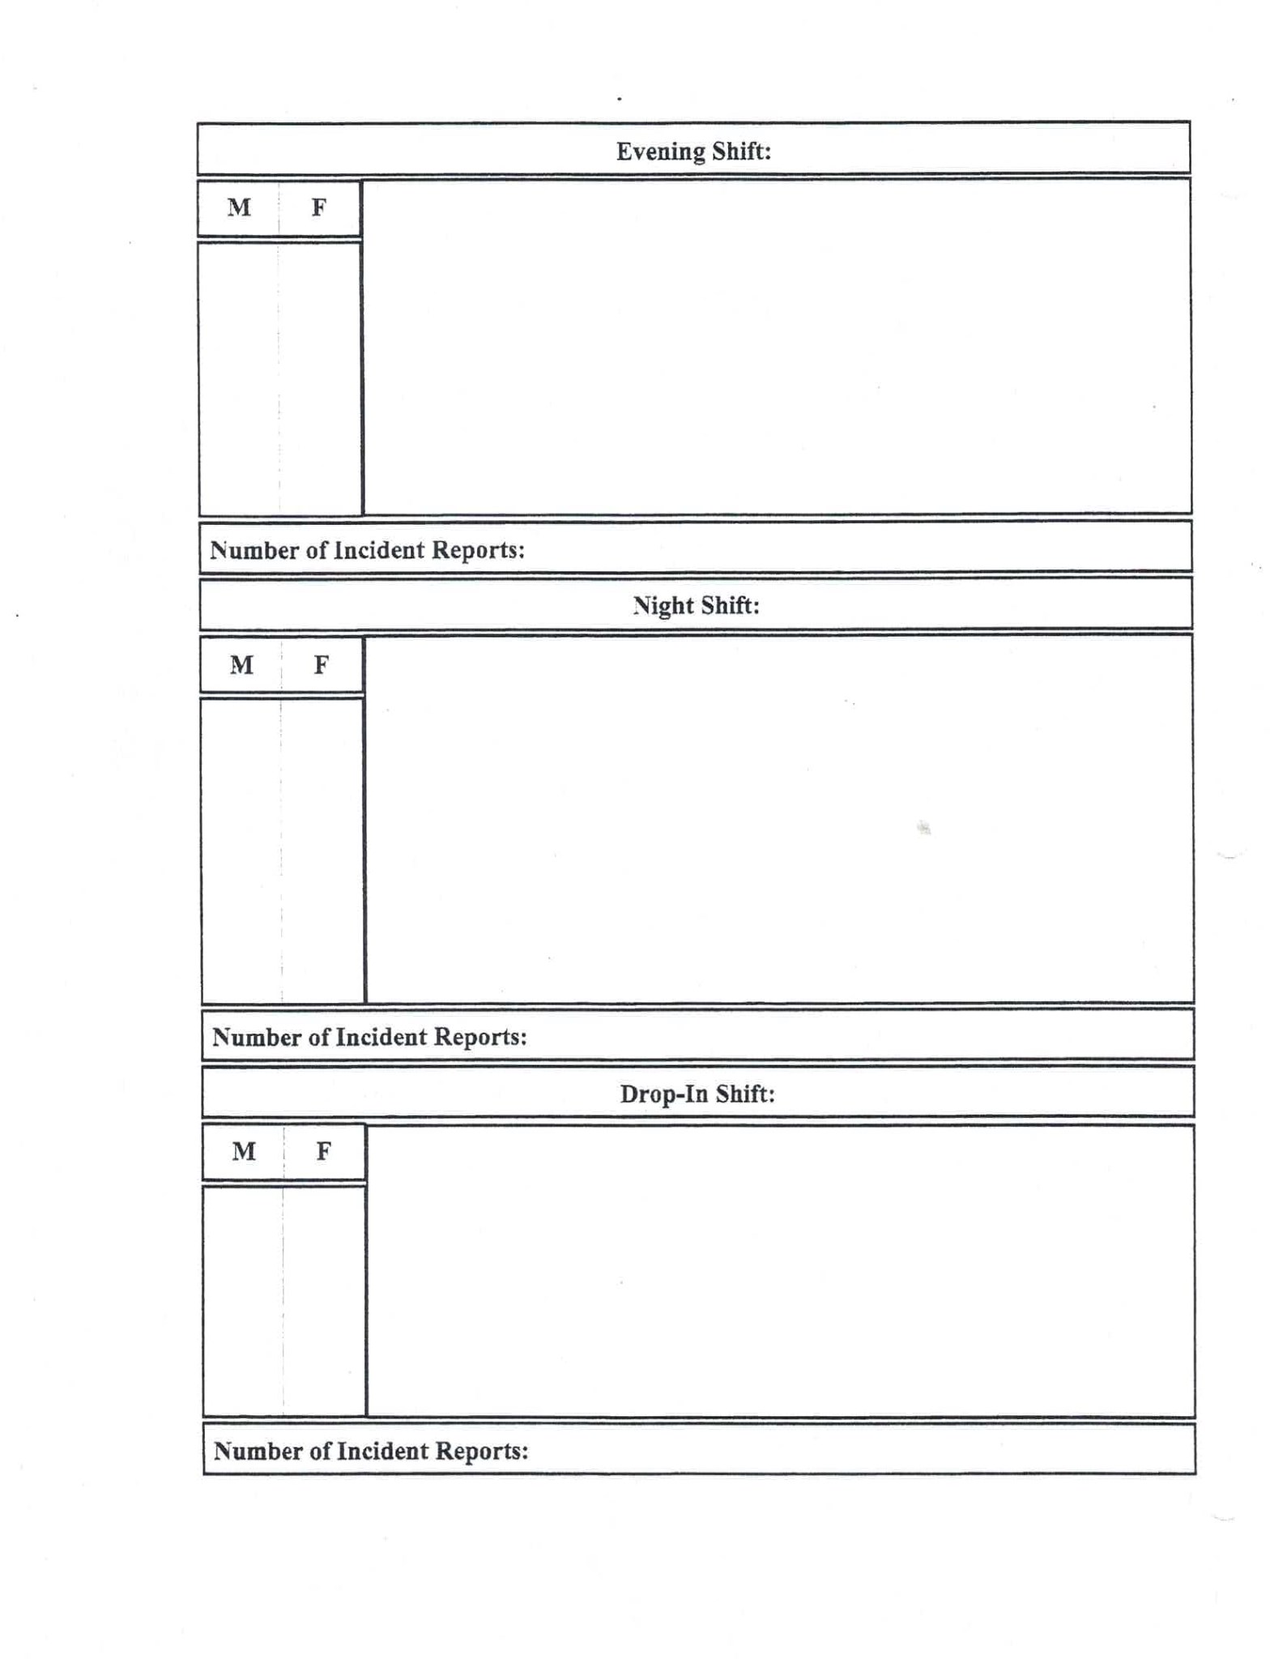

The Guesthouse Shelter Deviation Report
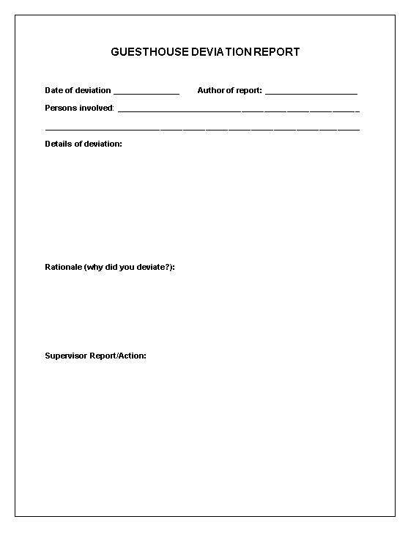

The Guesthouse Shelter Drop-In Log
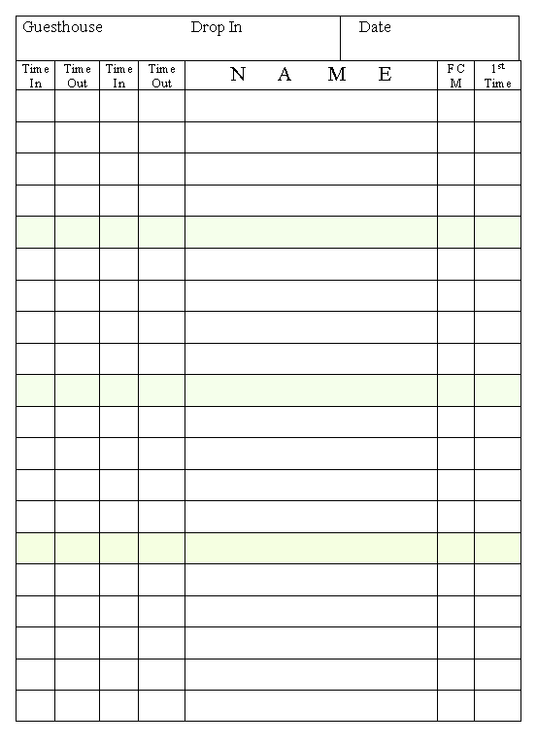

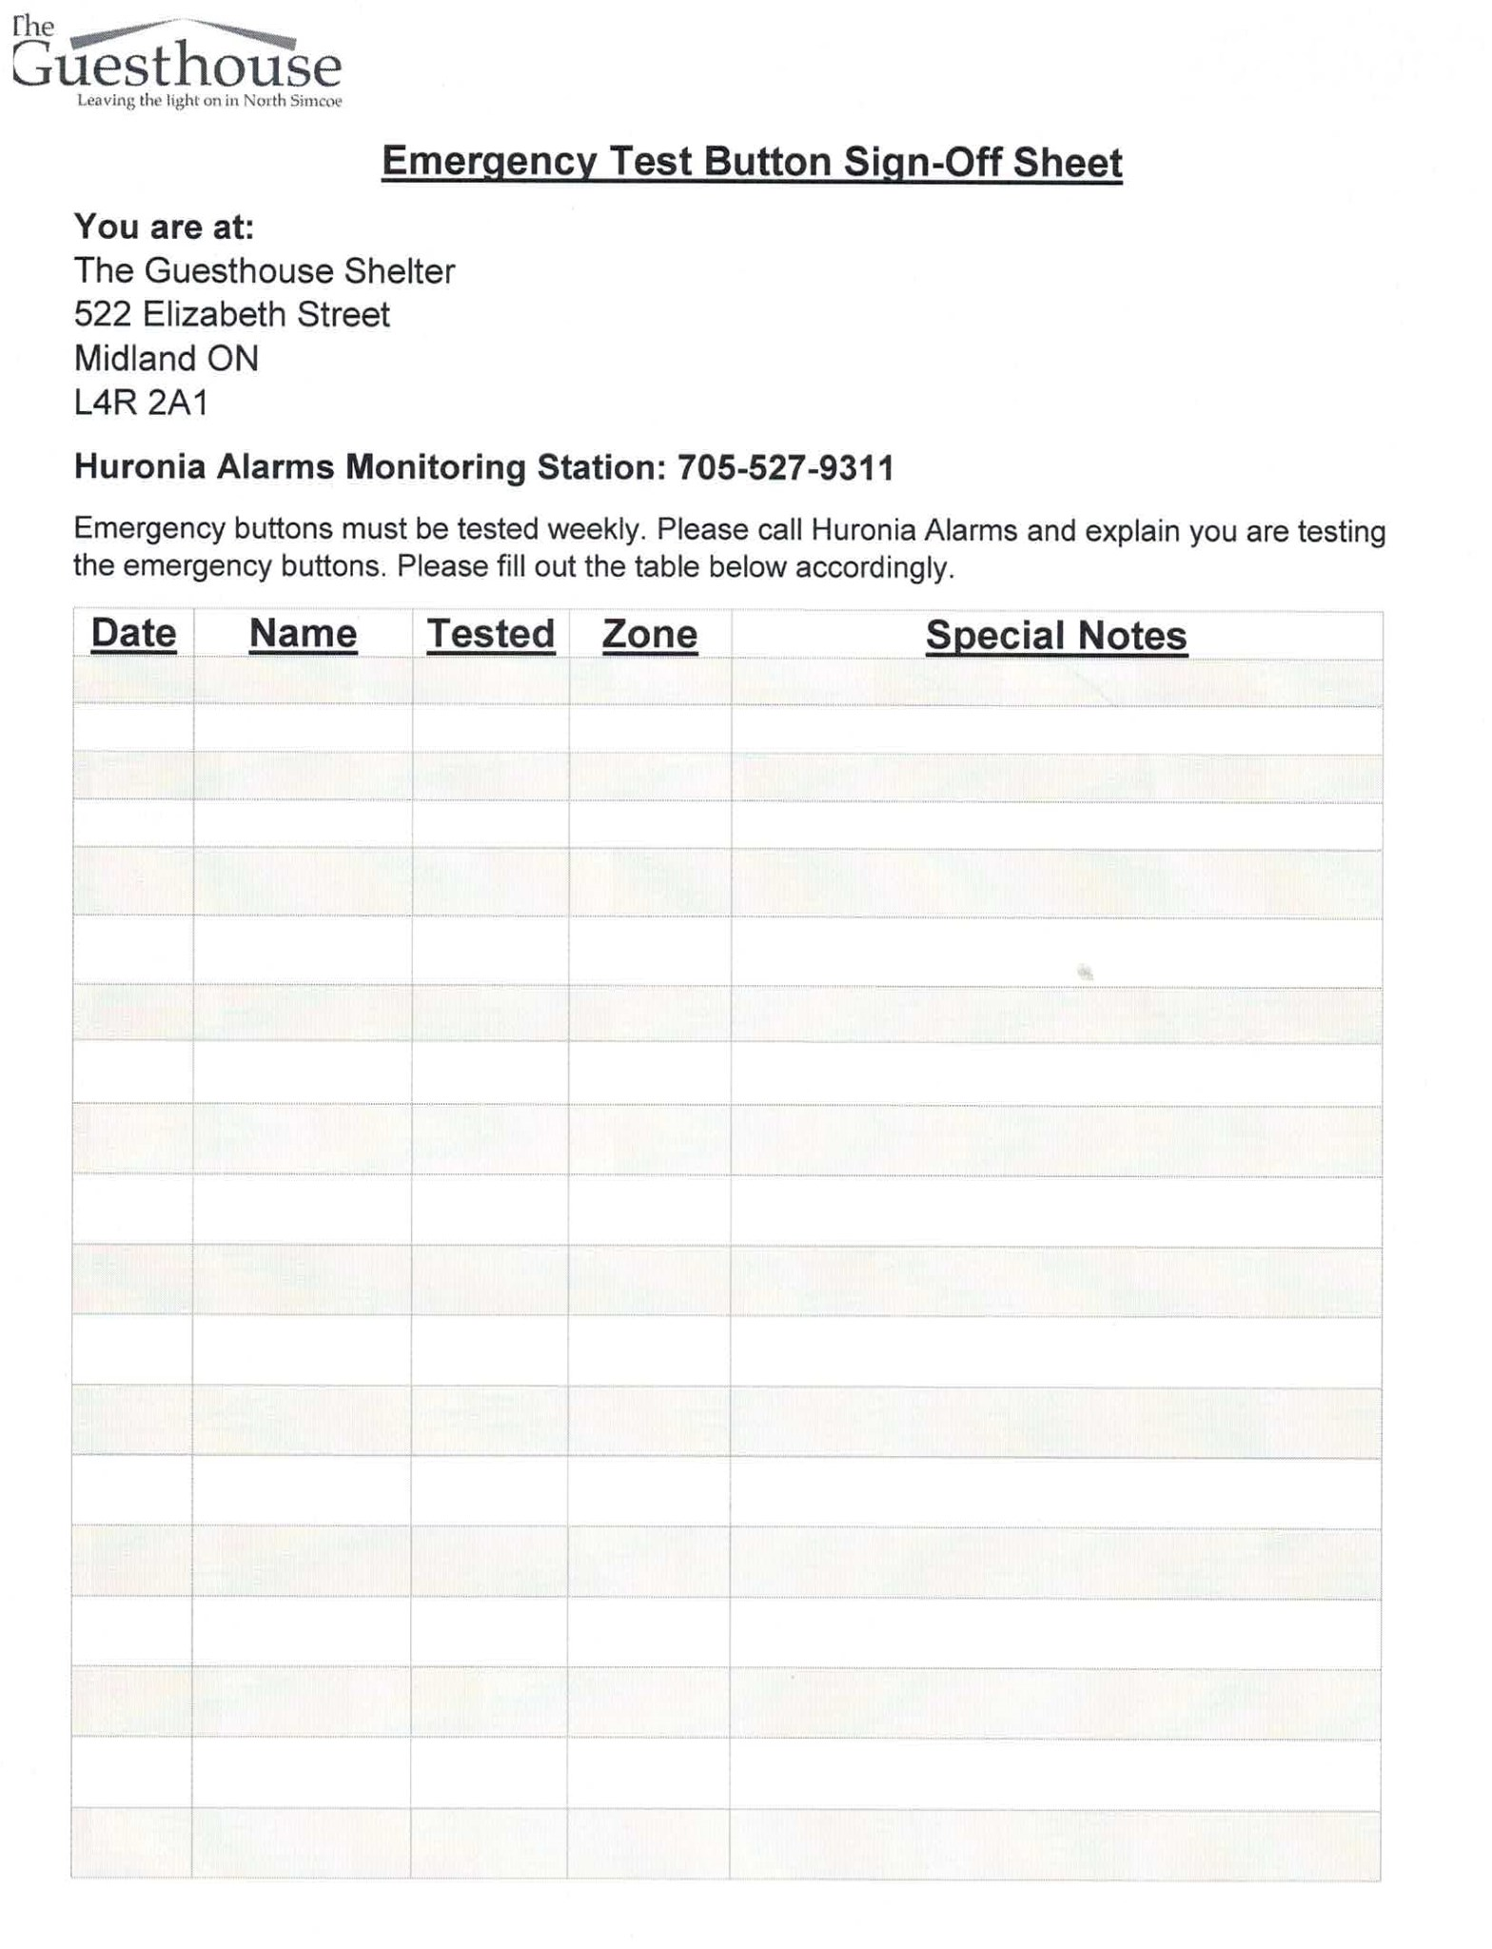
The Guesthouse Shelter Emergency Test Button Log
The Guesthouse Shelter Guest Log-In Form
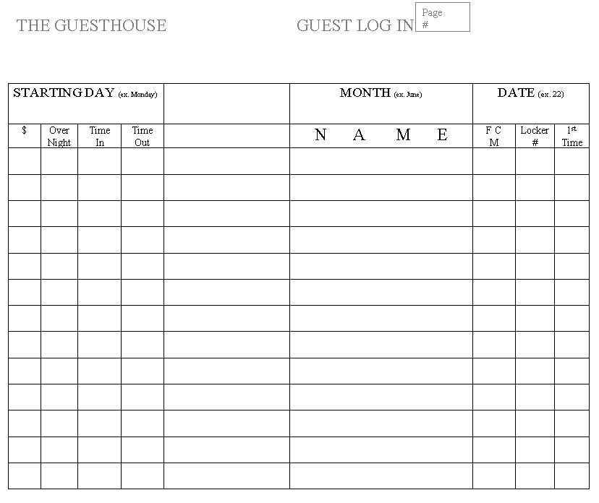

The Guesthouse Shelter Incident Report Form
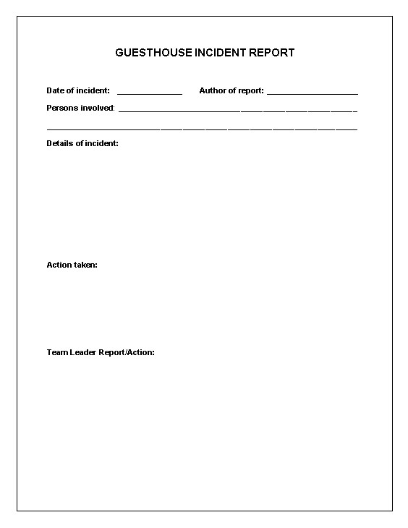

The Guesthouse Shelter Medication Cabinet Log
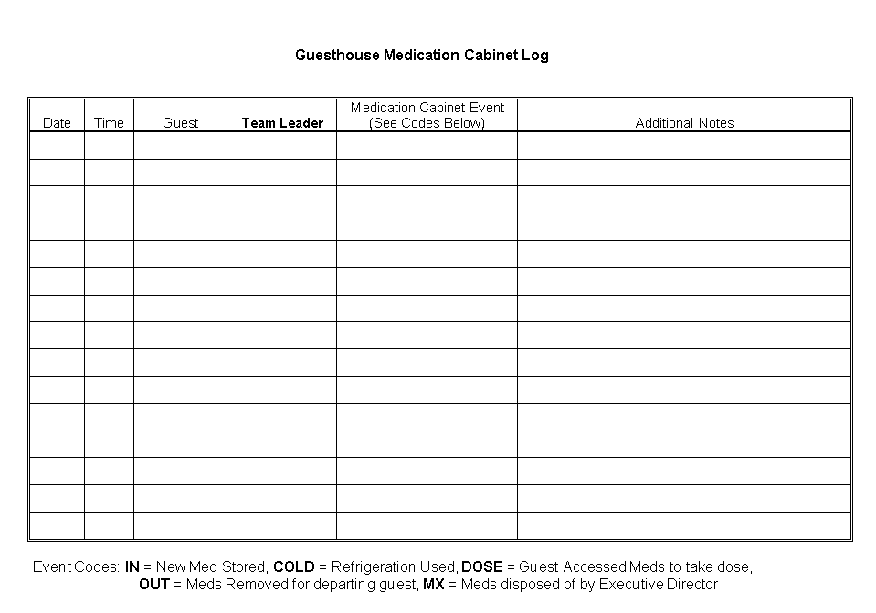

The Guesthouse Shelter Overnight Guest Sign-In
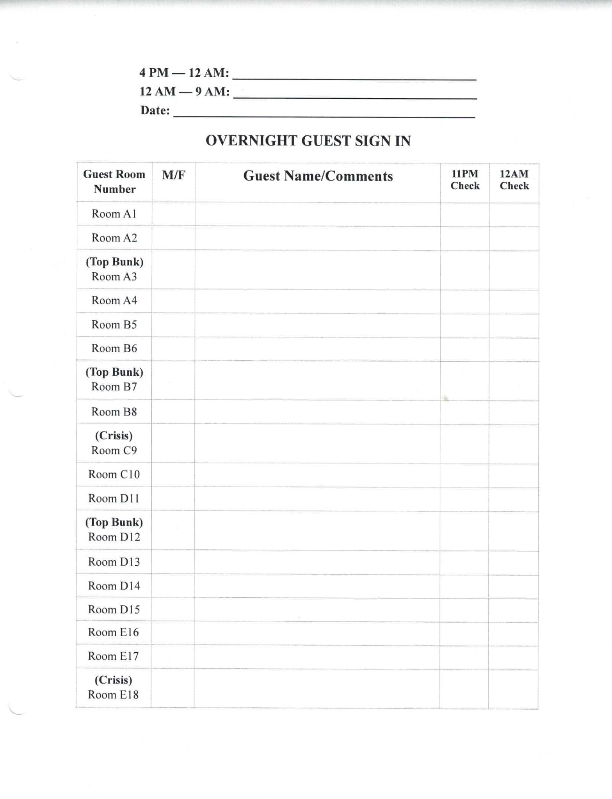

The Guesthouse Shelter Personnel Login
