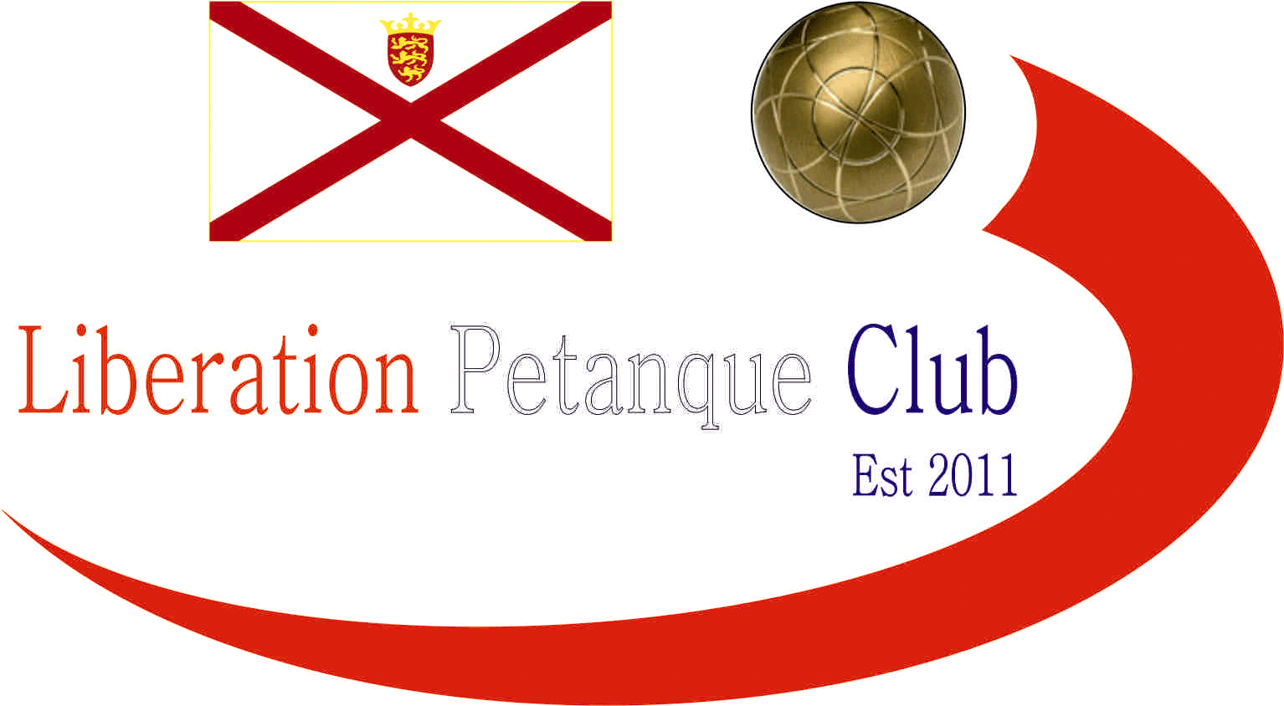

Summer 2021
End of Season
Report
What another great season it has been again this season with more new faces creating waves amongst the experienced members, we hope you all enjoyed it.
Premier League Double Champions
Laurent Pellaton & Matthew Pinel
Well, their average points scored and average points against were not as good as last year but they still won comfortably again and undefeated in two consecutive championship seasons. Neil Selby & Ross Payne again finished in the top three, this time taking second place with Geoffroy Buffetrille & Matthew Buesnel taking third place.
Commiserations to Colin Myers & Steve Simpkin who returned to Division 1 along with Alice & Brigitte Ibtison.
Division 1 Double Champions
Alex & Jean Stewart
An unbeaten season for another set of champions as Alex & Jean gain promotion to the Premier League winning the Division 1 league title and are now 18 matches unbeaten.
Also promoted Cassie Stewart & Chris Le Gallais in second and Alan Mitchell & Mike Robinson who took third place.
Commiserations to James Mold & Stephanie O’Driscoll who were relegated due to withdrawal.

Premier League Singles Champion
Laurent Pellaton
Winning his first Premier League title and doing so unbeaten adding his Doubles title to it for a remarkable Summer season for Laurent.
Neil Selby repeated his Summer 2020 season in finishing runners up with Ross Payne pipping Andrew Bellamy-Burt and Toby Northern on points difference taking third place.
Commiserations to Matthew Buesnel who suffers his first ever relegation from the Premier League. Matt is joined by Callum Stewart.

Singles Division 1 Champion
Gavin Scott
Gavin made it back to back promotions following his Division 2 title in Summer 2020 season, this time winning the Summer Division 1 title unbeaten with an impressive points difference of plus 81.
Keith Pinel joins him in the Premier League next summer as runner up, with Alex Stewart taking third place.
Commiserations to Brigitte Ibitson who finished bottom with Matt Hutchings also going down.
Singles Division 2 Champion
Kevin Daly
New member Kevin Daly won the title in his first season at the club but wasn’t unbeaten as runner up Gary Cowburn beat him on the last day of the season but wasn’t enough to catch him. Wendy Ritzema took third place.
Commiserations to Kim Gallichan who finished bottom of the leagues.

Club Singles Cup Winner
Andrew Bellamy-Burt
Andrew won a record fourth Singles Cup title in 10 years with a win over Geoffroy Buffetrille in the final, with Andrew Limbrick taking third place.

Club Doubles Cup Winners
Andrew Bellamy-Burt & Callum Stewart
Andrew & Callum beat Geoffroy Buffterille & Matthew Buesnel in the final with Daniel & James Villalard taking a great third place for a great performance.

Club Super 7’s Cup Winner
Matt Pinel
Matt won back to back Super 7’s Cups with a win over Doubles league partner Laurent Pellaton in the final with Geoffroy Buffetrille taking third.

Club HandyCap Cup Winner
Geoffroy Buffetrille
In the maiden competition Geoffroy beat Daniel Villalard in the final with Andrew Limbrick taking third place.

Club Precision Shooting Cup Winner
Geoffroy Buffetrille
Geoffroy won his third straight cup with a win over Brian Harris who beat Matt Pinel to make the final. Matt Pinel did take third place though.

Liberation Singles Open Winner
Matt Buesnel
Matt beat fellow club member Andrew Limbrick in the final.
Liberation Doubles Open Winner
Geoffroy Buffetrille & Matt Buesnel
Geoffroy & Matt beat club members Callum Stewart & Andrew Bellamy-Burt in the final.
Player of the Season

To be confirmed at the end of season meal.



None club tournaments won by members
Island Singles Championship
Geoffroy Buffetrille

Island Doubles Championship
Matt Pinel & Matt Ryan
Matt & Matt beat club members Laurent Pellaton & Toby Northern in the final.
Island Open Triples Championship
Matt Buesnel, Geoffroy Buffetrille and Laurent Pellaton
They beat club members Toby Northern, Matt Pinel & Mark Nicol in the final.
Island Mens Triples Championship
Andrew Limbrick
Andrew and his team beat Matt Buesnel, Laurent Pellaton & Toby Northern in the final
Carrefour Singles Open
Toby Northern

Special Thanks

Club Committee – Toby Northern, Matt Ryan, Matt Pinel, Matt Buesnel and James Rondel for their hard work making this club a success.

Other Helpers – Geoffroy Buffterille and Laurent Pellaton for their hard work on the terrains and support throughout the season. Anyone else who has helped out setting up the terrains for competitions/leagues etc and running competitions, very much appreciated.

Well, I hope you have all enjoyed the season and are looking forward to playing again in the Winter 2021 / 22 season.

Kind Regards

Toby Northern

Chairman

Liberation Petanque Club

