Trailing Arm Rebuild

Part 1
Part 1|Part 2|Part 3
Now that the differential is completed, the only real obstacle left before having a rolling chassis is the trailing arm rebuild. I questioned whether I should send them out or do it myself. The nice thing about sending them out is that they would be finished sooner and usually come with a warranty. Also, there aren't any expensive tools to buy. The negative is that you don't know the how much care and attention to detail is being put into your trailing arm. Because of this and the fact that I am always looking for an excuse to buy new tools, I decided rebuild my own trailing arms.
I am not in any way a professional at rebuilding trailing arms so this article is intended for educational purposes only. In this article, I show exactly everything that I did without leaving even the smallest detail. I bought three unique tools from Mid America; spindle knocker, spindle installation tool, and the set up tool. The majority of my hardware was bought from Van Steel.
Here are a few pictures before disassembly.
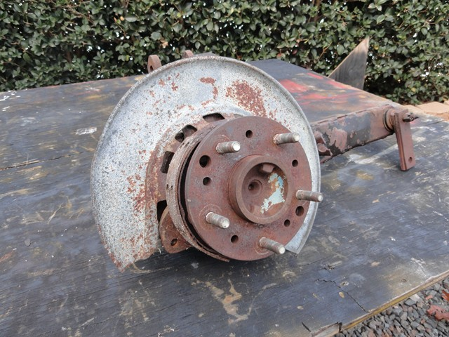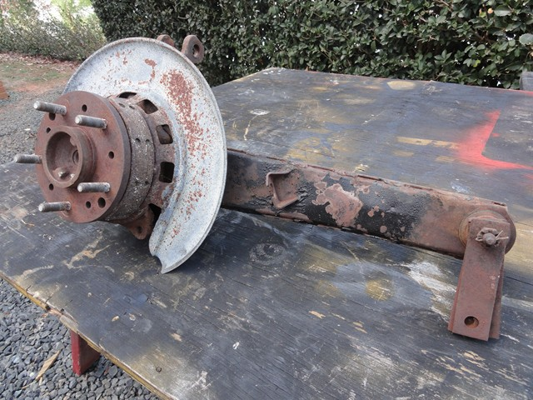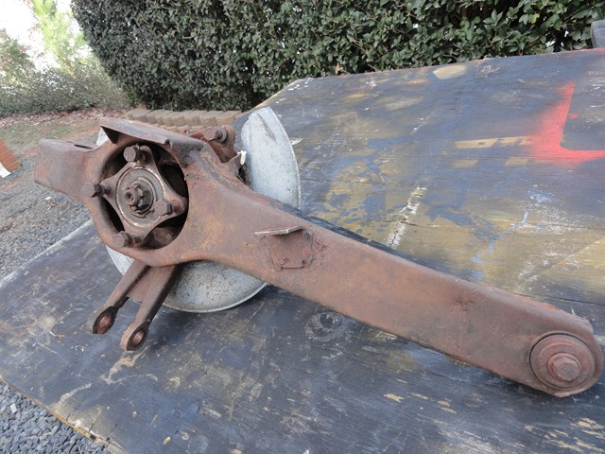

Some specialty tools. I ended up not using the one on the far right called the Spindle installation tool.
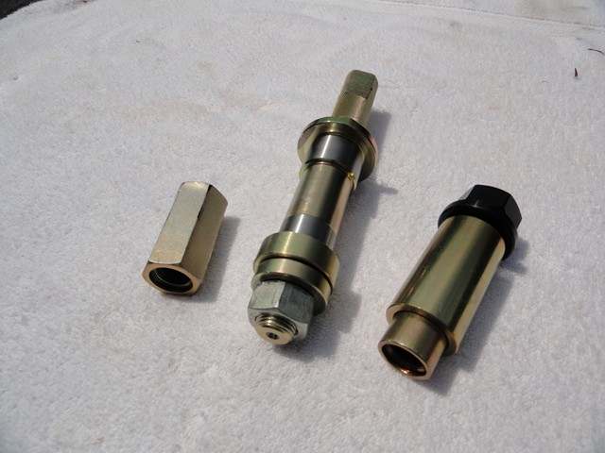

First, I removed the cotter pin, nut, and washer. The impact gun did a good job of removing the nut.
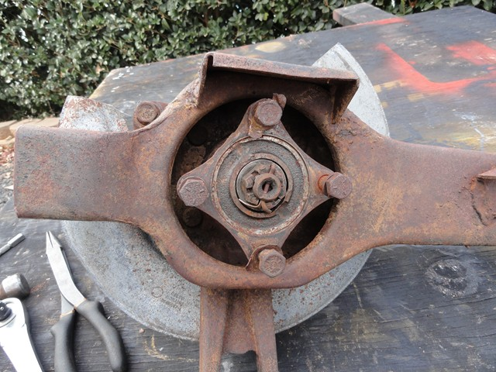
Once the nut was removed, the spindle flange was somewhat stuck on there. Since the studs were going to be replaced anyway, I placed the trailing arm in the vice and used a crow bar to remove the flange.
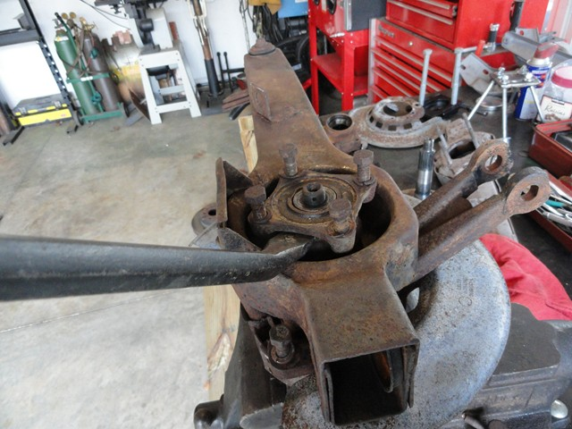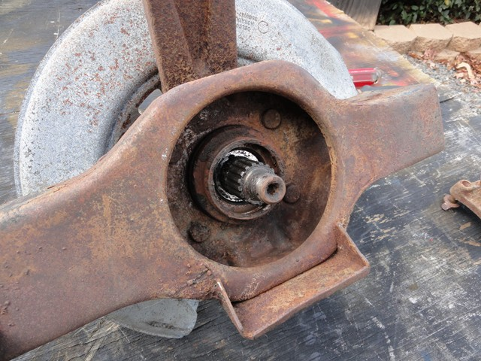

Next, I proceeded to remove the parking brake. This was easy with the absence of the top/bottom springs as well as the hold down springs.
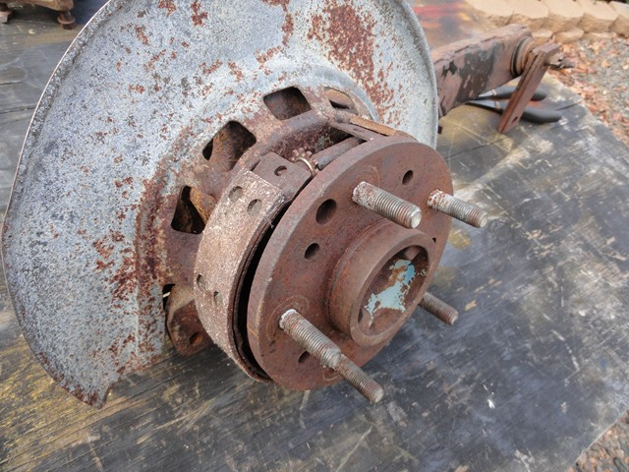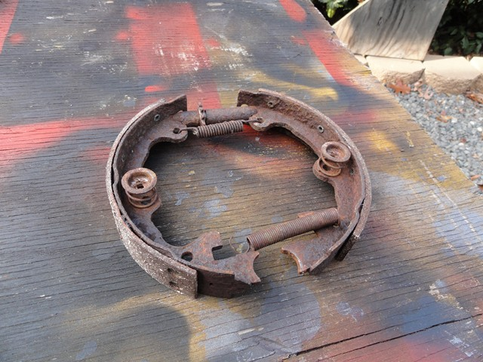
Unfortunately it looks like someone has been here already. Guess the mechanic or whoever could not figure out how to get the parking brake actuating lever through the backing plate without cutting it. I hope there aren't any other surprises down the road.
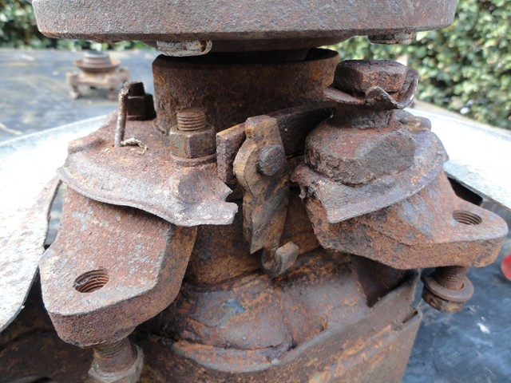
With the parking brake out of the way, I focused on removing the spindle. I placed the bearing spindle support in the vise and screwed the spindle knocker on. The spindle knocker is a piece of metal that is threaded to screw over the spindle. It is there to protect the threads while attempting to pound the spindle out.
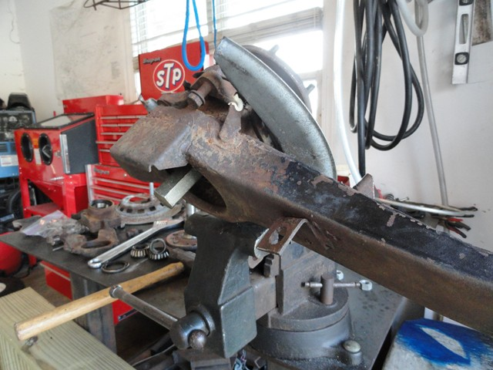

With a few taps of the hammer, the spindle came free.
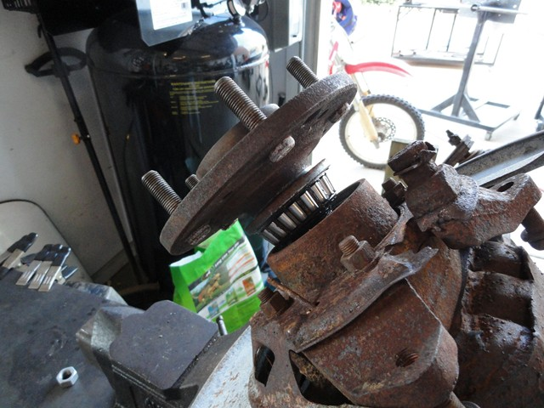
Now this isn't always going to be the case. Even though I did the same method with the other trailing arm, I couldn't get the spindle free. So it was time to make a new tool. If you remember from a previous article about installing u-joints in the half shafts, the half shafts flange required a metal plate mounted to them to prevent the flange from bending during the u-joint installation. I took the metal plate and drilled the four holes slightly larger. Then I bought four 8 inch bolts since 6 inches would be two short. To get the bolts to fit, I stacked each with a pile of washers. Next, I installed the spindle knocker to protect the thread. With nuts and washers installed on the bottom, I evenly tightened each bolt which in turn pulled the wheel bearing spindle support from the spindle until it came free. The first two pictures are the half shaft tool and the third is the wheel bearing support puller.
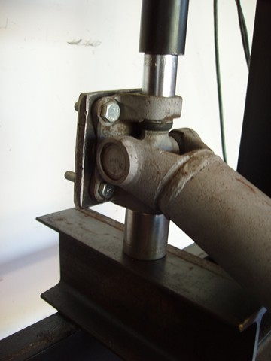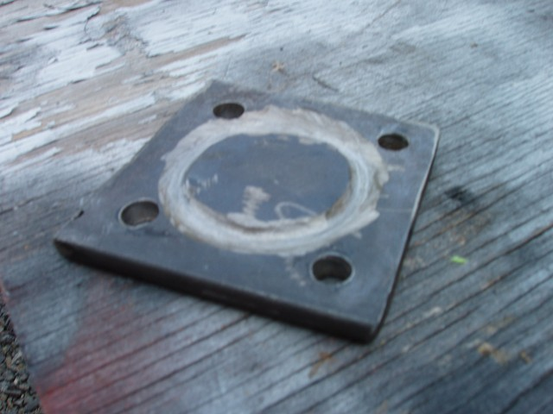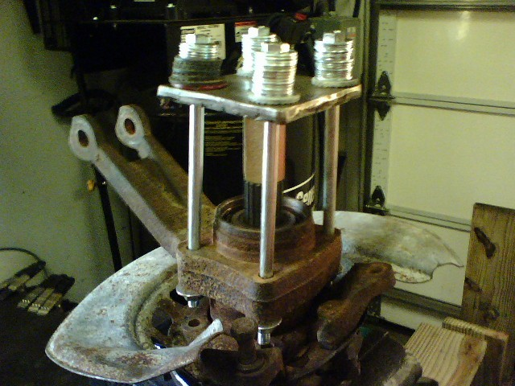
With the spindle out of the way, I continued with the disassembly by removing the dust shield, bearing, inner seal, shim, and spacer.
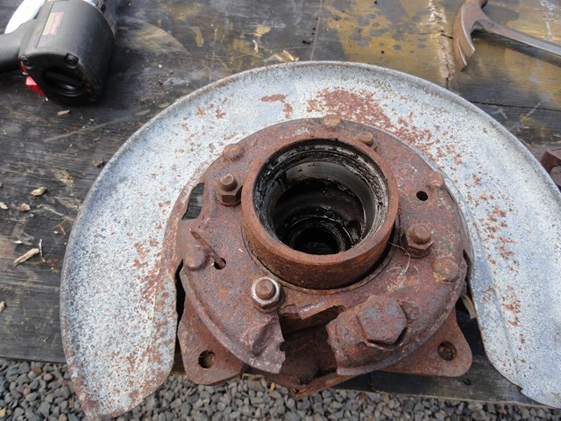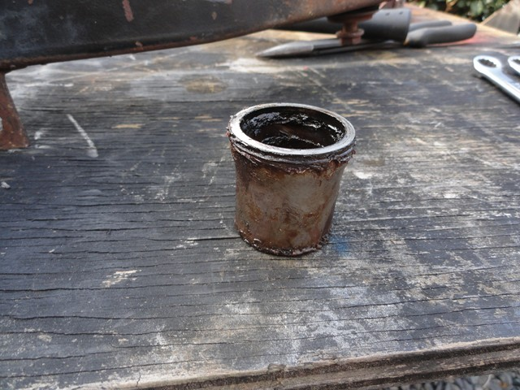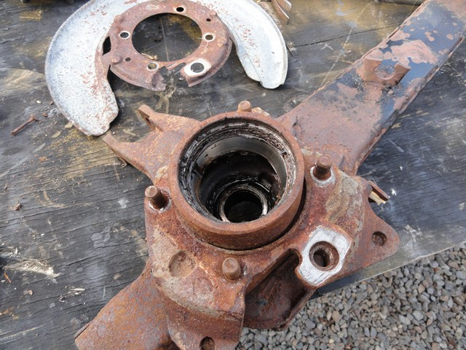

Next, I separated and removed the caliper mounting bracket from the top of the wheel bearing spindle support.
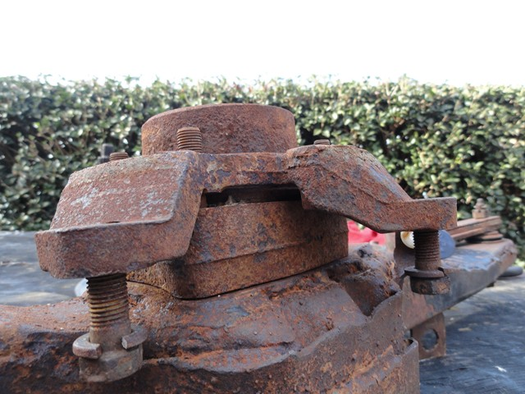
Once the caliper mounting bracket became free, I removed the spindle support the same way.
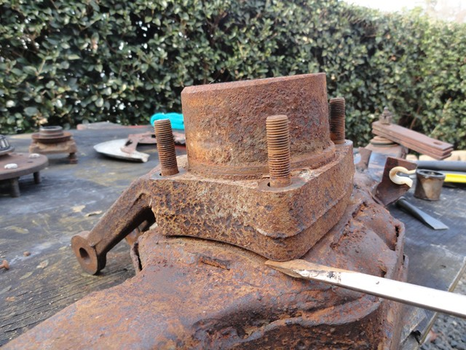

Here is a laid out view of all that has been removed so far.
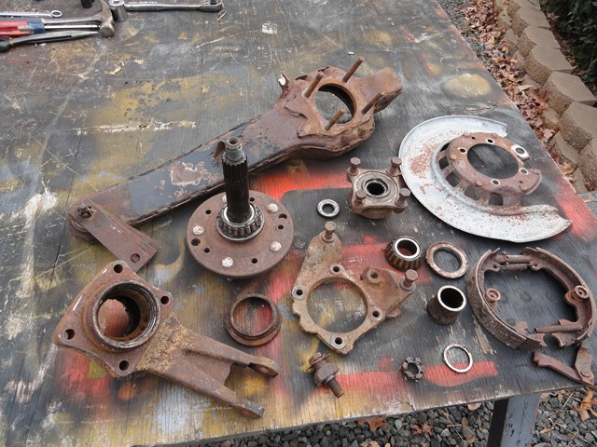
The next part to remove is the outer bearing. They make a special tool for this but it can run up to around $140. Since I already spent a pretty penny on the other tools necessary for this job I decided to rough it and figure another way around it. I ended up using the bearing splitter that I bought while rebuilding the differential. I believe it cost somewhere around $30. With plenty of use with the differential and some other projects, I accidently bent the main bolts that hold the metal pieces together. This is not a problem holding the pieces of metal together, but unfortunately with even the slightest bend, the bolts will not screw into the holes on top. I ended up retapping the thread to fit some larger bolts from Lowes. Now that I have a working puller again I placed it around the bearing and screwed the vertical bolts down evenly. This in turn pulled the splitter up and the bearing with it. The only problem I had with this is that the ends of the vertical bolts became somewhat compressed or mushroomed which makes the bolts unable to be removed fully without cutting or grinding the end of the bolt. Not a problem though.
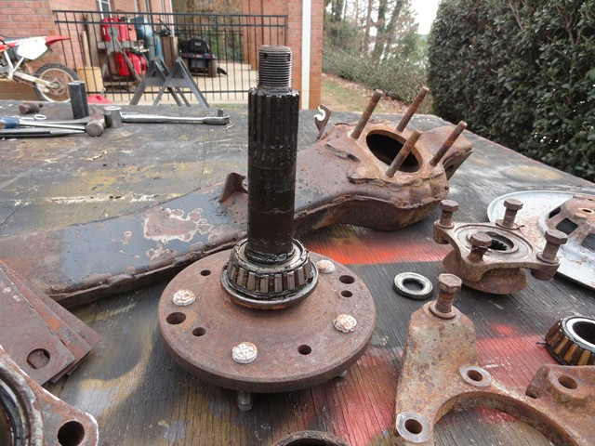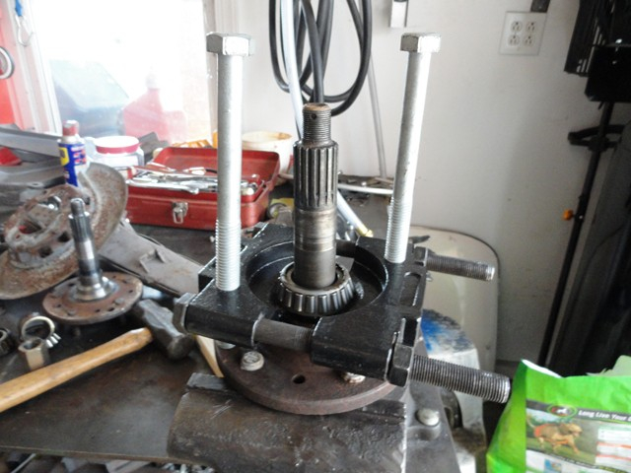

After the bearing and seal was removed, I placed the spindle securely in the vise and tapped the lug nut studs out.
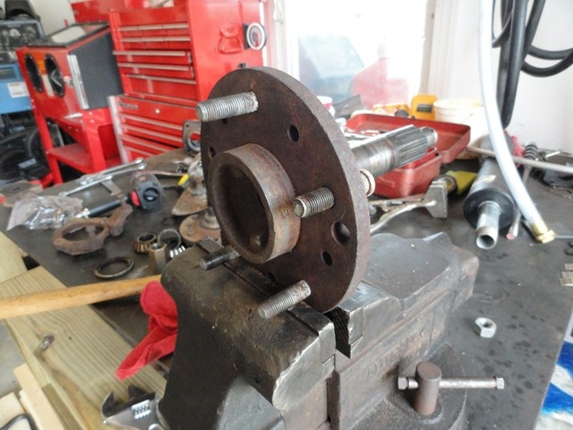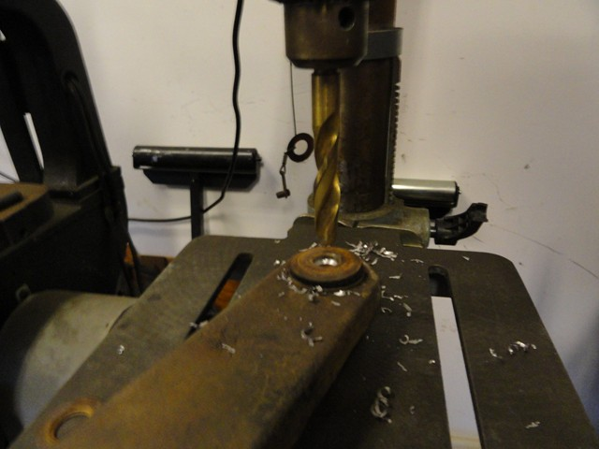

Once the flare was drilled out, I gave it a few pops with the air hammer to remove the sleeve.
Since there is no longer anything holding the two bushings together, I used a chisel to remove the bushings and the metal pieces that once surrounded the bushings.
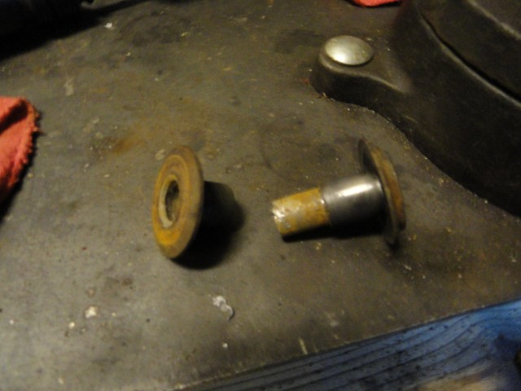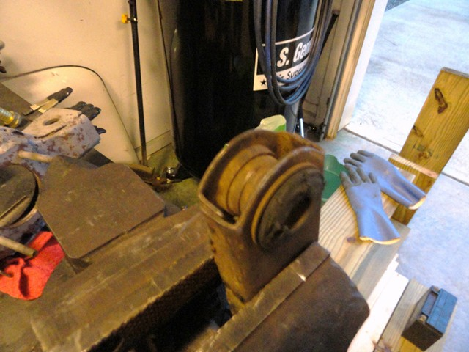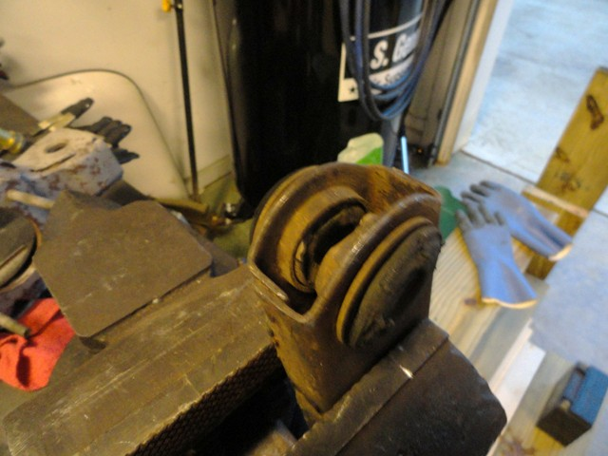

Now with almost everything removed, the next step is to clean, sand, and paint everything. With all the small parts the blast cabinet came in handy. After I removed the races in the bearing support housing, I gently used a wire wheel to truly clean it out well.
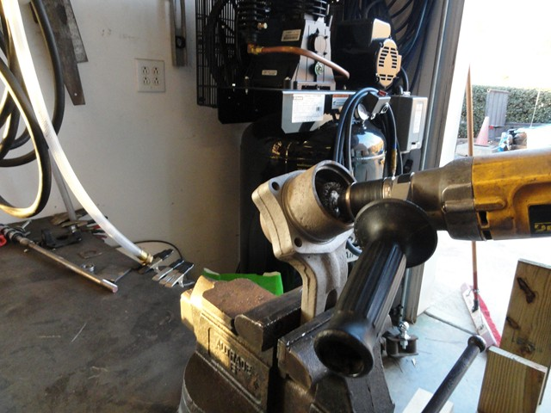
Next I used a chisel to remove the support of the leaf spring bushing.
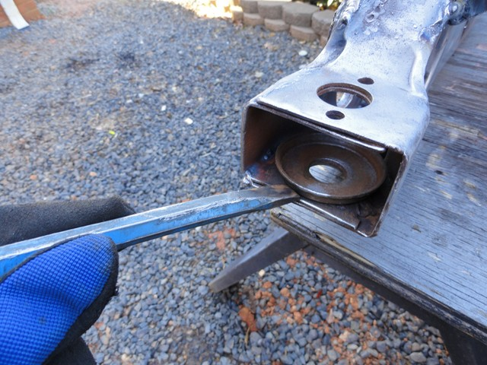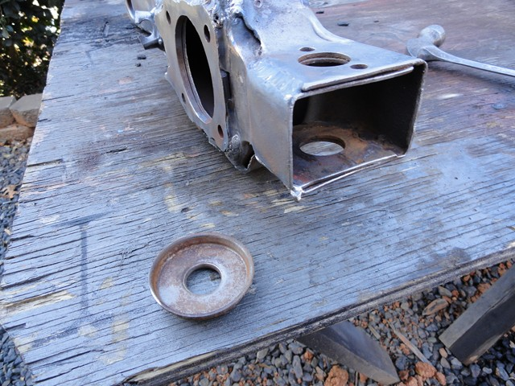

Trailing Arm Rebuild

Part 2
Part 1|Part 2|Part 3
After everything had been either sand blasted or wire wheeled, I moved on to improving the trailing arms by adding full welds. Just like the frame, the trailing arms are also spot welded. This isn't a big deal at all, but while I am there I might as well make it as strong as possible. I was careful to work in small sections to prevent them from any warping.
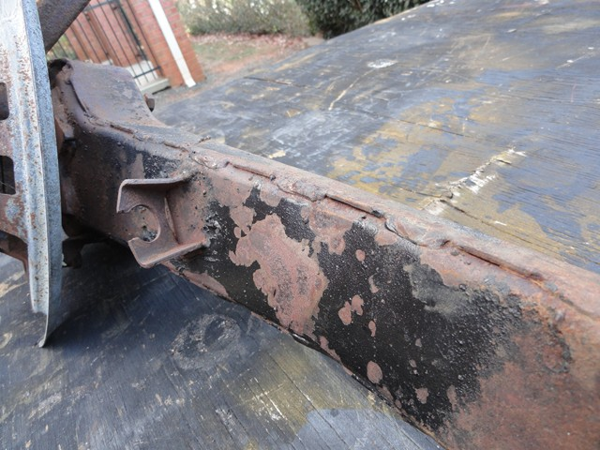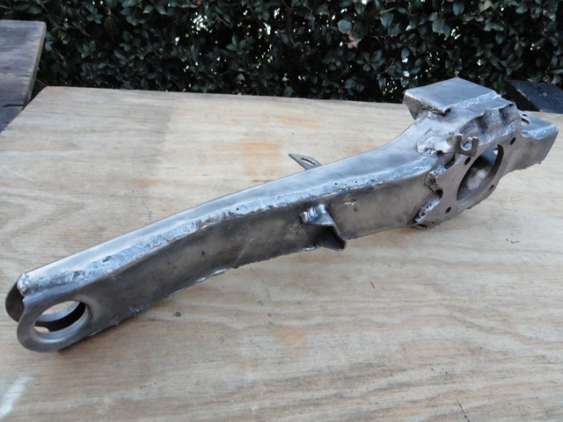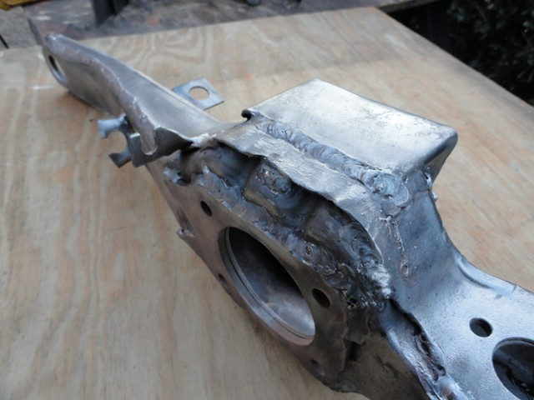

Since the full welds on the side and ends are the only modification I am going to do, I can move on to painting. I used the same paint that I used on the frame. It is a two part ceramic epoxy satin black paint sold from Eastwood. I do enjoy the durability and looks of this paint but it definitely isn't the cheapest paint on the market. I had a few other parts to paint at the time so everything was out to be sprayed. Once I finished painting everything and a day or so had past for it to fully cure, I removed the parts making sure to label them so that the spindles or other parts could not be mixed up or switch sides.
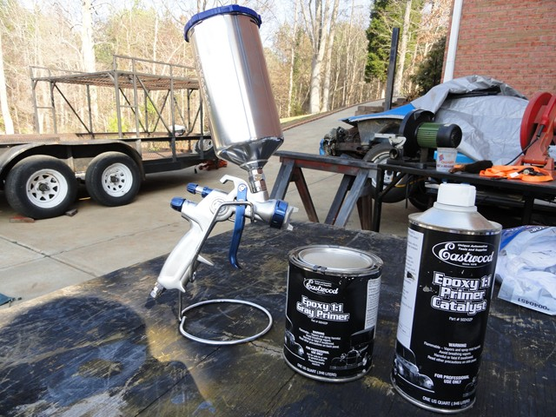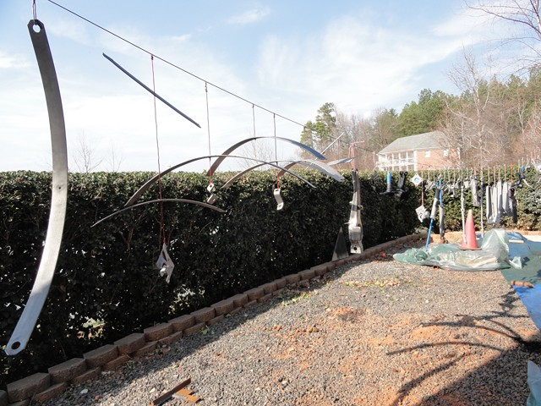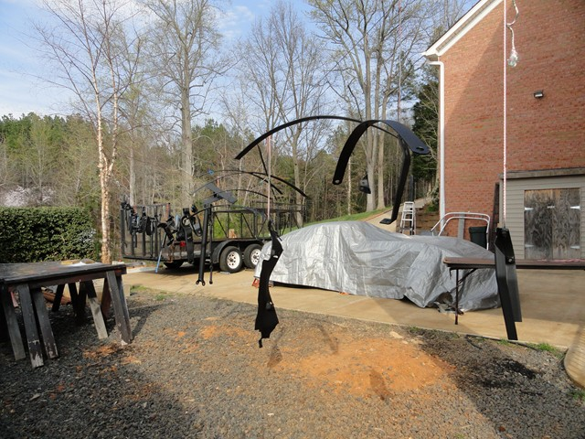
I made a mistake when painting the spindle. I forgot that the rotor run out has to be within a certain spec and that anything between the rotor and spindle like primer/ paint can mess up the measurement. So I will have to remove the paint off the front surface later when I am setting the rotor run out.
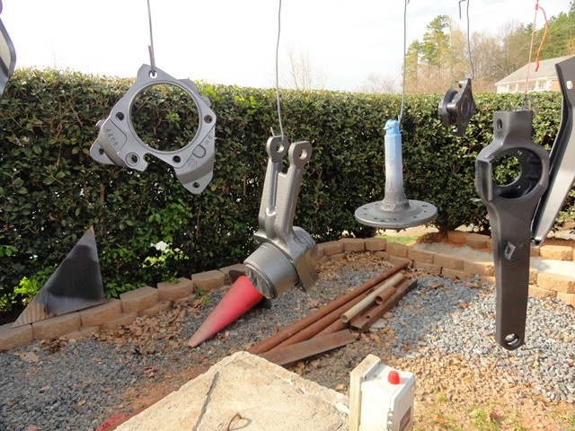
Now that everything is painted, I can move on to the fun part of reassembly. I first started out by installing the new races in the bearing support housing. Before installation, I cleaned the bearing housing once again in case I missed anything the first time. The last thing I want is for the races not to sit properly because something is in its way.
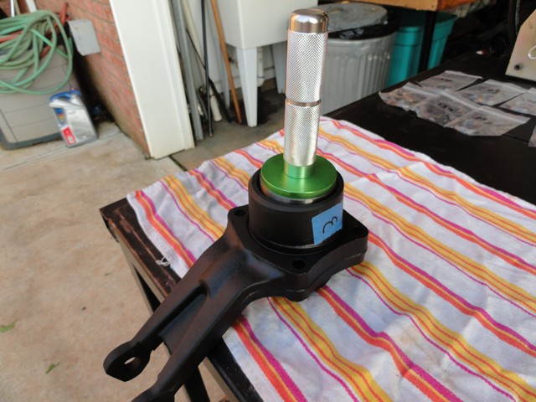

The kit from Van Steel includes Timken bearings and races as well as a shim kit. The shim kit includes a new spacer as well as different size shims to get a snug fit.
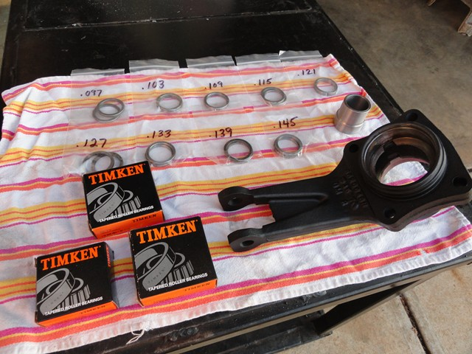
The tool seen on the left and in the picture above is the set up tool. What it does is mimics the spindle in the way of mounting the bearing so that one can find the exact size shim they need without going through the hassle of messing with or damaging the original spindle. Here is what it look like when it is in the bearing housing. There is the outer bearing, spacer, shim, inner bearing, and a few washers and a nut to hold it all together.
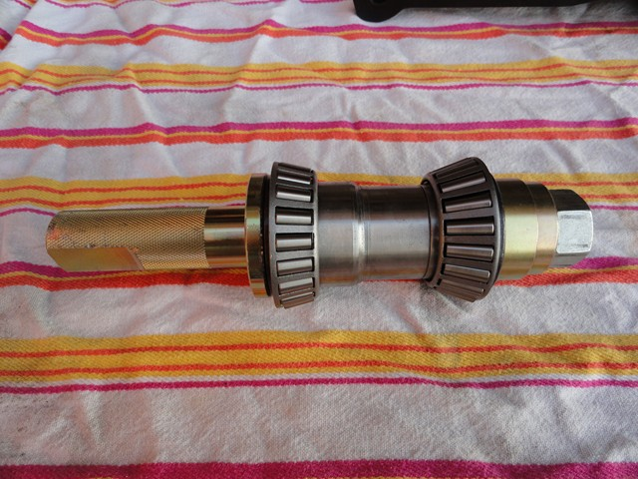
When first starting out to find the perfect size shim, I started out with the biggest one in the kit: .145. I placed it after the spacer and then assembled the rest of the tool in housing. I made sure to lightly oil the bearings to prevent from damaging the bearing or the races when installed.
Next, I held the bottom of the tool with the bench vise and torque the nut to 100ft lb.
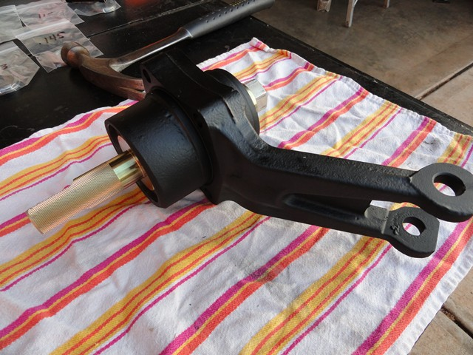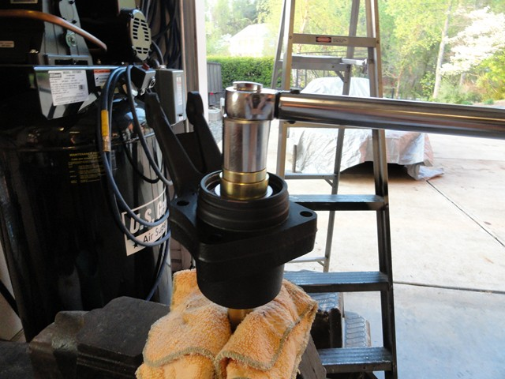
Then I used the vise to hold the housing while I checked the end play with the dial indicator. GM said that it should be between .001-.008 but to me that seems like a big difference. A .008 would feel extremely loose in comparison to a .001 so I am aiming for below .0025 and higher than .0015 just in case the grease affects the end play when added.
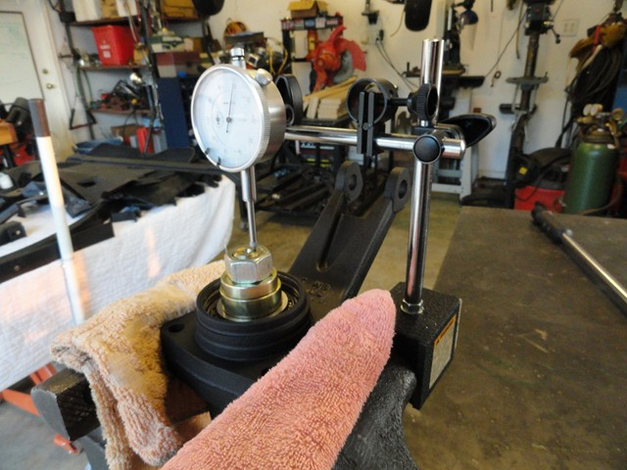
I am not sure if it would make a difference in end play but I made sure that the bearing housing was level in the vise.
The reason I started out with the thickest shim is to get a better idea of what size I would need. I started out with the .145 shim and end play came up with .0325. So if I were to take away .0325 I would have zero play but I am wanting around .002 so I will need to remove close to .30 instead. I could have taken the gamble and dropped down to a .115 shim but I wanted to play it safe and moved down to the .121 shim instead in case I measured the end play wrong. With this shim, the end play was 8.5. Getting closer, but still loose so I dropped down to a .115 shim. With the .115 shim the end play came up at very slightly under .0025. I am happy with that so I am not going to go any further with this shim.
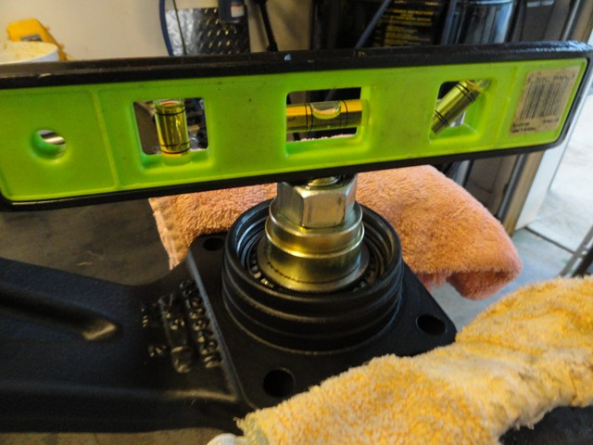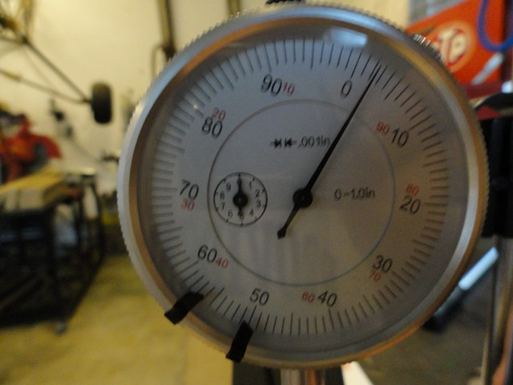
Luckily the passenger shim went together well without having to sand the shim but that wasn't the case with the driver side. When I put the .127 shim in, the end play came up to be .006. I couldn't drop down to the .121 shim because that would mean there would be no end play. That meant that I had to sand the .127 shim down to a .123. To do that, I placed a grinding wheel on a flat surface and dragged the shim along the side of it. I went in both direction and every twenty rotations switch my grip on it to lessen the chances of making it uneven. I constantly checked the size of it until I got it close to .123. After that I used very fine sand paper to smooth it out and give it back its shine. And just like that, I have a .123 size shim.
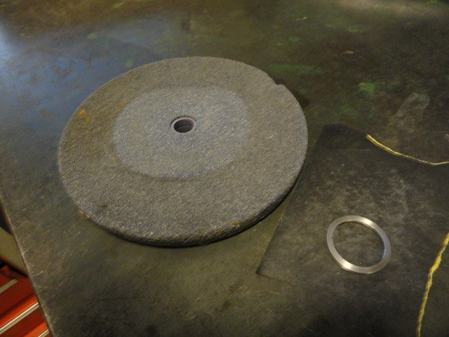
Now that the bearings are ready to go I can move on with the actual trailing arm. Before the trailing arms are loaded down during the assembly process, I decided to install the bushings. With rubber bushings, the rubber has to be compressed in order for the bushing's sleeve to flare and held the two ends firmly together. So once again it is time to make a new tool. I took two scrap pieces of metal and drilled a hold on both ends. On one of the pieces I drilled a 15/16th hole for the flaring tool to go into. From there, I bought a cheap flaring kit from Auto Zone and removed the plunger to flare the bushing sleeve. They do sell a trailing arm tool to compress and flare the sleeve but I decided that I could do without and save the $50 or so for another day.
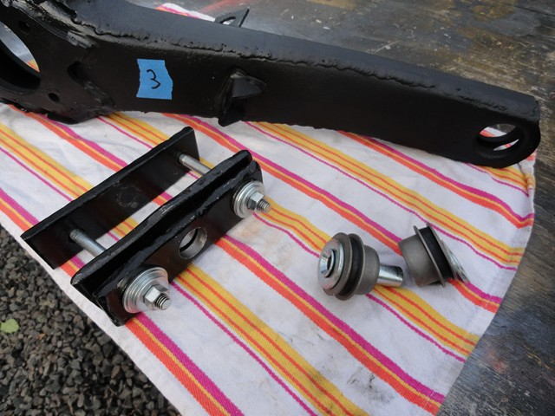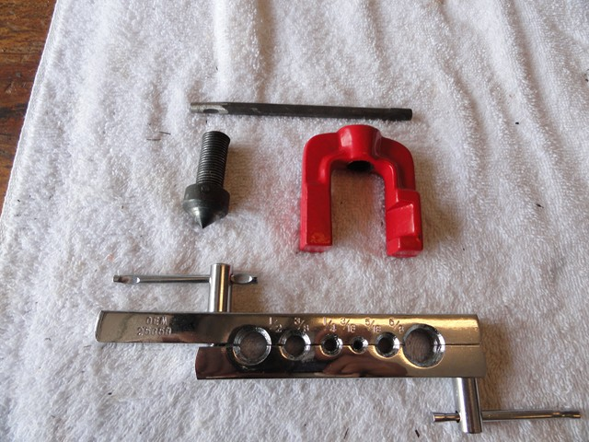

I did make a mistake the first time I used it though. My top piece of metal with the hole in it was not wide enough so when compressed, it bent and also bent the washers below. To strengthen it, I used a wider piece of metal below it to give it a stronger foundation.
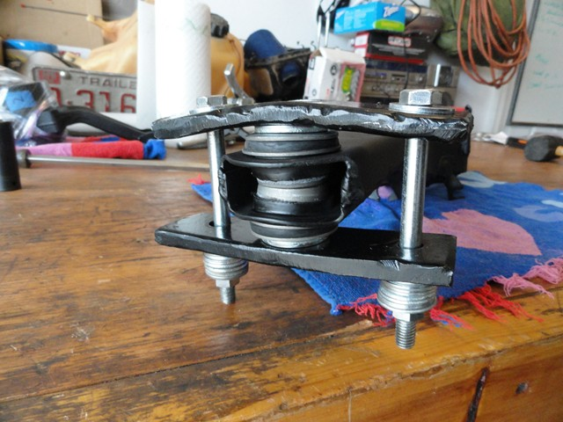

Once the tool is in position with the washers and sleeve installed, the bushings are ready to be compressed. I used the hydraulic press just because it is faster but I am sure that tightening the bolts would work as well. With the bushing compressed, I used the flaring plunger and the hydraulic press to slowly flare the end of the sleeve. I have heard of others using a hammer instead of the press but I figure this would distribute the pressure better. And just like that, the sleeve is flared and the bushings are held tightly together.
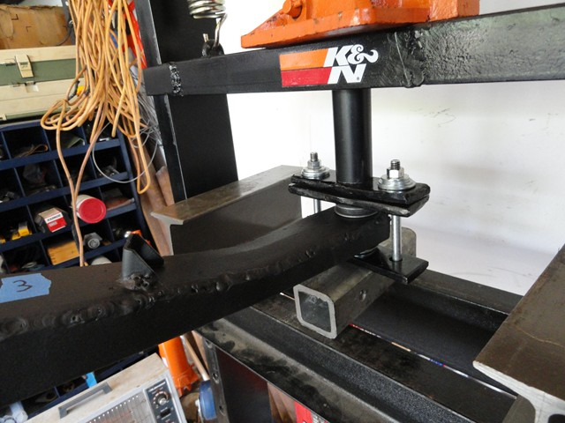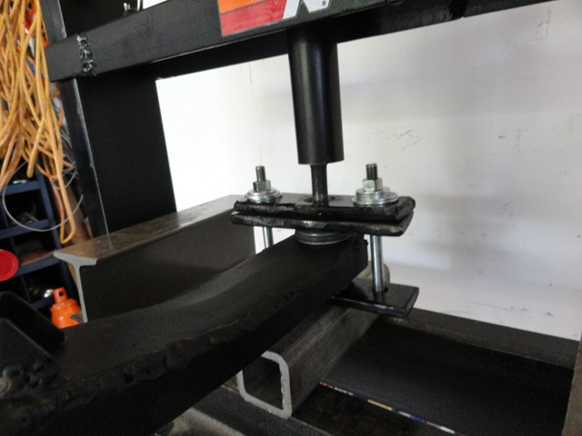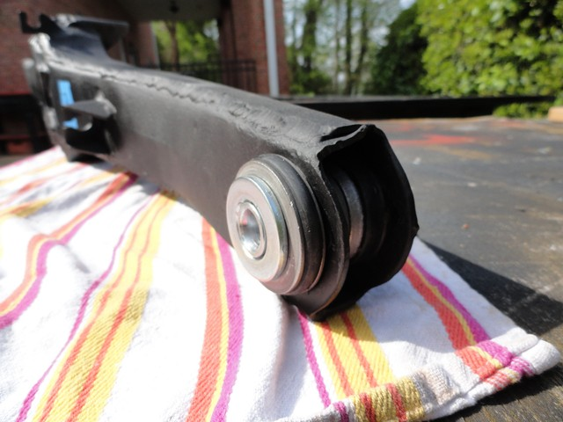
The first time I tried to flare the bushings; I went a little too fast and cracked the sleeve. Even though it did hold the two bushings together fine I didn't want that type of work on my restoration. I ended up drilling it out and ordering a new sleeve for close to $6. I have heard of people having problems with different length of the sleeves from different companies so I made sure to buy the new sleeve from the same company I bought the trailing arm kit from so there would not be any conflicting parts.
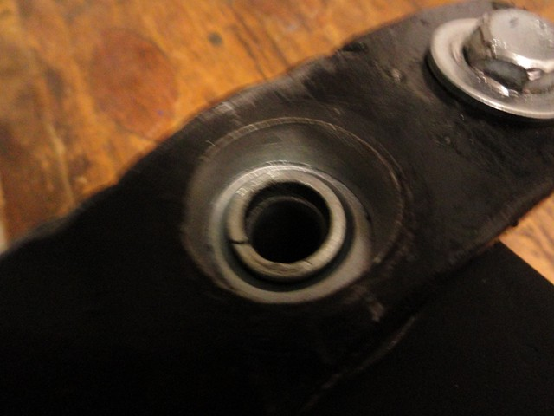

Trailing Arm Rebuild

Part 3
Part 1|Part 2| Part 3
Once the bushings are set, I move on to installing the bearing housing and the caliper bracket.
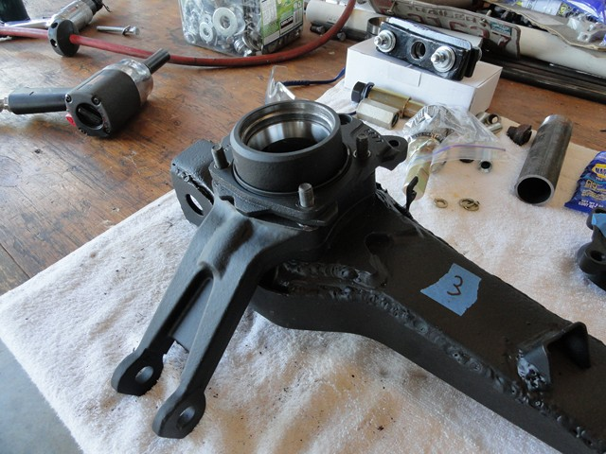
When buying the trailing arm kit, I decided to go with the kit that had Stainless steel (SS) hardware to prevent any rust from starting in the future. Before installing the backing plate, I applied RTV to the shoe hold down pins so that they couldn't move while installing the pads.
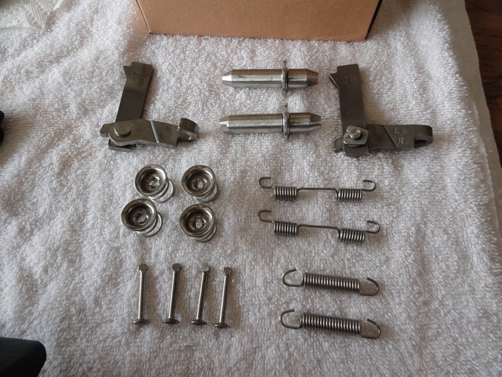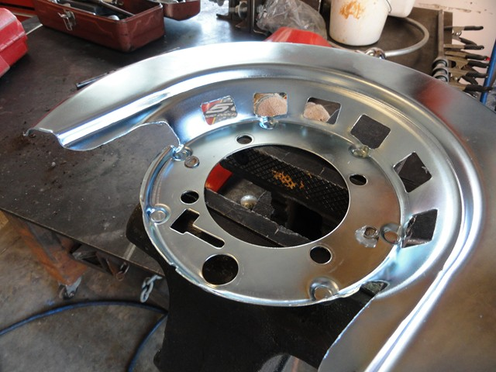
Once the RTV dried, I installed the backing plate, anchor, and guild plate and tightened everything down.
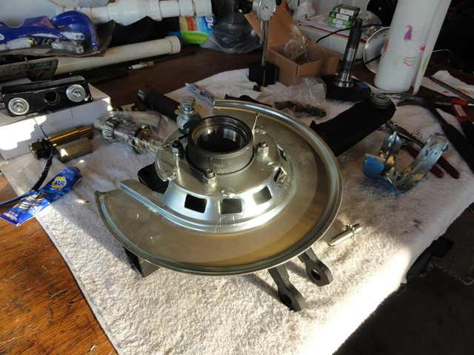
With everything tight, I worked my way to installing the parking brake. Before installing the actuator lever and star wheel adjuster, I added some grease to the pins and threads to prevent any future seize up.
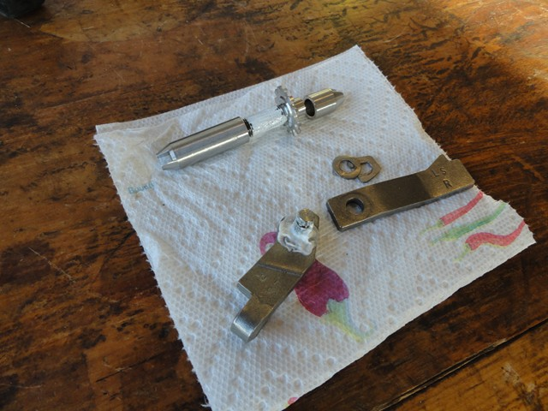

With the actuator lever apart, I installed the side with the pin on it though the backing plate and reattached the other part.
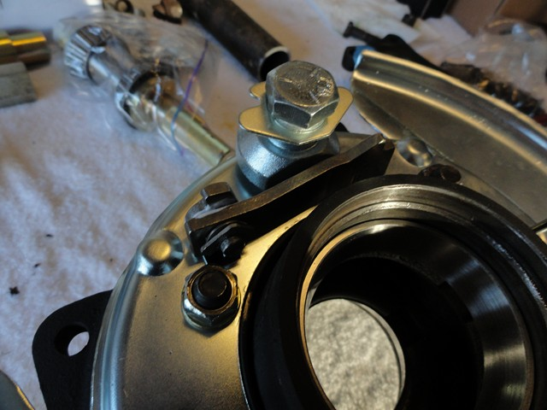

Before installing the shoes, I added brake grease to the six contact surfaces to prevent wear.
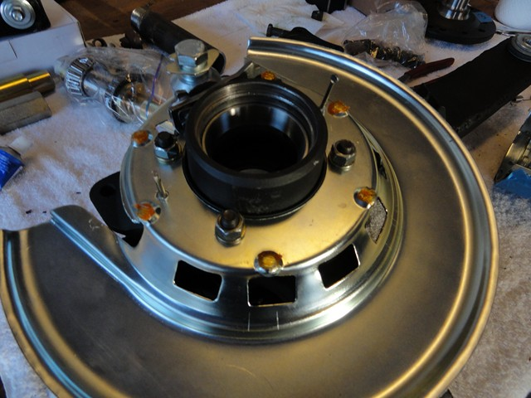

With everything set up, I can install the pads and all the hardware. I put masking tape on the pad surfaces to prevent oil or finger prints from affecting its performance later down the road. When installing the star wheel adjuster, the small detachable slotted end goes toward the rear on the driver side and toward the front on the passenger side. Below is the passenger trailing arm.
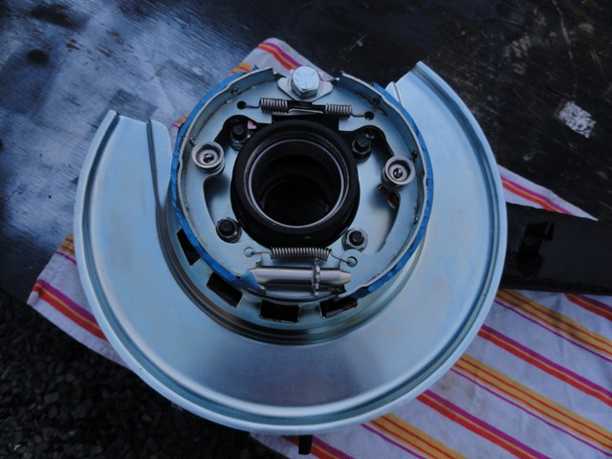

And below is driving trailing arm. Notice the direction of the star wheel adjuster in relevance with the front of the vehicle.
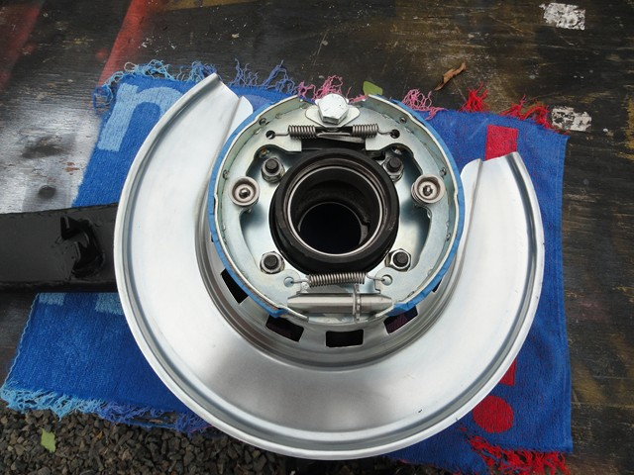
Once the parking brake is attached, I moved on to the bearings, spindle and lug nut installation. Before packing the bearings, I cleaned the bearing housing and races one last time in case any contaminants found their way inside. After I was sure the inside was clean, I packed the bearing with "Red and Tacky" grease. I have heard that there could be some variation in the end play with other brands of manufacture's grease. I am not sure if this is true or not but I thought I would play it safe and listen to the advise. I bought a bearing packer a while back when packing the eight bearings on my trailing. Well worth the money. It makes packing the bearing a breeze without too much of a mess and waste of grease in comparison to doing it by hand.
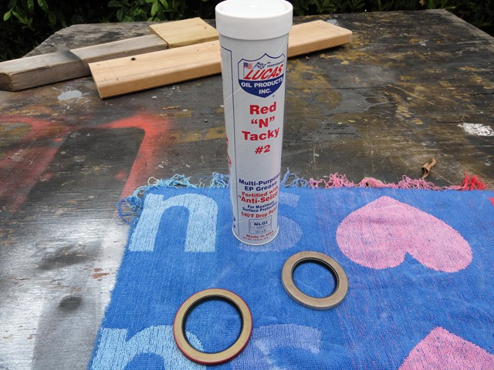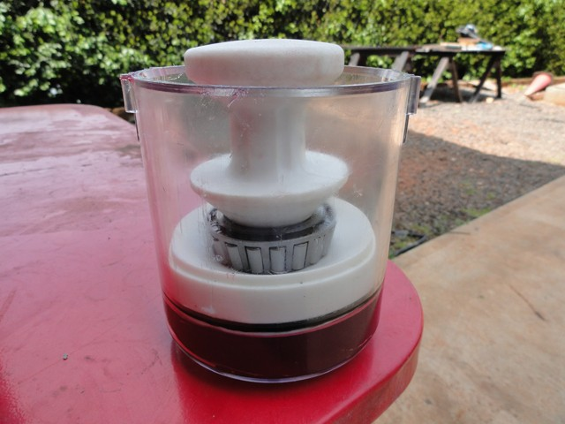
After I packed the bearing, I placed it in its race. Then I used a race and seal tool to knock the seal flush but before doing so I applied RTV to the OD (outer diameter) and made sure there was grease on the rubber seal. If it is driven with a dry seal then there is the possibility of it tearing due to friction causing an instant leak.
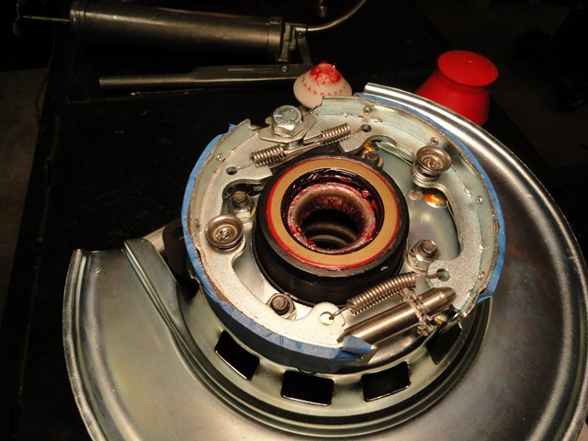

Next, I filled the bearing housing with grease, making sure to leave room for expansion, and installed the spacer and shim. With the spacer in place, I placed the inner bearing and seal in the housing the same way I did with the outer bearing and seal.
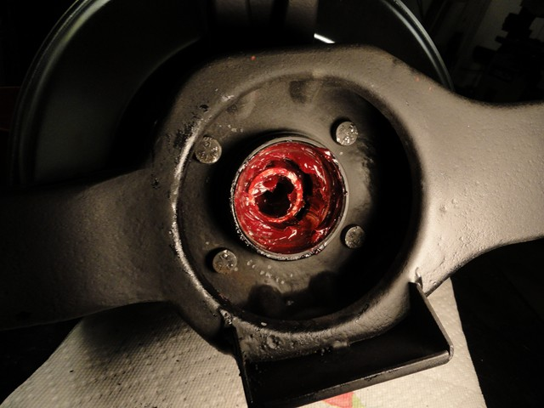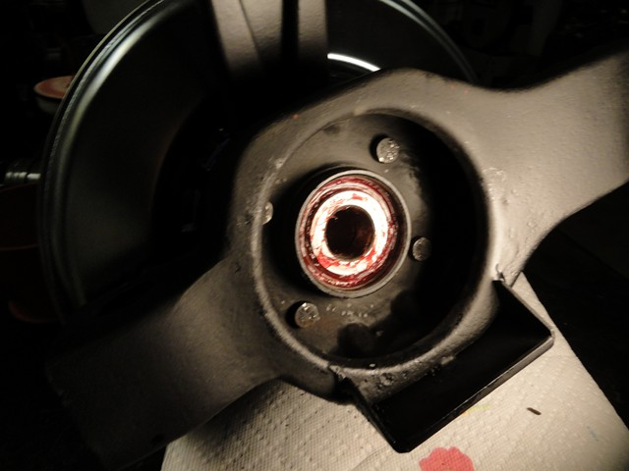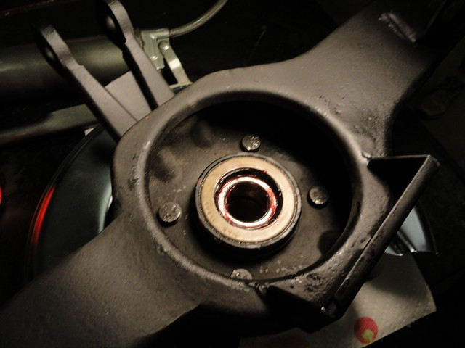

Now the fun part: installing the spindle. There is a tool call the Spindle installation tool you can use for this that screws on to the threads of the spindle and then uses a cylinder shaped piece of metal and a bolt to push against the spindle flange which in turn pulls the spindle into position. I figured that it would be much easier to use the hydraulic press to press the bearings on until they are fully seated. To do so I use scrap metal tubing that would press against the inner bearing without touching the spindle or seal. By applying pressure through the press, the bearings can be pressed onto the spindle.
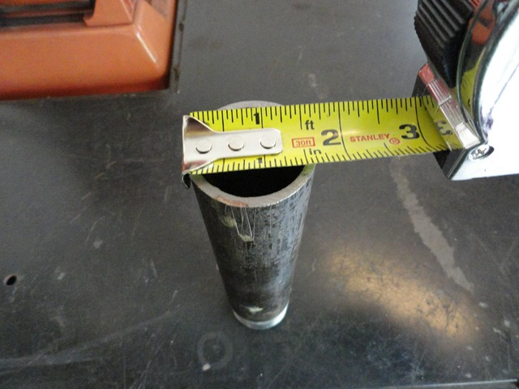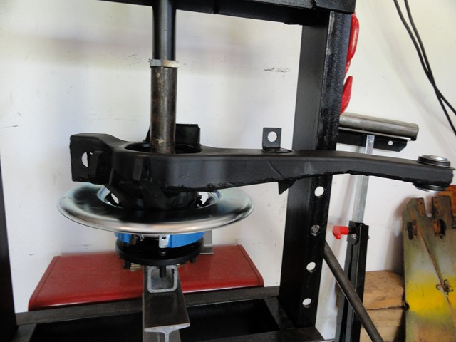

Disregard the threaded end. Like I said above, I am using scrap tubing so this just happened to be left over from a fire sprinkler job.
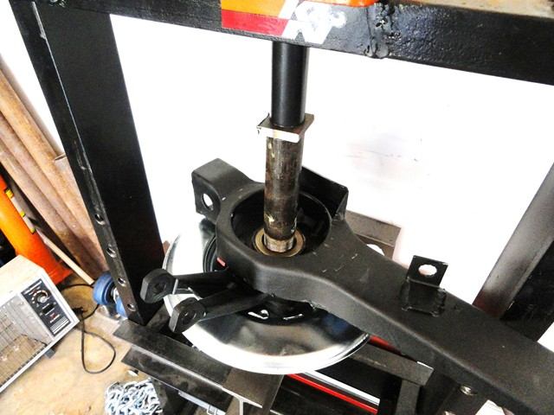

Next I installed the bearing dust shield and spindle flange. With the concave side of the washer facing down, I installed the nut and torqued it to 100 lbs. It is a pain to torque the nut down by yourself, so I tightened a lug nut on it and placed a breaker bar with the handle pressing against the table. With my right hand on the socket to hold down the trailing arm and my left hand pulling the torque wrench, I managed to reach the 100 lb click.
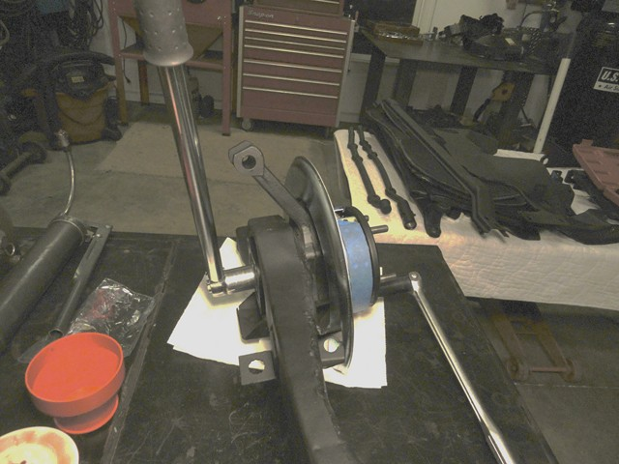

Before installing the cotter pin, I placed the dial indicator on the side to make sure the run out was still good. The spindle should have some drag to it but should definitely not be at the point of having to use two hands to move it. With the run out satisfactorily, I installed the cotter pin and the parking brake cable guild and just like that, you're done. The end result: two absolutely beautiful trailing arms with the peace of mind of knowing they were done right.
