SAFETY COMPLIANCE HECKLIST
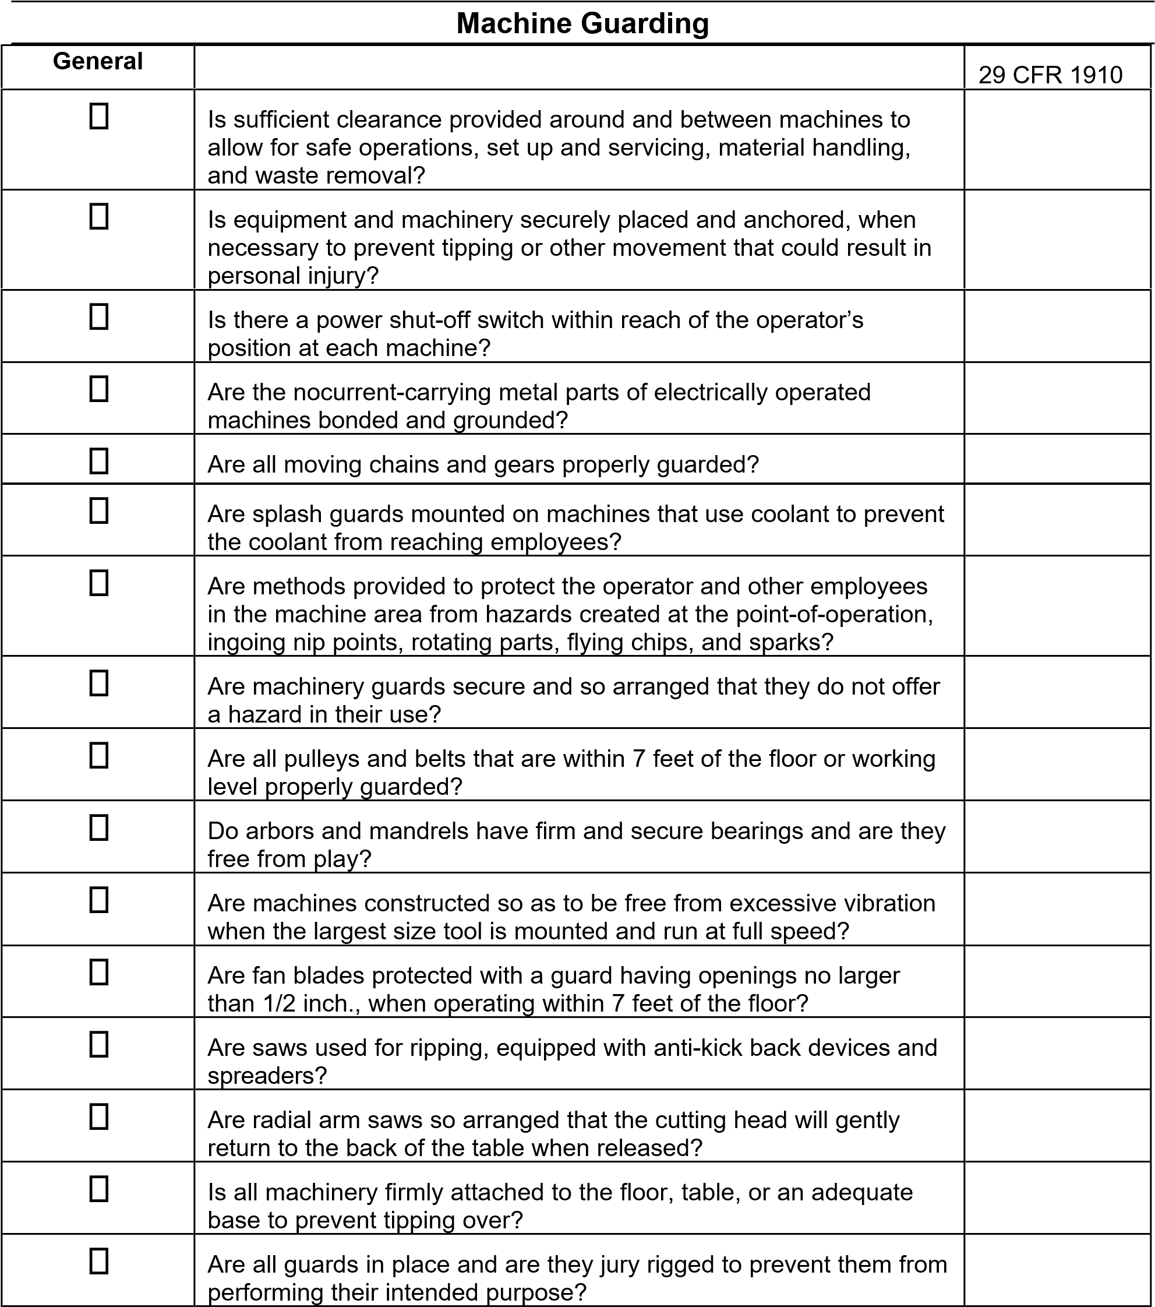
Machine Guarding (continued)

Housekeeping
 | Is machinery and equipment kept clean and properly maintained?
 | Is clothing, jewelry, and hair worn by the employee appropriate for machine hazards?
Fire Protection
 | Are all fire extinguishers inspected and recharged regularly, and noted on the inspection tag? | .157
 | Are electrical equipment parts which normally produce arcs, sparks, flames, or molten metal enclosed and separated from all combustible materials? | .303(d)
 | Are circuit breakers marked and accessible to personnel, protected from physical damage, and located away from ignitable material? | .304(e)(1)(iv)
Markings
 | Are manually operated valves and switches controlling the operation of equipment and chines clearly identified and readily accessible?
 | Are all emergency stop buttons colored red?
Lockout Procedures
 | Can electric power or other energy sources to each machine be locked for maintenance, repair, or security?
 | Are foot-operated switches guarded or arranged to prevent accidental actuation by personnel or falling objects?
 | Are revolving drums, barrels, points-of-contact, and containers required to be guarded by an enclosure that is interlocked with the drive mechanism, so that revolution cannot occur unless the guard enclosure is in place?
 | Are provisions made to prevent machines from automatically starting, or recycling, when power is restored after a power failure or shutdown?
2

