July 1, 2023
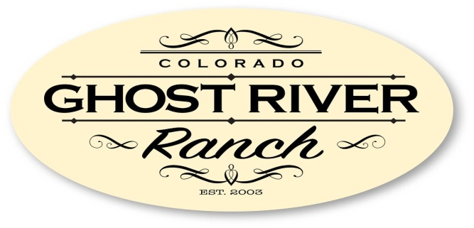

Searching for -

Two Candidates
to run FOR OUR BOARD OF DIRECTORS

Ghost River Ranch
Property Owners’ Association
The 2023 Election for two positions on the Board of Directors will be held at the Annual Meeting.
The elected will serve two-year terms.

OPPORTUNITY
We are currently looking for members of our association to help us contribute to the success of our future.
Seeking strategic or visionary thinkers with strong leadership skills and a capacity to cultivate relationships.

REQUIREMENT
A candidate shall be a member of the GRR POA currently in good standing (current on all dues/assessments and fully compliant with Articles, Bylaws, Covenants and Plats) with the Association.

If interested, please email your Candidate Statement
To admin@wwchoa.com.

