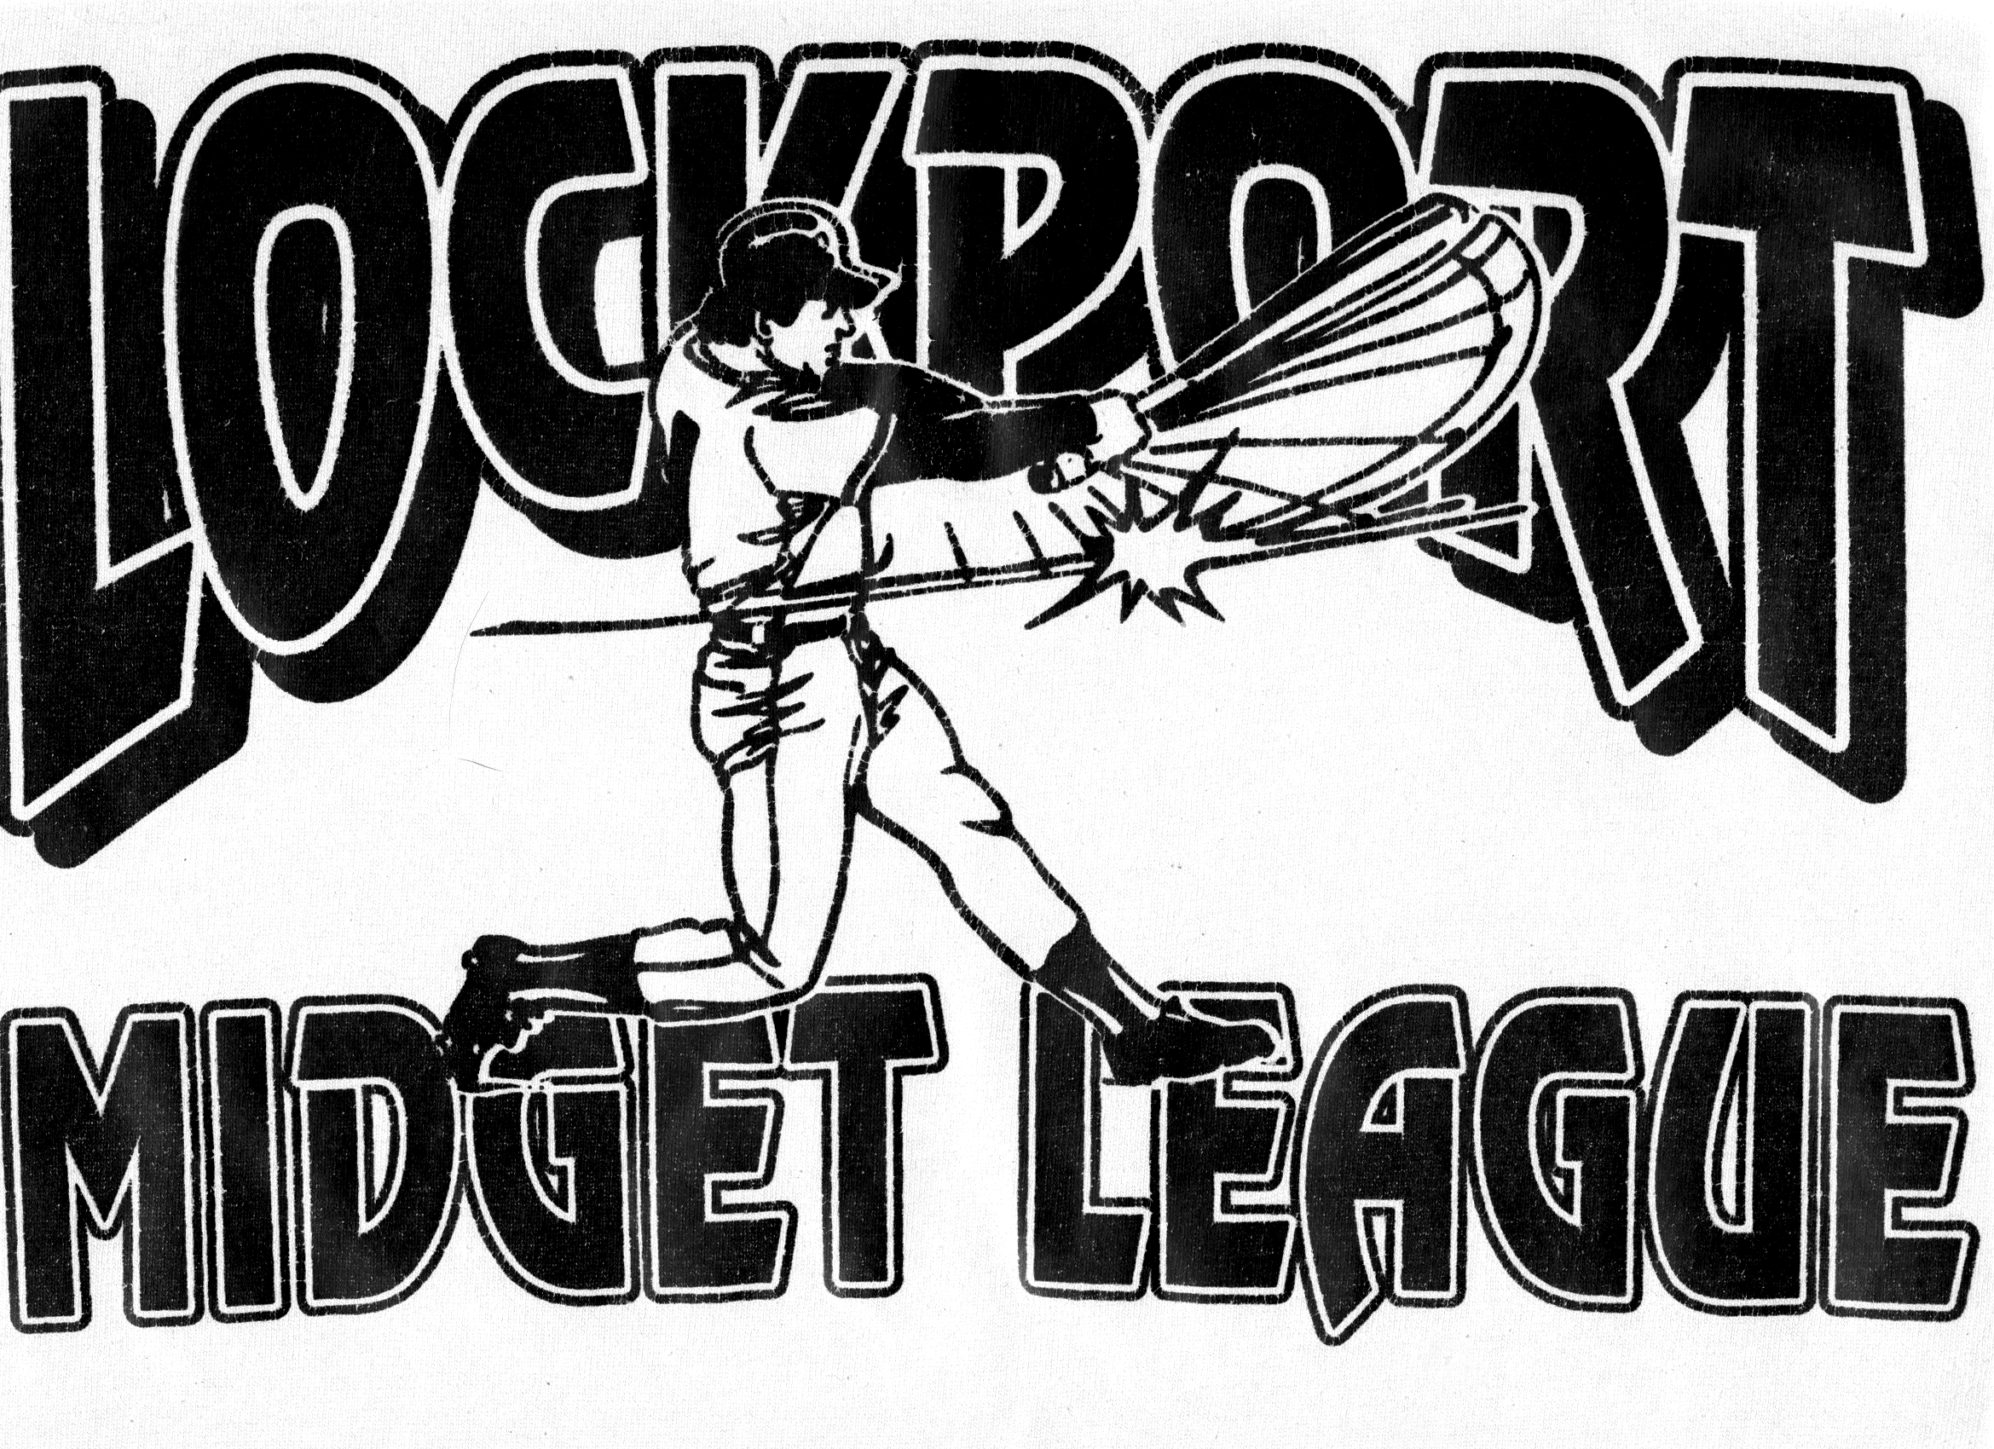
Lockport Midget Baseball League
Team Entry Rules

All Teams that desire Entry to the Lockport Midget Baseball League must meet the following criteria.

- All Age Guidelines must be followed (Proof of Birth Required)
  - “A” League 16-17-18
  - “B” League 13-14-15
a. See R+R Cutoff Date.

- Provide Home Field for Games.
  - All Out of Town Teams are Responsible for Field Maintenance.

- Must Meet the following Financial Guidelines.
1. Entry Fee: $1,300 per “A” League Team. Sponsor supplies Uniforms. (Hats & Jerseys)
$1,100 per “B” League Team. Sponsor supplies Uniforms. (Hats & Jerseys)

- Players Responsible for Completing a Player Contract.

E. Teams Must follow All Criteria Set forth in the Lockport Midget Baseball League Code of Ethics
Rules and Regulations.

F. League Presidents based on Field Availability, will Arrange Scheduling for Games.

-------------------------------------------------------------------------------------------------------------------

Lockport Midget Baseball League

Team Application

Sponsoring Township ________________________________________________________

Contact Person(s) ____________________________________________________________

Phone Number ______________________________________________________________

Team Sponsor(s) ____________________________________________________________

Coach(s) Name ________________________________________________________________

Phone Number ______________________________________________________________

