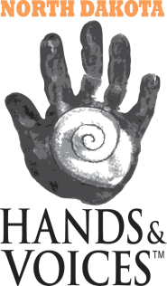
North Dakota Hands & Voices
PO Box 1776
Minot, ND 58702-1776
Phone: 701-484-1605

TRAVEL REIMBURSEMENT

North Dakota Hands & Voices would like to provide support for your travel to an event they are hosting. Please complete the below information so that we can consider your case and plan for reimbursement costs. You will be notified once approved.

EVENT: Mindful Parent: Strategies to Facilitate Communication
EVENT LOCATION: Minot, ND; The Grand Hotel
EVENT DATE: Friday, July 20th 6:00 – 8:00 PM

PARENT NAME: _____________________________________________________________________________________________________________
CHILD’S NAME: _______________________________________________________________ AGE: __________________________________
EMAIL: _______________________________________________________________________________________________________________________
PHONE: _______________________________________________________________________
ADDRESS: ___________________________________________________________________________________________________________________
CITY: ___________________________________________________ ZIP: ________________________________

EXPECTED TRAVEL COST:
MILEAGE: miles at $.545 / mile
HOTEL: nights at $58/night at the Grand Hotel
FOOD: dinner will be provided the evening of the training
OTHER: _____________________________________________________________________________________________________________________
_______________________________________________________________________________________________________________________________

*submit completed form via mail to the above address or to jerrica.maxson@trinityhealth.org

