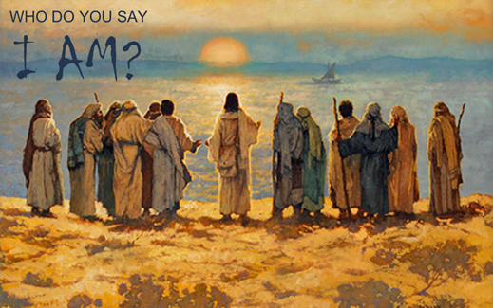

November 7, 2021

24th Sunday after Pentecost

Carson City United Methodist Church

10:30 am
Prelude/Greeting
*Indicates stand as you are able

Call to Worship

L: Blessed are those who walk according to the words of the Lord.

P: Blessed are those who keep Christ’s commandments and seek him with all their heart.

L: Oh, that our ways were steadfast in obeying your commandments Christ!

P: Then we would not be put to shame when we consider all your commands.

L: We will praise you with an upright heart as we learn your righteous commands.

P: We will obey your decrees; do not completely forget
us.

*Hymn: He Touched Me UMH

Opening Prayer: (unison)
Gracious Heavenly Father, we do not come to your table this morning, trusting in our own goodness. We come trusting in your all-embracing love and mercy. We know we are not worthy to gather the crumbs from under your table. But it is your nature to always have compassion and mercy. So feed us with the body and blood of Jesus Christ this morning, your Son, our savior, and Lord so that we may forever live in him and he in us AMEN.

Contemporary Song: Don’t Tread on Me (We the Kingdom)

Offering

Doxology UMH 95

Offertory Prayer

Gospel Reading: MATTHEW 16:13-16
Old Testament: JEREMIAH 10:10
Epistle Lesson: 1 JOHN 4:15
COMMUNION
Worship War Zone Song: Every Where I go (VBS)

Children’s Church

THE MESSAGE

Contemporary Song: Day’s of Elijah

Sharing of our Joys and Concerns

Call to Prayer: Seek Ye First UMH 405

Pastoral Prayer

*Hymn: Here I am Lord UMH 593

Benediction

CCUMC – Announcements & Upcoming Events:
=========================================
Please consider helping with the nursery on a Sunday @ 10:30 every other month. Contact Roberta Kile @ 989-584-3629 if you would like to be put on the schedule. Thank You. =========================================
COA Lunch: Is cancelled starting Nov 4th through Nov 19th.
========================================
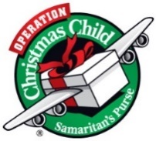
OCC Shoebox: Deadline for collection is Sun, 11/14/21. We pray to God you're passionate to help this year, because it takes all of us to meet the growing needs. Children need us and collection week is 3 weeks away! If you include a letter, photo and return address, sometimes the children send a note back. Please note, we can no longer pack toothpaste, candy or gum of any kind. How to pack a shoebox, boy/girl labels, and gift suggestions are available in the church foyer. A donation of $9 assists in covering shipping expenses for Samaritan’s Purse. Please make checks out to Samaritan's Purse and place it in the envelopes in the foyer or you can give it to Jeanneane at Toni and Ben's small group class each Sunday or mail it to:
Samaritan's Purse
P.O. Box 3000
Boone, NC 28607
Phone (828) 262-1980
You can also give or build a shoebox online by following this link - https://www.samaritanspurse.org/operation-christmas-child/ways-to-give/
=========================================
It’s time to “Fill-the-Pew” for IM 3rd Meal on Sun, Nov 14 & Sun Nov 21. The following are items needed for this project.
~Cheerios ~Fruit cups
~Fruit juice boxes – 100% fruit juice
~P-nut butter ~Skittles ~Mini pretzels
~Jell or Jam (grape or strawberry)
~Lunch bags ~Square snack bags
Let’s all work together to “Fill-the-Pew!”

Announcements cont’d
=========================================
Christmas Wreaths for sale: It is not too soon to think about decorating. CCUMC is selling evergreen wreaths on a 10” base with 2 pinecones and a red bow for $20.00. Contact CCUMC at 989-584-3797 to place an order. Proceeds go toward CCUMC mortgage. The more we sell, the greater the debt reduction. Deadline is Nov 21st. Money is due by deadline. Delivery to be announced.
========================================
Finance Budget Mtg: Tue Nov 23 @ 6:00 pm
AD Board/Finance Mtg: Wed Nov 24 @ 6:00 pm
========================================
Thanksgiving Meal: We would like to extend an invitation to EVERYONE to join us for our Free Annual Traditional Thanksgiving Dinner, Nov 25th, Noon-2pm @ CCUMC. If you would like to attend and need a ride, please call the Church office at
989-584-3797 by Tuesday, Nov 23rd. We also need donations of your time on that Thursday. It can be 1/2 hour or more. Please come and help us make this day great for others. It is a blessing to them and in turn to those who hear their gratitude and fellowship. The busiest time is getting food onto the steam table so that starts at 10am. Come join us and make the day special for others.
========================================
For those decorators or those that just love to get together for some fun and fellowship, decorating of
the Sanctuary will be Nov 27th from 10:00 am to about Noon. As the saying goes, many hands
make light work.
========================================
Serving and Supporting Sunday Worship Audio/Video: Pat Monroe
Children’s Ministry Audio/Video: Colin Fitzpatrick

Joys, Concerns & Prayer Request
For those battling cancers:
Beth Grienke, Jim Dunlap,
Carolyn Nykerk, Ray Seaman

For everyone who needs support,
guidance or has health concerns.

Monthly Giving
10/24 $4642.57 10/31 $2387.57

Nursery Schedule
11/7 Lauren Monroe 11/17 Maryann Severson

Lighting of Candles
11/7 Collin Benjamin & Blake Wilson

Passing of Collections Plate

Children’s Church
11/7 Deb Burt 11/14 Jenna Benjamin
11/21 Roberta Kile

Our Church in Ministry This Week

Sun 6:30-8 pm Women’s Group | Mon 6:30-8 pm  PT Class | Tue 6-8 pm  Cub Scouts
Wed 6:30-8 pm  ARK | Sat 5-7:30 pm  Euchre

Carson City United Methodist Church
Location: 119 East Elm St., Carson City, MI
Mail: PO Box 298, Carson City, MI 48811
Phone: 989-584-3797 Email: carsoncityumc@gmail.com
Website: carsoncityumc.com
Office Hours: Monday-Thursday, 9:00 am-12:00 pm
After hours by appointment
Pastor: Ian McDonald 906-322-5318
Secretary: Bonnie Seaman 989-763-1674

Weekly Sunday Bulletin now available on our website
@ www.carsoncityumc.com

“Father, when I struggle to know my
true identity, remind me to follow You
to discover in You my true self”

