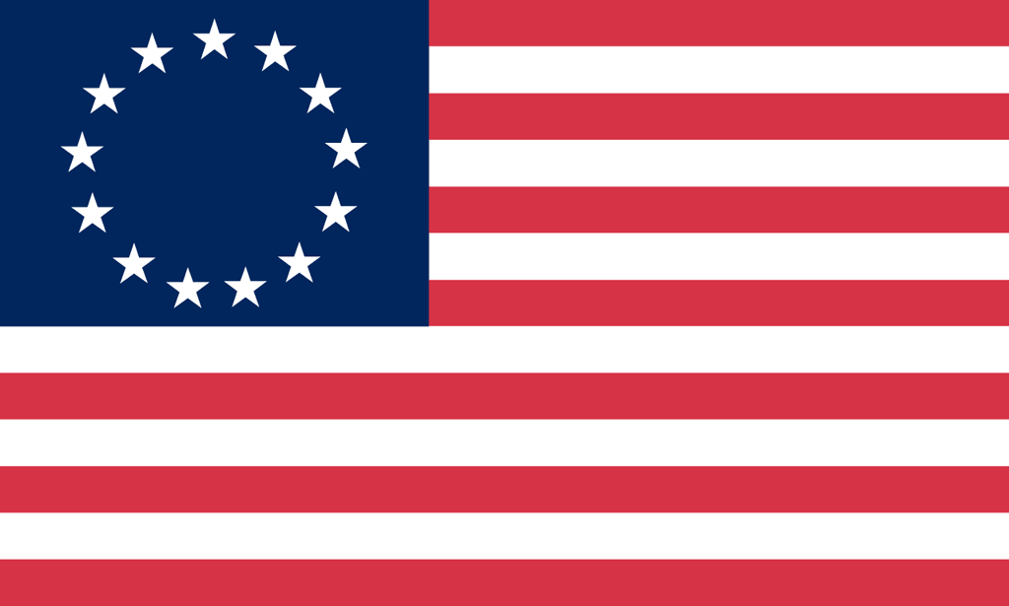U.S. History with Mr. Brown Name _______________________________ Period _____
Vocabulary Terms
Ch 3 The English Establish 13 Colonies

Directions: Use the text book to define the vocabulary terms in the space provided below.

Joint-stock company
Jamestown
John Smith
Indentured Servant
House of Burgesses
Pilgrims
Mayflower Compact
Puritans
Great Migration
Fundamental Orders of Connecticut
Roger Williams
Duke of York
William Penn
Quakers
James Oglethorpe

