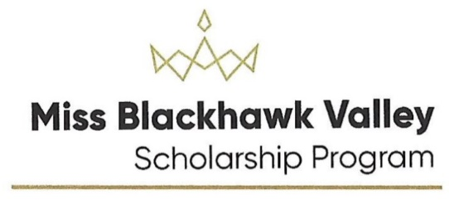
Script / Program Book Information 2022
This information will be used in the production of the Miss Blackhawk Valley Competition. Please write or print legibly. This is a worksheet and will be seen only by the producer and director of the pageant.
Turn in completed form as soon as possible by email to kodikargl@gmail.com and missblackhawkvalley@gmail.com
Introduction: How do you want the emcee to introduce you? This will also be the way your name appears in the program book. First and last name? Use middle name? Write exactly how you want to be introduced.
______________________________________________________________________________________
How do you want your parents to be introduced? Usual is “Daughter of Dad’s first name and Mom’s first name, then the last name”
_______________________________________________________________________________________
Address: City: State:
Mother’s phone number: Email:
Hometown: State:
Education: SEE BELOW

High School:

Gradation year: City:

College or University: City: State:

Major: Minor: Student Status:

What is the exact name of your Social Impact Initiative? Please include punctuation that you use. This is for the program book and/or stage script.
______________________________________________________________________________________
Talent Introduction: This is an opportunity for you to “set up” the story behind your talent.... can use composer, music, type of dance or vocal. It is customary for the contestant/parents to write this introduction. Producer will discuss if it needs to be edited. Limit 10 seconds. Do not include contestant name and number.
_______________________________________________________________________________________
_______________________________________________________________________________________
_______________________________________________________________________________________
The information that will be in the script during competition will be taken from your resume and SII.
8/25/2021

