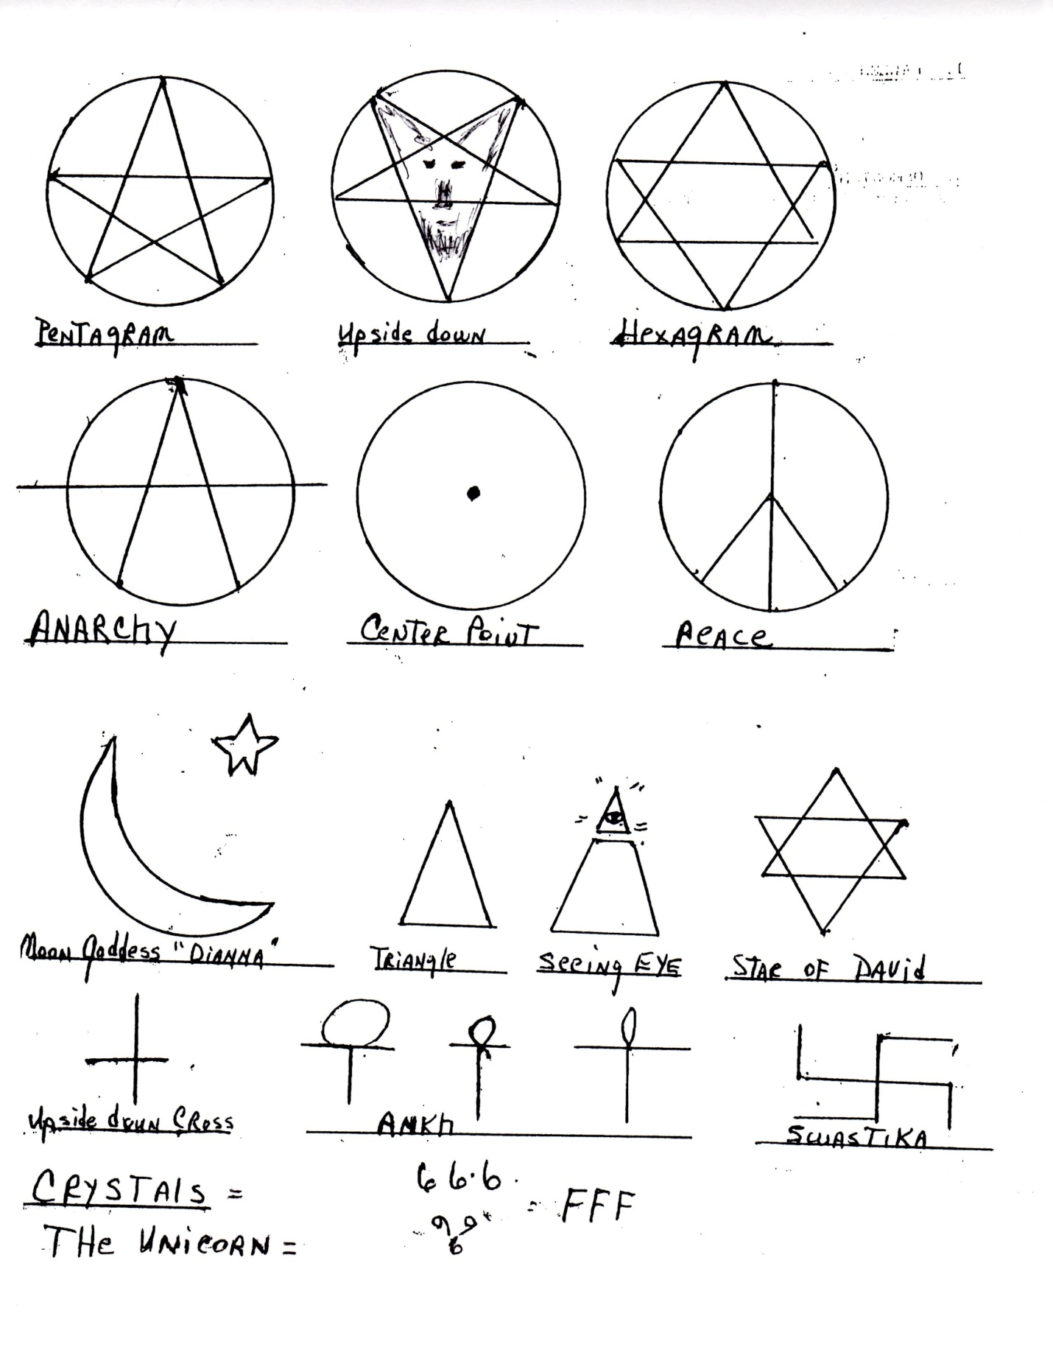

Satanic Signs- What are their meanings?

Psalm 119:105 says "The Word is a light to our path and a lamp to our feet." How much light do you have? The more light you have the more darkness you will see.

Romans 16:19 says "I want you to be wise in what is good and innocent in what is evil". To know what God says in His Word is good, and then to practice it, and to learn what God says is bad and avoid it. That sounds simple but we fail much of the time to that commitment. We are such naive people that we don't recognize the ways the devil takes authority over us. We have to remember the world we live in belongs to the devil and until it is destroyed he will remain it's god. As such he will exhibit his god ship through every means he can and one way is through his signs. Signs have meaning. Many people display signs because they are popular even though they don't know the real meaning of them.

Signs attract evil spirits as do objects that reflect false gods. Whatever is in opposition to God and His Christ will attract the enemy.

With this in mind we hope to inform Christians as to some of the many signs that the enemy has infiltrated our culture and which bring glory to the devil.

**1. The Pentagram. (pointed upwards)**

The five pointed star with a circle around it. There are two meanings: When the point is facing upward it is the sign of Wicca. There are two different types of Wicca, one is White Witchery and the other is Black Witchery. This is the sign of White Witchery, which portrays itself as doing good. (Wonder Woman wore this sign on her forehead.) White Witchery is the public relations group. It never shows itself to be evil. Sometimes there is a man with his arms extended inside the circle, which is a symbol of domination of the spirit.

The witches gather naked in a circle, usually 13 of them, and call on their spirit guides. They consult the dead who they believe gives them information.

**2. The Pentagram. (pointed downwards)**

The five pointed star with a circle around it with the point of the star pointing down and two points pointing up. Sometimes this upside down star has the picture of a goat within the star, with its ears within the points pointing upwards. (These are horns of the devil attacking the heavens.)

It is used in drawing a circle in Satanic rituals in calling up demons within the circle and casting spells and directing the demons to the target of the spell.)

**3. The Hexagram.**

The is a sign marking the place of a spell that has been cast on a person, place or thing. Indicating a Hex has been placed.

Witch covens usually have 13 members. When they cast spells to injure people or cure them, they stand within the Pentagram (the center of the 5 pointed star) and call on demons and the demon appears within the circle of the Hexagram, ( 6 pointed star), which is the most Evil Sign in Withcraft.

**4. Anarchy.**

The sign for Anarchy is a circle with a letter A placed within it. It stands for disorder and violence; the absence of law, (that the law and government interfere with the individuals liberty and is therefore undesirable. It also shows Rebellion, which is directed from demonic influence and power.

**5. Circle with a dot in the center.**

This sign is the 'all seeing eye of Lucifer'. It represents Satan to be the one true god.

**6. Peace symbol.**

The is a circle with a broken cross. The cross is upside down. It is a mockery to the cross of Christ. It indicates that the cross of Christ is not effective. It's called Peace because the witch who casts a spell gets peace from the broken cross.

**7. Moon goddess- Dianna.**

This is a quarter moon with the star pointing upwards, (a pentagram), at the northeast section of the moon. It's a sign of Symeramus. (She is the Babylonian wife of Nimrod and the mother of Tammuz.)

**8. The Triangle.**

The Triangle is Satan's mockery of the Holy Trinity. It is the primary form of the Pyramid, used in Egyptian Mythology for their 3 gods, Sut, Shu and Horus. These 3 gods were later called Osiris, (father god), and Isis, (mother god), and Horus, (their son). All three originated from Nimrod, Symeramus, and Tammuz.

With the apex facing downward, it represent Horus, the sun god. With the apex facing upward it represents Sut, (or Set), the Destroyer. ( A person high in Satanism, M. Aquino, named his temple of Set after Satan the destroyer.

Symeramus and Tammuz originate from Babylon as the mother/ son cult religion, usually represented by the figurine of a woman holding a baby in her arms. the Roman Catholic Church uses this particular figurine to represent the virgin Mary and the child Jesus. (This being only one of the many religious practices that originated in Babylon and passed through the Medio/Persian empire and the Grecian empire and settled in the Roman empire.)

**9. Seeing Eye.**

The capstone for the Pyramid on the U.S. Great Seal, (also on the back of $1.00 Federal Note), with the wording , 'Novus Ordo Seclorum', which means 'One World Government'. It's the sign of Satan's man who will bring all governments and religions under one person, the antichrist.

This also ties in with the Sun god (Tammuz) of Egypt or the Mother goddess (Symeramus).

Note the Eagle. (the number 13 appears many times on the Note.) There are 13 stars over the eagle's head ,(supposed to represent the 13 states), but notice how they are arranged. They form a Hexagram. Within the Hexagram are formed 13 Pentagrams. (stars). The Eagle Beast Shield has 13 strips. There are 13 berries on the olive branch in the eagle's right talon. There are 13 arrows in the eagle's left talon. There are 13 leaves on the olive branch.

Now about this Federal Note. The Federal Reserve is not a U.S. Agency, not even run by the United States. It is run and controlled by the Financial Dynasty's around the world who are the stock holders of the corporation. The numerical MDCCLXXVI on the pyramid add to 1776, however this does not celebrate the Independence Day of July 4th as the normal person would think, it does however celebrate and mark the beginning of July 1, 1776, the origination of the Illuminati.

The Eagle was a symbol for Lucifer to the ancients and was known as the Phoenix. It is now used by the President of the U.S. , and was also used by the extreme Satanist, Hitler.

**10. Star of David**.

Two Triangles intersecting each other form a Hexagram, which is used in all witchcraft and Satanism cults. As stated earlier, they are used to put hexes on its victims.

This star originated in 700 BC in Egyptian Mythology as a Magical Sign. It was never used by the ancient tribes of Israel. The original sign used by Israel was the 'Menorah', (the candelabra with 7 light holders).

Acts 7:43 mentions it as the star of Rephan, noted in the shrine of Moloch and again in Amos 5:25-26, as the star of Rephan. Archeology digs discovered it in 776AD as imbedded in a 120 year old Moslem floor.

It was replaced in the 16th century as the shield of David. However, it was not named after King David of the Bible but by another person. We are told by Arthur Koestler that the star is a magical emblem which dates back only to the 12 century AD. At that time, an Ashkenazic Jew, named Menahem Ben Duji, tried to convince his people he was the Messiah. He changed his name to David al-Roy, amassed some troops in Khazaria and Kurdistan, and was assassinated on his way to liberate Palestine. From the 13th century on the six pointed star was attributed to him and first appeared on a Jewish flag in Prague in 1527.

Free Masonry uses it as the Shield of Solomon, which they claim is Solomon's Seal. In Dr. Graham's book "the Six Pointed star", notes it was after Solomon's idolatry that he used the Hex star,( I Kings 11: 6-9), for the god Rephan in the shrine of Moloch. He also worshiped Ashtoreth or Astarte ( the star). (Both of these names were another name for Semeramus.)

**11. The Upside Down Cross.**

This is a mockery to the cross of Christ.

**12. The Ankh.**

New Agers and Satanists say wearers will have wisdom, peace, prosperity. (it's often used as jewelry.) It's meaning is that 'the Satanic Circle over the cross' shows Satan's power surmounts the cross of Christ.

**13. The Swastika.**

Hitler adopted the Swastika ,which was an Occultic sign, as the symbol for the 3rd Reich. It was used as a symbol of Lucifer, who is called the Solor Angel or Sun deity. It mocks the cross of Christ showing it to be the 'twisted cross'.

**14. Crystals.**

Crystals are used as an indication for the presence of demonic power. They are used in healing, to provide prosperity and effect all manner of miracles. They are also used for divination and fortune telling. Some wear them around the neck to attract positive energy to the body.

**15. Unicorn.**

It's a flying horse with a horn growing in the head. It started with nimrod, the father of Tammuz, the god of Babylon. He wore it as a headdress and later was worshipped in Occultic circles. It's roots lie in pagan idolatry.

Occultism embraces the unicorn as symbolic of it's god.

The horn between the eyes stands for the 'the Little Horn' mentioned in the Book of Daniel and is indicated to be the antichrist. It is the symbol for Satan.

16. 666 and FFF.

The number 666 is of course the number of the name of the antichrist as indicated in Revelation 13:17. FFF is the 6th letter of the Alphbet.

17. The Yin/Yang.

This is a circle which is half white and half black and has a dot in the white section . It signifies the ungodly synthesis of light and darkness. The separation of the white and black is a line that looks like the letter S. The S line stands for Satan and shoots through the diameter. It signifies the 'one', or the 'devil'. The dot represents the eye of Satan.