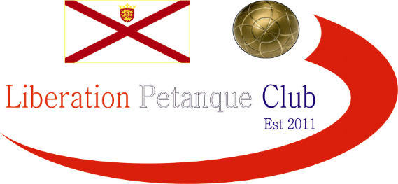
NEW
Liberation Petanque Club (JERSEY)
International 2022 Open Competition Weekend 27th to 29th August
Minimum Guaranteed Prize Fund for the Weekend over £3000
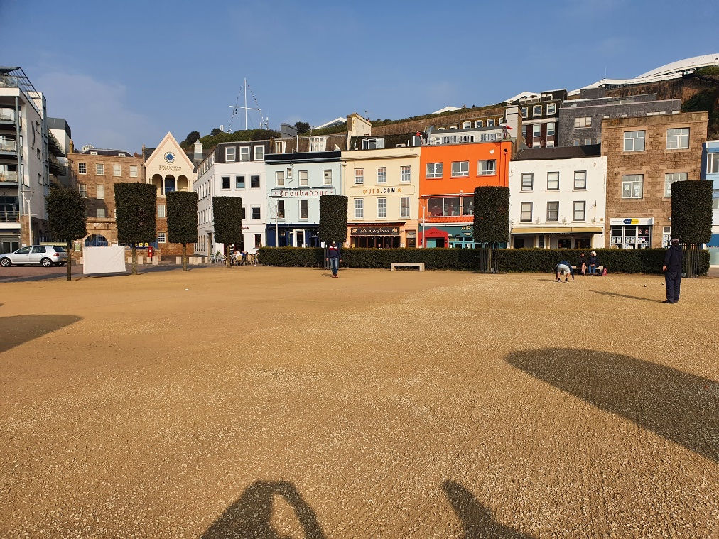

We are based in the Heart of Jersey’s Capital, St Helier surrounded by Bars, Restaurants, and the main shopping centre.
To celebrate our tenth anniversary (albeit a year late due to Covid) we have taken the opportunity to provide a new competition weekend spread over the three days with a different competition to be held each day. It will be held over the bank holiday weekend covering Saturday 27th to Monday 29th August inclusive.

Saturday - Open Doubles Competition
Sunday - Open Triples Competition
Monday - Open Singles Competition

Entry Fees and Prize Fund Breakdown

Entry Fees are as follows:
Doubles - £40 per team (£20pp)
Triples - £60 per team (£20pp)
Singles - £20 per person

Players playing in all three competitions – then enjoy a discount and pay just £50 saving £10.

Guaranteed Minimum Prize fund’s will be as follows:

Doubles - Main – First Place - £500 (Per Team)
- Main – Runners Up - £300 (Per Team)
- Main – Third Place - £150 (Per Team)
- Main – Fourth Place - £100 (Per Team)
Plate – First Place - £50 (Per Team)
- Plate – Runners Up - £30 (Per Team)
- Plate – Third Place - £20 (Per Team)

Triples - Main – First Place - £510 (Per Team)
- Main – Runners Up - £300 (Per Team)
- Main – Third Place - £150 (Per Team)
- Main – Fourth Place - £90 (Per Team)
Plate – First Place - £60 (Per Team)
- Plate – Runners Up - £45 (Per Team)
- Plate – Third Place - £30 (Per Team)

Singles - Main – First Place - £350
- Main – Runners Up - £200
- Main – Third Place - £100
- Main – Fourth Place - £75
Plate – First Place - £40
- Plate – Runners Up - £20
- Plate – Third Place - £10

Competition Format’s

We will be using the Swiss System for all three competitions (As used in the European and World Championships).

Maximum Entries 40 Teams / Players (Maybe increased)
5 Qualifying Rounds
Timed Matches
Qualifying Criteria - Wins
- BHN (Opponents Wins)
- Points Difference

Top 16 Teams / Players through to Main Competition
Teams / Players finishing 17th to 32nd through to the Plate Competition.
Teams / Players 33rd to 40th eliminated

Knockout stages - Last 16
Last 16 Match 1 - 1st v 16th
Last 16 Match 2 - 2nd v 15th
Last 16 Match 3 - 3rd v 14th
Last 16 Match 4 - 4th v 13th
Last 16 Match 5 - 5th v 12th
Last 16 Match 6 - 6th v 11th
Last 16 Match 7 - 7th v 10th
Last 16 Match 8 - 8th v 9th

Knockout Stages - Quarter-Finals
Winner - Match 1 v Winner - Match 8
Winner - Match 2 v Winner - Match 7
Winner - Match 3 v Winner - Match 6
Winner - Match 4 v Winner - Match 5

Knockout Stages - Semi-Finals
Winner - Match 1 v Winner - Match 4
Winner - Match 2 v Winner - Match 3

Links and Travel Information
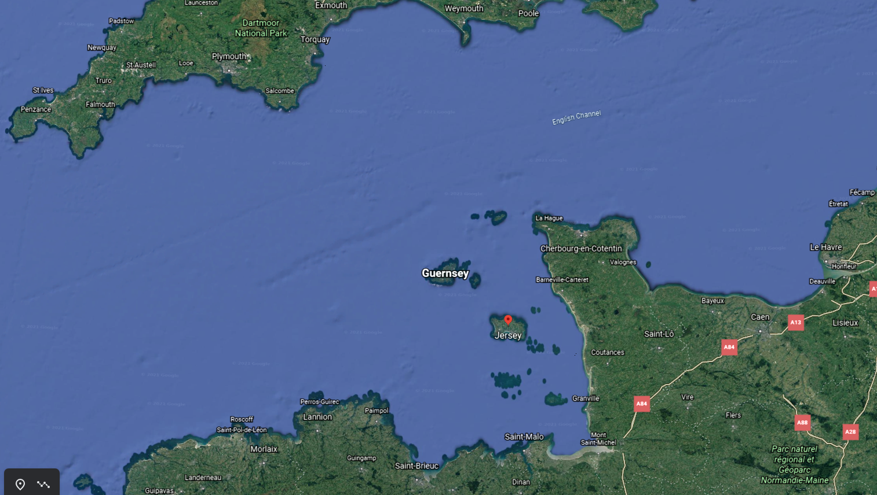
https://www.jersey.com/getting-here

Club Contacts
Email: liberationpc@gmail.com
Website: http://www.liberationpetanque.co.uk/
Phone: 01534 723442
Any Questions please let us know.
Kind Regards
Toby Northern
Chairman
Liberation Petanque Club

*Please note the club holds the right to cancel the competition if there is an Insufficient number of teams who enter.

International 2022 Open Competition Weekend 27th to 29th August
Entry Form
Saturday (27th August) - Open Doubles Competition - £40 per Team

Player 1 ____________________ Player 2 ____________________

Email: ____________________ Contact No. ____________________

Email: ____________________ Contact No. ____________________

Sunday (28th August) - Open Triples Competition - £60 per Team

Player 1 ____________________ Player 2 ____________________

Email1: ____________________ Contact No1. ____________________

Email2: ____________________ Contact No2. ____________________

Player 3 ____________________

Email: ____________________ Contact No. ____________________

Monday (29th August) - Open Singles Competition £20

Player ____________________

Email: ____________________ Contact No. ____________________

Please email entry forms to liberationpc@gmail.com
The clubs preferred method of payment is BACS which should be sent once entry has been confirmed.
Sort Code |  | 40 -25 - 34 | Account Number | 92557738
Alternatively, you can send this form and payment to Flat 1, 2 Elysian Terrace, St Saviours Road, St Helier, JE2 4GJ

