Deerfield Township Firemen’s Association 2nd Annual Golf Outing
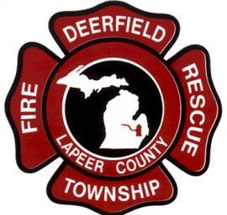

Saturday, September 28th , 2019, Rolling Hills Golf Club - 9 A.m. Shotgun Start

Golf Outing Registration Form

$65.00 per Person or $260 per Team of 4

Entry Fee Includes Green Fees, Cart and Dinner

(Sign up as a Team or Individual - Individuals will be placed on a Team by the Committee.)

PLAYERS NAMES

1.________________________________ 2._______________________________

3._________________________________ 4._______________________________

Contact Name and Phone Number:_________________________________________

Please Make Check Payable To and Mail To:

Deerfield Township Firemen’s Association, 30 east Burnside rd, North Branch, MI 48461

(GOLF OUTING FEES ARE NON-REFUNDABLE)

For additional information, contact Golf Committee Chairs:

Tom (810)358-3499 or Louie (810)358-7787

Due Date: | THANK YOU
September 15, | FOR YOUR
2019 | SUPPORT!

