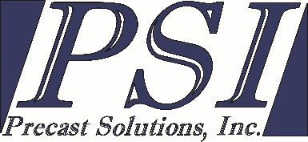
Job Description and Qualification Requirements:
Production Personnel:
Works with Production Supervisor, support staff and other Production Personnel in the set-up, casting, stripping, handling, repair, and loading of precast products; communicates and collaborates with Production Supervisor and quality control personnel to optimize production quality; performs daily clean-up and organization of tools, work areas and equipment.
RESPONSIBILITIES: High initiative, self-motivation, team player and ability to produce quality workmanship safely in a fast-paced production environment. Regular attendance is essential in this role.
ESSENTIAL DUTIES:
- Excels in regard to attendance, timeliness, loyalty, mutual respect and support for organizational teamwork and continuous improvement
- Works closely with other team members, Management, support staff and, quality control.
- Follows specifications, blueprints, and job orders presented by Production Supervisor/Production Manager
- Cleans and set-up molds for production.
- Performs minor patching and repairs to finished products.
- Constant regard for safety regulations.
- Safely operate fork lifts, overhead cranes and power tools.
- In plant and in yard duties as required by Management.
QUALIFICATIONS:
- Education and/or Experience: High School Diploma or equivalent (G.E.D.) and/or three to five years related experience and/or training; or equivalent combination of education and experience in the architectural, precast, or construction industry.
- Communication Skills: Ability to speak English. Must be able to effectively understand verbal and written procedures, Ability to read and understand construction documents. .
- Mathematical Skills: Ability to perform addition, subtraction, multiplication and division, Ability to apply concepts of basic algebra and geometry.
- Reasoning Ability: Ability to interpret a variety of technical instructions in mathematical or diagram form.
- Physical Demands: While performing the duties of this job, the employee is regularly required to walk, climb, sit, use hands and fingers, handle or feel objects, tools or controls; and talk and hear. Manual lifting requirements are moderate to heavy, but with the assistance of other personnel, fork trucks and cranes.
- Work Environment: The work described will require the Production Personnel to be in the plant or yard most of the time. This employee will be required to wear all safety equipment required of regular plant personnel. Must have the ability to work both indoors and outdoors during all seasons of the year, in all types of weather.

