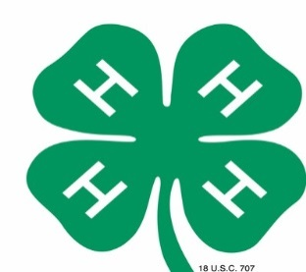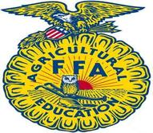
MANDATORY
4-H & FFA AGRICULTURE EXHIBITS
“PAST, PRESENT & FUTURE OF AGRICULTURE”

Each group entry should be based on the “Past, Present, & Future of Agriculture” theme.
Advancements in the farming industry and the changes over the years to accommodate the world’s growing population.
Dive deep with your group and show how agriculture has got us where we are today!!
Rules:
- Entries may be submitted by 4-H & FFA groups ONLY. It is MANDATORY FOR ALL LIVESTOCK GROUPS TO ENTER AN EXHIBIT. It is open to all other 4-H and FFA groups.
- Entries will be judged and awarded Ribbons and Cash Prizes.
- Placing/Awards will be awarded as follows:
1st Place – Blue Ribbon & $100.00 Cash Reward
2nd Place – Red Ribbon & $50.00 Cash Reward
3rd Place – White Ribbon & $25.00 Cash Reward
- The decision of the judges will be final
- A 4’x8’ space with electricity WILL be available
  - Do not ask for more space
- Registration forms must be turned into Catie Jones by March 30, 2024. You can email to flaglerctyfair@bellsouth.net or jonescatie15@gmail.com
- All exhibits will be on display at the fairgrounds during the upcoming Flagler County Fair & Youth Show
- Entrants shall assume all liability for table decorations placed on exhibits. The Flagler County Fair and its staff are not responsible for any damage or loss.

Judging Criteria: TOTAL POINTS = 100 POINTS
Educational Value
- Is the central theme of exhibit worthwhile, distinctive, significant and appropriate…20
- Does the story told around the central theme have unity, that is does each article, object, specimen and label contribute to the amplification of the central theme…25
- Is the booth free from error of thought – grammar, spelling, object use, label use, assumptions intended, figure of speech, etc…20
Power to Attract Attention & Hold Interest
- Exhibit presents an original, unusual or striking method of display…20
- Is the general appearance of the booth attractive, including background, good arrangement of objects, scale and balance, appearance of labels…15

Important Dates & Deadlines:
- April 6th, 2024 (2pm to 5pm) – Groups will be allowed to set their exhibits up
- April 9th, 2024 - Judging
- April 13th, 2024 at 9am – Take down exhibits

Contacts for this Competition:
Penny Buckles – Fair President (386) 931-6597
Catie Jones (386) 279-9792

FLAGLER COUNTY FAIR AND YOUTH SHOW, INC.

2024 4-H AND FFA AGRICULTURE EXHIBIT REGISTRATION FORM

THEME: “PAST, PRESENT & FUTURE OF AGRICULTURE”

NAME OF ORGANIZATION ______4H _______FFA
GROUP NAME______________________________________________________
CONTACT PERSON__________________________________________________
PHONE NUMBER___________________________________________________
ADDRESS_________________________________________________________

Signature :_________________________________________Date____________

Exhibit Space #_____________(fair use)

