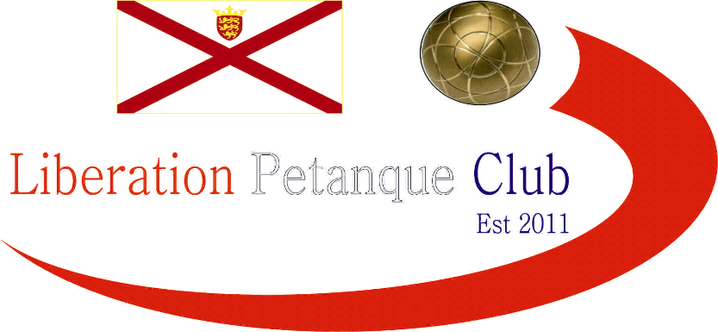

LIBERATION PETANQUE CLUB

CHARITY TRIPLES OPEN

20th October 2018

In Aid of Jersey Childrens Charity

13 teams entered this year resulting (along with donations and club contribution) raising £313.50 not far off doubling the 2017 amount for Jersey Childrens Charity which is fantastic. Well Done and thank you to everyone who played and contributed to such a great cause.

If you would like to know what other fundraising events are held by the Charity please see their facebook page:

https://www.facebook.com/jerseychildrenscharity/

or the Website

https://jerseychildren.co.uk/

Round 1 saw some really close games, with Tommie Glennie, Mikaela and Peter building an early lead and looking likely to win their first game against Ross Payne, Neil Selby and Paul Bell when 11 – 0 up, but went on to lose 13 – 11.

The same almost happened in the game between James Rondel, Gavin Scott and Paul Walker who fought back from 11 – 0 down before losing on the extra end 12 – 11 to Geoffroy Buffetrille, Laurent Pellaton and Helene Retrosi.

Keith Boleat, Mike Fennel and James Villalard faced tough opposition in Matt Pinel, Andrew Bellamy-Burt and Callum Stewart but made it hard work for the favourites just bowing out 13 – 8.

Round two

Another close match in this round saw Alex, Cassie and Jean Stewart lose out by the narrowest of margins 13 – 12 to Colin & Karen Hidrio and Stephen Stoneman.

Sally De St Paer, Carol Le Maistre & Sandra Manning playing in their first competition played Tommie, Mikaela and Peter who would have been disappointed losing their first match, recovered well though to win this one 13 – 3. James, Gavin & Scott were very lucky not to get beaten 13 – 0 by Toby Northern, Colin Myers and Steve Simpkin, with the former misfiring and knocking James boule onto the coche to give them two points on one end.

Andrew & Lorna Limbrick and Alan Lahiffe lost 13 – 11 to Ross, Neil and Paul who made it two straight wins but the surprise of the round was a win for Martin & Teresa Koradi and Hayden over Geoffroy, Laurent & Helene 13 – 8.

Round 3 saw Toby Colin and Steve beat Martin, Teresa and Hayden for three straight wins. Wendy Ritzema, Gary Cowburn and Barry Blampied moved into contention with a win over Tommie, Mikaela and Peter.

Ross, Neil and Paul lost their first match to Callum, Andrew and Matt 13 – 6.

The final round saw several teams in with a chance of a top four finish and a semi final place.

Callum, Andrew and Matt finished top of the rankings with four wins out of four by beating, Toby, Colin and Steve.

Andrew, Lorna and Alan finished fourth with a nail biting finish winning 13 – 10 over Martin, Teresa & Hayden. Geoffroy, Laurent & Helene just missed out on that fourth spot on points difference. Finishing second was Neil, Ross and Paul with a comfortable win over Colin, Karen and Stephen.

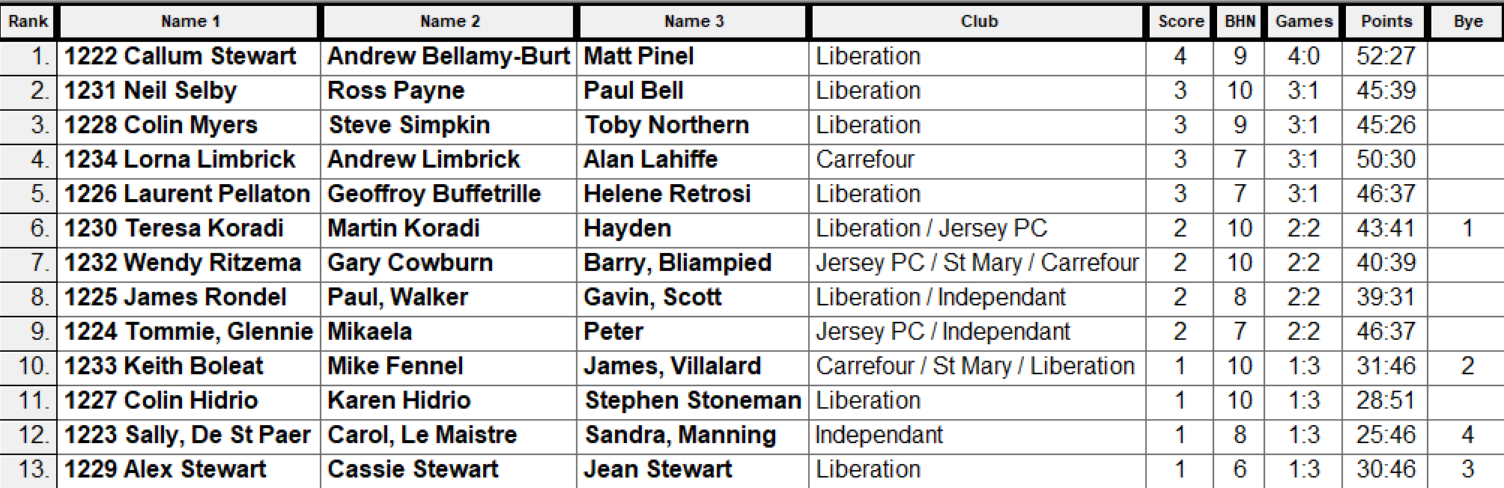

The semi final line up was as follows:

1st Callum, Andrew & Matt v Alan, Lorna & Andrew 4th
2nd Neil, Ross & Paul v Toby, Colin & Steve

Well the curse of the top ranked team in the swiss system continues as the top ranked team went out at the first knock out stage again as Callum, Andrew and Matt suffered a heavy defeat to Alan, Lorna and Andrew 13 – 2.

That score though was out done by Toby, Colin and Steve who handed Neil, Ross and Paul a 13 – 0 defeat.

The third place play-off saw a big comeback again by Neil, Ross and Paul from 9 – 0 down to take third place from Callum, Andrew and Matt, 13 - 11.

The final saw Alan, Lorna and Andrew take an early 7 – 1 lead, before Colin Myers got his team back into the match with a brilliant fire to make it 7 -7 but unfortunately didn’t take the advantage and three ends later Alan, Lorna and Andrew took the match 13 – 7.

The winners Pictured below.
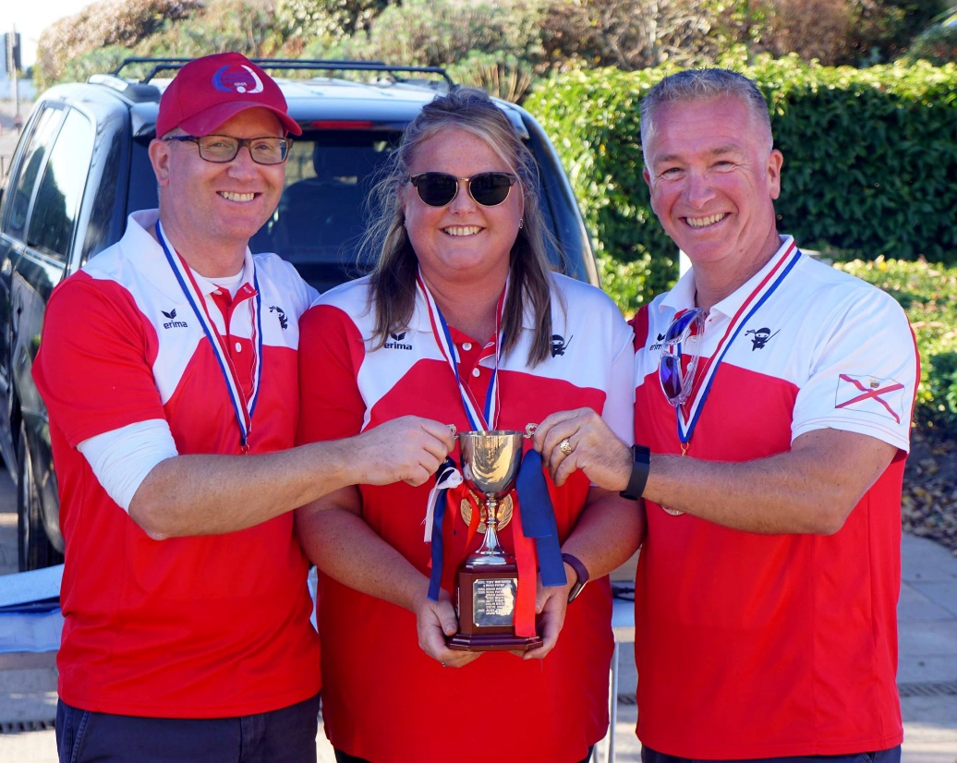

A wonderful days play and a great amount raised for a very worthwhile charity – Special thanks to everyone for their kind support and all those who put in a great deal of effort to make it the success it was.

Kind Regards
Toby Northern
Liberation Petanque Club

