JSB Capital Management, LLC
Pro-active Wealth Management

May 4, 2022

Today the Federal Reserve Open Market Committee (FOMC) announced a rare half-percentage-point interest rate increase and simultaneously announced plans to shrink its $9 trillion asset portfolio (balance sheet) starting next month in a double-barreled effort to reduce inflation that is running at a four-decade high. Today’s rate hike raised the central bank’s benchmark federal-funds rate to a target range between 0.75% and 1%. The Fed, which usually lifts interest rates in quarter-percentage-point increments, last raised rates by a half point in 2000.
Taken together, the aggressive rate hike combined with reducing their bond holdings marks the most aggressive FOMC tightening using monetary policy at one meeting in decades.
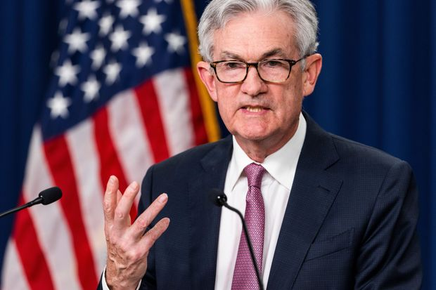
Federal Reserve Chairman Jerome Powell at today’s press conference.
Fed Chairman Jerome Powell noted in his press conference that monetary policy is a messy and hard business. "We don't have precision surgical tools. We have essentially interest rates, the balance sheet and forward guidance," Mr. Powell said. "They are famously blunt tools; they are not capable of surgical precision."
The war in Ukraine and factory lockdowns in China risk making supply-chain disruptions worse, he said, and there’s little the Fed can do about it.
Instead, Mr. Powell said, officials will stick to their role in cooling demand and hope the supply side gets resolved soon. “We’re focused on the job to do in demand and there’s plenty to be done there,” he said.
The Most Significant Turning Point Today
The most important event at today’s press conference came when the Chairman stated that the FOMC is not considering a one-time rate hike of ¾ of a percentage point. "A 75 basis point increase is not something the committee is actively considering," he said. Once he made this pronouncement, the stock and bond markets reacted instantly and synchronously by shooting higher. The stock markets were basically unchanged at the start of the chairman’s remarks, and they stunningly finished the day at their high-water marks. The Dow and the S&P 500 Index ended up nearly 3% and the tech-heavy NASDAQ roared 3.2% higher.
Mr. Powell also said he doesn't see a recession as something automatically following monetary policy tightening, noting "we have a good chance to have a soft or softish landing."
He said that households and businesses look like they are in good shape, adding, "The economy is strong and is well-positioned to handle tighter monetary policy. But I'll say I do expect that this will be very challenging, it is not going to be easy."
The Impact of Rising Interest Rates
The Interest Rate market has moved up dramatically more than the orchestrated (manipulated) movement of the Federal Reserve’s short-term rate hikes. This “rate inflation” has immediate and significant impacts on consumers and the cost of debt for corporations. Mortgage rates have soared this year and the end result will be a significant cooling in the upward price movements in the housing market. Similarly, the cost of credit card debt, auto debt and everything that has an interest rate component will be vastly more expensive before the trend in Fed induced rate hikes ends. Historically, the series of rate hikes we will experience this year will likely result in a recession late this year or early next year.
The chart below shows the impact on interest rates that the FOMC has had as they forecasted numerous rate hikes for 2022 and possibly beyond. Note that around six months ago the yield on the 2-year U.S. Treasury note was about ½ of a percent. As of today, the same Treasury investment will pay around 2.7% per year for the next two years with virtually no risk. Before the end of this year this bell-weather rate indicator will probably be at least 3.5% if not higher. That will certainly drain money out of the riskier stock market and feed it into the U.S. Treasury market thereby causing lower valuations for stocks.
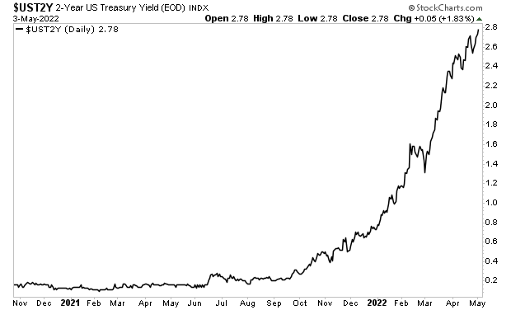
We have been forecasting the above events for some time and have taken the steps necessary to protect the portfolios from a declining stock market in a rising interest rate environment. In the days and weeks ahead, additional steps will most likely take place that will further insulate the portfolios from what could be significant downside in the stock markets.

