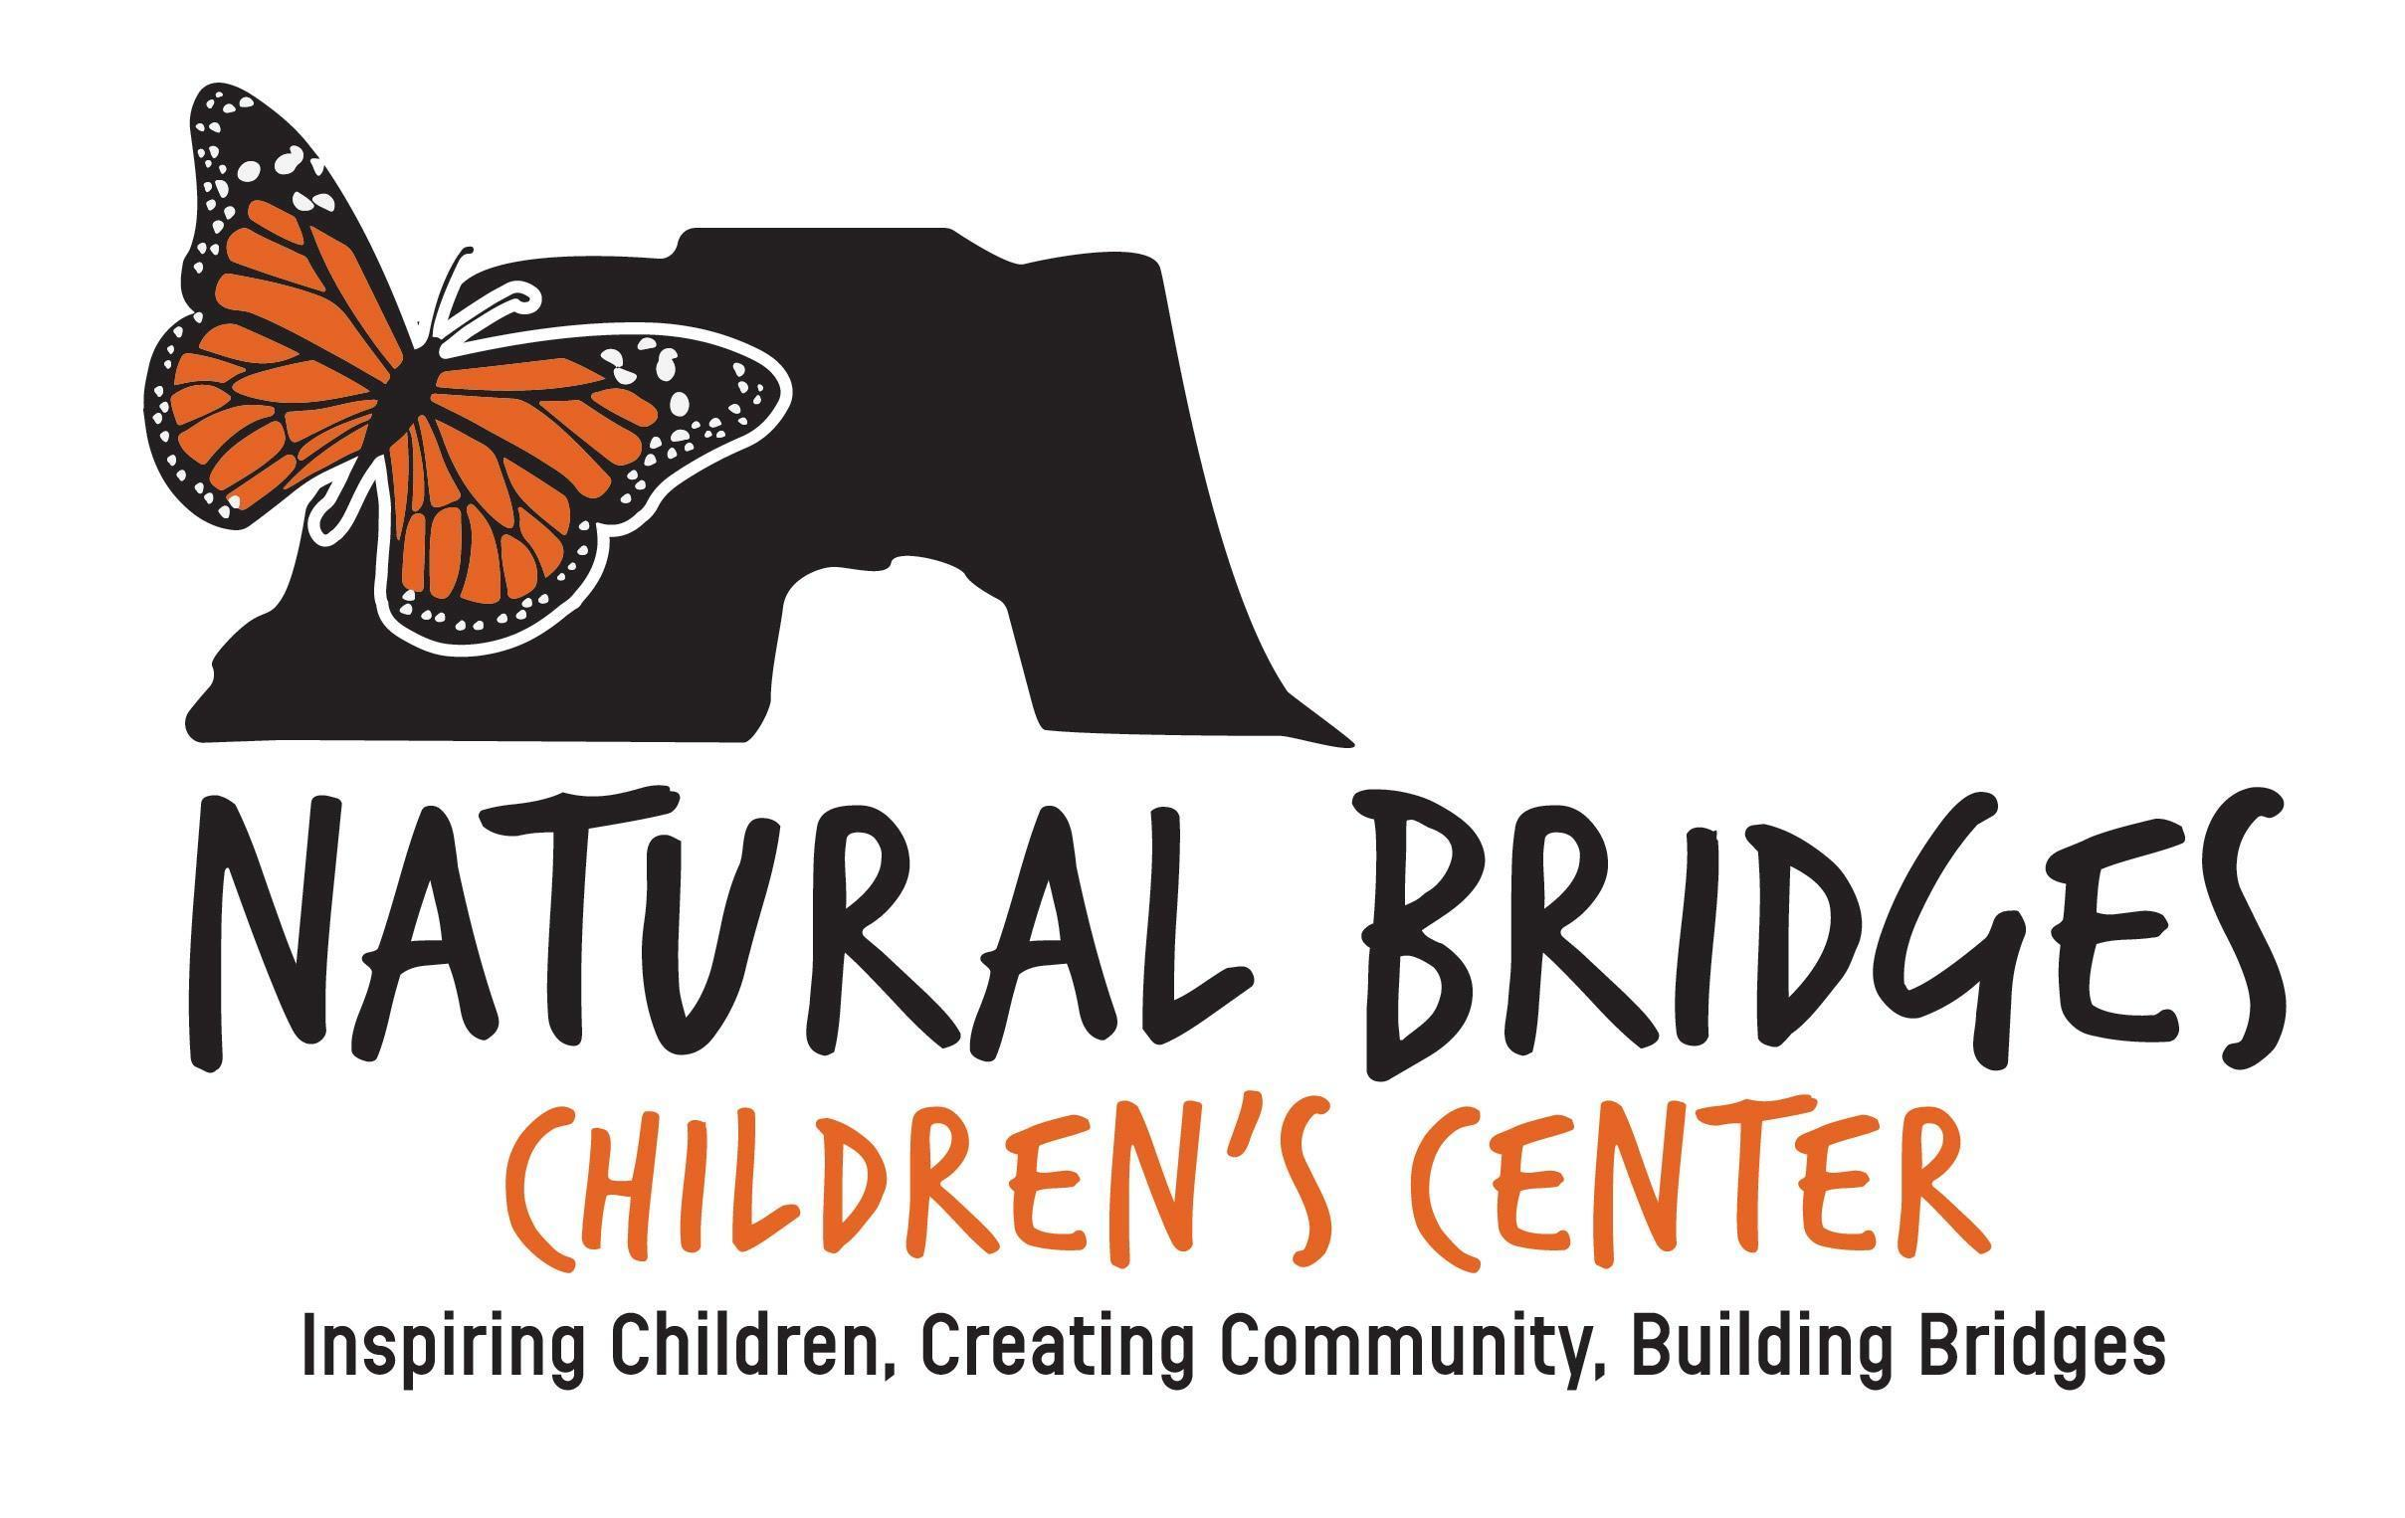
NBCC Tuition Schedule
2023-2024
Academic School Year  (Aug-May) | Hours | Days | Monthly Payment  (Aug.1st-May 1st) | Total Academic School Year Cost
3/4 Day - 5 days | 8:30-2:45 | M-Th | $1,745 | $17,450
 | 8:30-1:00 | Friday
3/4 Day - 4 days | 8:30-2:45 | M-Th | $1,550 | $15,550
½ Days - 4 days | 8:30-12:45 | M-Th | $1,200 | $12,000
Extended Day | 8:30-4:15 | M-Th | $2,065 | $20,650
 | 8:30-1:00 | Friday
6 Week Summer 2024 Program | Hours | Days | Monthly Payment  1st pull March 1st $1,150  (June 1st & July 1st) | Total Summer Program Cost
Camp | 9:00-2:00 | M-F | $1000 | $3,150

- There is a one-time $150.00 non-refundable application fee.

- If accepted, there is an annual $750 non-refundable enrollment fee.

- The ‘Academic’ School Year’ tuition is divided into 10 monthly payments and remains the same regardless of the number of days in any given month or regardless of your child’s attendance.

- Tuition is automatically withdrawn on the 1st of each month and begins August 1st and ends May 1st.

- A separate and ‘limited-space’ 6 week ‘Summer Camp Program’ is offered in January. If enrolled, a non refundable $1,150.00 deposit is due and pulled March 15th and is applied towards the total cost of the program. The remaining balance is divided into 2 payments of $1000 & withdrawn on June 1st & July 1st.

- Families are responsible for their contractual monthly tuition, including instances of emergency closures and/or pivots to ‘Distance Learning’, and voluntary decision to leave. There are no refunds under any circumstances.

*Prices subject to change

