Introducing:

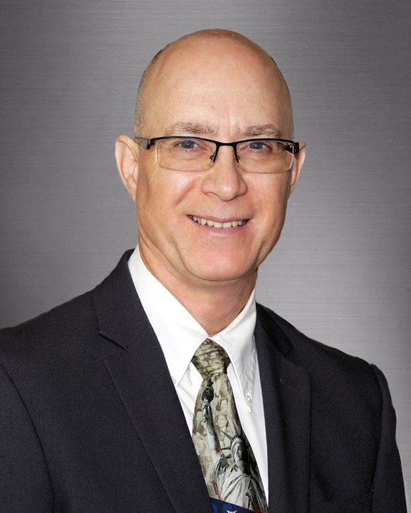

Gregg C. Pusateri, OD, M.Div.

Dr. Pusateri is the founder and Executive Director of the eCenter for Hope and Vision, Corp., the owner and President of New Horizons Low Vision Center, PC and is pleased to serve as the new owner of Low Vision Services of Southern Colorado, PC. He is thrilled to have the opportunity to serve the low-vision community of Colorado Springs and the surrounding area. As an expert in his field, Dr. Pusateri understands the unique needs of people with low-vision; he personally experiences low vision himself and infuses what he has learned throughout his own personal journey into his practice. He provides a unique, innovative and personalized approach to serving those with low-vision, educating patients on their specific condition and helping them understand what changes they can make in their lives to help them live fully with their limited vision. In addition to prescribing traditional optical devices, Dr. Pusateri empowers his patients to use technology (smart phones, tablets, computers, and smart devices) to improve their quality of life while employing his theological degree to provide compassion and hope to his patients when they feel that none exists. His teaching and research background allows him to access the latest diagnostic technology and the newest prescriptive devices for treating vision loss. His combined efforts, passion and experience enable patients to live more productive, independent and happy lives.

Education and Experience:

Dr. Pusateri’s extensive education has helped prepare him to have a deep impact in this role. He completed his doctorate of Optometry at the Illinois College of Optometry in 1986 and received his Master of Divinity from the University of Dubuque Theological Seminary in 2001. He served as the Senior Pastor of the Alto Reformed Church in Waupun, WI for over 9 years and has provided General Practice and Low Vision care for over 20 years. In 2016, Dr. Pusateri was honored to receive the Illinois College of Optometry Alumni Association’s Professional Achievement Award.

His prior work experience has given him the opportunity to provide services for a wide variety of needs. He has served as a Clinical Instructor and Adjunct Faculty for the Illinois College of Optometry and as Director of Access Technology for the Spectrios Institute for Low Vision (Wheaton, IL) where he supervised the Residents in Low Vision Rehabilitation, was the Research Coordinator, supervised the 4th year Externship program and was the liaison between Spectrios Institute for Low Vision and other Health Care Organizations. Most recently, Dr. Pusateri served as the Director of Optometry and Low Vision Services for the Lac Vieux Desert Health Center in Watersmeet, Michigan. Additionally, Dr. Pusateri has designed, prepared, and presented seminars on Low Vision Rehabilitation, engaging participants both across the U.S. and internationally to learn how counseling and technology training can transform the lives of patients struggling with permanent vision loss.

Family:

Children -

Jacob M. Pusateri, MD (30) who is currently in the Emergency Medical Residency program and University of Pittsburgh Medical Center Hamot in Erie, PA

Justin D. Pusateri (29) who serves as a Realtor with EXP Realty and also performs home construction and remodeling

Pets – 2 Yellow Labs Duke & Daisy

Person Interests:

Dr. Pusateri is passionate about his faith and his study of the Bible. He enjoys fellowship with family and friends, woodworking, running, fishing, skiing, yoga, music and movies.

