Sausage Stuffed Peppers! Sent out on 9/26/2017 by Catawba Fresh Market
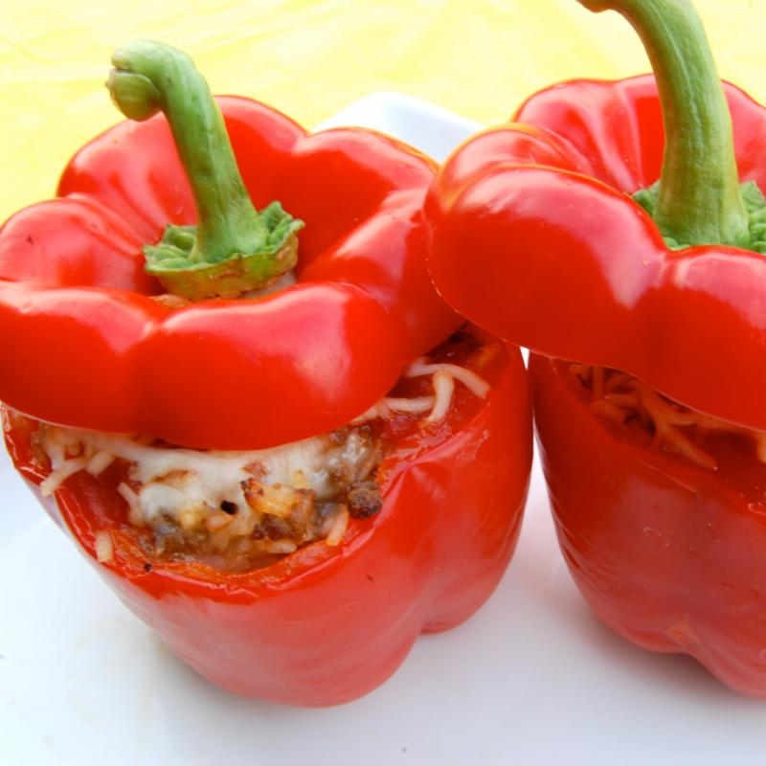
We thought it would be fun to share a recipe with you all this week! This features many different things that can be found and purchased at the market including sausage (in many different flavors), peppers (great bell peppers as well as a few varieties to spice up your dish), onions, garlic, tomatoes, and even fresh herbs!

4 bell peppers, tops cut off and cleaned out
1 lb sausage, crumbled or sliced
1/2 cup chopped onion
2 garlic cloves, minced
14 oz diced tomatoes
1 cup cooked rice
1 tablespoon chopped basil
salt and pepper to taste
1 cup shredded mozzarella cheese

- Saute sausage and onion until thoroughly cooked. Add garlic and saute 2-3 minutes.
- Stir in tomatoes and basil and simmer for 5 minutes. Stir in rice and season with salt and pepper.
- Boil peppers to precook for about 3 minutes or until tender. Remove and transfer to ice water to cool and stop the cooking process. Dry after cool.
- Stuff sausage mixture into peppers and place on lightly greased pan. Sprinkle with mozzarella cheese.
- Bake at 350 degrees for about 30 minutes or until peppers are tender.
- Enjoy!

