Our aim is to strengthen our trade union membership within EasyJet, by ensuring our workplace is a fair place to work, protecting the rights of our workers by negotiating better working conditions.

Branch LE/737 Newsletter June 2018

Buy back days/strike ready
We have been in negotiations with the company for several months in view of getting an agreement in place should the company wish for you to give up leave or a day off to work in times of emergency.

Unfortunately, we have been unable to agree an acceptable policy with the company up to now.

We wouldn’t recommend crew working on days off or leave until we agree a policy with the company.

We hope to be able to be in a position to agree a policy soon.

However, a breakdown in negotiations could escalate very quickly into balloting our members for industrial action, please ensure you’re “SRIKE READY” by checking with your Unite Reps that all your details are correct on our database, remember we now use electronic balloting so it is imperative we have an up to date personal email address to be able to contact you on should we have to.

Claim Income Tax relief for your uniform purchases

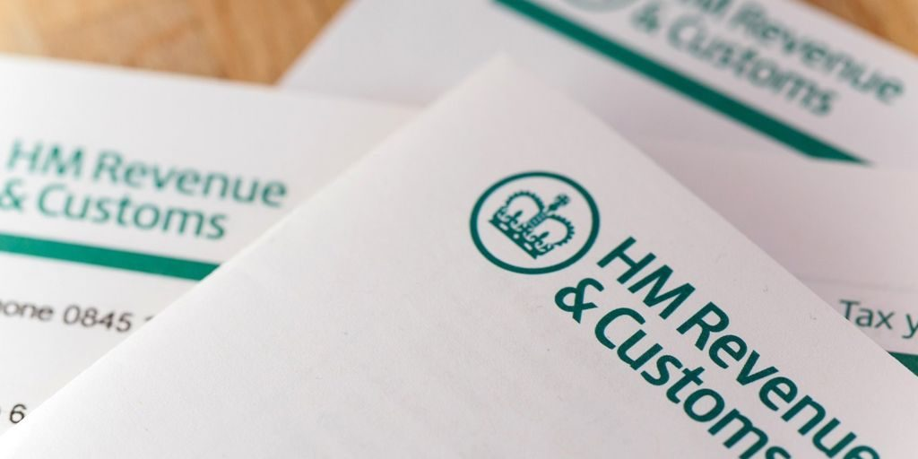Did you know you can claim back tax from uniform purchases?

If you would like to take advantage of this then please follow this link for more information:

https://www.gov.uk/guidance/claim-income-tax-relief-for-your-employment-expenses-p87

Crewing Issues
We have been hearing lots of reports of Crewing Officers making mistakes such as calling crew before SBY starts or after its ended.
We have investigated the reports we have received and found that although these mistakes are happening and are currently quite numerous, they are mostly down to genuine mistakes due to several Crewing Officers being new and the recent restructuring of the department.
We urge you to be mindful of your SBY times and FTLs whenever you’re on SBY until they get back up to speed.

You can find some help and guidance on SBY and EASA regulations on our website here: http://www.ezyunite.co.uk/help---guides.html

Recent Victories
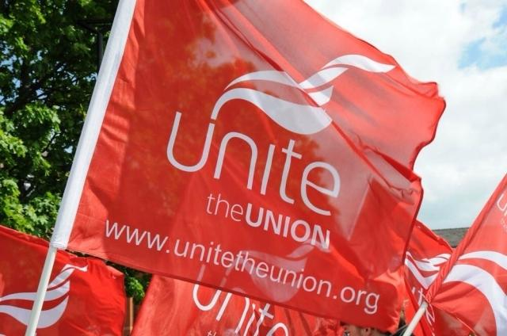Thanks to our members feedback, this month we can report three union victories!
- eCrew streamlining
eCrew will soon be updated to make it easier for you to change personal details, you will in future only have to update your details once rather than several times in several different places.
- High strength spirits on bistro
Due to our feedback after the current Gin promotion ends we will no longer sell high strength spirits onboard again after we found Gin containing up to 57% alcohol content for sale in our bistro.
- Uniform improvements
We will soon see improvements to the women’s white blouse and the men’s white shirt. Thread count will be improved so they will no longer be see-through, and they will be made longer so they remain tucked in.

Please keep continuing to report to your Unite Reps anything you would like us to look into to help improve your day to day working life, we have a lot of influence and contacts within the company to help bring about a lot of these changes.

Uniform Quality
This month we brought up with senior management the issue of uniform quality, for example items fading after washing and shrinking.
The company’s reply is as follows:
“We will need individual uniform items to send back to the manufacturer in this instance for them to review.
Fabric testing is carried out on every batch of fabric and as part of this process for each batch we wash the fabric X 300 cycles and test for colour fading and shrinkage at different temperatures.
Can we ask the individuals to contact the base management team, so we can send for expert testing?”

Equalities @ easyJet
Thanks in part to the hard work and dedication of our Unite Reps and especially our Equalities Reps over the years, we can all be proud that we work in a multi-cultural, discrimination free and tolerant workplace, where diversity between us is not only tolerated but celebrated.
Please report to our dedicated Equalities Rep Selena Kerr (EDI) if you experience or are aware of any kind of bullying, harassment or discrimination in our workplace.
Selena.Kerr@unitetheunion.org

Member Benefits

Being a Unite the union member at easyJet enables you to take advantage of some exclusive member benefits including access to Vauxhalls partners scheme, this enables you to an exclusive discount when buying a new Vauxhall car.
Just follow this link to find out more:
https://www.vauxhallpartners.co.uk/en/auth/login?camid=unite&dfa=vx_partners_Unite_Online

Your LOGIN is simply “UNITE”

You can find a link to details of all these and more exclusive offers and benefits on our websites home page: http://www.ezyunite.co.uk/home.html
Disciplinary Meetings

We need to remind you that it is YOUR responsibility to let your Rep and base management know as soon as possible if you are rostered a meeting that you wish to have union representation for.
As a Rep we need to do work before meetings also to ensure we can assist you in the most effective way possible.
Please do this as soon as possible when you are aware of your meeting date.
Remember that any notes taken in an investigation can be used in any further formal meetings, so think before you speak and read the notes CAREFULLY before signing them!
Please contact your Rep either through their Unite email address or phone number. Please DO NOT use their company email or social media!
We now have a disciplinary guidelines advice sheet on our website here: http://www.ezyunite.co.uk/template-letters.html

Communication and Feedback

When communicating with your Base Management, Reps or anyone within the company your Reps recommend that Email is the most appropriate tool.
This way we can gather a paper trail of communication and if necessary utilise this in meetings or as evidence if required. Verbal communication is fine but we suggest to always follow this up with a quick email and always feel free to cc or bcc your base Reps into any communication.

Update Your Details and ensure you are “strike ready”

Please ensure your contact details – including your mobile number, home address and email address – are updated and correct. Going forward, your Unite Committee will communicate with you using online media such as your email to send out the monthly newsletter and any surveys, or send you updates by text.

WE CANNOT EMAIL YOUR EASYJET EMAIL ACCOUNT.

We must therefore have a personal email address for you otherwise you are missing out on vital information and the chance to put your views across in surveys. It is a really important time for electronic balloting too, so please make sure all your details are updated, either contact your local Rep with your new details or contact us online here: http://www.ezyunite.co.uk/contact-us.html

EzyUnite Reps details:

Below a list of all the Union Reps at easyJet that are fully qualified to represent you in any meetings with management, answer any enquiries you may have and have sole recognition from easyJet to negotiate on behalf of yourselves on pay deals, and any other issues.

All the reps on this list (Lindsey Olliver, Regional Unite Officer the only exception) are current easyJet Cabin Crew (FAs, CMs, Line trainers, Leave Superusers etc.) and therefore have an excellent understanding of the business at all levels and its policies and procedures.

Because we are all working Cabin Crew at easyJet we ask that you email or contact us by phone during appropriate times if possible and be patient waiting for a reply as we may be flying.

LINDSEY OLLIVER  (Unite Regional Officer) | UNITE  LHR | 020 3004 3440 | Lindsey.Olliver@unitetheunion.org
CLINTON SHORTMAN  (Convenor) | BRS | 07702351846 | Clinton.Shortman@unitetheunion.org
MICHELLE AGUILAR (Deputy Convenor) | LGW | 07413199328 | Yuredyth.Aguilar@unitetheunion.org
JEMMA GRADWELL (Co-Convenor) | MAN | 07825223326 | Jemma.Gradwell@unitetheunion.org
MICHAEL BYRNE  (Communications Editor) | LPL | 07824559239 | Michael.Byrne@unitetheunion.org
ROBERT FETTES  (Health & Safety Rep) | LTN | 07713609029 | Robert.Fettes@unitetheunion.org
SELENA KERR (Equalities Rep) | EDI | 07902606012 | Selena.Kerr@unitetheunion.org
PAULA FEGAN | BFS | 07702805494 | Paula.Fegan@unitetheunion.org
VICKI BANE | BRS | 07989988135 | Vicki.Bane@unitetheunion.org
Rep on maternity leave | GLA |  | Please contact EDI rep for assistance.
ANTONIO MESA | LGW | 07456393033 | Antonio.Mesa@unitetheunion.org
PAUL IRWIN | LGW | 07912531225 | Paul.Irwin@unitetheunion.org
SAM GONZALEZ | LGW | 07413639478 | Samuel.Saez@unitetheunion.org
DUNCAN BULL | LGW | 07387570103 | Duncan.Bull@unitetheunion.org
LGW rep position available | LGW |  | Please contact Clinton Shortman if you would like to apply for the LGW rep role.
ALLY AINSLEY | LPL | 07506155567 | Alison.Ainslie@unitetheunion.org
JAZ McSHANE | LTN | 07984424698 | Jasmine.McShane@unitetheunion.org
ANDREW GEORGE | LTN | 07453493263 | Awaiting email address, please contact another LTN rep.
JON BLAND | MAN | 07488703861 | Awaiting email address, please contact another MAN rep.
New Rep to be announced shortly | NCL |  | Please contact any other Rep on this list.
LEESA DARRANT | SEN | 07786433216 | Leesa.Darrant@unitetheunion.org
Rep on maternity leave | STN |  | Please contact SEN rep for assistance.

For all the latest updates follow us on Facebook (Ezyunite) and check out our new website www.ezyunite.co.uk

