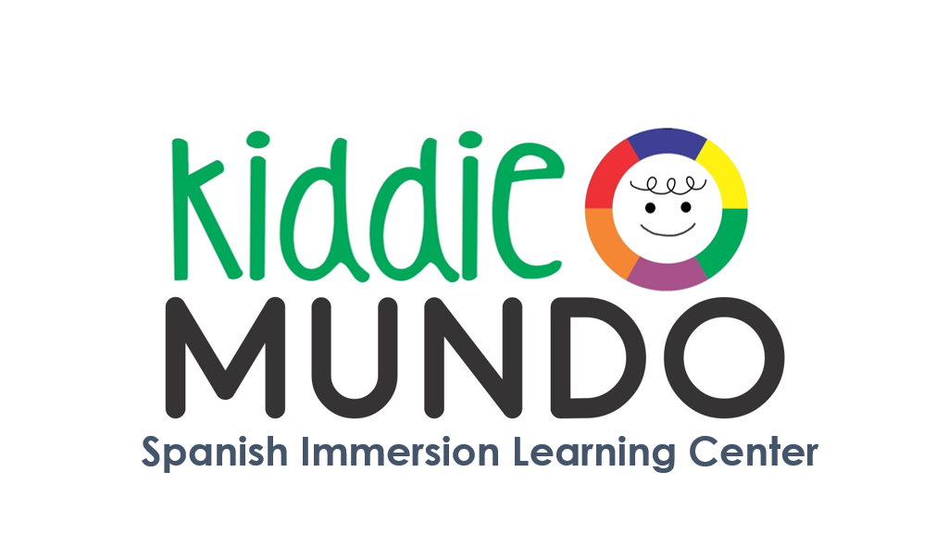
Summer
Camps

Camp #1  July 1 – July 12  No camp on 7/4 | Campamento  Multicolores  Multicolors Camps | Children will work in different art projects, learning about colors and developing fine motor skills during the activities. All materials will be provided. Recycling projects are included. Water-play on Fridays. No camp on 7/4. $620
Camp # 2  July 15 – July 26 | Arte y Naturaleza  Nature and Art | During two wonderful weeks, children will learn about insects, plants and nature, combining those learnings with art great projects. Music, gardening, cooking class games and sensorial activities are included. Water-play on Fridays. $680
Camp # 3  July 29 – Aug 9 | Los animales  All about animals | Let’s learn about animals!  We will learn about wild animals, domestic animals and sea animals. Crafts, games, music, songs, activities and projects are part of our two weeks. Water-play on Fridays. $680
Camp # 4  Aug 12 – Aug 23 | Bajo del Mar  Under the sea | Two weeks to learn about sea animals and learn about the ocean. Cooking class, music, projects, crafts, games and sensorial activities are included. Fiesta on the 23th. Water-play on Fridays. $680
Schedule: 9am – 4pm
Before / Aftercare available 8–9am and 4-5pm (limited spots)
Enrollment must include 2 consecutive weeks. Please note that spots are limited based on the license and children ratios. All children are welcome regardless of race, color, nationality, ethnic origin, sex, or special needs. A $10.00 Sibling discount is available. No refunds/discounts will be issued for failure to attend, family vacations, or if the center must be closed due to weather, power, and water or building emergencies.
Summer Camp
Registration

Child’s name: __________________________________________________________ M - F
Date of Birth: ___________________________ Current Age: _________years _____months
Home Address: ___________________________________________________________________
Name Parent/Guardian 1: ________________________________________________________
Relationship to child: __________________________ Cell Phone: _______________________
Home address: ___________________________________________________________________
Email address: ____________________________________________________________________
Name Parent/Guardian 1: ________________________________________________________
Relationship to child: __________________________ Cell Phone: _______________________
Home address: ___________________________________________________________________
Email address: ____________________________________________________________________
Sibling information:
Name: _________________________________________ School: __________________________
Name: _________________________________________ School: __________________________
Allergies: _________________________________________________________________________
Treatment: _______________________________________________________________________
Select the Summer Camps
________CAMP #1  Campamento  Multicolores  Multicolors Camps  $620 | _______CAMP #2  Arte y Naturaleza  Nature and Art  $680 | _______CAMP # 3  Los animales  All about animals  $680 | _______ CAMP #4  Bajo del Mar  Under the sea  $680
July 1 – July 12  No camp on 7/4 | July 15 – July 26 | July 29 – Aug 9 | Aug 12 – Aug 23

_______ Before care $40 per week _________ Aftercare $40 per week
CAMP POLICY AGREEMENT
-To reserve your child’s spot, please select one fee payment option. Please make your check payable Kiddie Mundo LLC.
______Deposit ($100 per camp); Balance due by May 6th, 2019 $ _________
______Pay in Full: 10% discount if paid in full by April 2, 2019.
A sibling discount of $10.00 is available same day registration and to the same family.
Cancellation Policy:
- All cancellations must be made in writing to info@kiddiemundoeducation.com.
-Cancellations made prior to May 6, 2019 will be refunded less the $50 Administrative fee.
-Cancelations made after May 6, 2019 will be refunded at 50% of camp registration.
-Cancellations made within 14 days of the start of camp week will not receive a refund.
-Fees remain the same even if Kiddie Mundo LLC close due to emergencies or inclement weather or open late/close early due to emergencies or inclement weather. No refunds or credits will be given for missed day. Makeups are not available. No exceptions.
Snacks and Lunch:
-Kiddie Mundo will provide AM and PM snacks for all campers. Families will provide a nonperishable lunch option. Sodas, juices boxes, grapes, candies are not permitted. Please do not send your child any peanut or tree-nut products, including peanut butter and jelly sandwiches. Kiddie Mundo is a Peanut and nut free place.
Necessary Forms:
Camp Registration will be completed once ALL forms are filled and returned to the center before June 1st, 2019. Kiddie Mundo Spanish Immersion counts with limited spots available for every age group.
Photo release:
_____I give ____I do not give my permission to Kiddie Mundo use my child’s photograph or image, voice for video or recording for any promotional materials, and release Kiddie Mundo of any claim or liability to that use.
I agree to release teachers of / and from any claims, demands or liability arising from the participation of my child/children in the Kiddie Mundo camps. I accept all responsibility for the activities performed during the camp.
I have read and agree to the policies of Kiddie Mundo LLC

Student’s name: ______________________________________ Date: _____________________________

Parent name: _____________________________ Signature: ______________________________

