Rock City Church Unoffendables
Curriculum

Contents

Introduction………………………………………………………………………..........Page 4

Table of Contents

Lesson 1: “A Clean Heart”……………………………………..………………….....Page
Lesson 2: “It’s Not Fair”...........…………………………………………………….. Page
Lesson 3: “Mad at Dad: When Fathers upset us.…………………………..Page
Lesson 4: “Don’t Quit, Stay and Obey”………...…………………………….....Page
Lesson 5: “Stronger than the Giants”…………………………………………..Page
Lesson 6: “A Precious Stone”…………..…………….………………………........Page
Lesson 7: “Building others up”..………………………………..…………..........Page
Lesson 8: “Forgiving others” ………………………...........................................Page
Lesson 9: “He is My Defender”………….………………………………………...Page
Lesson 10: “Don’t Judge Others”……………………………………………........Page
Lesson 11: “Getting It Right”.........………………………………………………..Page
Lesson 12: “Will you Forgive Me?”……………………….................................Page
Lesson 13: “Walking in Forgiveness”…………………………………………...Page

You Have to Give to Get
GODS GENERALS FALL LESSON 8
AGE: ELEMENTARY 6-8 YEAR OLDS
Adopted From Bait of Satan by John Bevere

Lesson Topic: You Have to Forgive to Be Forgiven

LESSON | WHAT CHILDREN DO | SUPPLIES | PREPARATION
1  Getting Started | Introduction/Ice Breaker:  Tug of War Game | Long, thick rope | Divide children evenly.
2  Bible Exploration.  Key Verse Activity | Key Verse:  Mark 11:25  Bible Story: The Unforgiving Servant- Matthew 18 | Bibles, copy of verse
 | Bible Activity:  Act out the Bible story. Matthew 18:25-35 | Bibles  Simple props for story:i.e. brown bags to represent gold, silver. Etc.  Or Use Puppets | Use the computer to print the Bible story.
 | Brainstorm and act out offense situations:
LESSON | WHAT CHILDREN DO | SUPPLIES  NEEDED | PREPARATION OVERVIEW
3  Weaving Faith  Into Life | Craft/Make and Take:  The Lord’s Prayer “Forgive us our sins, as we forgive others” | 1 Pipe Cleaner per child.  Black, red, blue, green white bead per child. | 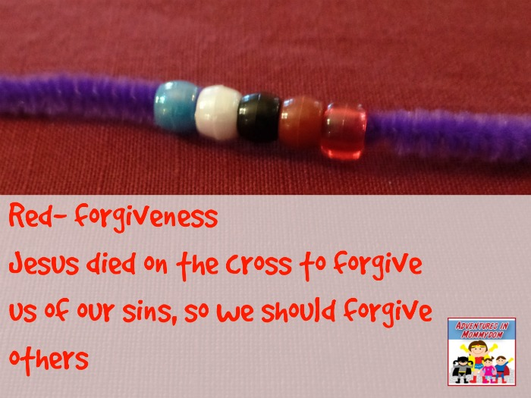  Retrieved from Adventures in Mommydom
 | Object Lesson/Activity:  Forgiveness Object Lesson | Empty clear water bottle with happy face drawn on.  Bendable straw,  Food coloring, 4 clear plastic cups with a little water in each, one clear cup with cross drawn on it, 1 balloon | Go to link to see how it is done: https://youtu.be/mrk82d9VYy4  Or https://youtu.be/LoJmvWEssso  If can’t find link google forgiveness object lesson
 | Additional Activity:  Make a word search on the computer of all the words in verse. | Bibles, copies of word search | http://puzzlemaker.discoveryeducation.com/WordSearchSetupForm.asp
4  Lasting Impressions | Prayer Points: In the Kingdom of God you are required to forgive.  The Holy Spirit helps us forgive.  When we forgive others, God forgives us. | Bible, journals | Students write or draw a picture of forgiving or something they learned in the lesson.
 | Faith at Home:  Talk about how to share what they learned with their families. |  | What parents can do at home: Take time to share with one another and forgive one another.
Lesson Topic:Forgiveness

Lesson Background/Foundation for Teachers: Forgiveness is an absolute principle in the Kingdom of God. Matthew 6:9-13 Jesus teaches the disciples to pray and ask forgiveness. Luke 23:34 Jesus, hanging on the cross, asks God the Father to forgive them. To help the disciples understand forgiveness Jesus tells a story about a servant who was forgiven his debts. Matthew 18:23-24 The servant did not forgive when he had the chance. Holding unforgiveness can be compared to the story of the unforgiving servant. Offense is like a debt. When we release others from the offense it’s like forgiving a debt.

Introduction Activity Tug of War
Supplies Needed: See overview
Directions: Children are divided equally by strength into two teams. For safety sake, try using 2 or 3 students on each side at first. Tie a scarf at the half way mark of a long, tug of war rope. Put tape on the floor at the half way mark. One team holds the rope close to the scarf, the other team allows more space or give. Give signal and have teams pull. Which side was easier to pull the scarf across the dividing line. The side with more give? Or the other side who barely gave any extra rope? Save the point of the lesson for after the Bible story. God said if we forgive, then we will be forgiven. .

Praise & Worship:
- Song 1: Let Your Words Bring Life by Third Day
- Song 2: Words by Hawk Nelson
- Song 3: I’m Forgiven by Chris Tomlin

Key Verse: Mark 11:25 And whenever you stand praying, forgive, if you have anything against anyone, so that your Father also who is in heaven may forgive you your trespasses.”

Bible Story:
- Scripture Reference: Matthew 18:23-35
Narrative of Story: To help the disciples understand forgiveness Jesus tells a story about a servant who was forgiven his debts. Matthew 18:23-24 The servant did not forgive when he had the chance. Holding unforgiveness can be compared to the story of the unforgiving servant. Offense is like a debt. When we release others from the offense it’s like forgiving a debt.

Bible Activity : Students will act out the Bible story. For a change you can use puppets to act out the story. If the group is large, have them act out different parts. One group can rap or make up a song or actions to Bible verse. They can present after the story. Discuss how forgiveness relates to being unoffendable. Students can share any unforgiving issues or needs for prayer.

Game/Object Lesson: See overview and the links to forgiveness object lesson.

Craft/Make & Take: Forgiveness Bracelet.

Title: Bracelet

Supplies Needed: See above overview

Directions: Put bead on pipe cleaner and practice moving bead and saying:
Blue- God, creator of world
Red-gave us Jesus. Jesus shed his blood to forgive us of our sins.
Black/brown- Things happens and we get upset/angry or offended.
Green- go to those who offend or make you upset- forgive them
White-God forgives us

Additional Activity:
- Title: Bible Verse Word Search
- Supplies Needed: Bibles, Copy of Word Search, pencils
- Directions: Go to the “Word Search Generator” link. It is given in the overview. Use the words from the verse to make the search.

Closing Activity & Prayer:
Call to Action:
In the Kingdom of God you are required to forgive.
The Holy Spirit helps us forgive.
When we forgive others, God forgives us.
- Prayer: Ask the Holy Spirit to help you to forgive.
Write a prayer about forgiveness.
Write a declaration about forgiving.

Faith At Home:
Take time to share with one another and forgive one another.

