Mountain Roots Golf Tournament
Silent Auction Donation Form
September 20, 2024
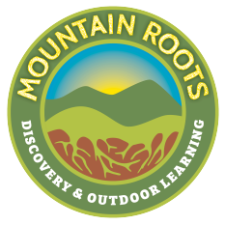

ABOUT MOUNTAIN ROOTS
We are a 501(c)3 non-profit organization providing discovery and outdoor learning experiences with a focus on environmentally responsible and community centered living. We provide outdoor experiences for the youth of our community year-round! For more information visit www.MountainRoots.org.

YOUR SUPPORT
Funds raised from the Silent Auction will support experiential education programs with our local schools. Your donation is tax-deductible, and you will receive a donation receipt.

Please send your Silent Auction donation and this form to:
Mountain Roots, Inc.
PO Box 248
Cedar Mountain, NC 28718
Or email it to: ali@mountainroots.org

Your Name: __________________________ Date: _____________
Address:________________________________________________
City / State & Zip:_______________________________________ Phone:_________________________________________________
E-mail:_________________________________________________
Silent Auction Donation Description: __________________________________
Value of Donation: ________________________________________________
Thank you for your support!
For your tax Purposes, Mountain Roots EIN is 27-0898040

