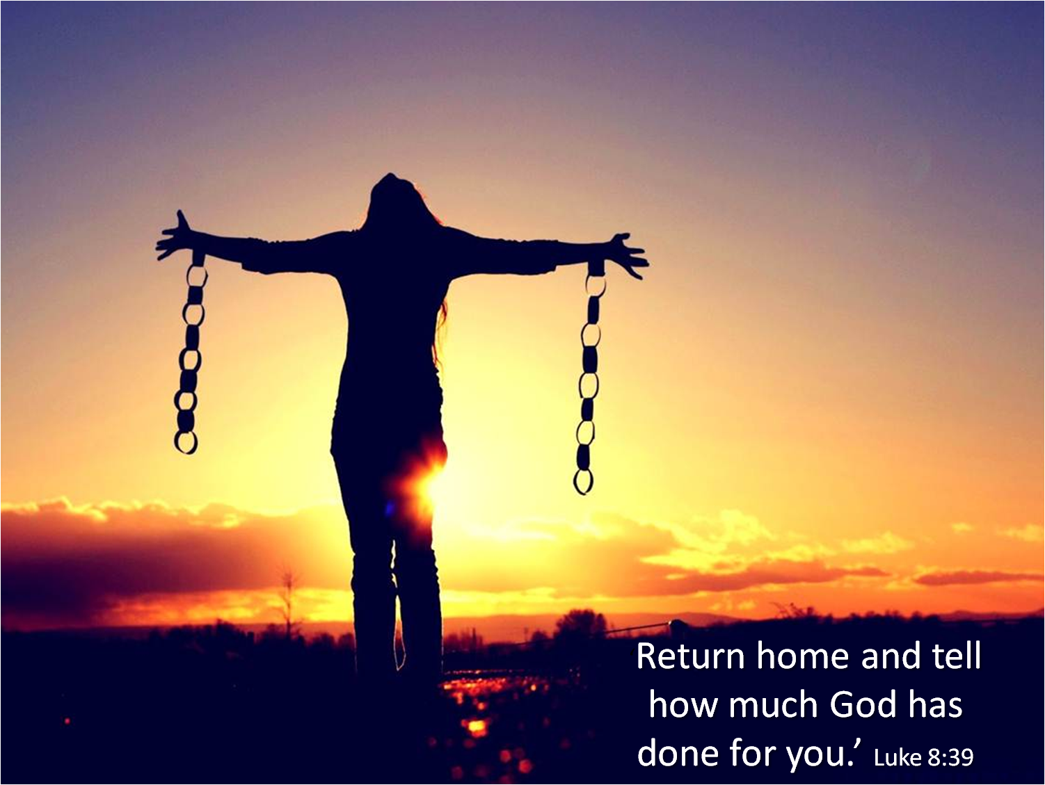
June 19, 2022

Second Sunday after Pentecost

Carson City United Methodist Church

10:30 am

Greeting/Announcements

Call to Worship

L: Come, you scattered and torn;
P: Here find hope.
L: Come, you scared and lonely;
P: Here find love.
L: Come, you tired and tense;
P: Here find rest.
L: Come, you confused and searching;
P: Here find guidance.
L: Come, happy or sad;
P: Here join the song. Here let your lives be embraced by
God's grace

*Hymn: Holy, Holy, Holy UMH 064

Opening Prayer:
Holy God, weave praise into the fabric of our days so our lives become a blessing to others.
Weave peace into our words and deeds so hatred and anger are disarmed.
Weave love into our work so accomplishments are imbued with humility.
Weave kindness into our actions so the world becomes a joyous place to live.
Weave hope into every encounter so we may testify to God's continuing resurrection.
Weave songs into our worship so our morning might echo in praise to God. Amen.
Contemporary Song: I am (Mark Schultz)

Offering

Doxology UMH 95

Offertory Prayer

Sharing of our Joys and Concerns

Call to Prayer: Surely the Presence of the Lord
UMH 328

Pastoral Prayer

Gospel Reading: LUKE 8:26-39

Old Testament: 1 KINGS 19:1-4, 8-15a
Epistle Lesson: GALATIONS 3:23-29
Contemporary Song: Goodness of God

MESSAGE

*Hymn: O God, Our Help in Ages Past UMH 117

Benediction

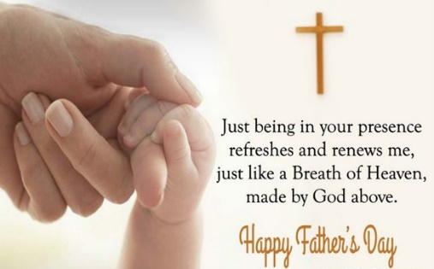

CCUMC – Announcements & Upcoming Events:

As a courtesy to others please silence or shut off cellphones

==================================================
Hall rentals for June: Sat, June 25th 10:00 am to ?
==================================================
Vacation Bible School for 2022: July 17th to July 21st, 6:00-8:30 pm. We need crew leaders and helpers. Please contact Roberta Kile if you are willing to help. Register via email here: vbs.register@gmail.com Or call the office 989-584-3797.
==================================================
VBS Supplies needed: white flat sheets, cylindrical oatmeal boxes, tissue paper, pool noodles, boxes, brown packing paper. Please place in tub under the Monumental table.
==================================================
Church Picnic: Sun, Aug 7, 2022, following 10:30 am Worship Service. See the flyer located throughout the Church for more information.
==================================================
Christmas 2022 Service: With Christmas Day falling on Sunday for 2022 we would like to go with the following schedule so people can spend Christmas Day with family and friends. Please let us know your thoughts.
- Christmas Candlelight Service: 12/24/22 @ 7 pm
- Christmas Day Service: No Sunday Worship Svc

Serving & Supporting Sunday Worship
Audio/Video: Lauren Monroe

Joys, Concerns & Prayer Request
For those battling cancers:
Jim Dunlap, Carolyn Nykerk, Ray Seaman, Dillan Abell, Amorena Newman-Wojciakowski

For those who need support, guidance or have health concerns: Mike Decker, Vivian Dennis

Monthly Giving
6/5 $3298.84 6/12 $1772.88

Nursery Schedule
Open for the summer but no supervision

Lighting of Candles

Passing of Collections Plate

Our Church in Ministry This Week
Mon: PT Class 6:30-8 pm
Tue: COA Meal @ Noon
NO COA on Thu 6/23

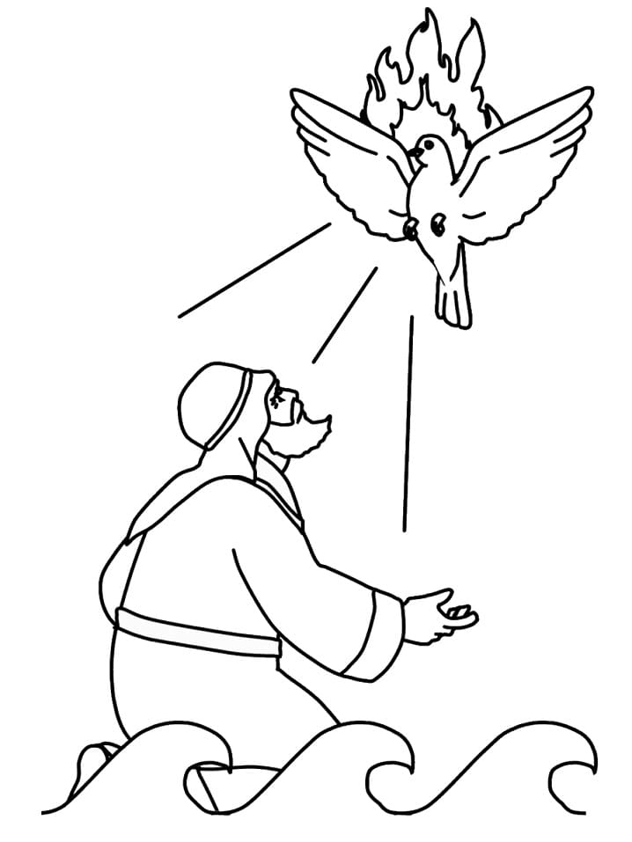
Coloring Page

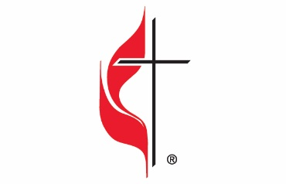

Carson City United Methodist Church
Location: 119 East Elm St., Carson City, MI
Mail: PO Box 298, Carson City, MI 48811
Phone: 989-584-3797 Email: carsoncityumc@gmail.com
Website: carsoncityumc.com
Sunday Worship Service: 10:30 am
Office Hours: Monday-Thursday, 9:00 am-12:00 pm
After hours by appointment
Pastor: Ian McDonald 906-322-5318
Secretary: Bonnie Seaman 989-763-1674

Weekly Sunday Bulletin now available on our website
@ www.carsoncityumc.com

“Dear God, please strengthen me to meet
the challenges I face today”

